EDEXCEL GCSE MATHS · FOUNDATION & HIGHER
Sectors of circles
Area and volume · Lesson 5 of 7
Teacher copy - includes the notes for whoever is teaching from it.
Warm-up
Answer each one, then check.
1. What is the circumference of a circle with radius 5 cm, in terms of π?
10π
2. What is the area of a circle with radius 6 cm, in terms of π?
36π
3. Simplify 90/360.
¼
4. How many degrees in a full turn?
360
5. What is the area of a triangle with base 8 and height 8?
32
Learning Objectives
1. Identify the arc and sector of a circle.
2. Find arc length and sector area as a fraction of the whole circle.
3. Find the perimeter of a sector.
4. Find the area of a segment (Higher).
A Sector and Its Arc
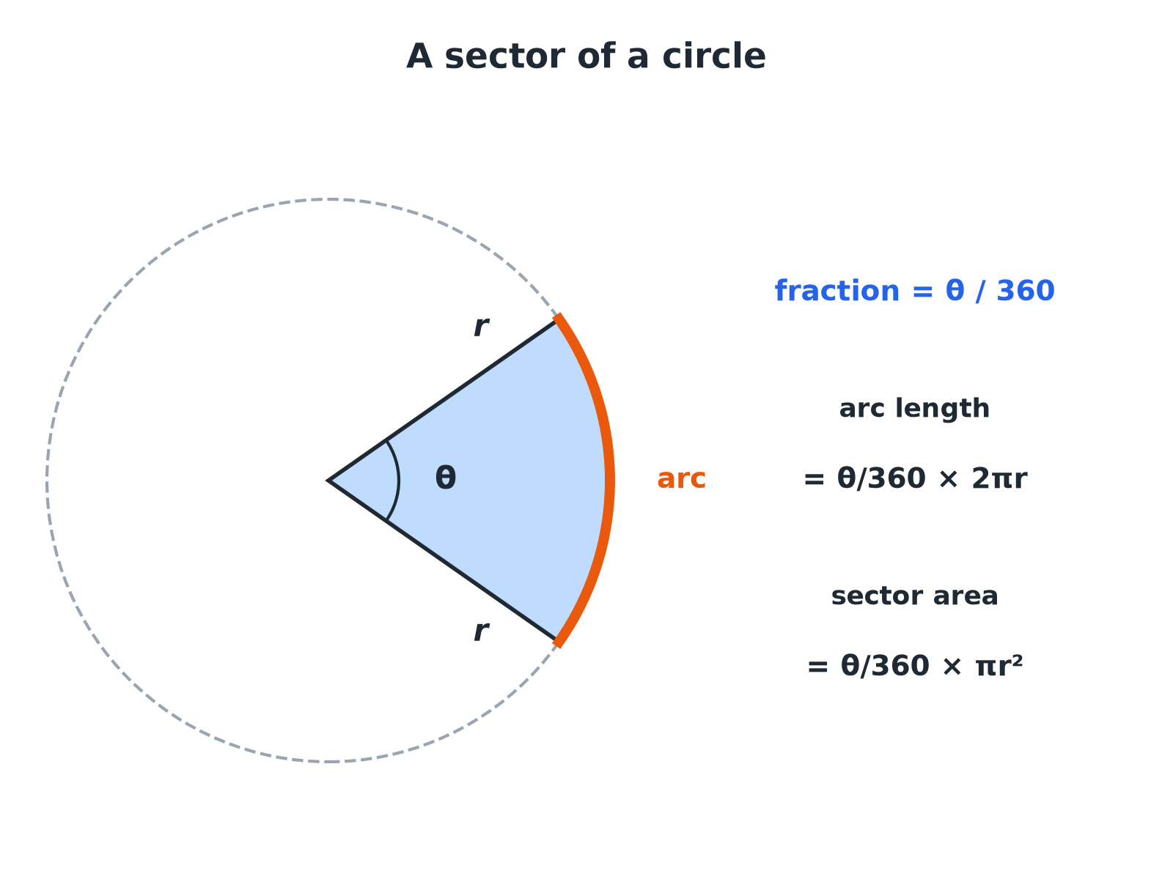
A sector is a fraction θ/360 of the whole circle.
A circle with a shaded sector, its arc highlighted and the angle theta at the centre, with the arc length and sector area formulae.
Sector Formulae
Fraction of the circle  θ/360, where θ is the angle at the centre in degrees. | Arc length  θ/360 × 2πr: a fraction of the circumference.
Sector area  θ/360 × πr²: a fraction of the circle's area. | Sector perimeter  Arc length + 2r (the two straight radii).
Arc Length and Sector Area
A sector has radius 6 cm and angle 60°. Find the arc length and the area, in terms of π.

1. Fraction of the circle
60/360 = 1/6
2. Arc length
1/6 × 2π × 6 = 2π
3. Area
1/6 × π × 6² = 6π
Answer: Arc length 2π cm (6.28 cm) and area 6π cm² (18.85 cm²).
Perimeter of a Sector
A sector has radius 5 cm and angle 90°. Find its perimeter to 1 decimal place.

1. Arc length
90/360 × 2π × 5 = 2.5π= 7.854...
2. Add the two radii
2 × 5 = 10
3. Total
7.854 + 10
Answer: 17.9 cm
Finding the Angle
A sector has radius 12 cm and an arc length of 8π cm. Find the angle at the centre.

1. Arc length formula
θ/360 × 2π × 12 = 8π
2. Simplify
θ/360 × 24π= 8π
3. Divide both sides by 24π
θ/360 = ⅓
4. Solve
θ= 120
Answer: 120°
HIGHER TIER
The Area of a Segment
Sector minus triangle.
Segment Area HIGHER
A sector has radius 8 cm and angle 90°. Find the area of the segment cut off by the chord, to 1 decimal place.

1. Sector area
90/360 × π × 8² = 16π= 50.27
2. Triangle area ½r² sin θ
½ × 8 × 8 × sin 90°= 32
3. Subtract
50.27 − 32
Answer: 18.3 cm²
Sector or Segment?
The words are easy to mix up.
▸ Sector. The "pizza slice" between two radii and an arc.
▸ Segment. The region between a chord and an arc. It is a sector with a triangle cut off.
▸ Segment area. Sector area − triangle area, where the triangle has area ½r²sin θ.
Key Terms
Sector  A region of a circle between two radii and the arc joining their ends. | Arc  Part of the circumference of a circle.
Segment  The part of a circle cut off by a chord. | Chord  A straight line joining two points on a circle.
Angle at the centre  The angle between the two radii of a sector. | Fraction of a circle  θ/360.
Your Task: Slice the Clock
10 minutes
The minute hand of a clock is 15 cm long. Find the distance its tip travels in 20 minutes, and the area swept out by the hand in 20 minutes. Give both answers in terms of π.
1. Find the fraction of a full turn.
2. Apply it to circumference and area.
A good answer shows: In 20 minutes the hand turns through 120°, which is ⅓ of a circle. Distance = ⅓ × 30π= 10π cm. Area = ⅓ × 225π= 75π cm².
Note: Link the angle to the fraction of an hour.
Can I...?
☐ Write the fraction θ/360.
☐ Find an arc length.
☐ Find a sector area.
☐ Find the perimeter of a sector.
☐ Find the angle from an arc length.
☐ Give answers in terms of π.
☐ Find a segment area (Higher).
☐ Tell a sector from a segment.
Summary
✓ Arc length = θ/360 × 2πr.
✓ Sector area = θ/360 × πr².
✓ Sector perimeter = arc + 2r.
✓ Segment area = sector − triangle (Higher).

EXAM FOCUS
A sector of a circle has radius 9 cm and angle 40°. Work out the length of the arc of the sector. Give your answer correct to 3 significant figures. (3 marks)
Write the fraction θ/360 first. Then multiply it by the circumference (arc) or the area (sector).
Exam Practice: Sectors of Circles
Answer all questions. Show your working. · 30 minutes
▸ Question 1 · 3 marks · Calculator. The diagram shows a sector of a circle of radius 9 cm. The angle at the centre is 40°. Work out the length of the arc. Give your answer…
▸ Question 2 · 3 marks · Calculator. A sector of a circle has radius 10 cm and angle 72°. Work out the area of the sector. Give your answer correct to 3 significant figures.
▸ Question 3 · 4 marks · Calculator. A sector of a circle has radius 5 cm and angle 90°. Work out the perimeter of the sector. Give your answer correct to 3 significant figures.
▸ Question 4 · 3 marks · Non-calculator. A sector of a circle has radius 12 cm and angle 150°. Work out the length of the arc. Give your answer in terms of π.
▸ Question 5 · 3 marks · Non-calculator. A sector of a circle has radius 12 cm. The arc length of the sector is 8π cm. Work out the angle at the centre of the sector.
▸ Question 6 · 4 marks · Calculator. A sector of a circle has radius 8 cm and angle 90°. Work out the area of the segment formed by the chord joining the ends of the two radii…
Question 1 · 3 marks · Calculator
The diagram shows a sector of a circle of radius 9 cm. The angle at the centre is 40°. Work out the length of the arc. Give your answer correct to 3 significant figures. (3 marks) | 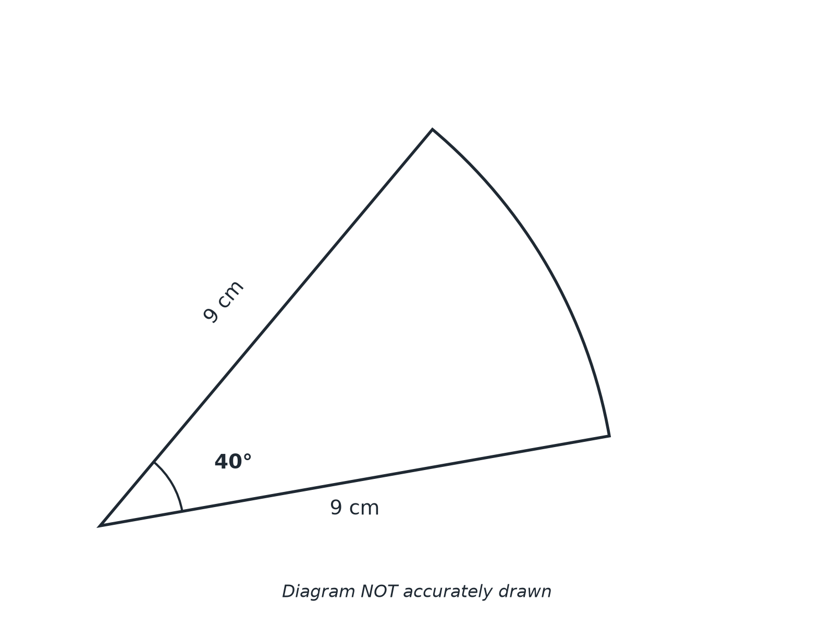

Question 1 · mark scheme
3 marks available. Award a mark for each point made.
▸ 40/360. M1
▸ 40/360 × 2 × π × 9. M1
▸ 6.28. A1
▸ Model answer. 40/360 × 2π × 9 = 2π= 6.28 cm.
Question 2 · 3 marks · Calculator
“A sector of a circle has radius 10 cm and angle 72°. Work out the area of the sector. Give your answer correct to 3 significant figures.”
HOW TO ANSWER IT Command word: Calculator. Worth 3 marks, so plan before writing.
Question 2 · mark scheme
3 marks available. Award a mark for each point made.
▸ 72/360. M1
▸ 72/360 × π × 10². M1
▸ 62.8. A1
▸ Model answer. 72/360 × π × 10² = 20π= 62.8 cm².
Question 3 · 4 marks · Calculator
“A sector of a circle has radius 5 cm and angle 90°. Work out the perimeter of the sector. Give your answer correct to 3 significant figures.”
HOW TO ANSWER IT Command word: Calculator. Worth 4 marks, so plan before writing.
Question 3 · mark scheme
4 marks available. Award a mark for each point made.
▸ Arc length method. M1
▸ 7.854. A1
▸ Adding two radii. M1
▸ 17.9. A1
▸ Model answer. The arc is 90/360 × 2π × 5 = 7.854 cm. The perimeter is 7.854 + 5 + 5 = 17.9 cm.
Question 4 · 3 marks · Non-calculator
“A sector of a circle has radius 12 cm and angle 150°. Work out the length of the arc. Give your answer in terms of π.”
HOW TO ANSWER IT Command word: Non-calculator. Worth 3 marks, so plan before writing.
Question 4 · mark scheme
3 marks available. Award a mark for each point made.
▸ 150/360 or 5/12. M1
▸ 5/12 × 24π. M1
▸ 10π. A1
▸ Model answer. 150/360 × 2 × π × 12 = 5/12 × 24π= 10π cm.
Question 5 · 3 marks · Non-calculator
“A sector of a circle has radius 12 cm. The arc length of the sector is 8π cm. Work out the angle at the centre of the sector.”
HOW TO ANSWER IT Command word: Non-calculator. Worth 3 marks, so plan before writing.
Question 5 · mark scheme
3 marks available. Award a mark for each point made.
▸ θ/360 × 2π × 12 = 8π. M1
▸ θ/360 = ⅓. M1
▸ 120. A1
▸ Model answer. θ/360 × 24π= 8π, so θ/360 = ⅓ and θ= 120°.
Question 6 · 4 marks · Calculator
“A sector of a circle has radius 8 cm and angle 90°. Work out the area of the segment formed by the chord joining the ends of the two radii. Give your answer correct to 3 significant figures.”
HOW TO ANSWER IT Command word: Calculator. Worth 4 marks, so plan before writing.
Question 6 · mark scheme
4 marks available. Award a mark for each point made.
▸ Sector area 50.27. M1
▸ Triangle area 32. M1
▸ 50.27 − 32. M1
▸ 18.3. A1
▸ Model answer. Sector = 16π= 50.27 cm². Triangle = ½ × 8 × 8 = 32 cm². Segment = 50.27 − 32 = 18.3 cm².

