EDEXCEL GCSE MATHS · FOUNDATION & HIGHER
Pyramids and cones
Area and volume · Lesson 7 of 7
Teacher copy - includes the notes for whoever is teaching from it.
Warm-up
Answer each one, then check.
1. What is the area of a square with side 6?
36
2. State Pythagoras' theorem.
a² + b² = c²
3. What is ⅓ of 36 multiplied by 9?
108
4. What is the area of a circle with radius 4, in terms of π?
16π
5. What is the volume of a prism?
Cross-sectional area times length
Learning Objectives
1. Find the volume of a pyramid using ⅓ × base area × h.
2. Find the volume and curved surface area of a cone.
3. Use Pythagoras to find a slant height.
4. Find the volume of a frustum (Higher).
Pyramids and Cones
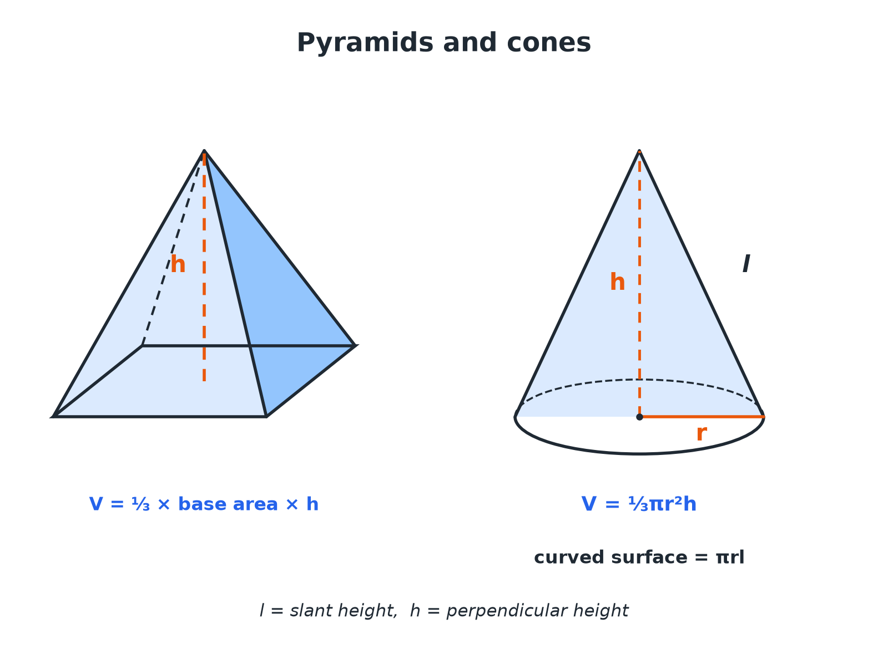
The perpendicular height is not the slant height.
A square-based pyramid and a cone, each with perpendicular height marked and the cone's slant height labelled.
The Key Fact
A pyramid or cone has one third of the volume of the prism or cylinder with the same base and height.
V = ⅓ × base area × perpendicular height
A Pyramid
A square-based pyramid has base side 6 cm and perpendicular height 9 cm. Find its volume.

1. Area of the base
6 × 6 = 36
2. Volume = ⅓ × base area × h
⅓ × 36 × 9
3. Work out
108
Answer: 108 cm³
A Cone
A cone has base radius 4 cm and perpendicular height 9 cm. Find its volume in terms of π and to 1 decimal place.

1. Volume = ⅓πr² h
⅓ × π × 16 × 9
2. Simplify
48π
3. As a decimal
150.8
Answer: 48π= 150.8 cm³
Slant Height and Curved Surface
A cone has base radius 5 cm and perpendicular height 12 cm. Find (a) the slant height, and (b) the curved surface area in terms of π.

1. (a) The radius, height and slant height form a right-angled triangle
l² = 5² + 12² = 169
2. Slant height
l = 13
3. (b) Curved surface area = πr l
π × 5 × 13 = 65π
Answer: (a) 13 cm (b) 65π cm² (204.2 cm²)
Formulae for Pyramids and Cones
The volume formula for a cone is on the formulae sheet; the curved surface area of a cone is too.
Solid | Volume | Surface
Pyramid | ⅓ × base area × h | Add the areas of all the faces
Cone | ⅓πr² h | Curved surface πr l; base πr²
Slant height | l = √(r² + h²) | Pythagoras in the cone
HIGHER TIER
Frustums
A cone with its top cut off.
Volume of a Frustum HIGHER
A cone of radius 6 cm and height 12 cm has a small cone of radius 3 cm and height 6 cm cut off the top. Find the volume of the frustum that is left, in terms of π.

1. Volume of the whole cone
⅓ × π × 6² × 12 = 144π
2. Volume of the small cone
⅓ × π × 3² × 6 = 18π
3. Subtract
144π− 18π
Answer: 126π cm³ (395.8 cm³)
Key Terms
Pyramid  A solid with a polygon base and triangular faces meeting at a point. | Apex  The point at the top of a pyramid or cone.
Cone  A solid with a circular base and a curved surface up to an apex. | Perpendicular height  The height measured at right angles to the base.
Slant height  The distance from the apex down the side of a cone to the base edge. | Frustum  What is left when the top of a cone or pyramid is cut off parallel to the base.
Your Task: Ice Cream Cone
12 minutes
A cone has radius 3 cm and slant height 10 cm. Work out the perpendicular height, the volume of the cone, and the volume of a hemisphere of ice cream of radius 3 cm on top. Will the ice cream fit inside the cone if it melts?
1. Use Pythagoras for the height.
2. Use each volume formula.
3. Compare.
A good answer shows: Height = √(100 − 9) = 9.54 cm. Cone volume = ⅓π × 9 × 9.54 = 89.9 cm³. Hemisphere = ⅔π × 27 = 56.5 cm³. The ice cream volume is less than the cone volume, so it would fit.
Note: Encourage students to give exact and decimal answers.
Can I...?
☐ Find the volume of a pyramid.
☐ Find the volume of a cone.
☐ Use Pythagoras to find a slant height.
☐ Find the curved surface area of a cone.
☐ Find the total surface area of a cone.
☐ Work backwards to find a height.
☐ Find the volume of a frustum (Higher).
☐ Give answers in terms of π.
Summary
✓ Pyramid and cone volume: one third of base area times perpendicular height.
✓ Cone curved surface πr l, with l = √(r² + h²).
✓ Do not confuse perpendicular height with slant height.
✓ Frustum: whole cone minus small cone (Higher).

EXAM FOCUS
A cone has radius 5 cm and vertical height 12 cm. Work out the curved surface area of the cone. Give your answer in terms of π. (3 marks)
Find the slant height with Pythagoras before you use πr l. The vertical height goes in the volume formula; the slant height goes in the surface area formula.
Exam Practice: Pyramids and Cones
Answer all questions. Show your working. · 30 minutes
▸ Question 1 · 2 marks · Non-calculator. A square-based pyramid has a base of side 6 cm and a perpendicular height of 9 cm. Work out the volume of the pyramid.
▸ Question 2 · 2 marks · Calculator. A cone has a base radius of 4 cm and a perpendicular height of 9 cm. Work out the volume of the cone. Give your answer correct to 3…
▸ Question 3 · 3 marks · Non-calculator. The diagram shows a cone with base radius 5 cm and vertical height 12 cm. Work out the curved surface area of the cone. Give your answer in…
▸ Question 4 · 2 marks · Calculator. Work out the volume of the cone in the last question. Give your answer correct to 3 significant figures.
▸ Question 5 · 4 marks · Calculator. A cone has base radius 6 cm and height 12 cm. A smaller cone of base radius 3 cm and height 6 cm is cut off the top, leaving a frustum…
▸ Question 6 · 2 marks · Non-calculator. A pyramid has a rectangular base measuring 8 cm by 6 cm and a perpendicular height of 5 cm. Work out the volume of the pyramid.
Question 1 · 2 marks · Non-calculator
“A square-based pyramid has a base of side 6 cm and a perpendicular height of 9 cm. Work out the volume of the pyramid.”
HOW TO ANSWER IT Command word: Non-calculator. Worth 2 marks, so plan before writing.
Question 1 · mark scheme
2 marks available. Award a mark for each point made.
▸ ⅓ × 6 × 6 × 9. M1
▸ 108. A1
▸ Model answer. ⅓ × 36 × 9 = 108 cm³.
Question 2 · 2 marks · Calculator
“A cone has a base radius of 4 cm and a perpendicular height of 9 cm. Work out the volume of the cone. Give your answer correct to 3 significant figures.”
HOW TO ANSWER IT Command word: Calculator. Worth 2 marks, so plan before writing.
Question 2 · mark scheme
2 marks available. Award a mark for each point made.
▸ ⅓π × 4² × 9. M1
▸ 151. A1
▸ Model answer. ⅓π × 4² × 9 = 48π= 151 cm³.
Question 3 · 3 marks · Non-calculator
The diagram shows a cone with base radius 5 cm and vertical height 12 cm. Work out the curved surface area of the cone. Give your answer in terms of π. (3 marks) | 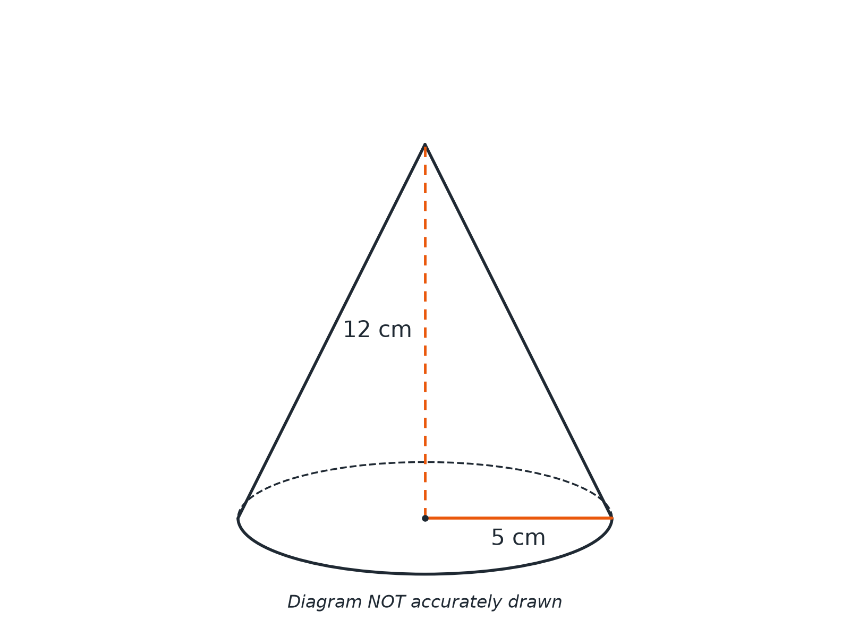

Question 3 · mark scheme
3 marks available. Award a mark for each point made.
▸ 5² + 12². M1
▸ Slant height 13. A1
▸ 65π. A1
▸ Model answer. The slant height is √(5² + 12²) = 13 cm. The curved surface area is π × 5 × 13 = 65π cm².
Question 4 · 2 marks · Calculator
“Work out the volume of the cone in the last question. Give your answer correct to 3 significant figures.”
HOW TO ANSWER IT Command word: Calculator. Worth 2 marks, so plan before writing.
Question 4 · mark scheme
2 marks available. Award a mark for each point made.
▸ ⅓π × 5² × 12. M1
▸ 314. A1
▸ Model answer. ⅓π × 5² × 12 = 100π= 314 cm³.
Question 5 · 4 marks · Calculator
“A cone has base radius 6 cm and height 12 cm. A smaller cone of base radius 3 cm and height 6 cm is cut off the top, leaving a frustum. Work out the volume of the frustum. Give your answer correct to 3 significant figures.”
HOW TO ANSWER IT Command word: Calculator. Worth 4 marks, so plan before writing.
Question 5 · mark scheme
4 marks available. Award a mark for each point made.
▸ Volume of the large cone. M1
▸ Volume of the small cone. M1
▸ Subtracting. M1
▸ 396. A1
▸ Model answer. Large cone: ⅓π × 6² × 12 = 144π. Small cone: ⅓π × 3² × 6 = 18π. Frustum: 126π= 396 cm³.
Question 6 · 2 marks · Non-calculator
“A pyramid has a rectangular base measuring 8 cm by 6 cm and a perpendicular height of 5 cm. Work out the volume of the pyramid.”
HOW TO ANSWER IT Command word: Non-calculator. Worth 2 marks, so plan before writing.
Question 6 · mark scheme
2 marks available. Award a mark for each point made.
▸ ⅓ × 8 × 6 × 5. M1
▸ 80. A1
▸ Model answer. ⅓ × 8 × 6 × 5 = 80 cm³.

