EDEXCEL GCSE MATHS · FOUNDATION & HIGHER
Cylinders and spheres
Area and volume · Lesson 6 of 7
Teacher copy - includes the notes for whoever is teaching from it.
Warm-up
Answer each one, then check.
1. What is the area of a circle with radius 4, in terms of π?
16π
2. What is the circumference of a circle with diameter 10, in terms of π?
10π
3. Work out 5³.
125
4. What is the volume of a prism?
Cross-sectional area times length
5. Round 3.979 to 2 decimal places.
3.98
Learning Objectives
1. Find the volume and surface area of a cylinder.
2. Find the volume and surface area of a sphere.
3. Find the volume and surface area of a hemisphere.
4. Solve problems that combine cylinders and hemispheres.
Cylinder, Sphere and Hemisphere
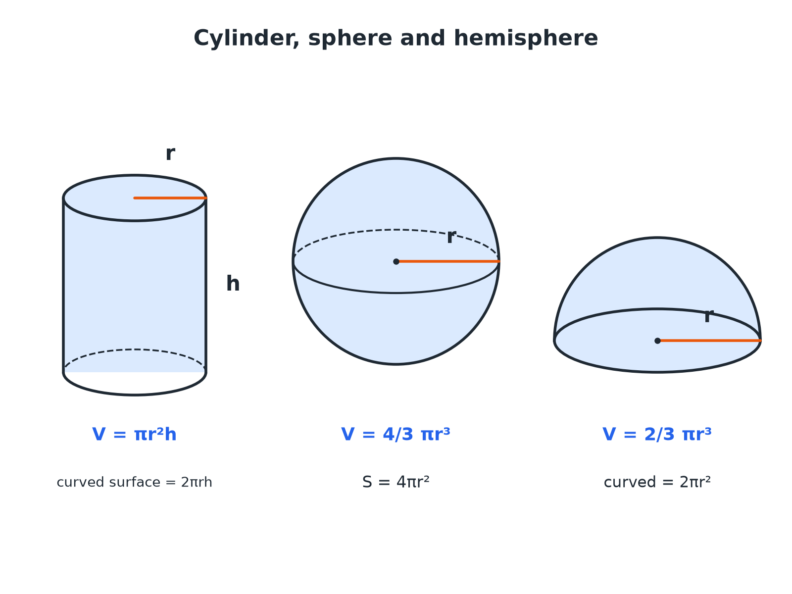
A cylinder is a prism with a circular cross-section.
A cylinder, a sphere and a hemisphere with their radius and height labelled and their volume formulae written beneath.
Formulae
The sphere formulae are given on the Edexcel formulae sheet, but you must know the cylinder ones.
Solid | Volume | Surface area
Cylinder | πr² h | 2πr² + 2πr h
Sphere | 4/3πr³ | 4πr²
Hemisphere | ⅔πr³ | 3πr²
A Cylinder
A cylinder has radius 5 cm and height 12 cm. Find its volume and total surface area, in terms of π and to 1 decimal place.

1. Volume = πr² h
π × 25 × 12 = 300π
2. As a decimal
942.5 cm³
3. Curved surface = 2πr h
2π × 5 × 12 = 120π
4. Two circular ends = 2πr²
2π × 25 = 50π
5. Total surface area
170π= 534.1 cm²
Answer: Volume 300π cm³ (942.5) and surface area 170π cm² (534.1).
A Sphere
A sphere has radius 6 cm. Find its volume and surface area, in terms of π.

1. Volume = 4/3πr³
4/3 × π × 216 = 288π
2. Surface area = 4πr²
4 × π × 36 = 144π
Answer: Volume 288π cm³ and surface area 144π cm².
A Hemisphere
A solid hemisphere has radius 3 cm. Find its volume in terms of π.

1. A hemisphere is half a sphere
½ × 4/3πr³ = ⅔πr³
2. Substitute r = 3
⅔ × π × 27
3. Work out
18π
Answer: 18π cm³
Finding the Height
A cylinder has volume 200 cm³ and radius 4 cm. Find its height to 2 decimal places.

1. πr² h = 200
π × 16 × h = 200
2. Divide by 16π
h = 200/16π
3. Calculate
3.979...
Answer: 3.98 cm
Combined Solids
Add the volumes; for surface area, do not count the joined faces.
▸ A capsule. A cylinder with a hemisphere at each end: total volume = πr² h + 4/3πr³.
▸ A hemisphere on top. Surface area is the cylinder's curved surface and one end, plus the hemisphere's curved surface 2πr².
▸ Watch the radius. The radius of the hemisphere is the radius of the cylinder.
Key Terms
Cylinder  A prism with a circle as its cross-section. | Sphere  A perfectly round 3D shape, like a ball.
Hemisphere  Half a sphere. | Curved surface area  The area of the curved part only, not the flat ends.
Volume  The amount of space inside a solid. | In terms of π  Leaving π in the answer.
Your Task: Tennis Ball Tube
12 minutes
Three tennis balls of radius 3.3 cm fit exactly in a cylindrical tube. Find the volume of the tube, the volume of the three balls, and the percentage of the tube filled with balls.
1. Find the height of the tube.
2. Work out both volumes.
3. Divide and convert to a percentage.
A good answer shows: The tube has radius 3.3 and height 19.8: π × 3.3² × 19.8 = 677.4 cm³. The balls: 3 × 4/3π × 3.3³ = 4π × 35.937 = 451.6 cm³. Percentage = 451.6 ÷ 677.4 = 66.7%, exactly two thirds.
Note: A famous result: the sphere is exactly two thirds of the enclosing cylinder.
Can I...?
☐ Find the volume of a cylinder.
☐ Find the surface area of a cylinder.
☐ Find the volume of a sphere.
☐ Find the surface area of a sphere.
☐ Find the volume of a hemisphere.
☐ Work backwards to find a radius or height.
☐ Solve problems with combined solids.
☐ Give answers in terms of π.
Summary
✓ Cylinder volume πr² h; curved surface 2πr h.
✓ Sphere volume 4/3πr³; surface 4πr².
✓ Hemisphere volume ⅔πr³.
✓ For combined solids, add volumes and take care with joined faces.

EXAM FOCUS
A cylinder has radius 5 cm and height 12 cm. Work out the volume of the cylinder. Give your answer correct to 3 significant figures. (2 marks)
Cylinder volume is the area of the circle times the height: πr² h. Check that you have the radius, not the diameter.
Exam Practice: Cylinders and Spheres
Answer all questions. Show your working. · 30 minutes
▸ Question 1 · 2 marks · Calculator. The diagram shows a cylinder with radius 5 cm and height 12 cm. Work out the volume of the cylinder. Give your answer correct to 3…
▸ Question 2 · 3 marks · Calculator. Work out the total surface area of the cylinder in the last question. Give your answer correct to 3 significant figures.
▸ Question 3 · 2 marks · Calculator. A sphere has a radius of 6 cm. Work out the volume of the sphere. Give your answer correct to 3 significant figures.
▸ Question 4 · 2 marks · Calculator. Work out the surface area of the sphere in the last question. Give your answer correct to 3 significant figures.
▸ Question 5 · 3 marks · Calculator. A cylinder has a volume of 200 cm³ and a radius of 4 cm. Work out the height of the cylinder. Give your answer correct to 2 decimal places.
▸ Question 6 · 2 marks · Non-calculator. A solid hemisphere has a radius of 3 cm. Work out the volume of the hemisphere. Give your answer in terms of π.
Question 1 · 2 marks · Calculator
The diagram shows a cylinder with radius 5 cm and height 12 cm. Work out the volume of the cylinder. Give your answer correct to 3 significant figures. (2 marks) | 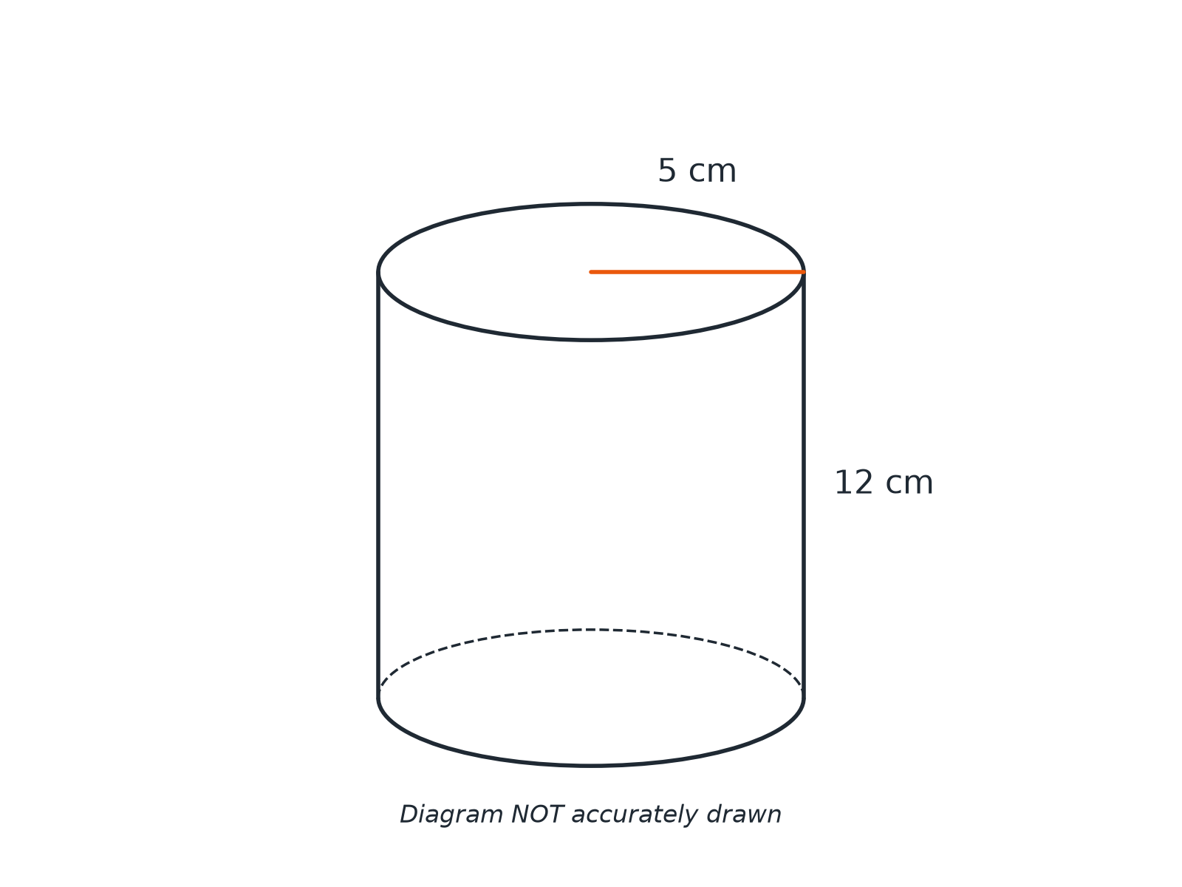

Question 1 · mark scheme
2 marks available. Award a mark for each point made.
▸ π × 5² × 12. M1
▸ 942. A1
▸ Model answer. π × 5² × 12 = 300π= 942 cm³.
Question 2 · 3 marks · Calculator
“Work out the total surface area of the cylinder in the last question. Give your answer correct to 3 significant figures.”
HOW TO ANSWER IT Command word: Calculator. Worth 3 marks, so plan before writing.
Question 2 · mark scheme
3 marks available. Award a mark for each point made.
▸ 2πr². M1
▸ 2πr h. M1
▸ 534. A1
▸ Model answer. 2π × 5² + 2π × 5 × 12 = 50π+ 120π= 170π= 534 cm².
Question 3 · 2 marks · Calculator
“A sphere has a radius of 6 cm. Work out the volume of the sphere. Give your answer correct to 3 significant figures.”
HOW TO ANSWER IT Command word: Calculator. Worth 2 marks, so plan before writing.
Question 3 · mark scheme
2 marks available. Award a mark for each point made.
▸ 4/3π × 6³. M1
▸ 905. A1
▸ Model answer. 4/3π × 6³ = 288π= 905 cm³.
Question 4 · 2 marks · Calculator
“Work out the surface area of the sphere in the last question. Give your answer correct to 3 significant figures.”
HOW TO ANSWER IT Command word: Calculator. Worth 2 marks, so plan before writing.
Question 4 · mark scheme
2 marks available. Award a mark for each point made.
▸ 4π × 6². M1
▸ 452. A1
▸ Model answer. 4π × 6² = 144π= 452 cm².
Question 5 · 3 marks · Calculator
“A cylinder has a volume of 200 cm³ and a radius of 4 cm. Work out the height of the cylinder. Give your answer correct to 2 decimal places.”
HOW TO ANSWER IT Command word: Calculator. Worth 3 marks, so plan before writing.
Question 5 · mark scheme
3 marks available. Award a mark for each point made.
▸ π × 4² × h = 200. M1
▸ 200/16π. M1
▸ 3.98. A1
▸ Model answer. π × 4² × h = 200, so h = 200/16π = 3.98 cm.
Question 6 · 2 marks · Non-calculator
“A solid hemisphere has a radius of 3 cm. Work out the volume of the hemisphere. Give your answer in terms of π.”
HOW TO ANSWER IT Command word: Non-calculator. Worth 2 marks, so plan before writing.
Question 6 · mark scheme
2 marks available. Award a mark for each point made.
▸ ⅔π × 27 or half of 4/3π × 27. M1
▸ 18π. A1
▸ Model answer. ⅔π × 3³ = 18π cm³.

