EDEXCEL GCSE MATHS · FOUNDATION & HIGHER
Constructions 1
Transformations and constructions · Lesson 6 of 8
Teacher copy - includes the notes for whoever is teaching from it.
Warm-up
Answer each one, then check.
1. What do the angles in a triangle add up to?
180°
2. What is a perpendicular line?
One that meets another at 90°
3. What does bisect mean?
Cut exactly in half
4. What is the longest side of a right-angled triangle called?
The hypotenuse
5. What is the midpoint of a line 8 cm long?
The point 4 cm from each end
Learning Objectives
1. Construct a triangle given three sides (SSS).
2. Construct a triangle given two sides and the angle between them (SAS).
3. Construct the perpendicular bisector of a line segment.
4. Explain why a triangle can or cannot be constructed.
The Rules of Construction
Use only a pencil, a ruler for straight lines, and compasses.
▸ Keep the construction arcs. Do not rub them out: they show your method and earn marks.
▸ Sharp pencil. Thin lines make the intersections easy to see.
▸ Keep the compasses fixed. Do not change the radius between two arcs that must be equal.
▸ Label the lengths. Write the length beside each side, and mark any angles.
Constructing a Triangle from Three Sides
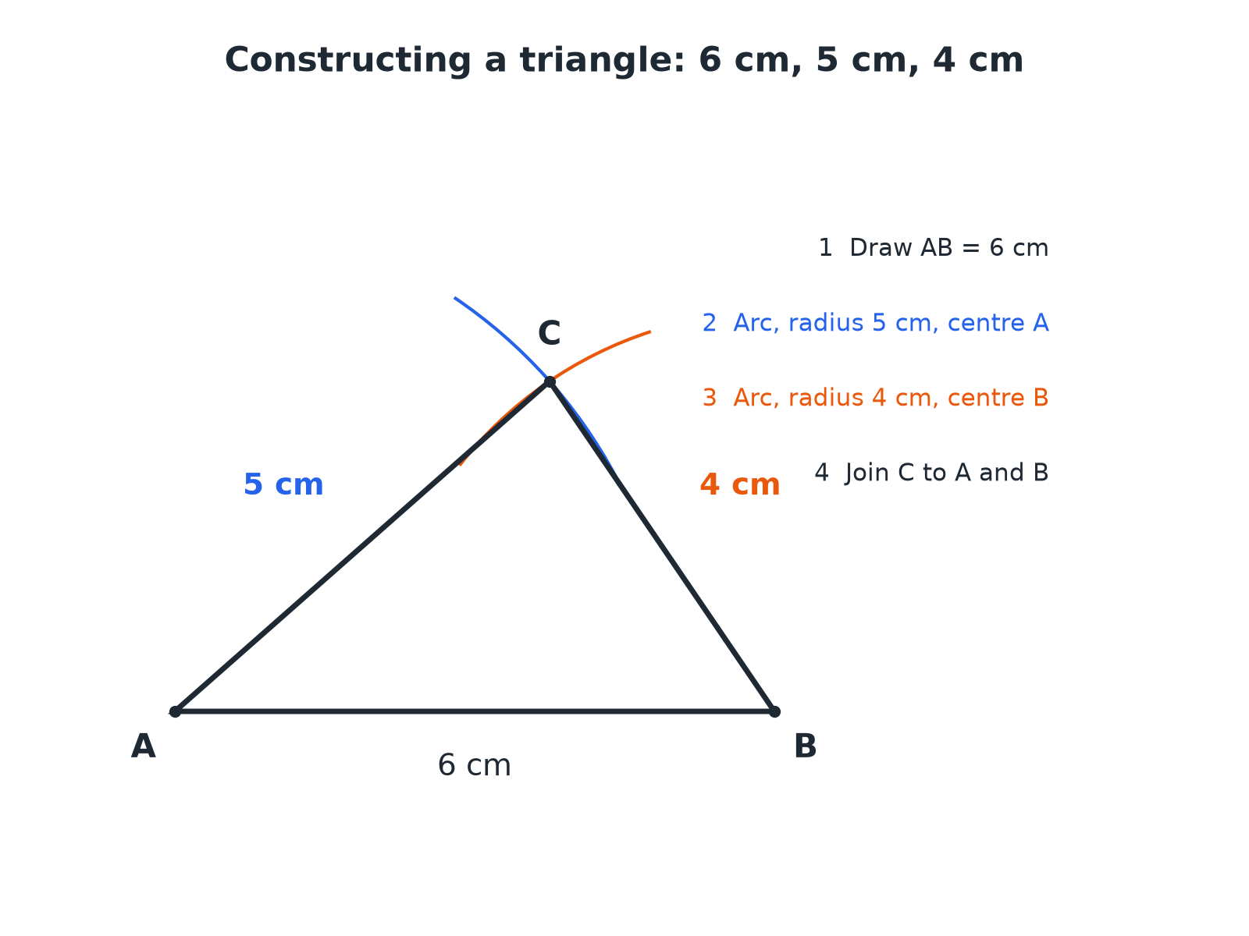
The point where the two arcs cross is the third vertex.
Triangle ABC constructed with a base of 6 centimetres and two arcs of radius 5 and 4 centimetres meeting above it.
Constructing an SSS Triangle
For a triangle with sides 6 cm, 5 cm and 4 cm.
1  Draw the longest side  Measure 6 cm with a ruler and label the ends A and B. | 2  Set the compasses to 5 cm  Put the point at A and draw an arc above the line. | 3  Set the compasses to 4 cm  Put the point at B and draw a second arc crossing the first. | 4  Mark C where the arcs cross  Join C to A and C to B with a ruler. | 5  Label and check  Measure to check each side and keep the arcs.
Can the Triangle Be Made?
Can a triangle be constructed with sides 3 cm, 4 cm and 8 cm?

1. The two shorter sides must add up to more than the longest
3 + 4 = 7
2. Compare with the longest side
7 < 8
3. The arcs would not meet
The two short sides cannot reach each other
Answer: No: 3 + 4 < 8, so the arcs do not cross and no triangle exists.
An SAS Triangle
Construct a triangle with sides of 5 cm and 7 cm and an angle of 40° between them.

1. Draw the 7 cm side
Label the ends A and B
2. Measure 40° at A
Use a protractor and mark the angle
3. Draw a line from A through the mark
Measure 5 cm along it and label C
4. Join B to C
The triangle ABC is complete
Answer: Triangle ABC with AB = 7 cm, AC = 5 cm and angle A = 40°.
The Perpendicular Bisector
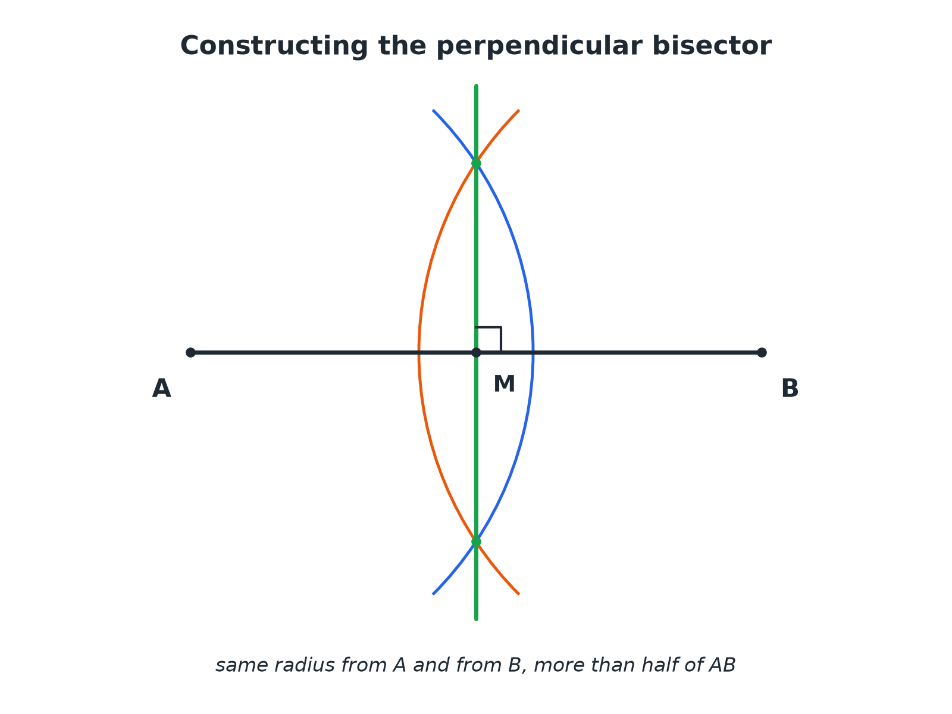
Every point on the perpendicular bisector is the same distance from A and B.
A line segment AB with two pairs of equal arcs crossing above and below it and a line through the crossings meeting AB at a right angle at its midpoint.
Constructing the Perpendicular Bisector
The same radius from both ends.
1  Open the compasses more than half of AB  Any radius bigger than half will do | 2  Draw arcs from A above and below the line  Keep the same radius | 3  Draw arcs from B, crossing the first arcs  Do not change the radius | 4  Mark the two crossing points  One above and one below AB | 5  Join the crossing points with a ruler  This line bisects AB at 90°
Which Construction?
SSS TRIANGLE | SAS TRIANGLE
▸ You know all three sides.  ▸ Use two arcs to find the third vertex.  ▸ Always check the two shorter sides add to more than the longest. | ▸ You know two sides and the angle between them.  ▸ Use a protractor for the angle.  ▸ The third side is found by joining the ends.
Key Terms
Construct  Draw accurately using only a ruler and compasses (a protractor when an angle is given). | Compasses  An instrument for drawing arcs and circles.
Arc  Part of the circumference of a circle. | Bisect  To cut exactly in half.
Perpendicular bisector  A line at 90° through the midpoint of a segment. | Vertex  A corner of a shape.
Your Task: Construct and Measure
15 minutes
Construct a triangle with sides 7 cm, 6 cm and 5 cm. Measure the three angles with a protractor and add them up. Then construct the perpendicular bisector of the 7 cm side and check it passes through the opposite vertex or not.
1. Construct with compasses.
2. Measure the angles.
3. Check the sum.
A good answer shows: The angles are about 78°, 57° and 44° (sum 180°). The perpendicular bisector of the 7 cm side does not pass through the opposite vertex because the triangle is scalene; it would only do that for an isosceles triangle with equal sides on either side.
Note: Ask what would be special if the bisector did pass through the vertex.
Can I...?
☐ Draw a line of exact length.
☐ Construct an SSS triangle.
☐ Construct an SAS triangle.
☐ Use a protractor accurately.
☐ Construct a perpendicular bisector.
☐ Keep construction arcs.
☐ Test whether three lengths make a triangle.
☐ Explain each step of a construction.
Summary
✓ SSS: draw the longest side, then two arcs.
✓ SAS: draw one side, measure the angle, then measure the second side.
✓ The perpendicular bisector cuts a segment in half at 90°.
✓ Always leave your construction lines.

EXAM FOCUS
Using ruler and compasses only, construct the perpendicular bisector of the line AB. You must show all your construction lines. (2 marks)
Use the same compass setting from both ends, more than half of AB. Do not rub out the arcs.
Exam Practice: Constructions 1
Answer all questions. Use a sharp pencil, a ruler, compasses and a protractor. Show all construction lines. · 30 minutes
▸ Question 1 · 3 marks · Construct. Using ruler and compasses only, construct a triangle with sides of length 6 cm, 5 cm and 4 cm. Show all your construction lines.
▸ Question 2 · 2 marks · Construct. The line AB is 6 cm long. Using ruler and compasses only, construct the perpendicular bisector of the line AB. Show all your construction…
▸ Question 3 · 2 marks · Explain. Explain why it is not possible to construct a triangle with sides of length 3 cm, 4 cm and 8 cm.
▸ Question 4 · 3 marks · Construct. Construct a triangle ABC with AB = 7 cm, AC = 5 cm and angle BAC = 40°.
▸ Question 5 · 2 marks · Measure. In the triangle with sides 6 cm, 5 cm and 4 cm, measure the size of the largest angle.
▸ Question 6 · 2 marks · Decide. For each set of lengths, state whether a triangle can be constructed. (a) 5 cm, 6 cm, 7 cm (b) 2 cm, 3 cm, 6 cm
Question 1 · 3 marks · Construct
“Using ruler and compasses only, construct a triangle with sides of length 6 cm, 5 cm and 4 cm. Show all your construction lines.”
HOW TO ANSWER IT Command word: Construct. Worth 3 marks, so plan before writing.
Question 1 · mark scheme
3 marks available. Award a mark for each point made.
▸ A 6 cm line drawn accurately. B1
▸ Both arcs drawn correctly. M1
▸ Triangle completed and arcs shown. A1
▸ Model answer. Draw a line of 6 cm. From one end draw an arc of radius 5 cm and from the other draw an arc of radius 4 cm, crossing above the line. Join the crossing to each end.
Question 2 · 2 marks · Construct
The line AB is 6 cm long. Using ruler and compasses only, construct the perpendicular bisector of the line AB. Show all your construction lines. (2 marks) | 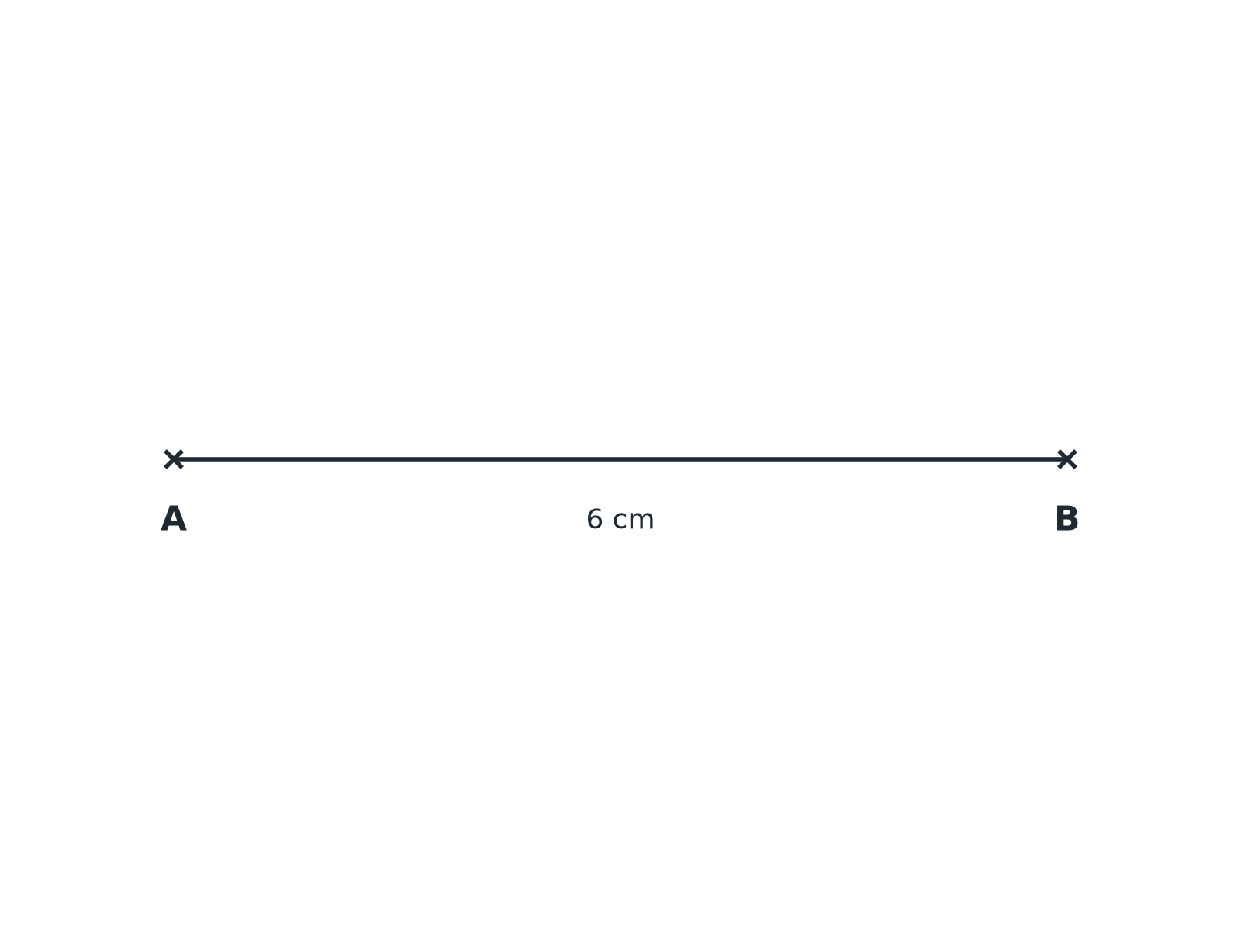

Question 2 · mark scheme
2 marks available. Award a mark for each point made.
▸ Arcs of equal radius from A and B. M1
▸ Correct crossings, both sides. A1
▸ Model answer. Equal arcs from A and B, with radius more than 3 cm, crossing above and below; a straight line through the two crossings.
Question 3 · 2 marks · Explain
“Explain why it is not possible to construct a triangle with sides of length 3 cm, 4 cm and 8 cm.”
HOW TO ANSWER IT Command word: Explain. Worth 2 marks, so plan before writing.
Question 3 · mark scheme
2 marks available. Award a mark for each point made.
▸ 3 + 4 = 7. M1
▸ 7 < 8, so the arcs do not meet. C1
▸ Model answer. The two shorter sides add up to 3 + 4 = 7 cm, which is less than 8 cm, so the arcs would not meet.
Question 4 · 3 marks · Construct
“Construct a triangle ABC with AB = 7 cm, AC = 5 cm and angle BAC = 40°.”
HOW TO ANSWER IT Command word: Construct. Worth 3 marks, so plan before writing.
Question 4 · mark scheme
3 marks available. Award a mark for each point made.
▸ AB drawn accurately. B1
▸ Angle of 40° at A. M1
▸ AC = 5 cm and triangle completed. A1
▸ Model answer. Draw AB = 7 cm. Measure 40° at A. Mark C 5 cm from A along the line. Join B to C.
Question 5 · 2 marks · Measure
“In the triangle with sides 6 cm, 5 cm and 4 cm, measure the size of the largest angle.”
HOW TO ANSWER IT Command word: Measure. Worth 2 marks, so plan before writing.
Question 5 · mark scheme
2 marks available. Award a mark for each point made.
▸ Identifying the angle opposite the 6 cm side. M1
▸ 83 (within the range). A1
▸ Model answer. The largest angle is opposite the 6 cm side and is about 83° (accept 81° to 85°).
Question 6 · 2 marks · Decide
“For each set of lengths, state whether a triangle can be constructed. (a) 5 cm, 6 cm, 7 cm (b) 2 cm, 3 cm, 6 cm”
HOW TO ANSWER IT Command word: Decide. Worth 2 marks, so plan before writing.
Question 6 · mark scheme
2 marks available. Award a mark for each point made.
▸ (a) Yes. B1
▸ (b) No. B1
▸ Model answer. (a) Yes, because 5 + 6 = 11 > 7. (b) No, because 2 + 3 = 5 < 6.

