EDEXCEL GCSE MATHS · FOUNDATION & HIGHER
Constructions 2
Transformations and constructions · Lesson 7 of 8
Warm-up
Answer each one, then check.
1. What does perpendicular mean?
At 90°
2. What is half of 60°?
30°
3. How many degrees in each angle of an equilateral triangle?
60°
4. What is an angle bisector?
A line that cuts an angle in half
5. What are the tools for a construction?
Ruler, compasses (and a sharp pencil)
Learning Objectives
1. Construct the bisector of an angle.
2. Construct a perpendicular from a point to a line.
3. Construct a perpendicular at a point on a line.
4. Construct angles of 60°, 30° and 90°.
Bisecting an Angle
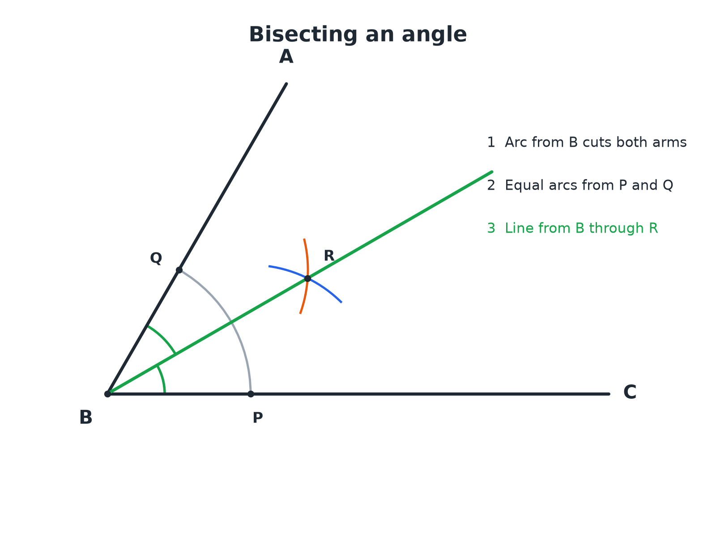
The bisector splits the angle into two equal halves.
An angle with arcs from its vertex and from the two points on its arms crossing at a point through which the bisector is drawn.
Bisecting an Angle
Three arcs and one line.
1  Arc from the vertex  Centre B, cutting both arms at P and Q | 2  Arcs from P and Q  Same radius from each; they cross at R | 3  Draw the line BR  This is the angle bisector | 4  Check  Measure the two halves; they should be equal
Angle Bisector Check
Angle ABC is 70°. After bisecting it, what is the size of each half?

1. The bisector cuts the angle in half
70 ÷ 2
2. Work out
35
Answer: Each half is 35°.
Perpendiculars
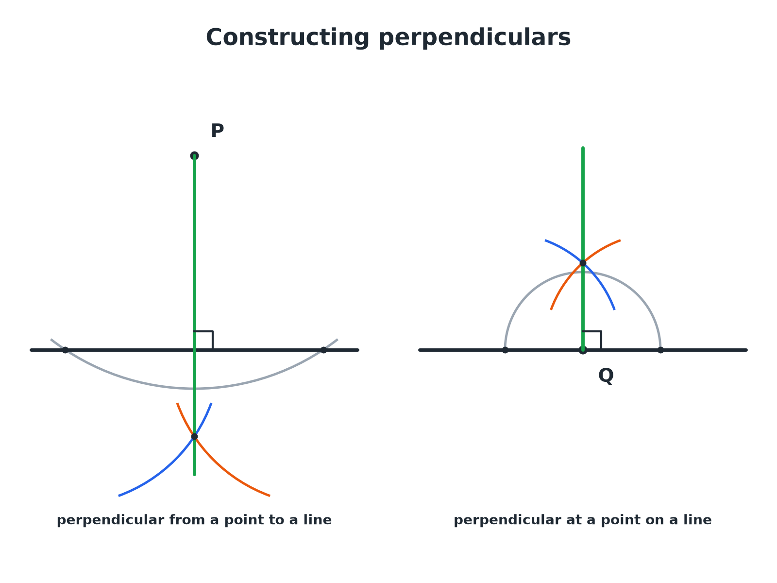
Both use the perpendicular bisector method on a pair of points.
Two constructions of a perpendicular line: one from a point above a line and one at a point on the line.
Perpendicular from a Point to a Line
Point P is above the line.
1  Arc centred on P  It crosses the line at two points, X and Y | 2  Arcs from X and Y  Same radius, crossing on the other side of the line at Z | 3  Join P to Z  This line is perpendicular to the line | 4  Label the right angle  Mark it with a small square
Perpendicular at a Point on a Line
Point Q is on the line.
1  Arc centred on Q  It crosses the line either side at U and V | 2  Larger arcs from U and V  Same radius, crossing above the line at W | 3  Join Q to W  This line is perpendicular to the line at Q | 4  Check  The angle is 90°
Constructing 60° and 30°
Compasses can make an equilateral triangle, which gives 60°.
▸ 60°. Draw an arc from A across the line at B, then an arc of the same radius from B; join A to where they cross.
▸ 30°. Bisect the 60° angle.
▸ 90°. Use the perpendicular construction.
▸ 45°. Bisect a 90° angle.
Key Terms
Angle bisector  A line that cuts an angle exactly in half. | Perpendicular  At 90° to a line.
Arc  Part of a circle's circumference. | Equidistant  The same distance from two things.
Construction lines  The arcs and lines you leave to show your method. | Vertex  The point where the arms of an angle meet.
Your Task: Build a Kite
12 minutes
Construct an angle of 60° at A. Bisect it to make 30°. Then use the perpendicular construction to make a right angle at a point on one arm. Sketch a kite using your construction lines.
1. Make 60° with compasses.
2. Bisect it.
3. Add a 90° angle.
A good answer shows: A 60° angle from an equilateral construction, 30° from the bisector, and a 90° angle by the perpendicular at a point. A kite can be made from two triangles sharing the bisector.
Can I...?
☐ Bisect an angle.
☐ Drop a perpendicular from a point.
☐ Draw a perpendicular at a point on a line.
☐ Construct 60°.
☐ Construct 30°.
☐ Construct 90°.
☐ Explain why the constructions work.
☐ Show all construction lines.
Summary
✓ Angle bisector: arc, two equal arcs, join to the vertex.
✓ Perpendicular from a point: arc, two equal arcs, join.
✓ 60° from an equilateral triangle; halve it for 30°.
✓ Keep all construction arcs.

EXAM FOCUS
Using ruler and compasses only, construct the bisector of angle ABC. You must show all your construction lines. (2 marks)
Start with an arc centred on the vertex, then use equal arcs from the two points where it crosses the arms.

