EDEXCEL GCSE MATHS · FOUNDATION & HIGHER
Constructions 2
Transformations and constructions · Lesson 7 of 8
Teacher copy - includes the notes for whoever is teaching from it.
Warm-up
Answer each one, then check.
1. What does perpendicular mean?
At 90°
2. What is half of 60°?
30°
3. How many degrees in each angle of an equilateral triangle?
60°
4. What is an angle bisector?
A line that cuts an angle in half
5. What are the tools for a construction?
Ruler, compasses (and a sharp pencil)
Learning Objectives
1. Construct the bisector of an angle.
2. Construct a perpendicular from a point to a line.
3. Construct a perpendicular at a point on a line.
4. Construct angles of 60°, 30° and 90°.
Bisecting an Angle
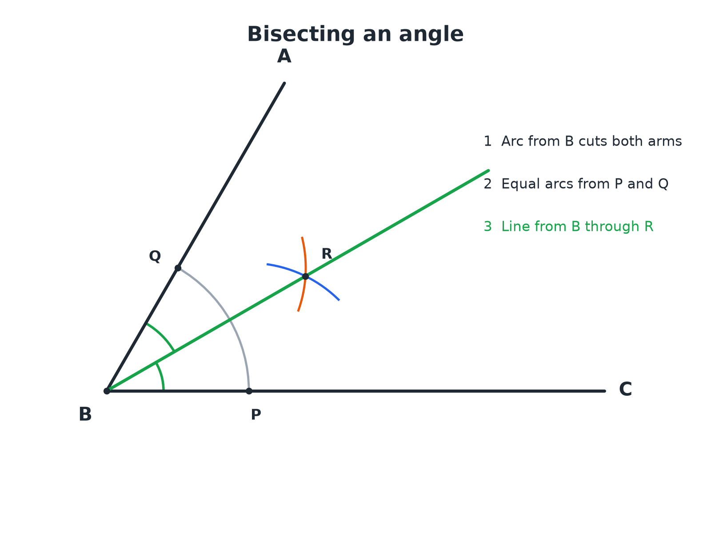
The bisector splits the angle into two equal halves.
An angle with arcs from its vertex and from the two points on its arms crossing at a point through which the bisector is drawn.
Bisecting an Angle
Three arcs and one line.
1  Arc from the vertex  Centre B, cutting both arms at P and Q | 2  Arcs from P and Q  Same radius from each; they cross at R | 3  Draw the line BR  This is the angle bisector | 4  Check  Measure the two halves; they should be equal
Angle Bisector Check
Angle ABC is 70°. After bisecting it, what is the size of each half?

1. The bisector cuts the angle in half
70 ÷ 2
2. Work out
35
Answer: Each half is 35°.
Perpendiculars
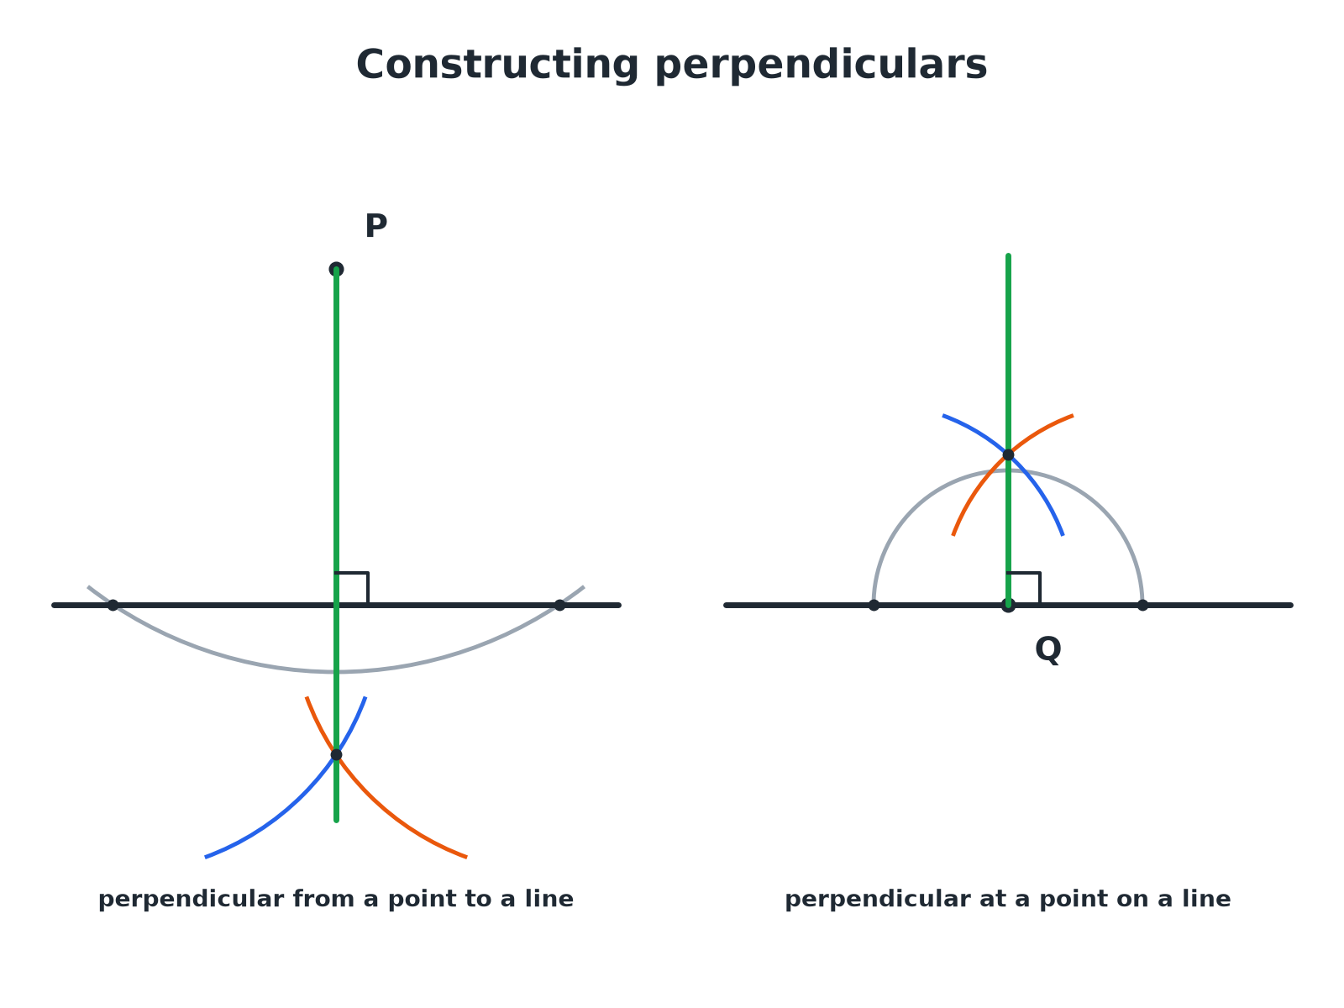
Both use the perpendicular bisector method on a pair of points.
Two constructions of a perpendicular line: one from a point above a line and one at a point on the line.
Perpendicular from a Point to a Line
Point P is above the line.
1  Arc centred on P  It crosses the line at two points, X and Y | 2  Arcs from X and Y  Same radius, crossing on the other side of the line at Z | 3  Join P to Z  This line is perpendicular to the line | 4  Label the right angle  Mark it with a small square
Perpendicular at a Point on a Line
Point Q is on the line.
1  Arc centred on Q  It crosses the line either side at U and V | 2  Larger arcs from U and V  Same radius, crossing above the line at W | 3  Join Q to W  This line is perpendicular to the line at Q | 4  Check  The angle is 90°
Constructing 60° and 30°
Compasses can make an equilateral triangle, which gives 60°.
▸ 60°. Draw an arc from A across the line at B, then an arc of the same radius from B; join A to where they cross.
▸ 30°. Bisect the 60° angle.
▸ 90°. Use the perpendicular construction.
▸ 45°. Bisect a 90° angle.
Key Terms
Angle bisector  A line that cuts an angle exactly in half. | Perpendicular  At 90° to a line.
Arc  Part of a circle's circumference. | Equidistant  The same distance from two things.
Construction lines  The arcs and lines you leave to show your method. | Vertex  The point where the arms of an angle meet.
Your Task: Build a Kite
12 minutes
Construct an angle of 60° at A. Bisect it to make 30°. Then use the perpendicular construction to make a right angle at a point on one arm. Sketch a kite using your construction lines.
1. Make 60° with compasses.
2. Bisect it.
3. Add a 90° angle.
A good answer shows: A 60° angle from an equilateral construction, 30° from the bisector, and a 90° angle by the perpendicular at a point. A kite can be made from two triangles sharing the bisector.
Note: Discuss how the bisector gives the kite its line of symmetry.
Can I...?
☐ Bisect an angle.
☐ Drop a perpendicular from a point.
☐ Draw a perpendicular at a point on a line.
☐ Construct 60°.
☐ Construct 30°.
☐ Construct 90°.
☐ Explain why the constructions work.
☐ Show all construction lines.
Summary
✓ Angle bisector: arc, two equal arcs, join to the vertex.
✓ Perpendicular from a point: arc, two equal arcs, join.
✓ 60° from an equilateral triangle; halve it for 30°.
✓ Keep all construction arcs.

EXAM FOCUS
Using ruler and compasses only, construct the bisector of angle ABC. You must show all your construction lines. (2 marks)
Start with an arc centred on the vertex, then use equal arcs from the two points where it crosses the arms.
Exam Practice: Constructions 2
Answer all questions. Use a sharp pencil, a ruler and compasses. Show all construction lines. · 30 minutes
▸ Question 1 · 2 marks · Construct. The diagram shows an angle ABC. Using ruler and compasses only, construct the bisector of angle ABC. Show all your construction lines.
▸ Question 2 · 3 marks · Construct. Point P is 4 cm above a horizontal line. Using ruler and compasses only, construct the perpendicular from P to the line. Show all your…
▸ Question 3 · 3 marks · Construct. Using ruler and compasses only, construct an angle of 60° at the end A of a line AB.
▸ Question 4 · 3 marks · Construct. Using ruler and compasses only, construct an angle of 30° at the end A of a line AB.
▸ Question 5 · 3 marks · Construct. Q is a point on a straight line. Using ruler and compasses only, construct the perpendicular to the line at Q.
▸ Question 6 · 2 marks · Explain. Explain why the line through the crossing arcs is the bisector of the angle in the angle bisector construction.
Question 1 · 2 marks · Construct
The diagram shows an angle ABC. Using ruler and compasses only, construct the bisector of angle ABC. Show all your construction lines. (2 marks) | 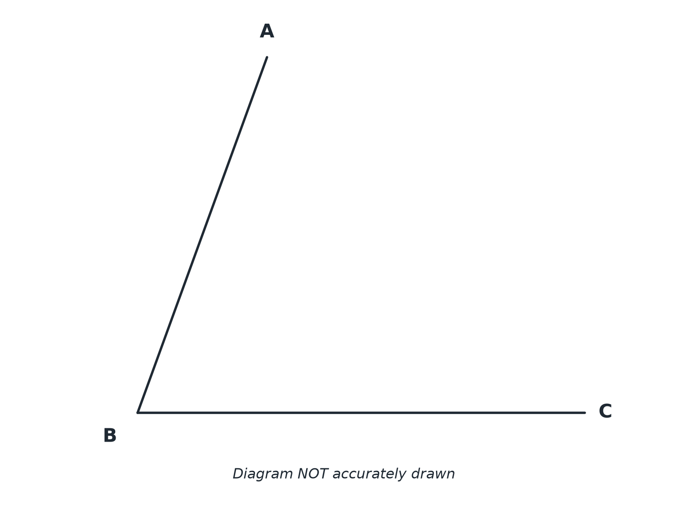

Question 1 · mark scheme
2 marks available. Award a mark for each point made.
▸ Arcs from B and from the two crossing points. M1
▸ A correct bisector with arcs shown. A1
▸ Model answer. An arc from B crossing both arms, two equal arcs from those points crossing inside the angle, and a line from B through the crossing.
Question 2 · 3 marks · Construct
“Point P is 4 cm above a horizontal line. Using ruler and compasses only, construct the perpendicular from P to the line. Show all your construction lines.”
HOW TO ANSWER IT Command word: Construct. Worth 3 marks, so plan before writing.
Question 2 · mark scheme
3 marks available. Award a mark for each point made.
▸ Arc from P crossing the line twice. M1
▸ Equal arcs from the two points. M1
▸ A correct perpendicular. A1
▸ Model answer. An arc centred on P cutting the line twice; equal arcs from those two points crossing below the line; a line from P to the crossing.
Question 3 · 3 marks · Construct
“Using ruler and compasses only, construct an angle of 60° at the end A of a line AB.”
HOW TO ANSWER IT Command word: Construct. Worth 3 marks, so plan before writing.
Question 3 · mark scheme
3 marks available. Award a mark for each point made.
▸ Arc centred on A. M1
▸ Second arc with the same radius. M1
▸ Line completed and angle correct. A1
▸ Model answer. An arc centred on A crossing AB; the same radius centred on that crossing; a line from A through the crossing of the arcs.
Question 4 · 3 marks · Construct
“Using ruler and compasses only, construct an angle of 30° at the end A of a line AB.”
HOW TO ANSWER IT Command word: Construct. Worth 3 marks, so plan before writing.
Question 4 · mark scheme
3 marks available. Award a mark for each point made.
▸ 60° constructed. M1
▸ Bisector constructed. M1
▸ Angle of 30°. A1
▸ Model answer. Construct 60° at A, then bisect it to make 30°.
Question 5 · 3 marks · Construct
“Q is a point on a straight line. Using ruler and compasses only, construct the perpendicular to the line at Q.”
HOW TO ANSWER IT Command word: Construct. Worth 3 marks, so plan before writing.
Question 5 · mark scheme
3 marks available. Award a mark for each point made.
▸ Arc centred on Q. M1
▸ Equal arcs from both points. M1
▸ Correct perpendicular. A1
▸ Model answer. An arc centred on Q cutting the line on both sides; equal larger arcs from those points crossing above; a line from Q through the crossing.
Question 6 · 2 marks · Explain
“Explain why the line through the crossing arcs is the bisector of the angle in the angle bisector construction.”
HOW TO ANSWER IT Command word: Explain. Worth 2 marks, so plan before writing.
Question 6 · mark scheme
2 marks available. Award a mark for each point made.
▸ Equal distances used. M1
▸ Congruent triangles or kite symmetry. C1
▸ Model answer. The point where the arcs cross is the same distance from the two points on the arms, and both points are the same distance from the vertex, so the two triangles are congruent (a kite) and the angles are equal.

