EDEXCEL GCSE MATHS · FOUNDATION & HIGHER
Solving quadratic equations 1
Equations and inequalities · Lesson 2 of 7
Teacher copy - includes the notes for whoever is teaching from it.
Warm-up
Answer each one, then check.
1. Factorise x² + 5x + 6.
(x + 2)(x + 3)
2. Factorise x² − 9.
(x − 3)(x + 3)
3. Solve x − 4 = 0.
x = 4
4. Expand (x + 2)(x + 3).
x² + 5x + 6
5. What is the product of 0 and any number?
0
Learning Objectives
1. Solve x² + bx + c = 0 by factorising.
2. Solve equations of the form x² − a² = 0.
3. Rearrange to zero before factorising.
4. Solve problems that lead to quadratic equations.
The Null Factor Law
If two things multiply to give zero, at least one of them must be zero.
So (x − 2)(x − 3) = 0 means x = 2 or x = 3.
Roots on a Graph
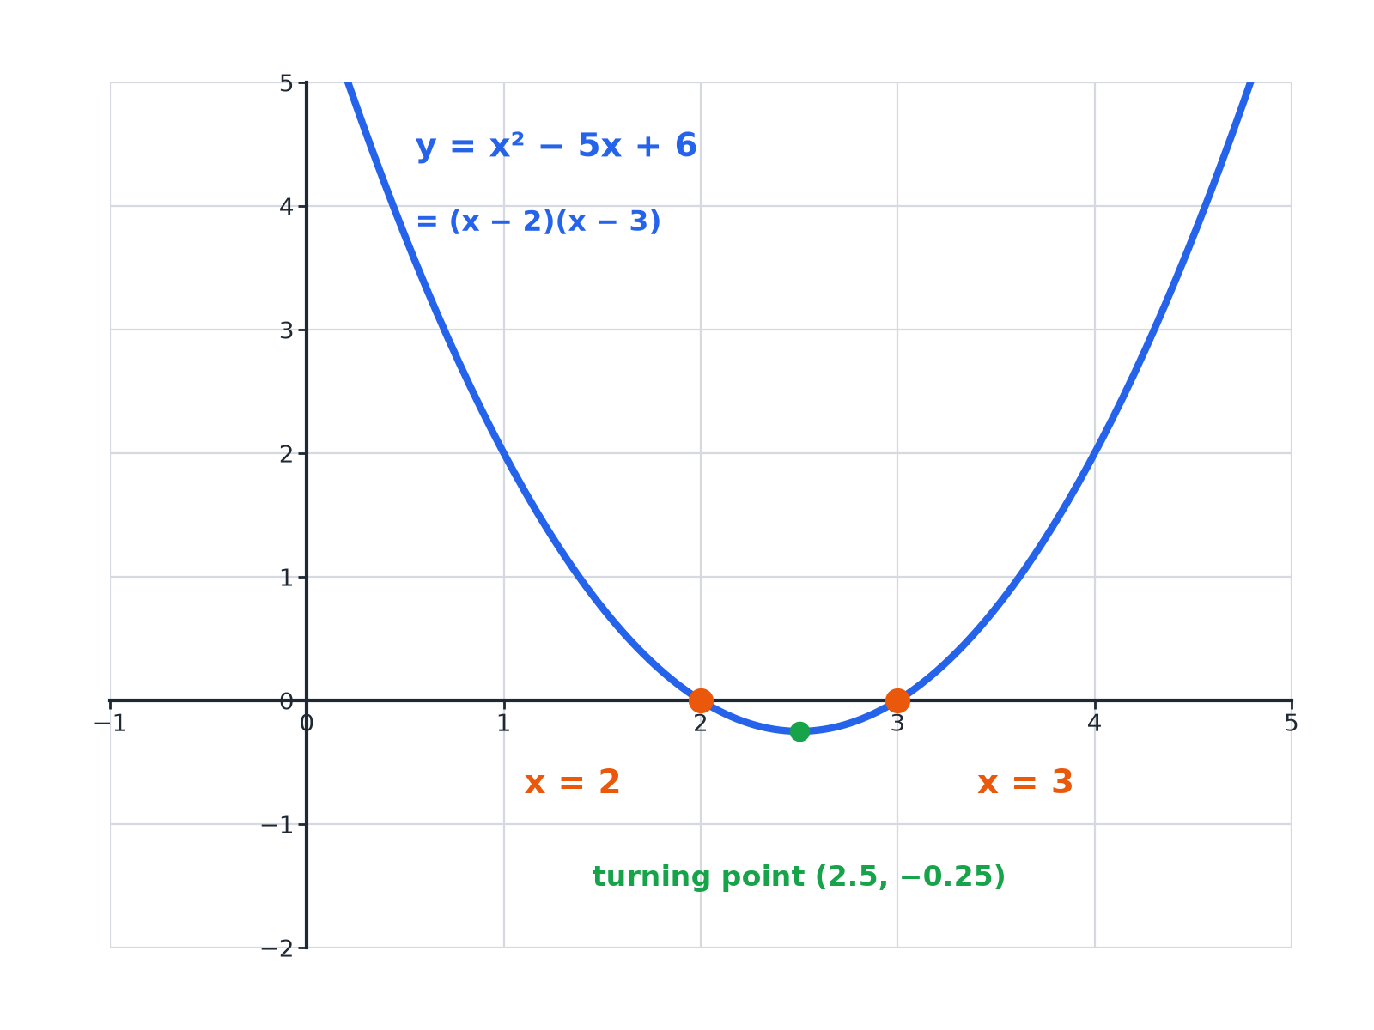
The solutions of the equation are where the graph crosses the x-axis.
The graph of y equals x squared minus 5x plus 6 crossing the x-axis at 2 and 3.
Solving by Factorising
Always get zero on one side first.
1  Rearrange  Write the equation as ax² + bx + c = 0 | 2  Factorise  Find two numbers that multiply to c and add to b | 3  Set each bracket to zero  Use the null factor law | 4  Solve  Two solutions, or one repeated solution
A Standard Quadratic
Solve x² + 5x + 6 = 0.

1. Two numbers with product 6 and sum 5
2 and 3
2. Factorise
(x + 2)(x + 3) = 0
3. Set each bracket to zero
x + 2 = 0 or x + 3 = 0
Answer: x = −2 or x = −3
With Negative Numbers
Solve x² − 2x − 15 = 0.

1. Product −15, sum −2
−5 and 3
2. Factorise
(x − 5)(x + 3) = 0
3. Solve
x = 5 or x = −3
Answer: x = 5 or x = −3
Special Cases
Difference of two squares  x² − 49 = 0 factorises as (x − 7)(x + 7), so x = 7 or x = −7. | No constant term  x² − 7x = 0 factorises as x(x − 7), so x = 0 or x = 7.
A perfect square  x² − 6x + 9 = 0 is (x − 3)², so there is one solution, x = 3. | Do not divide by x  Dividing x² = 7x by x loses the solution x = 0.
Rearranging First
Solve x² = 3x + 10.

1. Move everything to one side
x² − 3x − 10 = 0
2. Factorise
(x − 5)(x + 2) = 0
3. Solve
x = 5 or x = −2
Answer: x = 5 or x = −2
A Rectangle Problem
A rectangle has length (x + 3) cm and width x cm. Its area is 40 cm². Find x, and the dimensions.

1. Area equation
x(x + 3) = 40
2. Expand and rearrange
x² + 3x − 40 = 0
3. Factorise
(x + 8)(x − 5) = 0
4. A length cannot be negative
x = 5, and x = −8 is rejected
Answer: x = 5; the rectangle is 8 cm by 5 cm.
Key Terms
Quadratic equation  An equation whose highest power is x². | Root  A solution of an equation; where a graph crosses the x-axis.
Factorise  Write as a product of brackets. | Null factor law  If ab = 0, then a = 0 or b = 0.
Difference of two squares  a² − b² = (a − b)(a + b). | Perfect square  A quadratic that is a bracket squared.
Your Task: Solve and Check
12 minutes
Solve each equation by factorising, then substitute your answers back to check. (a) x² − 8x + 15 = 0 (b) x² + 4x = 0 (c) x² − 25 = 0 (d) x² = 2x + 24.
1. Rearrange to zero.
2. Factorise.
3. Check by substituting.
A good answer shows: (a) (x − 3)(x − 5) = 0: x = 3 or 5. (b) x(x + 4) = 0: x = 0 or −4. (c) (x − 5)(x + 5) = 0: x = ± 5. (d) x² − 2x − 24 = 0, (x − 6)(x + 4) = 0: x = 6 or −4.
Note: Ask students to show the graph would cross the axis at those values.
Can I...?
☐ Factorise x² + bx + c.
☐ Use the null factor law.
☐ Solve a difference of two squares.
☐ Solve an equation with no constant term.
☐ Rearrange to zero first.
☐ Reject impossible solutions.
☐ Form a quadratic from a problem.
☐ Check by substituting.
Summary
✓ Make the equation equal zero before factorising.
✓ Set each bracket to zero.
✓ Difference of two squares: x² − a² = (x − a)(x + a).
✓ Check solutions make sense in context.

EXAM FOCUS
A rectangle has length (x + 3) cm and width x cm. The area of the rectangle is 40 cm². Work out the value of x. (4 marks)
Form the equation, rearrange to zero, factorise, and reject any negative length.
Exam Practice: Solving Quadratic Equations 1
Answer all questions. Show your working. · 30 minutes
▸ Question 1 · 3 marks · Non-calculator. Solve x² + 5x + 6 = 0.
▸ Question 2 · 3 marks · Non-calculator. Solve x² − 2x − 15 = 0.
▸ Question 3 · 2 marks · Non-calculator. Solve x² − 49 = 0.
▸ Question 4 · 2 marks · Non-calculator. Solve x² − 7x = 0.
▸ Question 5 · 3 marks · Non-calculator. Solve x² = 3x + 10.
▸ Question 6 · 4 marks · Non-calculator. The diagram shows a rectangle. The length is (x + 3) cm and the width is x cm. The area of the rectangle is 40 cm². Work out the value of x.
Question 1 · 3 marks · Non-calculator
“Solve x² + 5x + 6 = 0.”
HOW TO ANSWER IT Command word: Non-calculator. Worth 3 marks, so plan before writing.
Question 1 · mark scheme
3 marks available. Award a mark for each point made.
▸ Correct factorisation. M1
▸ One solution. A1
▸ Both solutions. A1
▸ Model answer. (x + 2)(x + 3) = 0, so x = −2 or x = −3.
Question 2 · 3 marks · Non-calculator
“Solve x² − 2x − 15 = 0.”
HOW TO ANSWER IT Command word: Non-calculator. Worth 3 marks, so plan before writing.
Question 2 · mark scheme
3 marks available. Award a mark for each point made.
▸ Correct factorisation. M1
▸ One solution. A1
▸ Both solutions. A1
▸ Model answer. (x − 5)(x + 3) = 0, so x = 5 or x = −3.
Question 3 · 2 marks · Non-calculator
“Solve x² − 49 = 0.”
HOW TO ANSWER IT Command word: Non-calculator. Worth 2 marks, so plan before writing.
Question 3 · mark scheme
2 marks available. Award a mark for each point made.
▸ Factorising or x² = 49. M1
▸ x = 7 and x = −7. A1
▸ Model answer. (x − 7)(x + 7) = 0, so x = 7 or x = −7.
Question 4 · 2 marks · Non-calculator
“Solve x² − 7x = 0.”
HOW TO ANSWER IT Command word: Non-calculator. Worth 2 marks, so plan before writing.
Question 4 · mark scheme
2 marks available. Award a mark for each point made.
▸ x(x − 7). M1
▸ x = 0 and x = 7. A1
▸ Model answer. x(x − 7) = 0, so x = 0 or x = 7.
Question 5 · 3 marks · Non-calculator
“Solve x² = 3x + 10.”
HOW TO ANSWER IT Command word: Non-calculator. Worth 3 marks, so plan before writing.
Question 5 · mark scheme
3 marks available. Award a mark for each point made.
▸ Rearranging to zero. M1
▸ Correct factorisation. M1
▸ x = 5 and x = −2. A1
▸ Model answer. x² − 3x − 10 = 0, so (x − 5)(x + 2) = 0 and x = 5 or x = −2.
Question 6 · 4 marks · Non-calculator
The diagram shows a rectangle. The length is (x + 3) cm and the width is x cm. The area of the rectangle is 40 cm². Work out the value of x. (4 marks) | 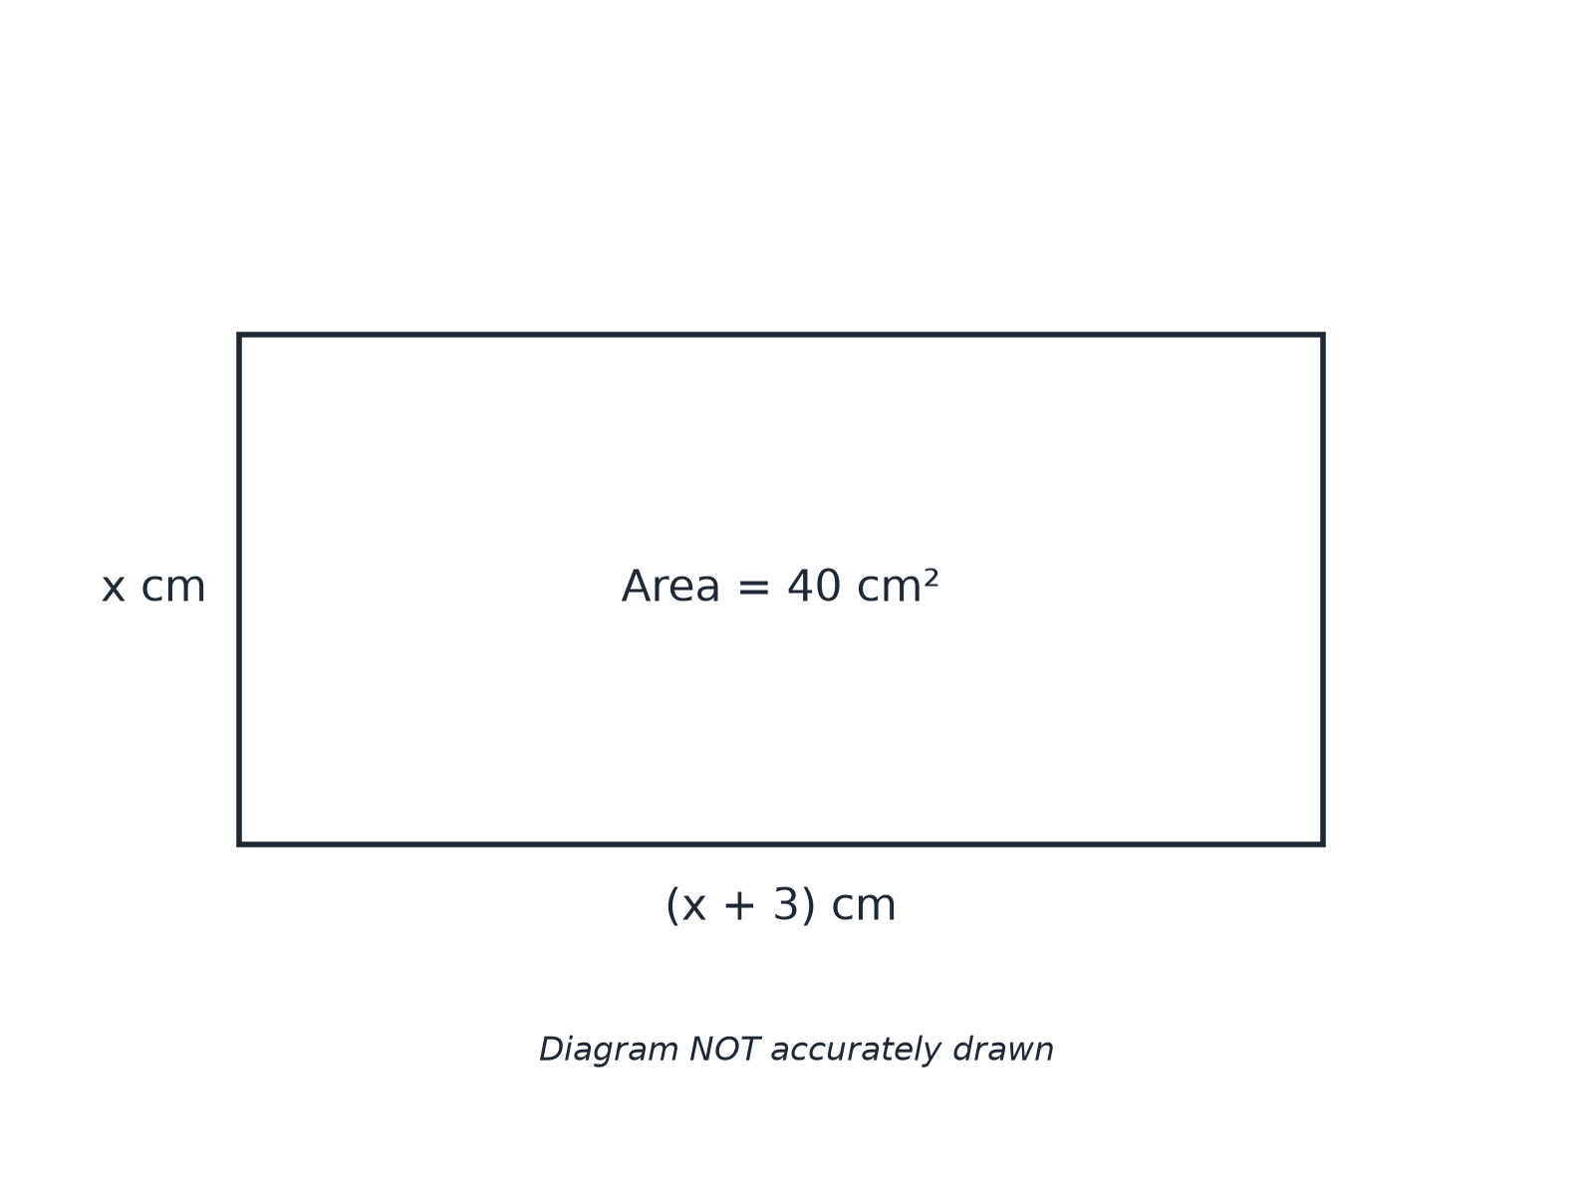

Question 6 · mark scheme
4 marks available. Award a mark for each point made.
▸ Forming the equation. M1
▸ Rearranging to zero. M1
▸ Factorising. M1
▸ x = 5. A1
▸ Model answer. x(x + 3) = 40, so x² + 3x − 40 = 0 and (x + 8)(x − 5) = 0. x = 5, since a length cannot be negative.

