EDEXCEL GCSE MATHS · HIGHER
Solving linear and quadratic simultaneous equations
Equations and inequalities · Lesson 7 of 7
Teacher copy - includes the notes for whoever is teaching from it.
Warm-up
Answer each one, then check.
1. Expand (x + 1)².
x² + 2x + 1
2. Solve x² + x − 12 = 0.
x = 3 or x = −4
3. Solve 5x² = 20.
x = ± 2
4. What is the equation of a circle with centre the origin and radius 5?
x² + y² = 25
5. What is a tangent to a curve?
A line that touches the curve at one point
Learning Objectives
1. Solve a linear and a quadratic equation together by substitution.
2. Solve a line with a circle x² + y² = r².
3. Find the points where a line meets a curve.
4. Show that a line is a tangent by getting a repeated root.
Substitution Method
Get the linear equation into y = … or x = … first.
1  Rearrange the linear equation  So one unknown is on its own | 2  Substitute into the quadratic  You now have a quadratic in one unknown | 3  Rearrange to zero and solve  Factorise, or use the formula | 4  Find the other unknown  Substitute each solution into the LINEAR equation | 5  Write pairs  Each solution is a pair of coordinates
A Line Meeting a Curve
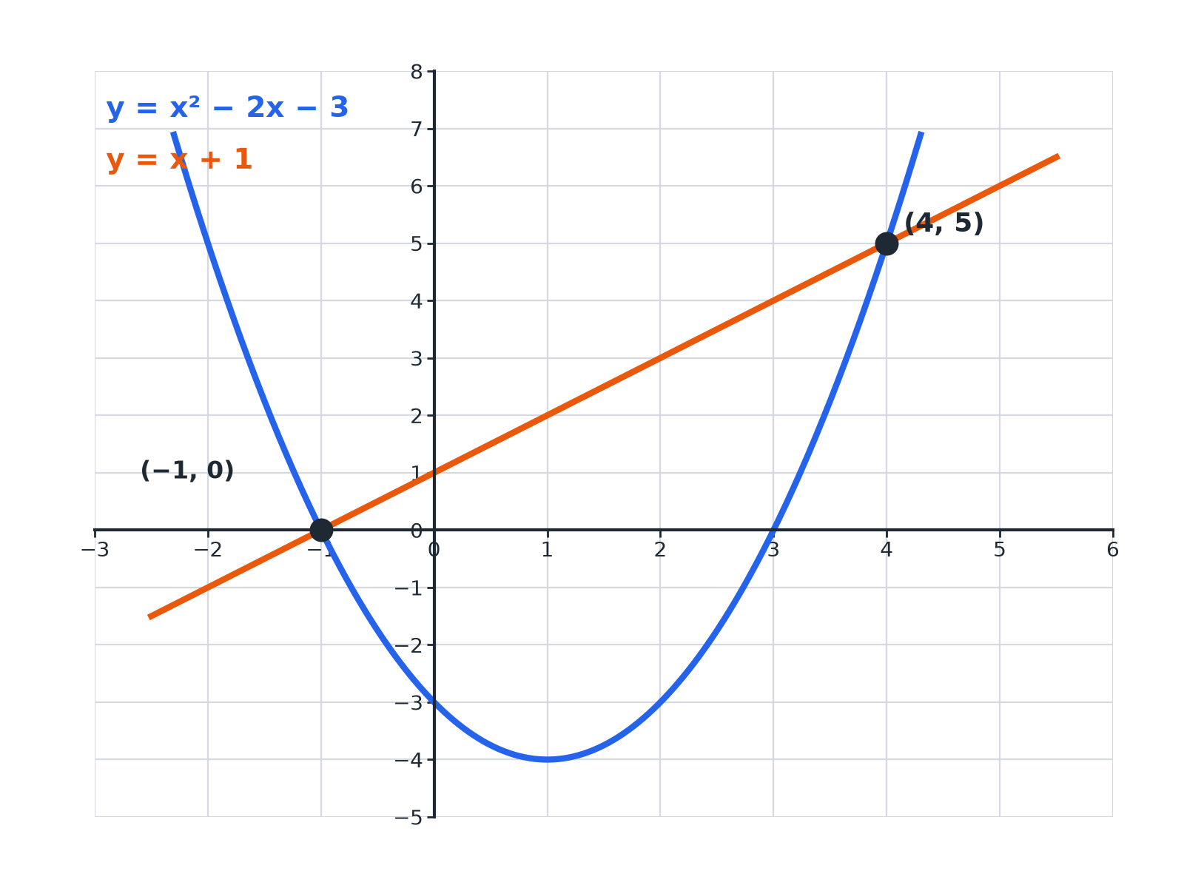
Two solutions mean the line crosses the curve twice.
The parabola y equals x squared minus 2x minus 3 and the line y equals x plus 1 crossing at the points minus 1, 0 and 4, 5.
A Line and a Parabola
Solve simultaneously y = x² − 2x − 3 and y = x + 1.

1. Set the y-values equal
x² − 2x − 3 = x + 1
2. Rearrange to zero
x² − 3x − 4 = 0
3. Factorise
(x − 4)(x + 1) = 0, so x = 4 or x = −1
4. Find y from the line y = x + 1
x = 4: y = 5; x = −1: y = 0
Answer: (4, 5) and (−1, 0)
A Line and a Circle
Solve simultaneously x² + y² = 25 and y = x + 1.

1. Substitute y = x + 1
x² + (x + 1)² = 25
2. Expand
2x² + 2x + 1 = 25, so 2x² + 2x − 24 = 0
3. Divide by 2 and factorise
x² + x − 12 = 0, so (x + 4)(x − 3) = 0
4. Find y
x = 3: y = 4; x = −4: y = −3
Answer: (3, 4) and (−4, −3)
A Line and a Circle
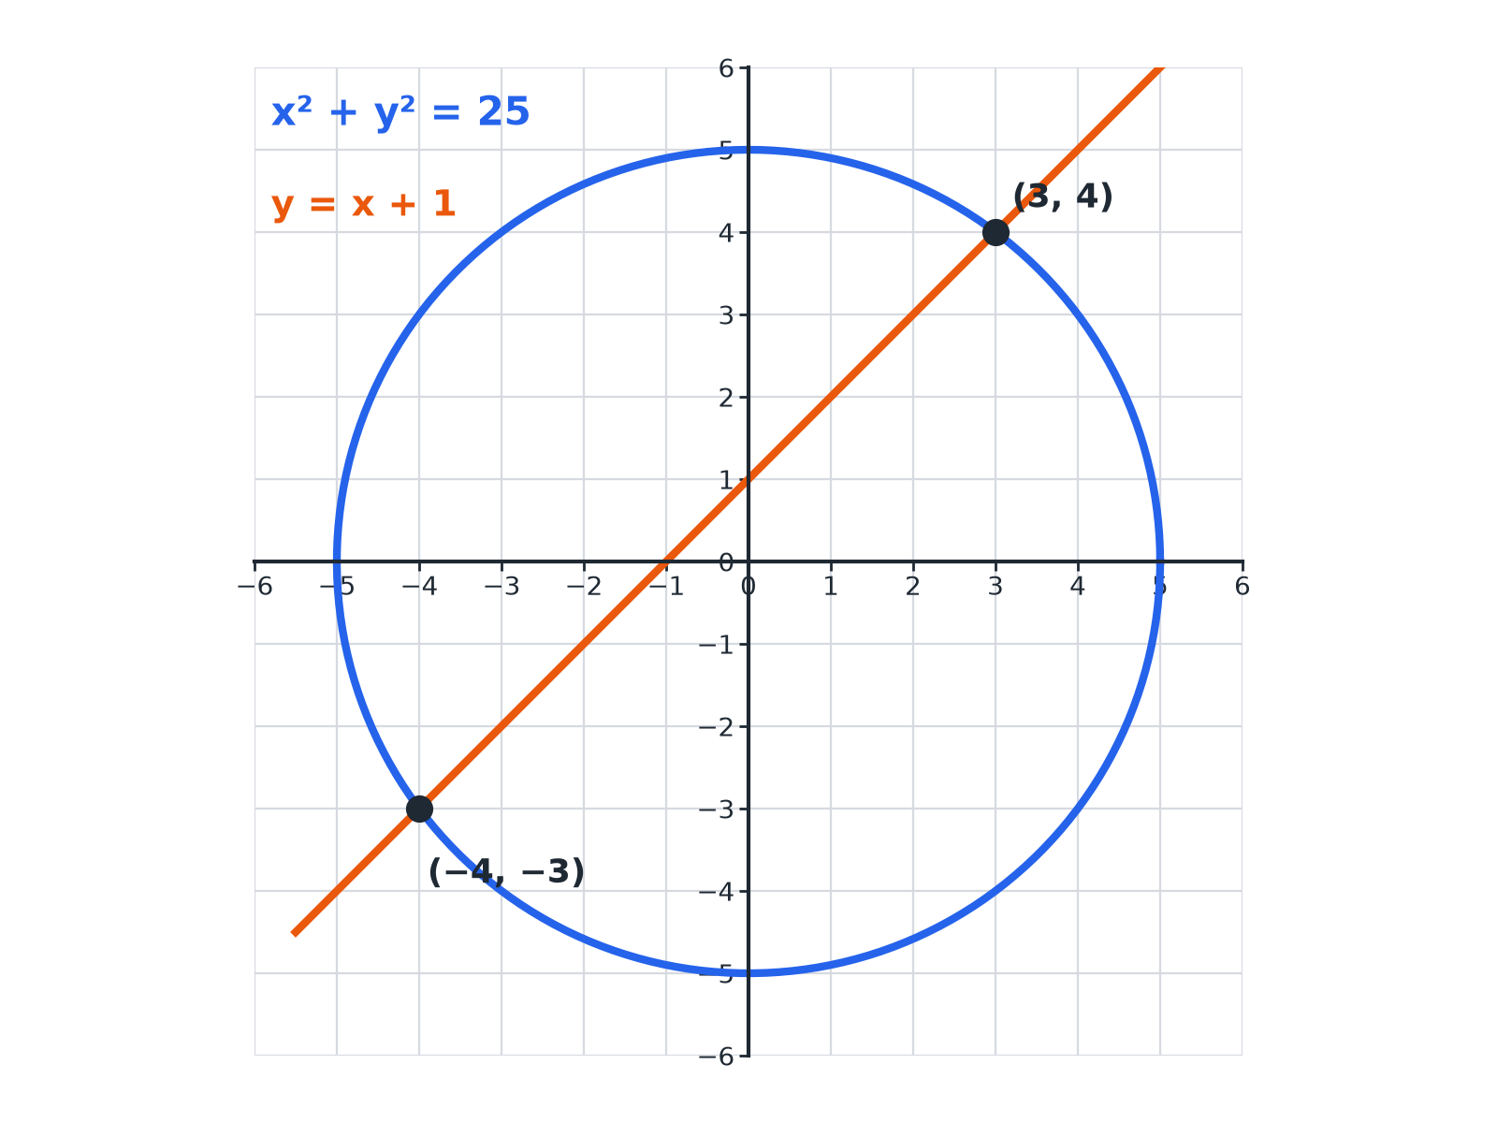
Substituting gives the two intersection points.
The circle x squared plus y squared equals 25 and the line y equals x plus 1 meeting at 3, 4 and minus 4, minus 3.
Another Circle Problem
Solve simultaneously x² + y² = 20 and y = 2x.

1. Substitute
x² + 4x² = 20
2. Simplify
5x² = 20, so x² = 4
3. Solve
x = 2 or x = −2
4. Find y
y = 4 or y = −4
Answer: (2, 4) and (−2, −4)
Showing a Line Is a Tangent
Show that the line y = 2x − 1 is a tangent to the curve y = x².

1. Set equal
x² = 2x − 1
2. Rearrange
x² − 2x + 1 = 0
3. Factorise
(x − 1)² = 0
4. One repeated solution
The line touches the curve at one point only, (1, 1)
Answer: The equation has one repeated root x = 1, so the line is a tangent.
How Many Solutions?
TWO SOLUTIONS | ONE OR NO SOLUTIONS
▸ The line crosses the curve at two points.  ▸ The quadratic has two different roots.  ▸ The discriminant b² − 4ac is positive. | ▸ One repeated root: the line is a tangent.  ▸ No real roots: the line misses the curve.  ▸ The discriminant is zero or negative.
Key Terms
Tangent  A line that touches a curve at exactly one point. | Repeated root  A solution that occurs twice, such as x = 1 in (x − 1)² = 0.
Intersection  A point where a line and a curve meet. | Substitution  Replacing a letter with an expression.
Circle equation  x² + y² = r² for a circle centred on the origin. | Discriminant  b² − 4ac; it shows the number of real roots.
Your Task: Where Do They Meet?
15 minutes
Find the intersection points of each pair. (a) y = x² and y = 3x − 2 (b) x + y = 7 and x² + y² = 25 (c) y = x² + 1 and y = 3x − 1.
1. Substitute.
2. Solve the quadratic.
3. Find y for each x.
A good answer shows: (a) x² − 3x + 2 = 0: (1, 1) and (2, 4). (b) y = 7 − x: 2x² − 14x + 24 = 0, x² − 7x + 12 = 0: (3, 4) and (4, 3). (c) x² − 3x + 2 = 0: (1, 2) and (2, 5).
Note: Ask which of these are tangents (none): the quadratics have two roots each.
Can I...?
☐ Rearrange the linear equation.
☐ Substitute into the quadratic.
☐ Solve the resulting quadratic.
☐ Find both coordinates of each point.
☐ Solve a line and a circle.
☐ Show a line is a tangent.
☐ Give answers as coordinate pairs.
☐ Check by substituting.
Summary
✓ Substitute the linear equation into the quadratic or the circle.
✓ Solve the quadratic in one unknown.
✓ Pair up each x with its y using the linear equation.
✓ A repeated root means the line is a tangent.

EXAM FOCUS
Solve the simultaneous equations y = x² − 2x − 3 and y = x + 1. (5 marks)
Substitute the linear equation into the quadratic. When you find each x, use the LINEAR equation to find the matching y.
Exam Practice: Linear and Quadratic Simultaneous Equations
Answer all questions. Show your working. · 35 minutes
▸ Question 1 · 5 marks · Non-calculator. Solve the simultaneous equations y = x² − 2x − 3 and y = x + 1.
▸ Question 2 · 5 marks · Non-calculator. The circle x² + y² = 25 and the line y = x + 1 intersect at two points. Find the coordinates of the two points.
▸ Question 3 · 4 marks · Non-calculator. Solve the simultaneous equations x² + y² = 20 and y = 2x.
▸ Question 4 · 4 marks · Show that. Show that the line y = 2x − 1 is a tangent to the curve y = x².
▸ Question 5 · 5 marks · Non-calculator. Solve the simultaneous equations x + y = 7 and x² + y² = 25.
▸ Question 6 · 5 marks · Non-calculator. Solve the simultaneous equations y = x² + 1 and y = 3x − 1.
Question 1 · 5 marks · Non-calculator
“Solve the simultaneous equations y = x² − 2x − 3 and y = x + 1.”
HOW TO ANSWER IT Command word: Non-calculator. Worth 5 marks, so plan before writing.
Question 1 · mark scheme
5 marks available. Award a mark for each point made.
▸ Equating. M1
▸ Rearranging to zero. M1
▸ Factorising. M1
▸ Both x values. A1
▸ Both correct pairs. A1
▸ Model answer. x² − 2x − 3 = x + 1, so x² − 3x − 4 = 0 and (x − 4)(x + 1) = 0. x = 4 or x = −1. The solutions are (4, 5) and (−1, 0).
Question 2 · 5 marks · Non-calculator
The circle x² + y² = 25 and the line y = x + 1 intersect at two points. Find the coordinates of the two points. (5 marks) | 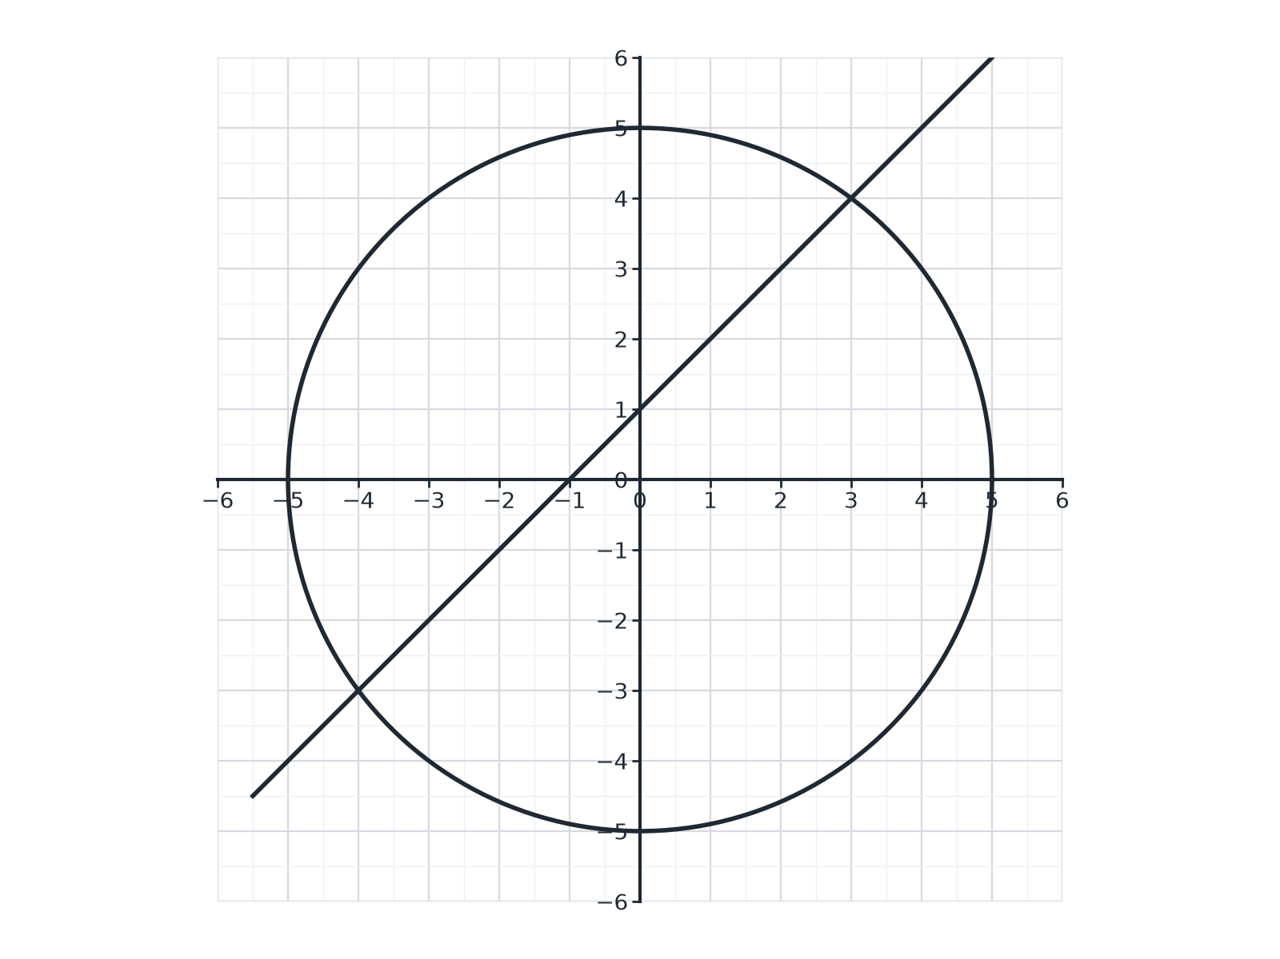

Question 2 · mark scheme
5 marks available. Award a mark for each point made.
▸ Substituting. M1
▸ Simplifying to a quadratic. M1
▸ Solving. M1
▸ Both x values. A1
▸ Both correct pairs. A1
▸ Model answer. x² + (x + 1)² = 25, so 2x² + 2x − 24 = 0, x² + x − 12 = 0, (x + 4)(x − 3) = 0. The points are (3, 4) and (−4, −3).
Question 3 · 4 marks · Non-calculator
“Solve the simultaneous equations x² + y² = 20 and y = 2x.”
HOW TO ANSWER IT Command word: Non-calculator. Worth 4 marks, so plan before writing.
Question 3 · mark scheme
4 marks available. Award a mark for each point made.
▸ Substituting. M1
▸ 5x² = 20. M1
▸ x = 2 and x = −2. A1
▸ Both pairs. A1
▸ Model answer. x² + 4x² = 20, so x² = 4, x = ± 2. The solutions are (2, 4) and (−2, −4).
Question 4 · 4 marks · Show that
“Show that the line y = 2x − 1 is a tangent to the curve y = x².”
HOW TO ANSWER IT Command word: Show that. Worth 4 marks, so plan before writing.
Question 4 · mark scheme
4 marks available. Award a mark for each point made.
▸ Equating. M1
▸ Rearranging to x² − 2x + 1 = 0. M1
▸ (x − 1)² = 0. M1
▸ Conclusion. C1
▸ Model answer. x² = 2x − 1, so x² − 2x + 1 = 0 and (x − 1)² = 0. There is only one solution, x = 1, so the line touches the curve at one point and is a tangent.
Question 5 · 5 marks · Non-calculator
“Solve the simultaneous equations x + y = 7 and x² + y² = 25.”
HOW TO ANSWER IT Command word: Non-calculator. Worth 5 marks, so plan before writing.
Question 5 · mark scheme
5 marks available. Award a mark for each point made.
▸ Rearranging and substituting. M1
▸ Expanding (7 − x)². M1
▸ Solving. M1
▸ Both x values. A1
▸ Both correct pairs. A1
▸ Model answer. y = 7 − x, so x² + (7 − x)² = 25, 2x² − 14x + 24 = 0, x² − 7x + 12 = 0, (x − 3)(x − 4) = 0. The solutions are (3, 4) and (4, 3).
Question 6 · 5 marks · Non-calculator
“Solve the simultaneous equations y = x² + 1 and y = 3x − 1.”
HOW TO ANSWER IT Command word: Non-calculator. Worth 5 marks, so plan before writing.
Question 6 · mark scheme
5 marks available. Award a mark for each point made.
▸ Equating. M1
▸ Rearranging to zero. M1
▸ Factorising. M1
▸ Both x values. A1
▸ Both correct pairs. A1
▸ Model answer. x² + 1 = 3x − 1, so x² − 3x + 2 = 0 and (x − 1)(x − 2) = 0. The solutions are (1, 2) and (2, 5).

