EDEXCEL GCSE MATHS · FOUNDATION & HIGHER
Experimental probability
Probability · Lesson 3 of 6
Teacher copy - includes the notes for whoever is teaching from it.
Warm-up
Answer each one, then check.
1. Simplify 30/120.
¼
2. Write 18/60 as a decimal.
0.3
3. What is the theoretical probability of heads on a fair coin?
½
4. Work out 500 × 0.3.
150
5. What is 1/6 as a decimal, to 2 decimal places?
0.17
Learning Objectives
1. Work out relative frequency.
2. Use relative frequency to estimate probability.
3. Predict how many times an event will happen.
4. Decide whether a coin, dice or spinner is fair.
Relative Frequency
Relative frequency is the number of times an event happens divided by the total number of trials.
relative frequency = (frequency of the event)/(total number of trials)
Relative Frequency Settles Down
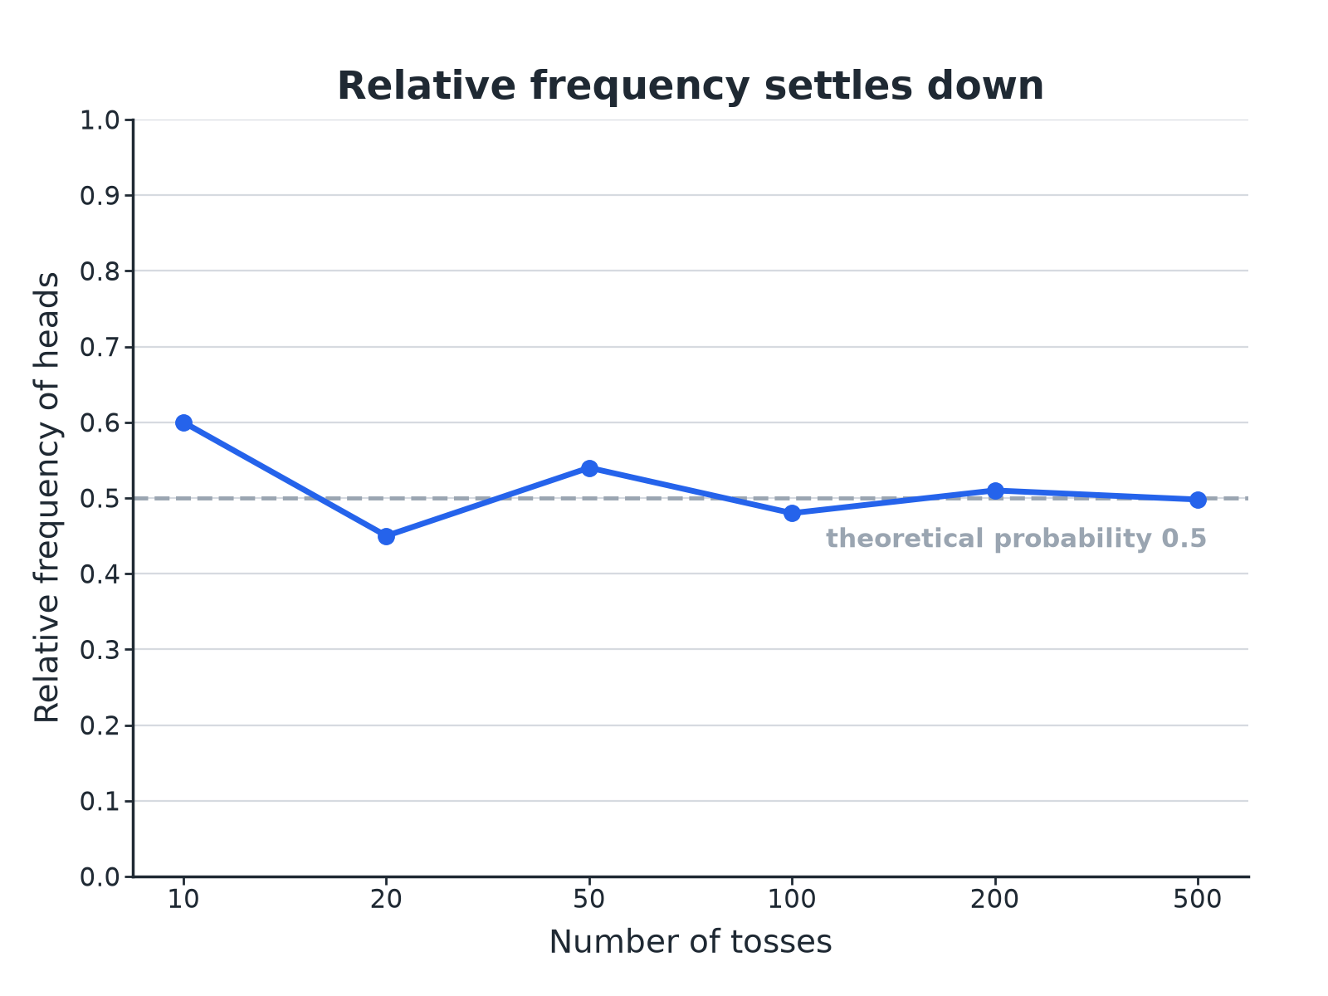
The more trials, the closer the relative frequency gets to the true probability.
A graph of relative frequency of heads for increasing numbers of coin tosses, wobbling at first and settling near 0.5.
Relative Frequency
A spinner is spun 60 times. It lands on red 18 times, blue 30 times and green 12 times. Find the relative frequency of each colour.

1. Red
18/60 = 0.3
2. Blue
30/60 = 0.5
3. Green
12/60 = 0.2
Answer: Red 0.3, blue 0.5, green 0.2. These add up to 1.
Predicting Outcomes
Use the spinner results to estimate how many times you would expect blue in 500 spins.

1. Estimated probability of blue
0.5
2. Multiply by the number of spins
0.5 × 500 = 250
Answer: About 250 blues.
Is the Dice Fair?
A dice is rolled 120 times and lands on 6 a total of 30 times. Does this suggest the dice is biased?

1. Relative frequency of a 6
30/120 = 0.25
2. Expected for a fair dice
1/6 = 0.167, so about 20 sixes
3. Compare
30 is much bigger than 20
Answer: The relative frequency 0.25 is well above 1/6, which suggests the dice may be biased, but more trials would give a more reliable conclusion.
Theoretical or Experimental?
THEORETICAL PROBABILITY | EXPERIMENTAL PROBABILITY
▸ Worked out from equally likely outcomes.  ▸ Example: P(head) = ½.  ▸ Does not change. | ▸ Estimated from the results of trials.  ▸ Example: 18 heads in 40 tosses gives 0.45.  ▸ Changes as you do more trials.
How Reliable Is an Estimate?
More trials give better estimates.
▸ Small samples. 10 tosses might give 7 heads: 0.7 is a poor estimate of 0.5.
▸ Large samples. 1000 tosses will usually give a relative frequency very close to 0.5.
▸ Fair. A fair dice or coin should give relative frequencies close to the theoretical values.
Key Terms
Trial  One repeat of an experiment. | Frequency  How many times an outcome happens.
Relative frequency  Frequency divided by the number of trials. | Theoretical probability  The probability worked out from equally likely outcomes.
Expected number  Probability multiplied by the number of trials. | Fair  Every outcome is equally likely.
Your Task: Coin Toss Experiment
15 minutes
Toss a coin 10 times and record the number of heads. Combine class results in groups of 10, 50 and 100 tosses. Work out the relative frequency of heads for each total and comment on how close each is to 0.5.
1. Collect results.
2. Combine.
3. Compare.
A good answer shows: Small groups vary widely (for example 3 or 7 heads out of 10), while the combined class total is very close to 0.5. This shows that relative frequency settles as the number of trials grows.
Note: Draw the class results on a graph like the one in the lesson.
Can I...?
☐ Work out relative frequency.
☐ Use it as an estimate of probability.
☐ Work out an expected number.
☐ Compare experimental and theoretical results.
☐ Say whether a dice looks fair.
☐ Explain why more trials are better.
☐ Show relative frequencies add to 1.
☐ Draw a relative frequency graph.
Summary
✓ Relative frequency = frequency/trials.
✓ Expected number = probability × trials.
✓ More trials give a more reliable estimate.
✓ Compare with the theoretical probability to test fairness.

EXAM FOCUS
A spinner is spun 200 times. It lands on red 62 times. Work out an estimate for the probability that it lands on red, and how many reds you expect in 500 spins. (3 marks)
Relative frequency is frequency divided by the number of trials. Multiply by the number of spins for the expected number.
Exam Practice: Experimental Probability
Answer all questions. Show your working. · 25 minutes
▸ Question 1 · 2 marks · Calculator. A spinner is spun 60 times. It lands on red 18 times. Work out the relative frequency of red.
▸ Question 2 · 3 marks · Calculator. A spinner is spun 200 times. It lands on red 62 times. Work out an estimate for the number of times it will land on red in 500 spins.
▸ Question 3 · 3 marks · Calculator. The graph shows the relative frequency of heads as a coin is tossed more and more times. Use it to explain whether the coin is likely to be…
▸ Question 4 · 3 marks · Calculator. A dice is rolled 120 times. It lands on 6 a total of 30 times. Kim says the dice is biased. Is she right? You must show working.
▸ Question 5 · 3 marks · Calculator. The probability that a bus is late is 0.15. Work out the expected number of late buses in 200 journeys.
▸ Question 6 · 2 marks · Explain. Amy tosses a coin 10 times and gets 7 heads. Ben tosses the same coin 1000 times and gets 505 heads. Whose result gives a better estimate…
Question 1 · 2 marks · Calculator
“A spinner is spun 60 times. It lands on red 18 times. Work out the relative frequency of red.”
HOW TO ANSWER IT Command word: Calculator. Worth 2 marks, so plan before writing.
Question 1 · mark scheme
2 marks available. Award a mark for each point made.
▸ 18/60. M1
▸ 0.3. A1
▸ Model answer. 18/60 = 0.3.
Question 2 · 3 marks · Calculator
“A spinner is spun 200 times. It lands on red 62 times. Work out an estimate for the number of times it will land on red in 500 spins.”
HOW TO ANSWER IT Command word: Calculator. Worth 3 marks, so plan before writing.
Question 2 · mark scheme
3 marks available. Award a mark for each point made.
▸ 62/200. M1
▸ 0.31 × 500. M1
▸ 155. A1
▸ Model answer. The relative frequency is 62/200 = 0.31. The expected number is 0.31 × 500 = 155.
Question 3 · 3 marks · Calculator
The graph shows the relative frequency of heads as a coin is tossed more and more times. Use it to explain whether the coin is likely to be fair. (3 marks) | 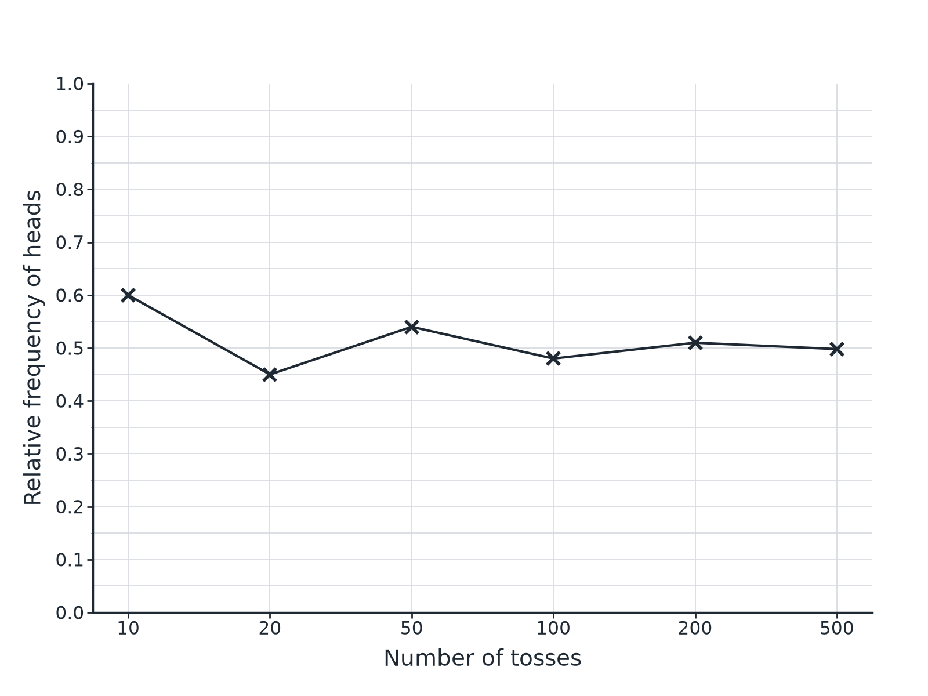

Question 3 · mark scheme
3 marks available. Award a mark for each point made.
▸ The relative frequency settles. M1
▸ It is near 0.5. M1
▸ Conclusion that the coin is likely to be fair. C1
▸ Model answer. The relative frequency gets close to 0.5 as the number of tosses increases, so the coin is likely to be fair.
Question 4 · 3 marks · Calculator
“A dice is rolled 120 times. It lands on 6 a total of 30 times. Kim says the dice is biased. Is she right? You must show working.”
HOW TO ANSWER IT Command word: Calculator. Worth 3 marks, so plan before writing.
Question 4 · mark scheme
3 marks available. Award a mark for each point made.
▸ 30/120 = 0.25 or expected 20. M1
▸ Comparison with 1/6 or 20. M1
▸ A conclusion with a reason. C1
▸ Model answer. The relative frequency of a 6 is 30/120 = 0.25, compared with 1/6 ≈ 0.17 for a fair dice. The expected number of sixes is 20. 30 is much higher, so the dice may be biased, but more trials would make the conclusion more reliable.
Question 5 · 3 marks · Calculator
“The probability that a bus is late is 0.15. Work out the expected number of late buses in 200 journeys.”
HOW TO ANSWER IT Command word: Calculator. Worth 3 marks, so plan before writing.
Question 5 · mark scheme
3 marks available. Award a mark for each point made.
▸ 0.15 × 200. M1
▸ 30. A1
▸ A sensible unit or statement. B1
▸ Model answer. 0.15 × 200 = 30.
Question 6 · 2 marks · Explain
“Amy tosses a coin 10 times and gets 7 heads. Ben tosses the same coin 1000 times and gets 505 heads. Whose result gives a better estimate of the probability of a head? Give a reason.”
HOW TO ANSWER IT Command word: Explain. Worth 2 marks, so plan before writing.
Question 6 · mark scheme
2 marks available. Award a mark for each point made.
▸ Ben. B1
▸ More trials give a more reliable estimate. C1
▸ Model answer. Ben's result, because he did many more trials, so his relative frequency (0.505) is more reliable.

