EDEXCEL GCSE MATHS · FOUNDATION & HIGHER
Independent events and tree diagrams
Probability · Lesson 4 of 6
Teacher copy - includes the notes for whoever is teaching from it.
Warm-up
Answer each one, then check.
1. Work out 3/5 × 3/5.
9/25
2. Work out 0.2 × 0.8.
0.16
3. What is 1 − 0.2?
0.8
4. Work out 9/25 + 4/25.
13/25
5. What do all the probabilities on a set of branches add up to?
1
Learning Objectives
1. Recognise independent events.
2. Use P(A and B) = P(A) × P(B) for independent events.
3. Draw and complete a tree diagram.
4. Use a tree diagram to find the probability of combined events.
Independent Events
Two events are independent if the outcome of one does not affect the outcome of the other.
For independent events, P(A and B) = P(A) × P(B).
Multiplying Probabilities
The probability that Sam is late for school is 0.3. The probability that it rains is 0.5. These events are independent. Find the probability that Sam is late and it rains.

1. Independent events, so multiply
0.3 × 0.5
2. Work it out
0.15
Answer: 0.15
A Tree Diagram
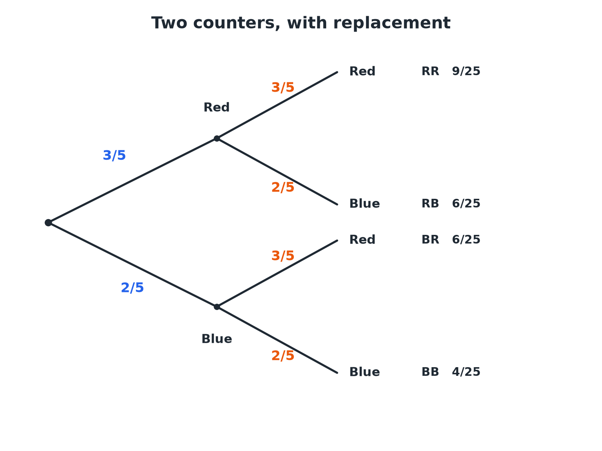
Multiply along the branches; add the outcomes you want.
A two-stage tree diagram for drawing two counters with replacement from a bag of 3 red and 2 blue, with the four outcomes and their probabilities.
Using a Tree Diagram
Two rules do all the work.
1  Draw the branches  One set for each event, with the probability on each branch | 2  Check  The probabilities on each set of branches add up to 1 | 3  Multiply along the branches  This gives the probability of each combined outcome | 4  Add the outcomes you want  If more than one outcome fits, add their probabilities | 5  Check the total  All the outcomes add up to 1
Two Counters with Replacement
A bag has 3 red and 2 blue counters. A counter is taken, its colour is noted and it is put back. A second counter is then taken. Find the probability that both counters are the same colour.

1. Both red
3/5 × 3/5 = 9/25
2. Both blue
2/5 × 2/5 = 4/25
3. Same colour means RR or BB, so add
9/25 + 4/25
Answer: 13/25
Late Two Days
The probability that Amy is late for school on any day is 0.2, independent of other days. Find (a) the probability she is late on both of two days, (b) late on exactly one of the two days, (c) late on at least one day.

1. (a) Multiply
0.2 × 0.2 = 0.04
2. (b) Late then not late, or not late then late
0.2 × 0.8 + 0.8 × 0.2 = 0.16 + 0.16 = 0.32
3. (c) Use the complement: never late is 0.8 × 0.8 = 0.64
1 − 0.64 = 0.36
Answer: (a) 0.04 (b) 0.32 (c) 0.36
Shortcut: At Least One
"At least one" is easier by subtraction.
▸ Find the opposite. "None" is the outcome where the event never happens.
▸ Subtract from 1. P(at least one) = 1 − P(none).
▸ Saves work. You avoid adding many branches.
The Four Outcomes
The outcomes of a two-stage tree with replacement.
Outcome | Working | Probability
Red, Red | 3/5 × 3/5 | 9/25
Red, Blue | 3/5 × 2/5 | 6/25
Blue, Red | 2/5 × 3/5 | 6/25
Blue, Blue | 2/5 × 2/5 | 4/25
Total |  | 1
Key Terms
Independent  The outcome of one event does not change the other. | Tree diagram  A diagram showing the outcomes of events and their probabilities on branches.
Branch  A line on a tree diagram carrying a probability. | With replacement  Putting the item back before the next pick.
Combined event  Two or more events considered together. | Complement  The event "not A".
Your Task: Free Throws
12 minutes
A basketball player scores a free throw with probability 0.7, independently each time. She takes two throws. Draw a tree diagram and find the probability she scores (a) both (b) exactly one (c) none.
1. Draw the tree.
2. Multiply along branches.
3. Add the outcomes needed.
A good answer shows: (a) 0.7 × 0.7 = 0.49. (b) 0.7 × 0.3 + 0.3 × 0.7 = 0.42. (c) 0.3 × 0.3 = 0.09. The three add up to 1.
Note: Ask students to check the total is 1.
Can I...?
☐ Decide if events are independent.
☐ Multiply probabilities of independent events.
☐ Draw a two-stage tree diagram.
☐ Label the branches with probabilities.
☐ Multiply along a path.
☐ Add the outcomes I want.
☐ Use "1 minus" for at least one.
☐ Check the total is 1.
Summary
✓ Independent: P(A and B) = P(A) × P(B).
✓ Multiply along the branches, add between outcomes.
✓ The branches from a node add up to 1.
✓ At least one = 1 − none.

EXAM FOCUS
The probability that Amy is late on any day is 0.2. Work out the probability that she is late on at least one of two days. (3 marks)
"At least one" means one minus none. Never late on both days is 0.8 × 0.8.
Exam Practice: Independent Events and Tree Diagrams
Answer all questions. Show your working. · 30 minutes
▸ Question 1 · 2 marks · Non-calculator. A and B are independent events. P(A) = 0.3 and P(B) = 0.5. Work out P(A and B).
▸ Question 2 · 3 marks · Non-calculator. The probability that Amy is late for school on any day is 0.2. The tree diagram shows the probabilities for two days. Complete the tree…
▸ Question 3 · 2 marks · Non-calculator. Using the tree diagram, work out the probability that Amy is late on both days.
▸ Question 4 · 3 marks · Non-calculator. Using the tree diagram, work out the probability that Amy is late on exactly one of the two days.
▸ Question 5 · 3 marks · Non-calculator. Work out the probability that Amy is late on at least one of the two days.
▸ Question 6 · 4 marks · Non-calculator. A bag contains 3 red counters and 2 blue counters. A counter is taken at random, its colour is noted and it is replaced. A second counter…
Question 1 · 2 marks · Non-calculator
“A and B are independent events. P(A) = 0.3 and P(B) = 0.5. Work out P(A and B).”
HOW TO ANSWER IT Command word: Non-calculator. Worth 2 marks, so plan before writing.
Question 1 · mark scheme
2 marks available. Award a mark for each point made.
▸ 0.3 × 0.5. M1
▸ 0.15. A1
▸ Model answer. 0.3 × 0.5 = 0.15.
Question 2 · 3 marks · Non-calculator
The probability that Amy is late for school on any day is 0.2. The tree diagram shows the probabilities for two days. Complete the tree diagram. (3 marks) | 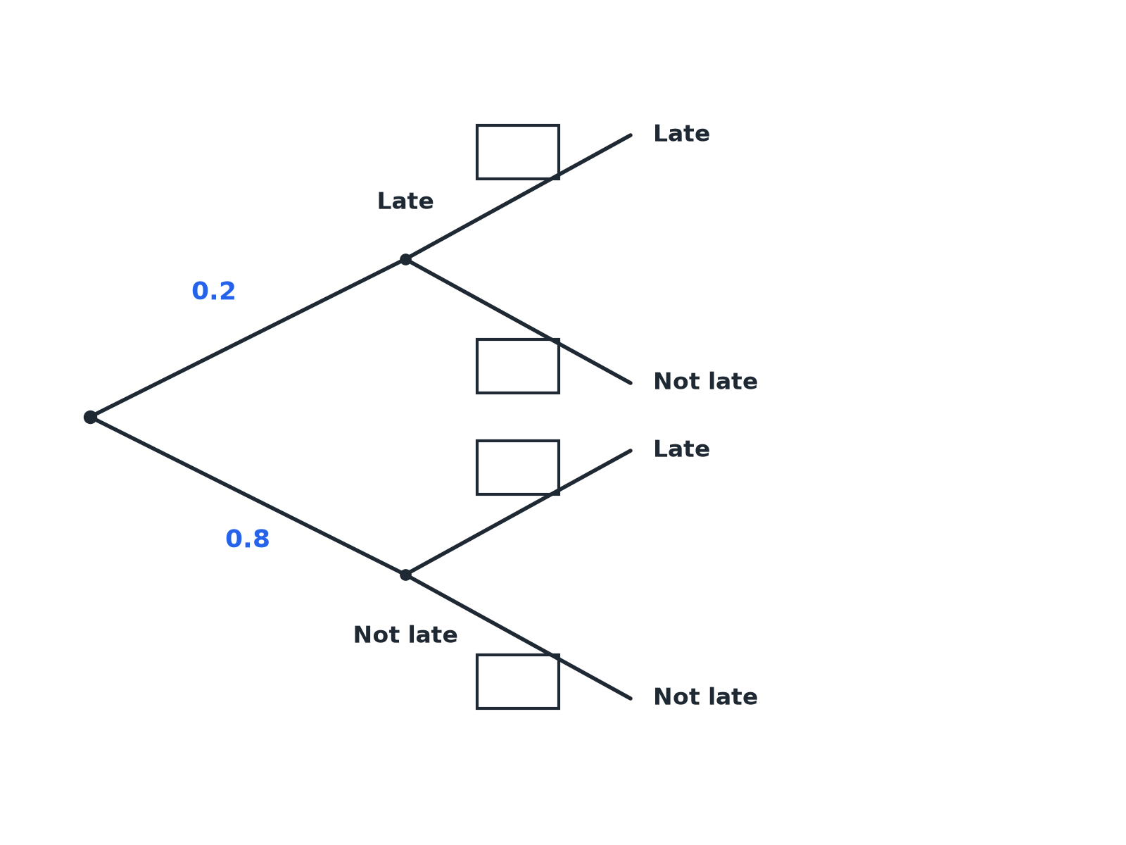

Question 2 · mark scheme
3 marks available. Award a mark for each point made.
▸ Late branches 0.2 on day 2. B1
▸ Not late branches 0.8 on day 2. B1
▸ All four correct. B1
▸ Model answer. All four second-stage branches: Late 0.2 and Not late 0.8, after either first-day outcome.
Question 3 · 2 marks · Non-calculator
“Using the tree diagram, work out the probability that Amy is late on both days.”
HOW TO ANSWER IT Command word: Non-calculator. Worth 2 marks, so plan before writing.
Question 3 · mark scheme
2 marks available. Award a mark for each point made.
▸ 0.2 × 0.2. M1
▸ 0.04. A1
▸ Model answer. 0.2 × 0.2 = 0.04.
Question 4 · 3 marks · Non-calculator
“Using the tree diagram, work out the probability that Amy is late on exactly one of the two days.”
HOW TO ANSWER IT Command word: Non-calculator. Worth 3 marks, so plan before writing.
Question 4 · mark scheme
3 marks available. Award a mark for each point made.
▸ One correct product. M1
▸ Adding the two paths. M1
▸ 0.32. A1
▸ Model answer. 0.2 × 0.8 + 0.8 × 0.2 = 0.16 + 0.16 = 0.32.
Question 5 · 3 marks · Non-calculator
“Work out the probability that Amy is late on at least one of the two days.”
HOW TO ANSWER IT Command word: Non-calculator. Worth 3 marks, so plan before writing.
Question 5 · mark scheme
3 marks available. Award a mark for each point made.
▸ 0.8 × 0.8. M1
▸ 1 − 0.64. M1
▸ 0.36. A1
▸ Model answer. The probability of never being late is 0.8 × 0.8 = 0.64. So P(at least one) = 1 − 0.64 = 0.36.
Question 6 · 4 marks · Non-calculator
“A bag contains 3 red counters and 2 blue counters. A counter is taken at random, its colour is noted and it is replaced. A second counter is taken. Work out the probability that the two counters are the same colour.”
HOW TO ANSWER IT Command word: Non-calculator. Worth 4 marks, so plan before writing.
Question 6 · mark scheme
4 marks available. Award a mark for each point made.
▸ 3/5 × 3/5. M1
▸ 2/5 × 2/5. M1
▸ Adding the two. M1
▸ 13/25. A1
▸ Model answer. P(RR) = 3/5 × 3/5 = 9/25 and P(BB) = 2/5 × 2/5 = 4/25. Together: 13/25.

