EDEXCEL GCSE MATHS · HIGHER
Conditional probability
Probability · Lesson 5 of 6
Teacher copy - includes the notes for whoever is teaching from it.
Warm-up
Answer each one, then check.
1. Work out ⅝ × 4/7.
5/14
2. Simplify 30/56.
15/28
3. Work out 1 − 5/14.
9/14
4. What does "independent" mean?
One event does not affect the other
5. What does "with replacement" mean?
The item is put back before the next pick
Learning Objectives
1. Explain what conditional probability means.
2. Draw a tree diagram for events without replacement.
3. Work out probabilities of combined events without replacement.
4. Find a conditional probability from a two-way table.
Conditional Probability
The probability of an event happening, given that another event has already happened, is a conditional probability.
Without replacement, the numbers change after each pick.
A Tree Without Replacement
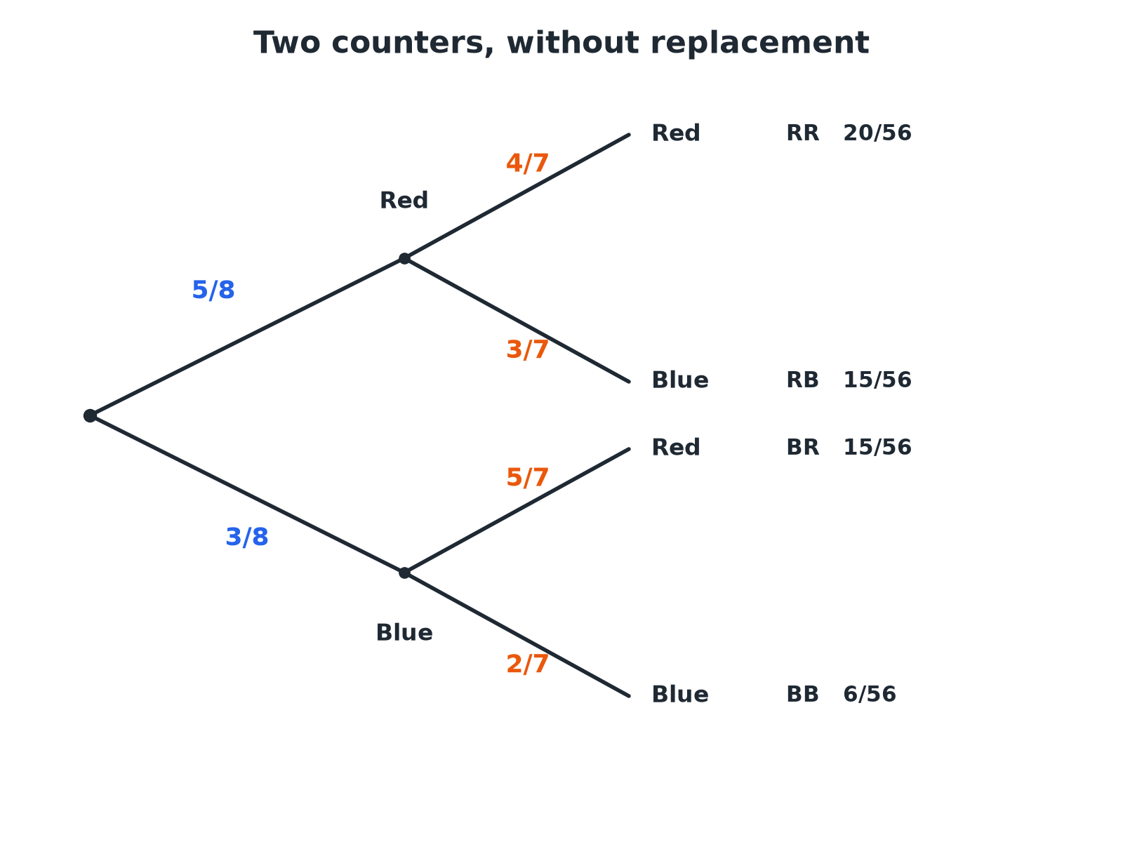
After one counter is taken, only 7 are left, so the second-stage probabilities change.
A two-stage tree diagram for two counters taken without replacement from 5 red and 3 blue, where the second-stage probabilities have denominator 7.
Without Replacement
A bag has 5 red and 3 blue counters. Two counters are taken at random without replacement. Find the probability that both are red.

1. First counter red
⅝
2. Now 4 red among 7 remaining
4/7
3. Multiply
⅝ × 4/7 = 20/56
4. Simplify
5/14
Answer: 5/14
One of Each Colour
For the same bag, find the probability that the two counters are different colours.

1. Red then blue
⅝ × 3/7 = 15/56
2. Blue then red
⅜ × 5/7 = 15/56
3. Add
30/56
4. Simplify
15/28
Answer: 15/28
At Least One Red
A bag has 4 red and 6 blue counters. Two are taken without replacement. Find the probability that at least one is red.

1. At least one red is the opposite of both blue
Use 1 − P(both blue)
2. Both blue
6/10 × 5/9 = 30/90 = ⅓
3. Subtract from 1
1 − ⅓ = ⅔
Answer: ⅔
Two-Way Tables
Conditional probabilities can be read from a table by restricting to a group.
▸ The idea. For "given that", use only the people in that group as the total.
▸ Example. 60 students: 35 like football, and 20 of those are boys. Given that a student likes football, the probability that they are a boy is 20/35.
▸ Simplify. 20/35 = 4/7.
A Two-Way Table
60 students were asked whether they like football.
Likes football | Does not like football | Total
Boys | 20 | 10 | 30
Girls | 15 | 15 | 30
Total | 35 | 25 | 60
Given That
Use the table. A student is chosen at random. Find the probability that they are a boy given that they like football.

1. Restrict to students who like football
35 students
2. Boys among them
20
3. Probability
20/35 = 4/7
Answer: 4/7
Key Terms
Conditional probability  The probability of an event given that another has happened. | Without replacement  The item is not put back, so later probabilities change.
Dependent events  Events where one affects the probability of the other. | Tree diagram  A diagram showing outcomes and probabilities on branches.
Two-way table  A table showing two categories at once. | Complement  The event "not A".
Your Task: Cards Without Replacement
12 minutes
Three cards are taken from a pack of ten cards numbered 1 to 10, one after another without replacement. Find the probability that the first is even and the second is odd, and that the first two are both greater than 7.
1. Reduce the numbers after each pick.
2. Multiply along the path.
A good answer shows: First even and second odd: 5/10 × 5/9 = 25/90 = 5/18. Both greater than 7: 3/10 × 2/9 = 6/90 = 1/15.
Note: Ask why the second denominator is 9.
Can I...?
☐ Explain what conditional means.
☐ Adjust the numbers after a pick.
☐ Draw a tree diagram without replacement.
☐ Multiply along the branches.
☐ Add paths for combined outcomes.
☐ Use "1 minus" for at least one.
☐ Find a conditional probability from a table.
☐ Simplify my fractions.
Summary
✓ Without replacement, probabilities on the second branches change.
✓ Multiply along the branches; add different paths.
✓ "Given that" means restrict to that group.
✓ At least one = 1 − none.

EXAM FOCUS
A bag has 5 red and 3 blue counters. Two counters are taken at random without replacement. Work out the probability that the counters are different colours. (3 marks)
Both orders count: red then blue AND blue then red. Reduce the total by 1 for the second pick.
Exam Practice: Conditional Probability
Answer all questions. Show your working. · 30 minutes
▸ Question 1 · 3 marks · Non-calculator. A bag contains 5 red counters and 3 blue counters. Two counters are taken at random without replacement. Work out the probability that both…
▸ Question 2 · 3 marks · Non-calculator. For the same bag, work out the probability that the two counters are different colours.
▸ Question 3 · 3 marks · Non-calculator. A bag contains 4 red counters and 6 blue counters. Two counters are taken at random without replacement. Complete the tree diagram.
▸ Question 4 · 3 marks · Non-calculator. Using the tree diagram, work out the probability that both counters are blue.
▸ Question 5 · 3 marks · Non-calculator. Using the tree diagram, work out the probability that at least one of the counters is red.
▸ Question 6 · 3 marks · Non-calculator. 60 students were asked whether they like football. 35 like football, and 20 of these are boys. 30 of the 60 students are boys. A student is…
Question 1 · 3 marks · Non-calculator
“A bag contains 5 red counters and 3 blue counters. Two counters are taken at random without replacement. Work out the probability that both counters are red.”
HOW TO ANSWER IT Command word: Non-calculator. Worth 3 marks, so plan before writing.
Question 1 · mark scheme
3 marks available. Award a mark for each point made.
▸ ⅝. M1
▸ ⅝ × 4/7. M1
▸ 5/14. A1
▸ Model answer. ⅝ × 4/7 = 20/56 = 5/14.
Question 2 · 3 marks · Non-calculator
“For the same bag, work out the probability that the two counters are different colours.”
HOW TO ANSWER IT Command word: Non-calculator. Worth 3 marks, so plan before writing.
Question 2 · mark scheme
3 marks available. Award a mark for each point made.
▸ One correct product. M1
▸ Adding both orders. M1
▸ 15/28. A1
▸ Model answer. ⅝ × 3/7 + ⅜ × 5/7 = 15/56 + 15/56 = 15/28.
Question 3 · 3 marks · Non-calculator
A bag contains 4 red counters and 6 blue counters. Two counters are taken at random without replacement. Complete the tree diagram. (3 marks) | 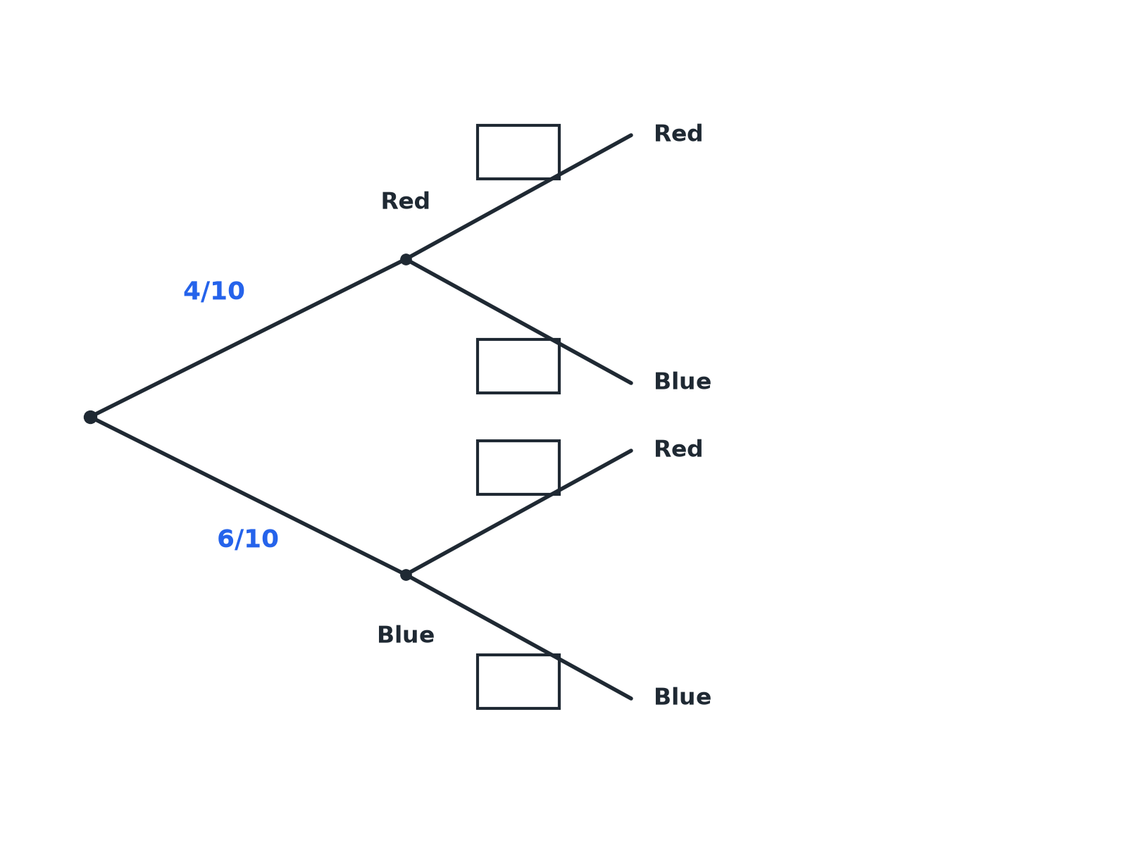

Question 3 · mark scheme
3 marks available. Award a mark for each point made.
▸ Denominator 9 on all four branches. B1
▸ After red: 3/9, 6/9. B1
▸ After blue: 4/9, 5/9. B1
▸ Model answer. After red: red 3/9 and blue 6/9. After blue: red 4/9 and blue 5/9.
Question 4 · 3 marks · Non-calculator
“Using the tree diagram, work out the probability that both counters are blue.”
HOW TO ANSWER IT Command word: Non-calculator. Worth 3 marks, so plan before writing.
Question 4 · mark scheme
3 marks available. Award a mark for each point made.
▸ 6/10 × 5/9. M1
▸ 30/90. A1
▸ ⅓. A1
▸ Model answer. 6/10 × 5/9 = 30/90 = ⅓.
Question 5 · 3 marks · Non-calculator
“Using the tree diagram, work out the probability that at least one of the counters is red.”
HOW TO ANSWER IT Command word: Non-calculator. Worth 3 marks, so plan before writing.
Question 5 · mark scheme
3 marks available. Award a mark for each point made.
▸ 1 − P(both blue). M1
▸ 1 − ⅓. M1
▸ ⅔. A1
▸ Model answer. 1 − P(both blue) = 1 − ⅓ = ⅔.
Question 6 · 3 marks · Non-calculator
“60 students were asked whether they like football. 35 like football, and 20 of these are boys. 30 of the 60 students are boys. A student is chosen at random. Given that the student likes football, work out the probability that they are a boy.”
HOW TO ANSWER IT Command word: Non-calculator. Worth 3 marks, so plan before writing.
Question 6 · mark scheme
3 marks available. Award a mark for each point made.
▸ 35 as the total. M1
▸ 20/35. A1
▸ 4/7. A1
▸ Model answer. Of the 35 who like football, 20 are boys. The probability is 20/35 = 4/7.

