EDEXCEL GCSE MATHS · FOUNDATION & HIGHER
Congruence
Similarity and congruence · Lesson 1 of 5
Teacher copy - includes the notes for whoever is teaching from it.
Warm-up
Answer each one, then check.
1. What do the angles in a triangle add up to?
180°
2. What does isosceles mean?
Two equal sides
3. What is a right-angled triangle's longest side called?
The hypotenuse
4. Do reflections keep the size of a shape?
Yes
5. What do the angles on a straight line add up to?
180°
Learning Objectives
1. Explain what congruent means.
2. Use SSS, SAS, ASA and RHS to show triangles are congruent.
3. Explain why AAA and SSA do not prove congruence.
4. Use congruence to find missing sides and angles.
Congruent
Two shapes are congruent if they are exactly the same shape and size.
One can be moved onto the other by a rotation, a reflection, a translation, or a combination.
The Four Congruence Conditions
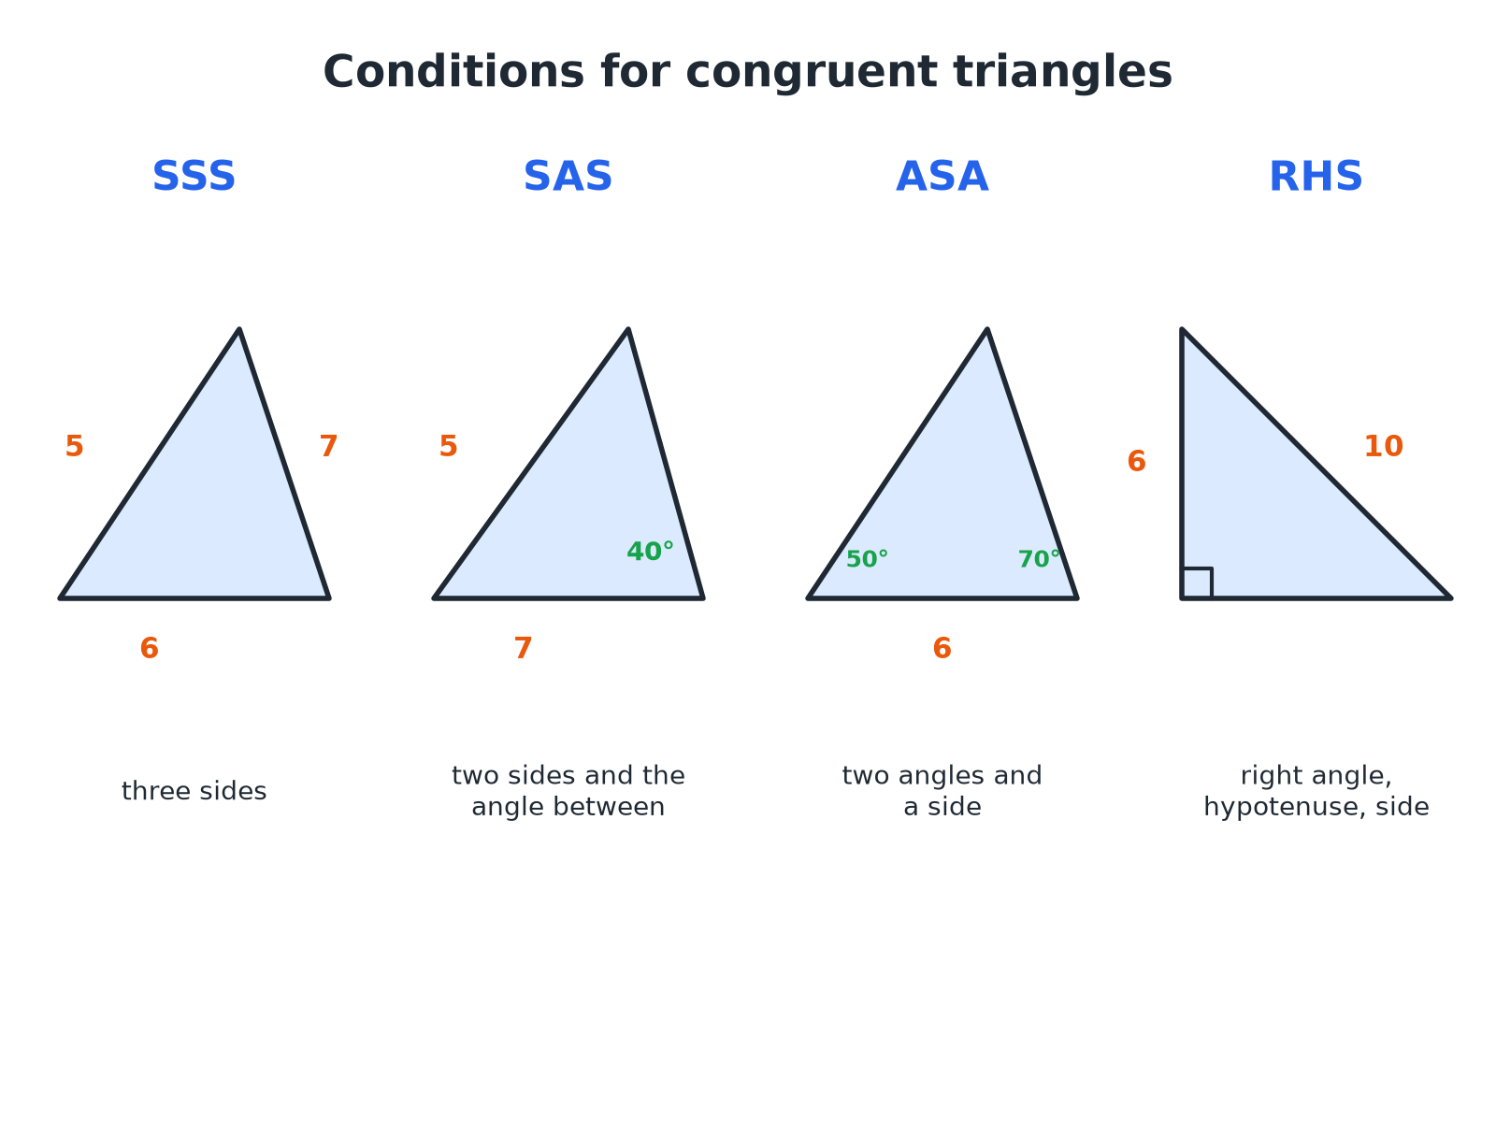
If two triangles satisfy any one of these, they are congruent.
Four triangles labelled with the congruence conditions SSS, SAS, ASA and RHS.
The Four Conditions
Learn the letters and what they mean.
Condition | Means | Example
SSS | All three sides equal | 5, 6, 7 and 5, 6, 7
SAS | Two sides and the included angle equal | 5, 40°, 7 and 5, 40°, 7
ASA | Two angles and a corresponding side equal | 50°, 6, 70°
RHS | Right angle, hypotenuse and one other side equal | Right angle, 10, 6
Proving Two Triangles Congruent
Triangle ABC has AB = 5 cm, BC = 7 cm and angle ABC = 50°. Triangle PQR has PQ = 5 cm, QR = 7 cm and angle PQR = 50°. Are the triangles congruent?

1. Two pairs of equal sides
AB = PQ and BC = QR
2. The angle between them is equal too
Angle B = angle Q = 50°
3. Two sides and the included angle
SAS
Answer: Yes, the triangles are congruent by SAS.
Conditions That Do NOT Work
AAA  Three equal angles give similar triangles, but they can be different sizes. | SSA  Two sides and a non-included angle can give two different triangles.
Only sides  Two sides alone are not enough. | Angles not between the sides  If the angle is not between the two sides, it is not SAS.
Using Congruence to Find a Length
Triangles ABC and DEF are congruent by SSS, with A matching D, B matching E and C matching F. AB = 6 cm, BC = 8 cm, DF = 10 cm. Find AC and DE.

1. Corresponding sides are equal
AB = DE, BC = EF, AC = DF
2. Find AC
AC = DF = 10 cm
3. Find DE
DE = AB = 6 cm
Answer: AC = 10 cm and DE = 6 cm.
Writing the Reason
A congruence answer needs three things.
▸ The equal parts. Write which sides or angles are equal, with the reason for each.
▸ The condition. State SSS, SAS, ASA or RHS.
▸ The conclusion. "So triangle ABC is congruent to triangle DEF."
Key Terms
Congruent  Exactly the same shape and size. | Corresponding  In matching positions in two shapes.
Included angle  The angle between two given sides. | Hypotenuse  The longest side of a right-angled triangle.
SSS, SAS, ASA, RHS  The four conditions for congruent triangles. | Similar  The same shape but a different size.
Your Task: Congruent or Not?
12 minutes
Decide which pairs of triangles are congruent and name the condition. (a) 4, 5, 6 and 6, 4, 5 (b) sides 5 and 8 with an angle of 30° between them, and sides 5 and 8 with an angle of 40° between them (c) angles 40°, 60°, 80° in both triangles, but one has a side of 3 cm and the other a side of 6 cm.
1. Match the equal parts.
2. Name the condition.
A good answer shows: (a) Congruent by SSS. (b) Not congruent: the included angles differ. (c) Not congruent: AAA does not prove congruence; the sides are different sizes, so the triangles are similar.
Note: Ask what extra information would make (c) congruent.
Can I...?
☐ Say what congruent means.
☐ Recall SSS, SAS, ASA and RHS.
☐ Decide whether two triangles are congruent.
☐ Explain why AAA is not enough.
☐ Explain why SSA is not enough.
☐ Find corresponding sides and angles.
☐ Use congruence to find a length.
☐ Write a clear reason.
Summary
✓ Congruent means identical in shape and size.
✓ Conditions: SSS, SAS, ASA (or AAS), RHS.
✓ AAA and SSA do not prove congruence.
✓ Always give the condition as your reason.

EXAM FOCUS
Triangle ABC has AB = 6 cm, AC = 8 cm and angle A = 50°. Triangle PQR has PQ = 6 cm, PR = 8 cm and angle P = 50°. Show that the two triangles are congruent. (3 marks)
Name the pairs of equal parts and check the angle is between the two sides. Then state SAS.
Exam Practice: Congruence
Answer all questions. Give reasons for your answers. · 25 minutes
▸ Question 1 · 3 marks · Give a reason. The diagram shows three triangles A, B and C. Two of the triangles are congruent. Write down which two, and give a reason.
▸ Question 2 · 3 marks · Show that. Triangle ABC has AB = 5 cm, BC = 7 cm and angle ABC = 50°. Triangle PQR has PQ = 5 cm, QR = 7 cm and angle PQR = 50°. Show that triangle…
▸ Question 3 · 2 marks · Give a reason. Two triangles both have angles of 40°, 60° and 80°. Ben says they must be congruent. Explain why Ben is not necessarily correct.
▸ Question 4 · 2 marks · Work out. Triangles ABC and DEF are congruent, with A matching D, B matching E and C matching F. AB = 6 cm, BC = 8 cm and DF = 10 cm. Write down the…
▸ Question 5 · 3 marks · Explain. Triangle ABC is right-angled at B, with hypotenuse AC = 10 cm and AB = 6 cm. Triangle PQR is right-angled at Q, with hypotenuse PR = 10 cm…
▸ Question 6 · 2 marks · Decide. Triangle ABC has sides 4 cm, 5 cm and 6 cm. Triangle DEF has sides 6 cm, 4 cm and 5 cm. Are the triangles congruent? Give a reason.
Question 1 · 3 marks · Give a reason
The diagram shows three triangles A, B and C. Two of the triangles are congruent. Write down which two, and give a reason. (3 marks) | 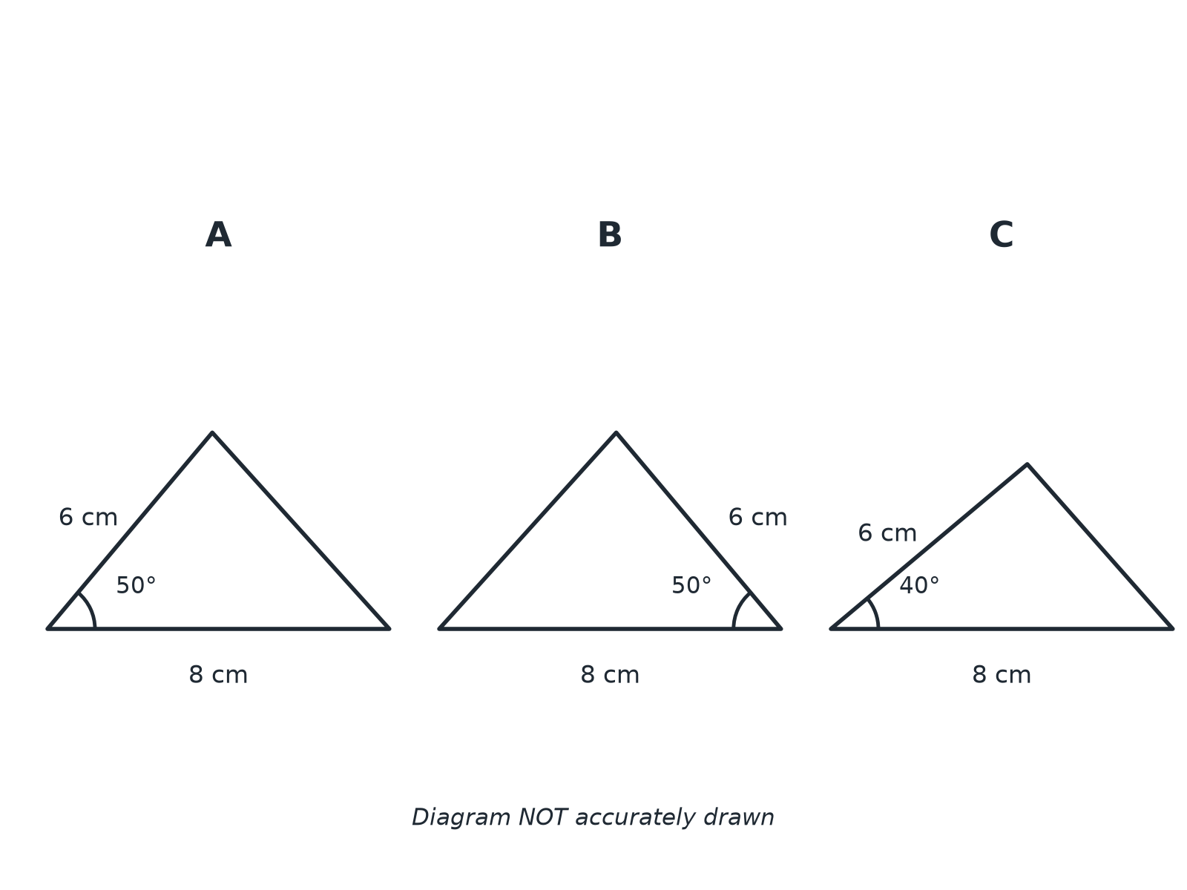

Question 1 · mark scheme
3 marks available. Award a mark for each point made.
▸ A and B. B1
▸ Two sides and the included angle equal. M1
▸ SAS. A1
▸ Model answer. Triangles A and B are congruent by SAS: two sides (6 cm and 8 cm) and the included angle 50° are equal.
Question 2 · 3 marks · Show that
“Triangle ABC has AB = 5 cm, BC = 7 cm and angle ABC = 50°. Triangle PQR has PQ = 5 cm, QR = 7 cm and angle PQR = 50°. Show that triangle ABC is congruent to triangle PQR.”
HOW TO ANSWER IT Command word: Show that. Worth 3 marks, so plan before writing.
Question 2 · mark scheme
3 marks available. Award a mark for each point made.
▸ Equal sides stated. M1
▸ Equal included angle stated. M1
▸ SAS and conclusion. A1
▸ Model answer. AB = PQ = 5 cm, BC = QR = 7 cm, and angle ABC = angle PQR = 50°. Two sides and the included angle are equal, so the triangles are congruent by SAS.
Question 3 · 2 marks · Give a reason
“Two triangles both have angles of 40°, 60° and 80°. Ben says they must be congruent. Explain why Ben is not necessarily correct.”
HOW TO ANSWER IT Command word: Give a reason. Worth 2 marks, so plan before writing.
Question 3 · mark scheme
2 marks available. Award a mark for each point made.
▸ AAA is not a congruence condition. M1
▸ The triangles could be different sizes. C1
▸ Model answer. Equal angles (AAA) do not prove congruence. The triangles could be different sizes, so they are similar but not necessarily congruent.
Question 4 · 2 marks · Work out
“Triangles ABC and DEF are congruent, with A matching D, B matching E and C matching F. AB = 6 cm, BC = 8 cm and DF = 10 cm. Write down the length of AC.”
HOW TO ANSWER IT Command word: Work out. Worth 2 marks, so plan before writing.
Question 4 · mark scheme
2 marks available. Award a mark for each point made.
▸ Corresponding sides identified. M1
▸ 10. A1
▸ Model answer. AC = DF = 10 cm, because AC and DF are corresponding sides.
Question 5 · 3 marks · Explain
“Triangle ABC is right-angled at B, with hypotenuse AC = 10 cm and AB = 6 cm. Triangle PQR is right-angled at Q, with hypotenuse PR = 10 cm and PQ = 6 cm. Explain why the triangles are congruent.”
HOW TO ANSWER IT Command word: Explain. Worth 3 marks, so plan before writing.
Question 5 · mark scheme
3 marks available. Award a mark for each point made.
▸ Right angle in each. B1
▸ Hypotenuse and one other side equal. M1
▸ RHS. A1
▸ Model answer. Each triangle has a right angle, a hypotenuse of 10 cm and another side of 6 cm. This is RHS, so the triangles are congruent.
Question 6 · 2 marks · Decide
“Triangle ABC has sides 4 cm, 5 cm and 6 cm. Triangle DEF has sides 6 cm, 4 cm and 5 cm. Are the triangles congruent? Give a reason.”
HOW TO ANSWER IT Command word: Decide. Worth 2 marks, so plan before writing.
Question 6 · mark scheme
2 marks available. Award a mark for each point made.
▸ Yes. B1
▸ SSS. B1
▸ Model answer. Yes, all three sides are equal (SSS).

