EDEXCEL GCSE MATHS · FOUNDATION & HIGHER
Geometric proof and congruence
Similarity and congruence · Lesson 2 of 5
Teacher copy - includes the notes for whoever is teaching from it.
Warm-up
Answer each one, then check.
1. Name the four conditions for congruent triangles.
SSS, SAS, ASA, RHS
2. What are alternate angles?
Equal angles between parallel lines, in a Z shape
3. What do the diagonals of a parallelogram do?
Bisect each other
4. What is a proof?
A logical argument that shows a statement is always true
5. Are vertically opposite angles equal?
Yes
Learning Objectives
1. Set out a geometric proof with statements and reasons.
2. Prove triangles congruent.
3. Use congruent triangles to prove other facts.
4. Use standard reasons for angles in parallel lines and triangles.
Writing a Proof
A proof is a chain of statements, each with a reason.
1  State what you are given  Write down the facts from the question | 2  Find equal sides and angles  Give a reason for each: "opposite sides of a parallelogram are equal" | 3  Name the congruence condition  SSS, SAS, ASA or RHS | 4  State the conclusion  "Therefore triangle ABC is congruent to triangle DEF" | 5  Use it  Corresponding parts of congruent triangles are equal
Diagonals of a Parallelogram
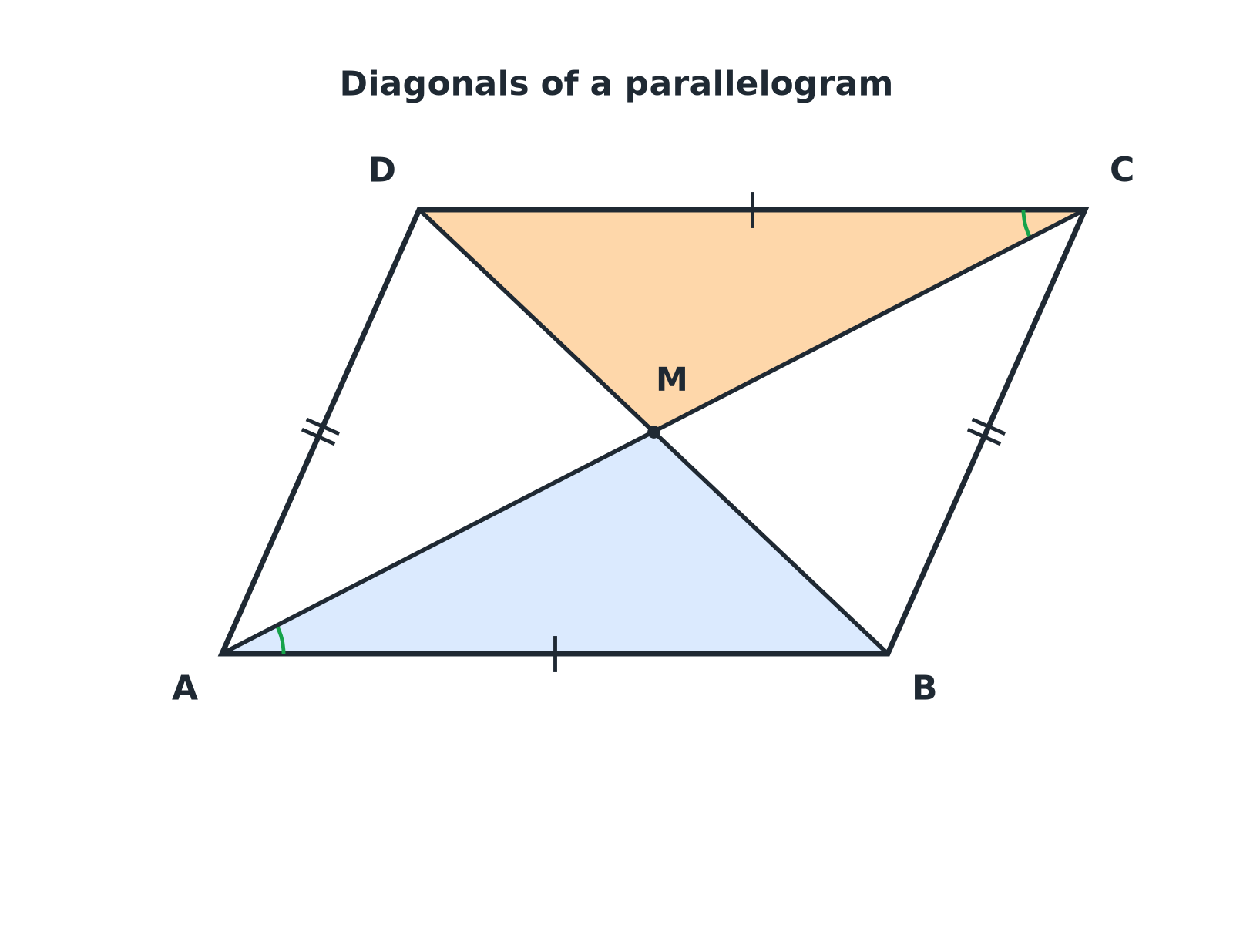
Triangles AMB and CMD are congruent, which shows the diagonals bisect each other.
Parallelogram ABCD with diagonals meeting at M and triangles AMB and CMD shaded.
Proving Diagonals Bisect
ABCD is a parallelogram with diagonals AC and BD meeting at M. Prove that AM = MC and BM = MD.

1. AB = DC
Opposite sides of a parallelogram are equal
2. Angle BAM = angle DCM
Alternate angles (AB parallel to DC)
3. Angle ABM = angle CDM
Alternate angles (AB parallel to DC)
4. Triangles AMB and CMD are congruent
ASA (two angles and the corresponding side)
5. So AM = CM and BM = DM
Corresponding sides of congruent triangles
Answer: The diagonals of a parallelogram bisect each other, because triangles AMB and CMD are congruent (ASA).
Base Angles of an Isosceles Triangle
In triangle ABC, AB = AC. D is the midpoint of BC. Prove that angle ABC = angle ACB.

1. AB = AC
Given
2. BD = DC
D is the midpoint of BC
3. AD = AD
Common side
4. Triangles ABD and ACD are congruent
SSS
5. So angle ABD = angle ACD
Corresponding angles of congruent triangles
Answer: The base angles are equal because triangles ABD and ACD are congruent (SSS).
Good Proof, Weak Proof
A GOOD PROOF | A WEAK PROOF
▸ Every statement has a reason.  ▸ Uses correct mathematical language.  ▸ Names the congruence condition.  ▸ Ends with a clear conclusion. | ▸ Says "it is obvious" or "it looks equal".  ▸ Uses measurements from a drawing.  ▸ Misses out a step.  ▸ Does not say why triangles are congruent.
Reasons You Can Use
Choose the exact words the mark scheme expects.
▸ Parallel lines. Alternate angles are equal; corresponding angles are equal; co-interior angles add to 180°.
▸ Triangles. Angles in a triangle add to 180°; base angles of an isosceles triangle are equal.
▸ Parallelograms. Opposite sides are equal and parallel; diagonals bisect each other.
▸ Common side. Write "AD is common" when two triangles share a side.
Key Terms
Proof  A logical argument showing a statement is always true. | Statement  A fact written in a proof.
Reason  The rule that justifies a statement. | Corresponding  In matching positions in congruent triangles.
Common side  A side shared by two triangles. | Bisect  Cut exactly in half.
Your Task: Complete the Proof
15 minutes
PQRS is a kite with PQ = PS and RQ = RS. Prove that triangles PQR and PSR are congruent, and hence that angle PQR = angle PSR.
1. List equal sides.
2. Name SSS.
3. Conclude.
A good answer shows: PQ = PS (given), RQ = RS (given), PR = PR (common side). The triangles are congruent by SSS. Corresponding angles are equal, so angle PQR = angle PSR.
Note: Ask students to underline the reason for each statement.
Can I...?
☐ Set out statements and reasons.
☐ Use alternate angles in a proof.
☐ Name a common side.
☐ Choose SSS, SAS, ASA or RHS.
☐ Use corresponding parts of congruent triangles.
☐ Prove diagonals bisect.
☐ Prove base angles are equal.
☐ Finish with a conclusion.
Summary
✓ Every step needs a reason.
✓ Give the congruence condition in words or letters.
✓ Corresponding parts of congruent triangles are equal.
✓ End with a conclusion that answers the question.

EXAM FOCUS
ABCD is a parallelogram. The diagonals AC and BD meet at M. Prove that triangles AMB and CMD are congruent. (4 marks)
Write each fact with its reason: opposite sides equal, alternate angles equal. Then name the condition (ASA here).
Exam Practice: Geometric Proof and Congruence
Answer all questions. Give reasons for every step. · 30 minutes
▸ Question 1 · 4 marks · Prove. ABCD is a parallelogram. The diagonals AC and BD meet at M. Prove that triangles AMB and CMD are congruent.
▸ Question 2 · 2 marks · Prove. Using the congruent triangles from the last question, prove that AM = MC.
▸ Question 3 · 4 marks · Prove. Triangle ABC is isosceles with AB = AC. D is the midpoint of BC. Prove that angle ABC = angle ACB.
▸ Question 4 · 3 marks · Prove. PQRS is a kite with PQ = PS and RQ = RS. Prove that angle PQR = angle PSR.
▸ Question 5 · 2 marks · Explain. Explain why "the triangles look the same" is not a good reason in a proof.
▸ Question 6 · 3 marks · Prove. ABCD is a rectangle. The diagonals AC and BD are drawn. Prove that AC = BD.
Question 1 · 4 marks · Prove
ABCD is a parallelogram. The diagonals AC and BD meet at M. Prove that triangles AMB and CMD are congruent. (4 marks) | 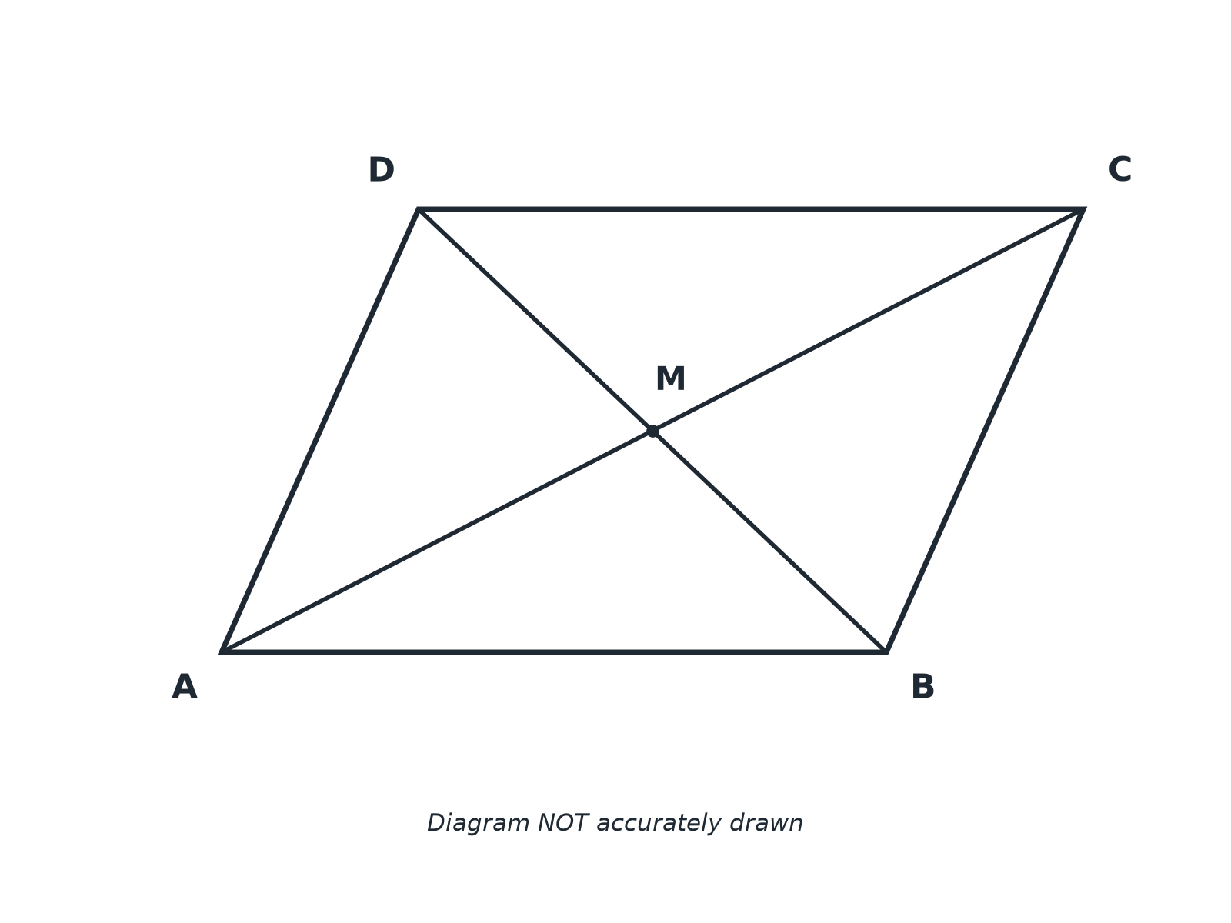

Question 1 · mark scheme
4 marks available. Award a mark for each point made.
▸ AB = DC with a reason. B1
▸ One pair of equal angles with a reason. M1
▸ The second pair of equal angles with a reason. M1
▸ Congruent by ASA. A1
▸ Model answer. AB = DC (opposite sides of a parallelogram). Angle BAM = angle DCM (alternate angles, AB parallel to DC). Angle ABM = angle CDM (alternate angles). So the triangles are congruent by ASA.
Question 2 · 2 marks · Prove
“Using the congruent triangles from the last question, prove that AM = MC.”
HOW TO ANSWER IT Command word: Prove. Worth 2 marks, so plan before writing.
Question 2 · mark scheme
2 marks available. Award a mark for each point made.
▸ Corresponding sides of congruent triangles. M1
▸ AM = MC. A1
▸ Model answer. Triangles AMB and CMD are congruent, so corresponding sides are equal. AM corresponds to CM, so AM = MC.
Question 3 · 4 marks · Prove
Triangle ABC is isosceles with AB = AC. D is the midpoint of BC. Prove that angle ABC = angle ACB. (4 marks) | 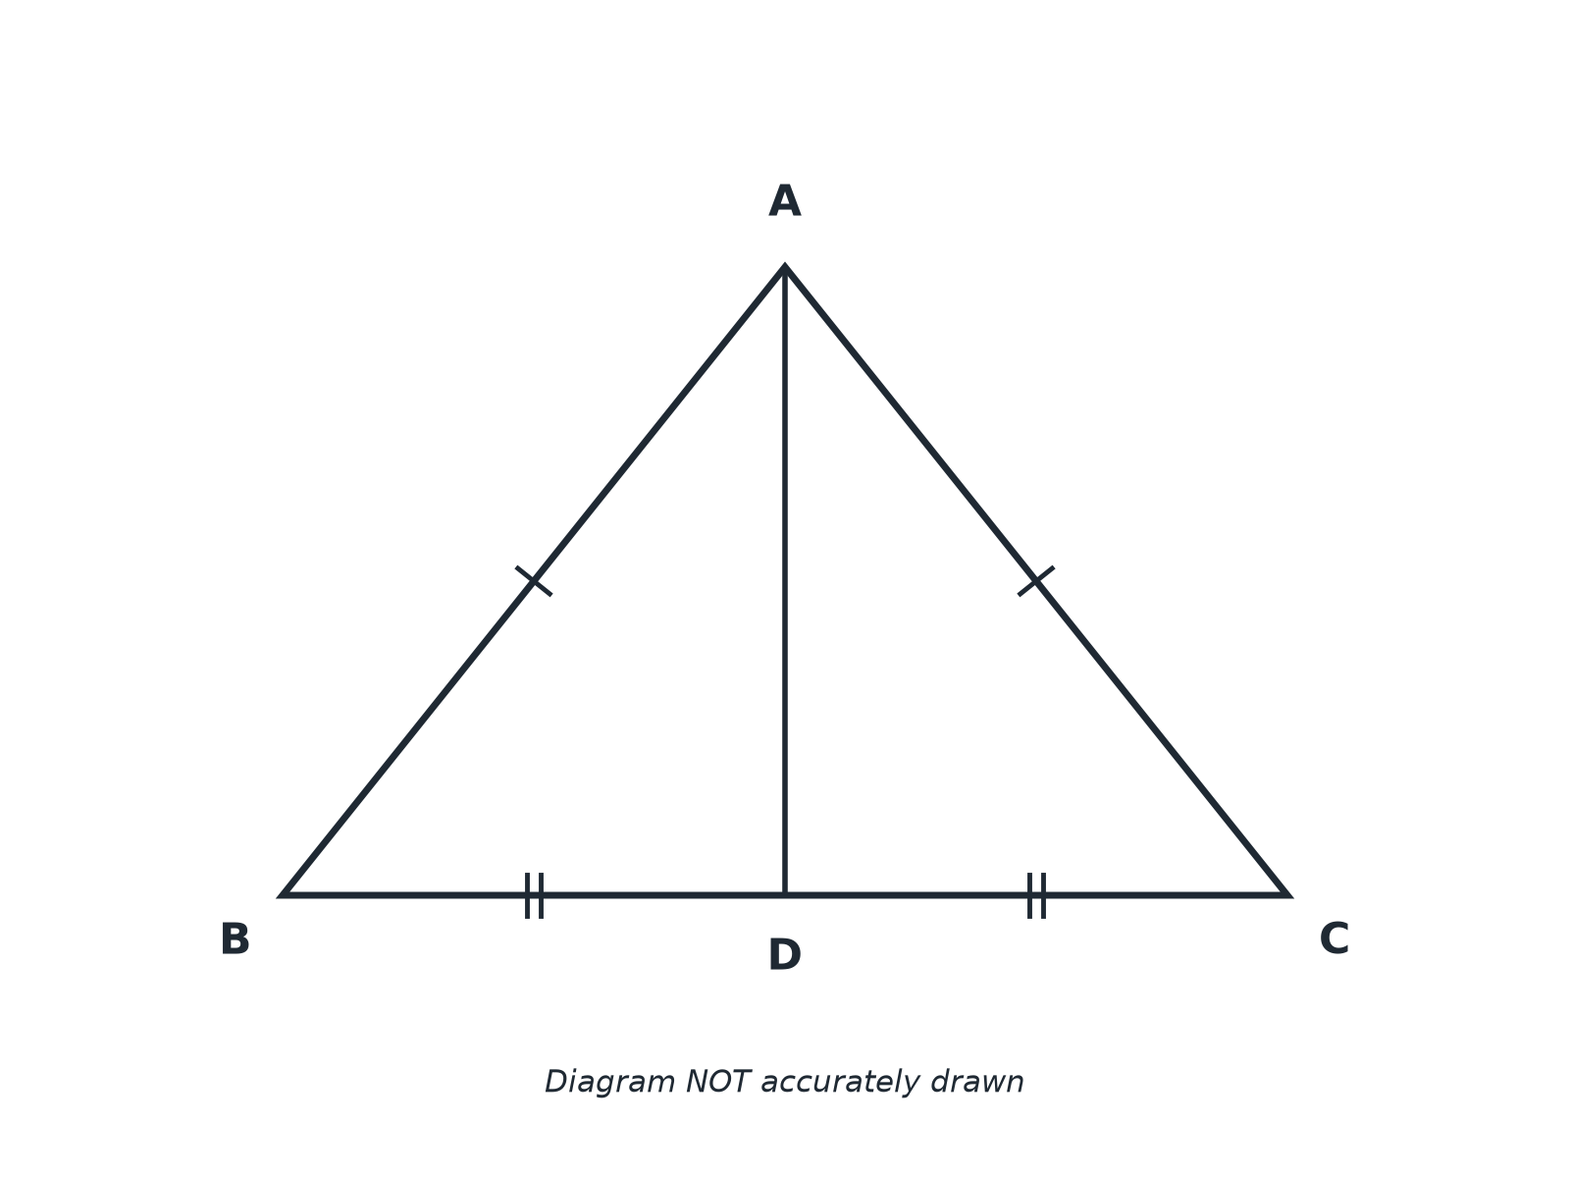

Question 3 · mark scheme
4 marks available. Award a mark for each point made.
▸ AB = AC and BD = DC with reasons. M1
▸ AD common. M1
▸ SSS. A1
▸ Conclusion about angles. C1
▸ Model answer. AB = AC (given). BD = DC (D is the midpoint). AD is common. So triangles ABD and ACD are congruent by SSS, and angle ABC = angle ACB (corresponding angles).
Question 4 · 3 marks · Prove
“PQRS is a kite with PQ = PS and RQ = RS. Prove that angle PQR = angle PSR.”
HOW TO ANSWER IT Command word: Prove. Worth 3 marks, so plan before writing.
Question 4 · mark scheme
3 marks available. Award a mark for each point made.
▸ Equal sides and common side. M1
▸ SSS. M1
▸ Conclusion. A1
▸ Model answer. PQ = PS and RQ = RS (given). PR is common. The triangles PQR and PSR are congruent by SSS, so angle PQR = angle PSR.
Question 5 · 2 marks · Explain
“Explain why "the triangles look the same" is not a good reason in a proof.”
HOW TO ANSWER IT Command word: Explain. Worth 2 marks, so plan before writing.
Question 5 · mark scheme
2 marks available. Award a mark for each point made.
▸ Not appearances or measurements. M1
▸ Each step needs a mathematical reason. C1
▸ Model answer. A proof must use exact facts, not appearances or measurements. Each step needs a mathematical reason such as SSS or a parallel-line rule.
Question 6 · 3 marks · Prove
“ABCD is a rectangle. The diagonals AC and BD are drawn. Prove that AC = BD.”
HOW TO ANSWER IT Command word: Prove. Worth 3 marks, so plan before writing.
Question 6 · mark scheme
3 marks available. Award a mark for each point made.
▸ Equal sides and right angles. M1
▸ SAS. M1
▸ AC = BD. A1
▸ Model answer. AB = DC (opposite sides of a rectangle). BC is common to triangles ABC and DCB. Angle ABC = angle DCB = 90°. So triangles ABC and DCB are congruent by SAS, and AC = BD.

