EDEXCEL GCSE MATHS · HIGHER
Similarity in 3D solids
Similarity and congruence · Lesson 5 of 5
Teacher copy - includes the notes for whoever is teaching from it.
Warm-up
Answer each one, then check.
1. Work out 2³.
8
2. Work out 1.5³.
3.375
3. What is the area scale factor if k = 3?
9
4. Work out ∛27.
3
5. What is the formula for the volume of a cone?
⅓πr² h
Learning Objectives
1. Use length, area and volume scale factors.
2. Find a volume, capacity or mass of a similar solid.
3. Work out the length ratio from a volume ratio.
4. Solve problems with similar cones, cylinders and frustums.
Similar Cubes
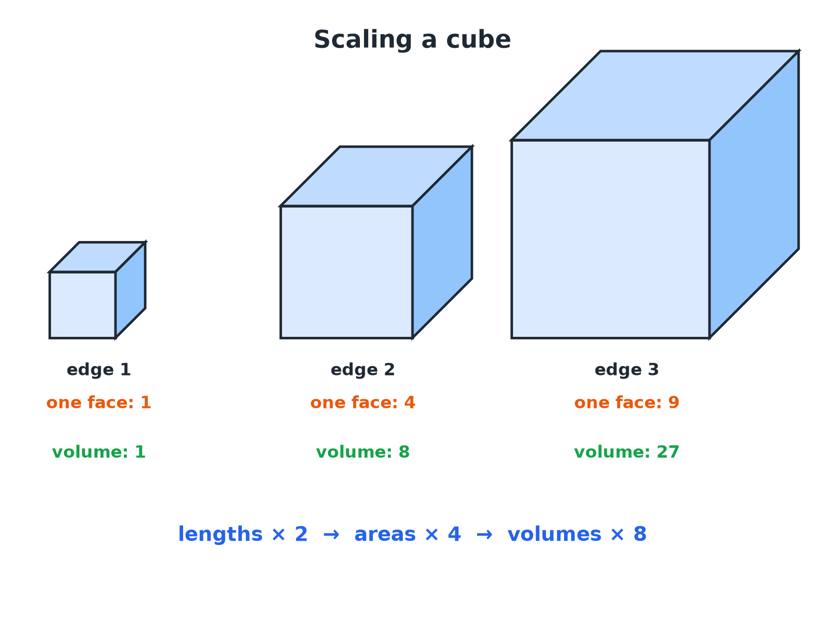
Doubling lengths multiplies areas by 4 and volumes by 8.
Three cubes with edges 1, 2 and 3 showing that when lengths are doubled areas are multiplied by 4 and volumes by 8.
Scale Factors for Similar Solids
If the length scale factor is k.
Measure | Scale factor | If k = 2
Lengths | k | 2
Areas (including surface area) | k² | 4
Volumes (and capacity, mass) | k³ | 8
Volume of a Similar Cone
Cone A has height 6 cm and volume 40 cm³. Cone B is similar to A and has height 9 cm. Find the volume of cone B.

1. Length scale factor
9/6 = 1.5
2. Volume scale factor
1.5³ = 3.375
3. Volume of B
40 × 3.375
Answer: 135 cm³
A Model and the Real Thing
A model statue is 20 cm tall and has mass 2 kg. The real statue is 1.2 m tall and made of the same material. Find the mass of the real statue.

1. Length scale factor
120 ÷ 20 = 6
2. Volume (and mass) scale factor
6³ = 216
3. Mass
2 × 216
Answer: 432 kg
A Frustum
A cone of height 15 cm has volume 500 cm³. A small cone of height 6 cm is cut off the top, leaving a frustum. Find the volume of the frustum.

1. The small cone is similar to the large cone
Length scale factor 6/15 = 0.4
2. Volume scale factor
0.4³ = 0.064
3. Volume of the small cone
500 × 0.064 = 32
4. Frustum = large cone minus small cone
500 − 32
Answer: 468 cm³
From Volumes to Lengths
Two similar solids have volumes 8 cm³ and 125 cm³. Find the ratio of their lengths and of their surface areas.

1. Take the cube root of the volumes
∛8 : ∛125 = 2 : 5
2. Lengths
2 : 5
3. Surface areas: square the ratio
4 : 25
Answer: Lengths 2 : 5; surface areas 4 : 25.
Which Scale Factor?
USE K (LENGTHS) | USE K² OR K³
▸ Heights, radii, edges, perimeters.  ▸ Anything measured in a straight line.  ▸ Read directly from the two shapes. | ▸ k²: area, surface area, cross-section.  ▸ k³: volume, capacity, mass (same material).  ▸ Cube or square root to go backwards.
Key Terms
Similar solids  Solids with the same shape and all lengths in the same ratio. | Volume scale factor  k³.
Surface area scale factor  k². | Frustum  A cone or pyramid with the top cut off parallel to the base.
Capacity  The volume a container holds. | Density  Mass per unit volume; the same in similar solids of the same material.
Your Task: Bottle Sizes
12 minutes
A small bottle is 10 cm tall and holds 250 ml. A similar large bottle is 15 cm tall. Find the capacity of the large bottle. A label on the small bottle has area 40 cm²; find the label area on the large bottle.
1. Find k.
2. Cube for volume.
3. Square for area.
A good answer shows: Scale factor 1.5. Capacity 250 × 1.5³ = 843.75 ml, about 844 ml. Label 40 × 1.5² = 90 cm².
Note: Ask why the large bottle holds more than 1.5 times as much.
Can I...?
☐ State the scale factors k, k², k³.
☐ Find a volume of a similar solid.
☐ Find a mass using a volume factor.
☐ Find the surface area of a similar solid.
☐ Use a cube root to find a length ratio.
☐ Find the volume of a frustum.
☐ Choose the right scale factor.
☐ Show clear working.
Summary
✓ Lengths k, areas k², volumes k³.
✓ For the same material, mass scales like volume.
✓ From a volume ratio take the cube root for lengths.
✓ A frustum is a large cone minus a similar small cone.

EXAM FOCUS
Cone A has height 6 cm and volume 40 cm³. Cone B is similar to A and has height 9 cm. Work out the volume of cone B. (3 marks)
Find the length scale factor first. Cube it for volume. Do not square it.
Exam Practice: Similarity in 3D Solids
Answer all questions. Show your working. · 30 minutes
▸ Question 1 · 3 marks · Work out. Cone A and cone B are mathematically similar. The height of cone A is 6 cm and its volume is 40 cm³. The height of cone B is 9 cm. Work out…
▸ Question 2 · 3 marks · Work out. A model of a statue is 20 cm tall and has a mass of 2 kg. The real statue is 1.2 m tall and is made from the same material. Work out the…
▸ Question 3 · 4 marks · Work out. A cone has a height of 15 cm and a volume of 500 cm³. A smaller cone of height 6 cm is cut off the top, leaving a frustum. The small cone…
▸ Question 4 · 3 marks · Work out. Two similar solids have surface areas in the ratio 4 : 9. Work out the ratio of their volumes.
▸ Question 5 · 3 marks · Work out. A small bottle is 10 cm tall and holds 250 ml of juice. A similar large bottle is 15 cm tall. Work out the capacity of the large bottle…
▸ Question 6 · 3 marks · Work out. Two similar solids have volumes of 8 cm³ and 125 cm³. The surface area of the smaller solid is 20 cm². Work out the surface area of the…
Question 1 · 3 marks · Work out
Cone A and cone B are mathematically similar. The height of cone A is 6 cm and its volume is 40 cm³. The height of cone B is 9 cm. Work out the volume of cone B. (3 marks) | 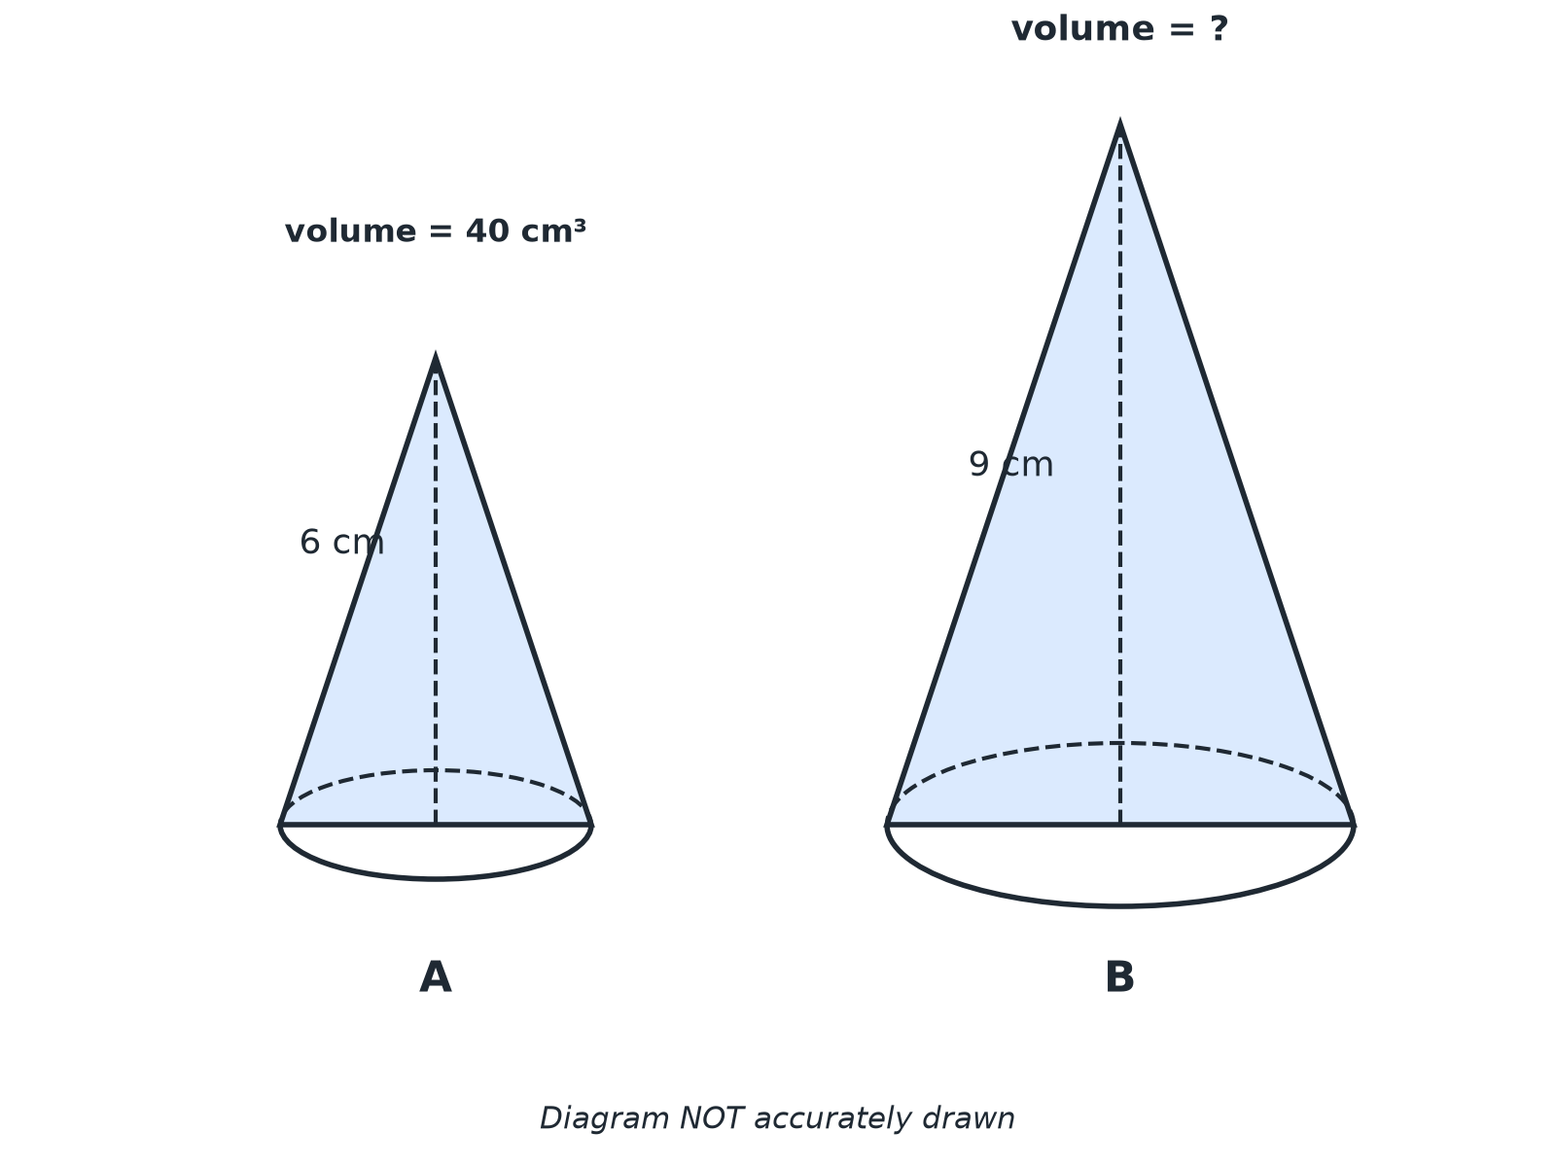

Question 1 · mark scheme
3 marks available. Award a mark for each point made.
▸ Length scale factor 1.5. M1
▸ 1.5³ = 3.375. M1
▸ 135. A1
▸ Model answer. The length scale factor is 9/6 = 1.5. The volume scale factor is 1.5³ = 3.375. The volume is 40 × 3.375 = 135 cm³.
Question 2 · 3 marks · Work out
“A model of a statue is 20 cm tall and has a mass of 2 kg. The real statue is 1.2 m tall and is made from the same material. Work out the mass of the real statue.”
HOW TO ANSWER IT Command word: Work out. Worth 3 marks, so plan before writing.
Question 2 · mark scheme
3 marks available. Award a mark for each point made.
▸ Scale factor 6. M1
▸ 6³ = 216. M1
▸ 432. A1
▸ Model answer. The length scale factor is 120 ÷ 20 = 6. The volume scale factor is 6³ = 216. The mass is 2 × 216 = 432 kg.
Question 3 · 4 marks · Work out
“A cone has a height of 15 cm and a volume of 500 cm³. A smaller cone of height 6 cm is cut off the top, leaving a frustum. The small cone is similar to the large cone. Work out the volume of the frustum.”
HOW TO ANSWER IT Command word: Work out. Worth 4 marks, so plan before writing.
Question 3 · mark scheme
4 marks available. Award a mark for each point made.
▸ Scale factor 0.4. M1
▸ 0.4³ = 0.064. M1
▸ Small cone 32. A1
▸ 468. A1
▸ Model answer. The length scale factor is 6/15 = 0.4 and the volume scale factor is 0.4³ = 0.064. The small cone has volume 500 × 0.064 = 32 cm³. The frustum is 500 − 32 = 468 cm³.
Question 4 · 3 marks · Work out
“Two similar solids have surface areas in the ratio 4 : 9. Work out the ratio of their volumes.”
HOW TO ANSWER IT Command word: Work out. Worth 3 marks, so plan before writing.
Question 4 · mark scheme
3 marks available. Award a mark for each point made.
▸ Length ratio 2 : 3. M1
▸ Cubing. M1
▸ 8 : 27. A1
▸ Model answer. The length ratio is √4 : √9 = 2 : 3. The volume ratio is 2³ : 3³ = 8 : 27.
Question 5 · 3 marks · Work out
“A small bottle is 10 cm tall and holds 250 ml of juice. A similar large bottle is 15 cm tall. Work out the capacity of the large bottle. Give your answer to the nearest ml.”
HOW TO ANSWER IT Command word: Work out. Worth 3 marks, so plan before writing.
Question 5 · mark scheme
3 marks available. Award a mark for each point made.
▸ Scale factor 1.5. M1
▸ 250 × 1.5³. M1
▸ 844. A1
▸ Model answer. The scale factor is 1.5, so the volume scale factor is 1.5³ = 3.375. The capacity is 250 × 3.375 = 843.75 ≈ 844 ml.
Question 6 · 3 marks · Work out
“Two similar solids have volumes of 8 cm³ and 125 cm³. The surface area of the smaller solid is 20 cm². Work out the surface area of the larger solid.”
HOW TO ANSWER IT Command word: Work out. Worth 3 marks, so plan before writing.
Question 6 · mark scheme
3 marks available. Award a mark for each point made.
▸ Length scale factor 5/2. M1
▸ Area scale factor 6.25. M1
▸ 125. A1
▸ Model answer. The length ratio is ∛8 : ∛125 = 2 : 5, so the area scale factor is (5/2)² = 6.25. The surface area is 20 × 6.25 = 125 cm².

