EDEXCEL GCSE MATHS · FOUNDATION & HIGHER
Sampling
Further statistics · Lesson 1 of 6
Teacher copy - includes the notes for whoever is teaching from it.
Warm-up
Answer each one, then check.
1. What is a percentage of an amount, e.g. 10% of 300?
30
2. What is the mean of 4, 6 and 8?
6
3. Simplify the ratio 20 : 30.
2 : 3
4. What does "random" mean?
Every item has an equal chance of being chosen
5. What is a fraction of a total, e.g. ¼ of 80?
20
Learning Objectives
1. Explain the difference between a population and a sample.
2. Recognise and describe bias in a sample.
3. Take a random, a systematic and a stratified sample.
4. Estimate a population size using capture-recapture (Higher).
Sampling
A sample should be a small group that fairly represents the whole population.
A bigger, random sample is more likely to be representative and give reliable results.
Population and Stratified Sample
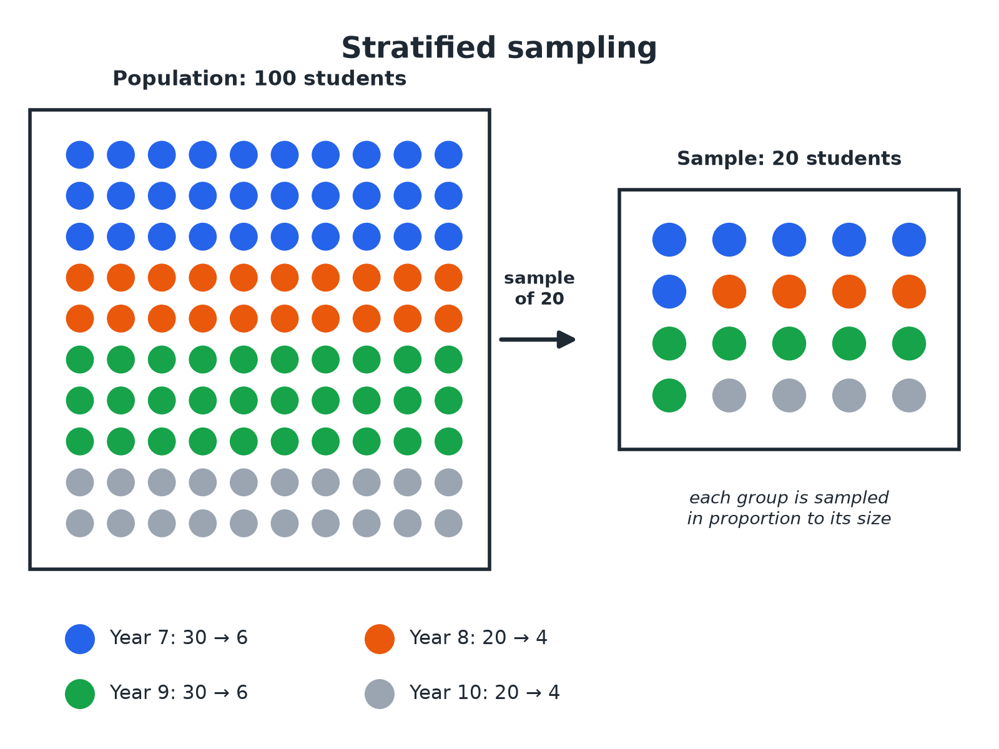
A stratified sample keeps the same proportions as the population.
A population of 100 students split into four year groups, and a stratified sample of 20 with the same proportions.
Types of Sample
Know how each one is chosen.
Sample | How it is chosen | Good point
Random | Every member has an equal chance, e.g. numbers from a random number generator | Not biased
Systematic | Every kth member from a list, after a random start | Easy and quick
Stratified | Groups sampled in proportion to their size | Represents every group
Convenience | The people who are easiest to reach | Cheap, but often biased
A Stratified Sample
A school has 200 pupils in Year 9, 160 in Year 10 and 240 in Year 11. A stratified sample of 60 pupils is taken. How many pupils come from each year?

1. Total pupils
200 + 160 + 240 = 600
2. Fraction sampled
60/600 = 1/10
3. Year 9
200 ÷ 10 = 20
4. Year 10
160 ÷ 10 = 16
5. Year 11
240 ÷ 10 = 24
Answer: 20 from Year 9, 16 from Year 10 and 24 from Year 11.
A Systematic Sample
A list has 800 names. A systematic sample of 40 names is needed. Describe how to take it.

1. Interval
800 ÷ 40 = 20
2. Random start
Pick a random number from 1 to 20, e.g. 7
3. Then
Take every 20th name: 7, 27, 47, and so on
Answer: Choose a random start between 1 and 20, then take every 20th name.
Capture-Recapture (Higher)
50 fish are caught, tagged and released. Later, 40 fish are caught and 8 of them are tagged. Estimate the number of fish in the lake.

1. Proportion tagged in the second sample
8/40
2. Set equal to the proportion tagged in the lake
8/40 = 50/N
3. Rearrange
N = (50 × 40)/8 = 250
Answer: There are about 250 fish in the lake.
Bias
A sample is biased if some members are more likely to be chosen than others.
▸ Where you ask. Asking only people at a football match about sport is biased.
▸ Who answers. Only those who reply to an online poll may hold stronger views.
▸ Sample too small. Small samples can be unrepresentative just by chance.
▸ Fix it. Use a random method and a large enough sample.
Key Terms
Population  The whole group you want to know about. | Sample  A smaller group taken from the population.
Bias  Unfairness that makes a sample unrepresentative. | Random sample  Every member has an equal chance of selection.
Stratified sample  A sample split into groups in proportion to the population. | Capture-recapture  A method to estimate the size of a wild population.
Your Task: Fair or Biased?
10 minutes
Decide whether each sample is fair or biased and explain why. (a) Asking 20 people leaving a gym how much they exercise. (b) Choosing 30 pupils at random from the register. (c) Asking the first 10 people to arrive at school about school start times.
1. Ask who might be missing.
2. Suggest a fairer method.
A good answer shows: (a) Biased: gym users exercise more than most people. (b) Fair: random. (c) Biased: early arrivals may have different views (for example they may travel by bus).
Note: Ask learners for a fairer way to do (a).
Can I...?
☐ Define population and sample.
☐ Spot bias.
☐ Take a random sample.
☐ Take a systematic sample.
☐ Work out a stratified sample.
☐ Explain why bigger is better.
☐ Use capture-recapture.
☐ Give a reason for my choice.
Summary
✓ Sample = part of the population.
✓ Random samples avoid bias.
✓ Stratified: number in each group = group/population × sample size.
✓ Capture-recapture: N = (first × second)/(tagged in second).

EXAM FOCUS
A school has 200 pupils in Year 9, 160 in Year 10 and 240 in Year 11. Alex takes a stratified sample of 60 pupils. How many pupils should he take from each year? (3 marks)
Find the fraction sampled, then multiply each group by it.
Exam Practice: Sampling
Answer all questions. Show your working. · 25 minutes
▸ Question 1 · 3 marks · Work out. A school has 200 pupils in Year 9, 160 in Year 10 and 240 in Year 11. Alex takes a stratified sample of 60 pupils. Work out how many pupils…
▸ Question 2 · 2 marks · Explain. Priya wants to find out how much exercise pupils in her school do. She asks 20 pupils leaving the school gym. Give one reason why her…
▸ Question 3 · 2 marks · Describe. There are 900 pupils on a school register. Describe how to take a systematic sample of 60 pupils.
▸ Question 4 · 3 marks · Estimate. 60 fish are caught in a lake, tagged and put back. Later, 30 fish are caught and 5 of them are tagged. Estimate the number of fish in the…
▸ Question 5 · 2 marks · Give a reason. Sam takes a random sample of 10 people to find the mean height of adults in a town. Give one way he could improve his sample.
▸ Question 6 · 3 marks · Work out. A club has 30 boys and 20 girls. A stratified sample of 10 members is taken. Work out how many boys and how many girls are in the sample.
Question 1 · 3 marks · Work out
“A school has 200 pupils in Year 9, 160 in Year 10 and 240 in Year 11. Alex takes a stratified sample of 60 pupils. Work out how many pupils he should take from each year.”
HOW TO ANSWER IT Command word: Work out. Worth 3 marks, so plan before writing.
Question 1 · mark scheme
3 marks available. Award a mark for each point made.
▸ 60/600 or equivalent. M1
▸ Any two correct. M1
▸ All three correct. A1
▸ Model answer. Year 9: 20; Year 10: 16; Year 11: 24.
Question 2 · 2 marks · Explain
“Priya wants to find out how much exercise pupils in her school do. She asks 20 pupils leaving the school gym. Give one reason why her sample may be biased.”
HOW TO ANSWER IT Command word: Explain. Worth 2 marks, so plan before writing.
Question 2 · mark scheme
2 marks available. Award a mark for each point made.
▸ Reason linked to gym users. M1
▸ Not representative. C1
▸ Model answer. The pupils at the gym probably exercise more than most pupils, so the sample is not representative of the whole school.
Question 3 · 2 marks · Describe
“There are 900 pupils on a school register. Describe how to take a systematic sample of 60 pupils.”
HOW TO ANSWER IT Command word: Describe. Worth 2 marks, so plan before writing.
Question 3 · mark scheme
2 marks available. Award a mark for each point made.
▸ 15. M1
▸ Random start and every 15th. A1
▸ Model answer. 900 ÷ 60 = 15. Choose a random start between 1 and 15, then take every 15th pupil on the list.
Question 4 · 3 marks · Estimate
“60 fish are caught in a lake, tagged and put back. Later, 30 fish are caught and 5 of them are tagged. Estimate the number of fish in the lake.”
HOW TO ANSWER IT Command word: Estimate. Worth 3 marks, so plan before writing.
Question 4 · mark scheme
3 marks available. Award a mark for each point made.
▸ 5/30 = 60/N. M1
▸ (60 × 30)/5. M1
▸ 360. A1
▸ Model answer. 5/30 = 60/N, so N = 360.
Question 5 · 2 marks · Give a reason
“Sam takes a random sample of 10 people to find the mean height of adults in a town. Give one way he could improve his sample.”
HOW TO ANSWER IT Command word: Give a reason. Worth 2 marks, so plan before writing.
Question 5 · mark scheme
2 marks available. Award a mark for each point made.
▸ Larger sample. M1
▸ Random or representative. A1
▸ Model answer. Use a larger sample, still chosen at random, so it is more likely to represent the town.
Question 6 · 3 marks · Work out
“A club has 30 boys and 20 girls. A stratified sample of 10 members is taken. Work out how many boys and how many girls are in the sample.”
HOW TO ANSWER IT Command word: Work out. Worth 3 marks, so plan before writing.
Question 6 · mark scheme
3 marks available. Award a mark for each point made.
▸ 10/50 or ⅕. M1
▸ 6. A1
▸ 4. A1
▸ Model answer. 6 boys and 4 girls.

