AQA GCSE PHYSICS · PAPER 1 · FOUNDATION & HIGHER
Exam Practice: Energy transfers, conservation and dissipation
Energy transfers, conservation and dissipation · Energy · Lesson 5 of 7 · 17 marks · 18 minutes
Name |  | Date

Instructions
• Answer all the questions.
• Write your answers in the spaces provided.
• The marks for each question are shown in brackets - use this as a guide to how much to write.
• The answers are on separate pages at the back. Attempt every question before you look at them.
• Answer all questions. Use the mark allocation as a guide to how much to write.

Question 1 EXPLAIN (2 marks)
A bicycle chain is lubricated with oil. Explain how this reduces the amount of energy wasted.
(Total for Question 1 = 2 marks)
Question 2 EXPLAIN (2 marks)
A ball bounces, and each bounce is lower than the one before. Explain why, using the idea of conservation of energy.
(Total for Question 2 = 2 marks)
Question 3 USE THE GRAPH (4 marks)
A student investigates how quickly hot water cools in three beakers, A, B and C. Each beaker is surrounded by a different insulating material. The graph shows the results. (a) Which beaker was surrounded by the best insulator? Give a reason. (b) Give two variables that should be controlled.
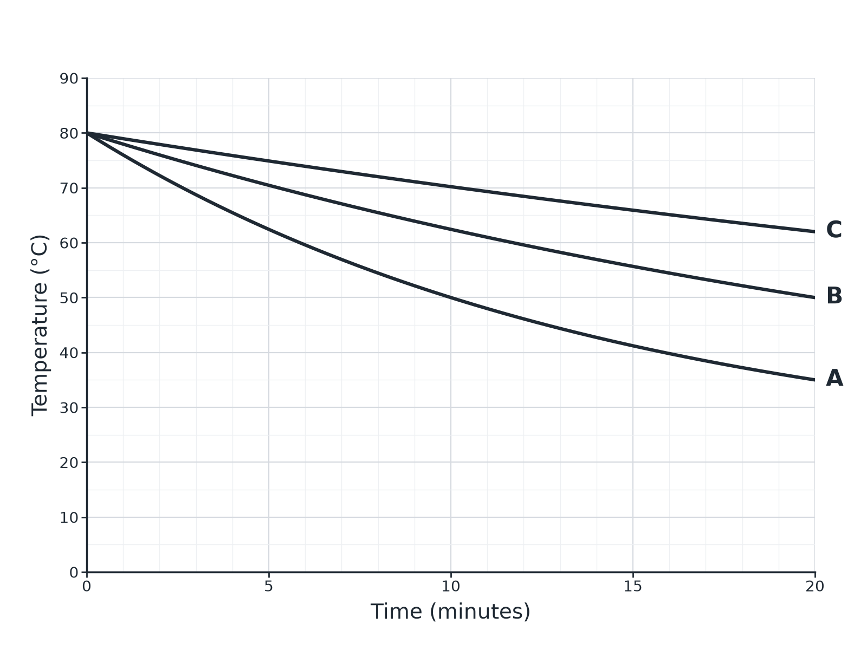
(Total for Question 3 = 4 marks)
Question 4 EXPLAIN (3 marks)
A house has walls of thickness 20 cm. The walls are replaced with walls of the same material but thickness 30 cm. Explain what happens to the rate at which the house cools.
(Total for Question 4 = 3 marks)
Question 5 DESCRIBE (6 marks)
Describe an investigation to compare the effectiveness of different materials as thermal insulators. Your answer should include the apparatus, how you would make it a fair test, and how you would use the results.
(Total for Question 5 = 6 marks)
TOTAL FOR PAPER = 17 MARKS

Answers and mark scheme
Check your answer only once you have written one.
Question 1 (2 marks)
The oil reduces friction between the moving parts, so less energy is transferred to the thermal energy stores of the chain and surroundings.
• Reduces friction 1 mark
• Less energy transferred to thermal stores 1 mark
Question 2 (2 marks)
Energy is not destroyed. Some energy is dissipated to the thermal energy store of the ball, floor and surroundings each time, so less is available as gravitational potential energy.
• Total energy is conserved or not destroyed 1 mark
• Some energy dissipated to thermal stores or surroundings 1 mark
Question 3 (4 marks)
(a) Beaker C, because the temperature fell the least. (b) Any two from: volume of water, starting temperature, size of beaker, thickness of insulation, lid.
• C 1 mark
• Smallest fall in temperature or slowest cooling 1 mark
• Any two controls, 1 mark each 2 marks
Question 4 (3 marks)
The rate of cooling decreases. Thicker walls reduce the rate of energy transfer by conduction through the wall, so the house loses energy more slowly.
• Rate of cooling decreases 1 mark
• Thicker walls 1 mark
• Lower rate of energy transfer by conduction 1 mark
Question 5 (6 marks)
See levels-of-response scheme.
• Level 3 (5 to 6 marks): a clear method using beakers, hot water, thermometer and timer with each material; several controls named; temperature change compared to identify the best insulator; repeats 5 to 6 marks
• Level 2 (3 to 4 marks): a method with some controls and a way to compare 3 to 4 marks
• Level 1 (1 to 2 marks): simple statements about insulating a beaker 1 to 2 marks

