AQA GCSE PHYSICS · PAPER 1 · FOUNDATION & HIGHER
Radioactive contamination and irradiation
Atomic structure · Lesson 7 of 10
Warm-up
Answer each one, then check.
1. What is ionising radiation?
Radiation that can knock electrons off atoms
2. What are alpha, beta and gamma?
Types of nuclear radiation
3. Which radiation is most penetrating?
Gamma
4. What is a hazard?
Something that could cause harm
5. What does peer review mean?
Checking by other scientists before results are accepted
Learning Objectives
1. Define radioactive contamination and irradiation.
2. Compare the hazards of contamination and irradiation.
3. Describe precautions when handling sources.
4. Explain why studies on the effects of radiation are published and peer reviewed.
CONTAMINATION vs IRRADIATION
Radioactive contamination is the unwanted presence of materials containing radioactive atoms on other materials. Irradiation is exposing an object to nuclear radiation: the irradiated object does not become radioactive.
The hazard from contamination is due to the decay of the contaminating atoms; the type of radiation emitted affects the level of hazard.
Contamination and Irradiation
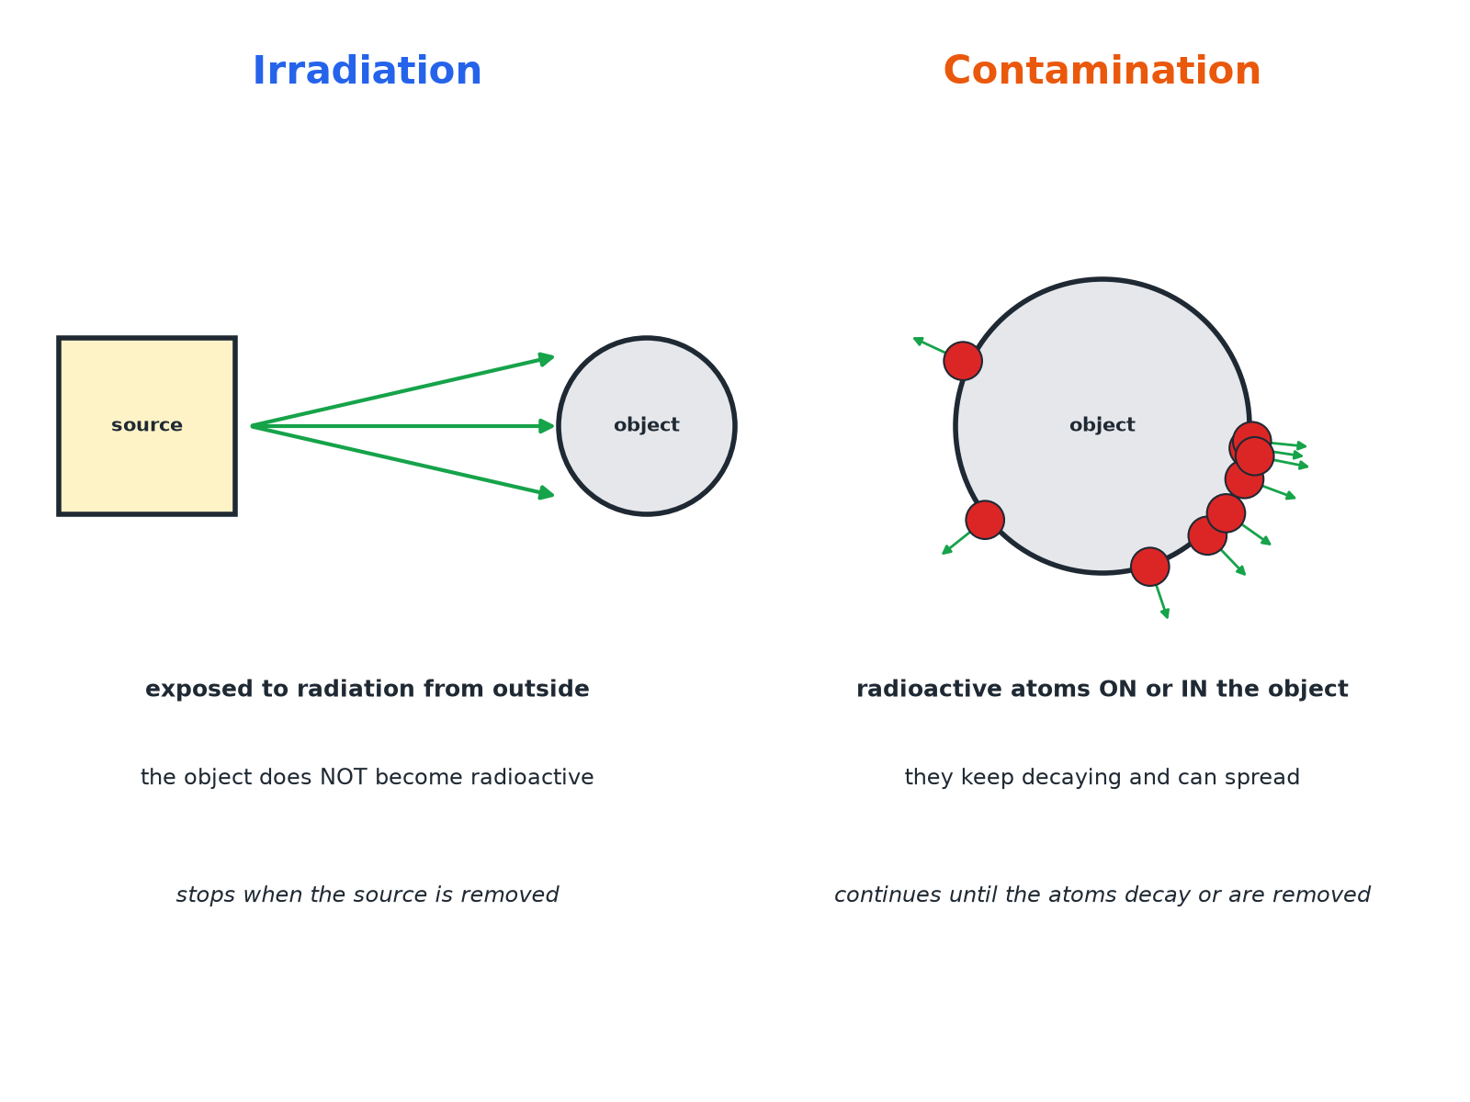
Contamination puts radioactive atoms on the object itself.
Irradiation by an external source compared with contamination by radioactive atoms on an object.
Which Is More Hazardous?
IRRADIATION | CONTAMINATION
▸ The object is exposed from outside.  ▸ It stops when the source is removed or shielded.  ▸ The object does not become radioactive.  ▸ Hazard depends on the type of radiation and time exposed. | ▸ Radioactive atoms are on or in the object.  ▸ Radiation continues until the atoms decay or are removed.  ▸ Alpha sources inside the body are very dangerous.  ▸ Can spread to other objects.
Precautions When Using Sources
Protect against irradiation and contamination.
1  Distance  Handle sources with tongs; keep away. | 2  Time  Keep exposure times short. | 3  Shielding  Store sources in lead-lined containers. | 4  Protective clothing  Gloves and coats stop contamination. | 5  Hygiene  No eating or drinking; wash hands.
Comparing Hazards
Explain why an alpha source is not very hazardous outside the body but is very hazardous if swallowed.

1. Outside
Alpha is stopped by air, paper or skin
2. Inside
Contamination puts the source in contact with living cells
3. Ionising
Alpha is strongly ionising and damages cells
Answer: Outside, alpha cannot penetrate skin; inside it is contamination and its strong ionising damages cells.
Peer Review
Why it matters.
▸ Publish and share. Findings on the effects of radiation on humans must be published so that other scientists can check them.
▸ Peer review. Other scientists check the methods and conclusions before they are accepted.
▸ Trust. This makes conclusions more reliable and helps set safety rules.
Key Terms
Contamination  The unwanted presence of radioactive atoms on or in other materials. | Irradiation  Exposure to nuclear radiation without radioactive atoms being transferred.
Shielding  Material used to absorb radiation. | Peer review  Checking of scientific work by other scientists.
Hazard  Something that could cause harm. | Precaution  An action to reduce a risk.
Your Task: Compare the Hazards
12 minutes
A worker handles a gamma source with tongs and a worker accidentally spills a solution containing radioactive iodine on their skin. Say which is irradiation and which is contamination, and compare the hazards.
1. Name each.
2. Compare how long exposure lasts.
A good answer shows: The gamma source: irradiation (they are exposed while nearby, they do not become radioactive). The spill: contamination (radioactive atoms are on the skin and keep decaying). Contamination can continue and be spread or absorbed, so is more serious unless removed.
Can I...?
☐ Define contamination.
☐ Define irradiation.
☐ Explain irradiated objects are not radioactive.
☐ Compare the hazards.
☐ Give precautions.
☐ Explain why peer review matters.
☐ Explain why alpha is dangerous inside the body.
☐ Choose safe handling.
Summary
✓ Contamination: radioactive atoms on or in the object.
✓ Irradiation: exposed to radiation; not radioactive.
✓ Hazard depends on the type of radiation.
✓ Peer review checks findings.

EXAM FOCUS
State the difference between contamination and irradiation. (2 marks)
Contamination involves radioactive atoms on the object; irradiation is exposure without the object becoming radioactive.

