AQA GCSE PHYSICS · PAPER 1 · FOUNDATION & HIGHER
Exam Practice: Background radiation
Background radiation · Atomic structure · Lesson 8 of 10 · 12 marks · 13 minutes
Name |  | Date

Instructions
• Answer all the questions.
• Write your answers in the spaces provided.
• The marks for each question are shown in brackets - use this as a guide to how much to write.
• The answers are on separate pages at the back. Attempt every question before you look at them.
• Answer all questions. Use the mark allocation as a guide to how much to write.

Question 1 STATE (2 marks)
Give two natural sources of background radiation.
(Total for Question 1 = 2 marks)
Question 2 STATE (2 marks)
Give one man-made source of background radiation.
(Total for Question 2 = 2 marks)
Question 3 USE THE CHART (3 marks)
The pie chart shows the sources of background radiation. The total annual dose is 2.7 mSv. Radon is 50% of the total. (a) Calculate the dose from radon. (b) Is most of the background radiation natural or man-made? Give a reason.
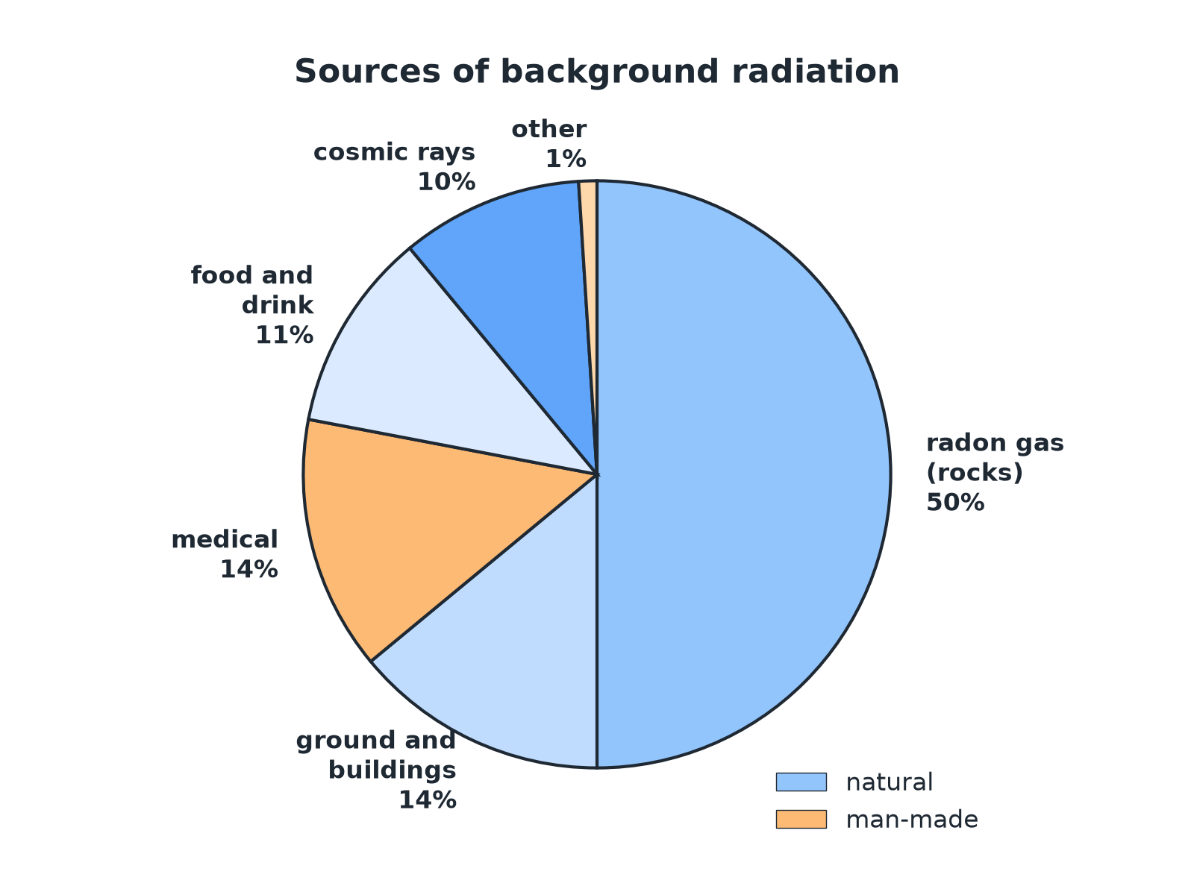
(Total for Question 3 = 3 marks)
Question 4 EXPLAIN (2 marks)
The background radiation is higher in some parts of the UK than others. Suggest one reason.
(Total for Question 4 = 2 marks)
Question 5 EXPLAIN (3 marks)
Airline pilots receive a higher radiation dose than office workers. Explain why. Also state how background radiation is taken into account when measuring the radiation from a radioactive source.
(Total for Question 5 = 3 marks)
TOTAL FOR PAPER = 12 MARKS

Answers and mark scheme
Check your answer only once you have written one.
Question 1 (2 marks)
Any two from: rocks (including radon gas), cosmic rays, food and drink.
• First source 1 mark
• Second source 1 mark
Question 2 (2 marks)
Fallout from nuclear weapons testing or nuclear accidents (or medical procedures).
• One correct source 1 mark
• Man-made linked to human activity 1 mark
Question 3 (3 marks)
(a) 0.50 × 2.7 = 1.35 mSv. (b) Natural, because the natural sources (radon, ground, food, cosmic rays) make up most of the chart.
• 1.35 mSv 1 mark
• Natural 1 mark
• Reason from the chart 1 mark
Question 4 (2 marks)
Some areas have rocks such as granite that contain radioactive isotopes and release radon gas.
• Type of rock or radon 1 mark
• Linked to higher levels in that location 1 mark
Question 5 (3 marks)
Pilots fly at high altitude where cosmic rays are stronger. The background count rate is measured without the source and subtracted from the reading with the source.
• Cosmic rays at altitude 1 mark
• Measure background count rate 1 mark
• Subtract from the reading 1 mark

