AQA GCSE PHYSICS · PAPER 2 · FOUNDATION & HIGHER
Acceleration and velocity–time graphs
Forces · Lesson 12 of 20
Teacher copy - includes the notes for whoever is teaching from it.
Warm-up
Answer each one, then check.
1. What is velocity?
Speed in a given direction
2. What is the unit of acceleration?
Metres per second squared (m/s²)
3. What does deceleration mean?
Slowing down
4. What is the gradient of a graph?
Change in y divided by change in x
5. What is the acceleration of free fall near Earth?
About 9.8 m/s²
Learning Objectives
1. Recall and apply a = Δv ÷ t.
2. Draw and interpret velocity–time graphs.
3. Use the gradient to find acceleration.
4. Use the area under a velocity–time graph to find distance (Higher tier).
5. Apply v² − u² = 2as.
Acceleration
acceleration = change in velocity ÷ time taken a = Δv/t
For uniform acceleration v² − u² = 2as (given on the equation sheet). Near Earth's surface a freely falling object accelerates at about 9.8 m/s².
A Velocity–Time Graph
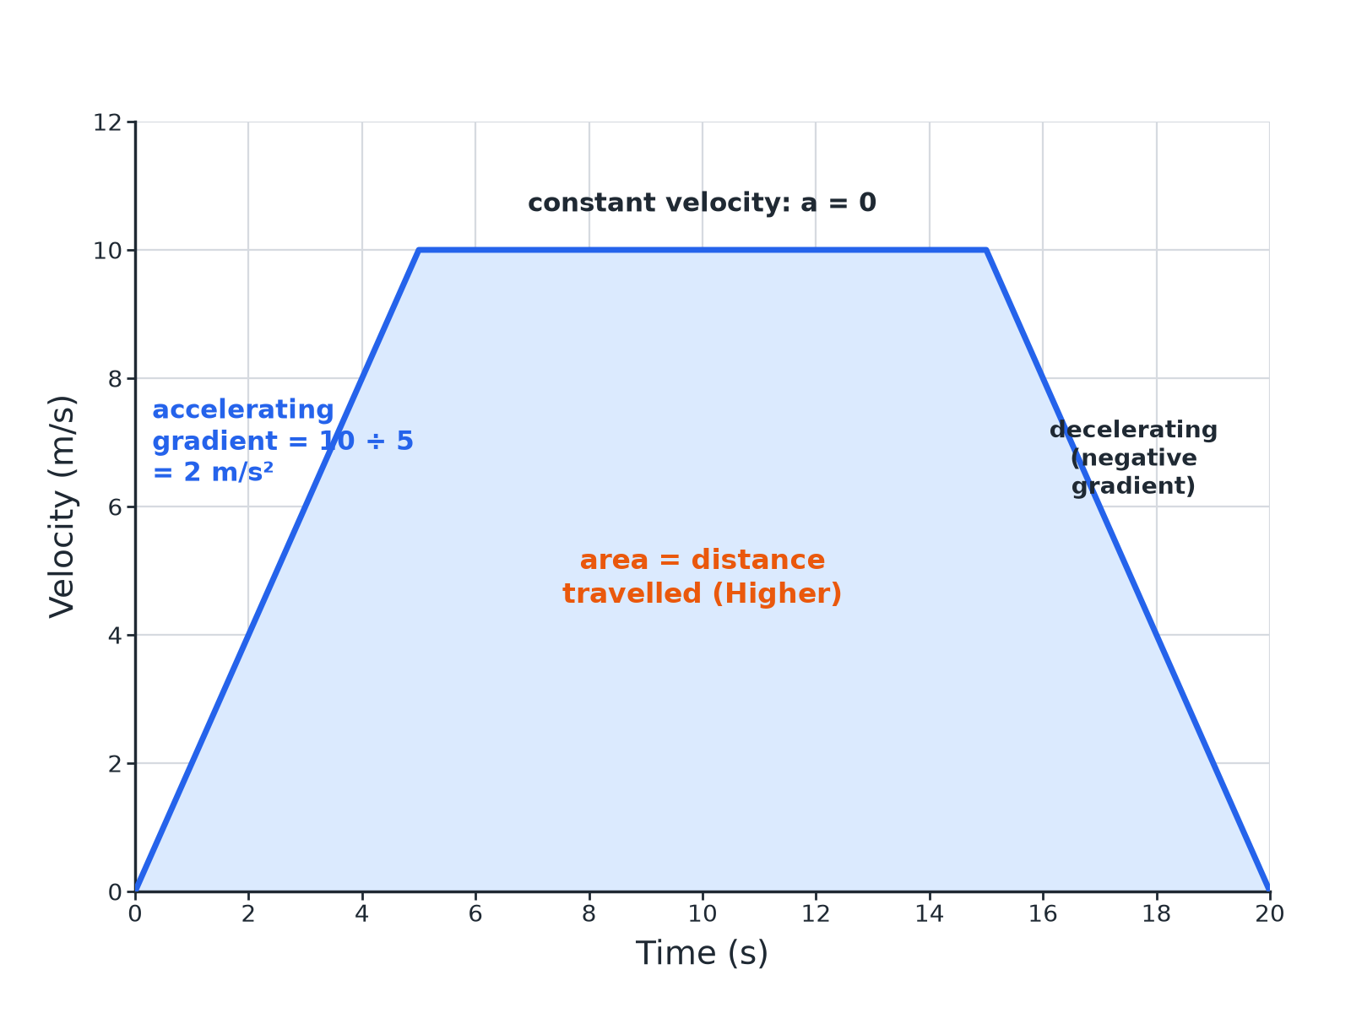
Gradient = acceleration; area = distance.
A velocity-time graph showing acceleration, constant velocity and deceleration with the area under it shaded.
Calculating Acceleration
A car accelerates from rest to 12 m/s in 4.0 s. Calculate its acceleration.

1. Change in velocity
12 − 0 = 12 m/s
2. Substitute
a = 12 ÷ 4.0
3. Answer
a = 3.0 m/s²
Answer: 3.0 m/s²
Using v² − u² = 2as
A car starts at 10 m/s and accelerates at 2.0 m/s² over a distance of 100 m. Calculate the final speed.

1. Write the equation
v² − u² = 2as
2. Substitute
v² − 10² = 2 × 2.0 × 100
3. Rearrange
v² = 100 + 400 = 500
4. Square root
v = 22.4 m/s
Answer: 22 m/s (2 s.f.)
Area Under a Graph (Higher)
Use the graph (accelerating from 0 to 10 m/s in 5 s, constant for 10 s, then stopping in 5 s) to find the distance travelled.

1. Section 1 (triangle)
½ × 5 × 10 = 25 m
2. Section 2 (rectangle)
10 × 10 = 100 m
3. Section 3 (triangle)
½ × 5 × 10 = 25 m
4. Total
25 + 100 + 25 = 150 m
Answer: 150 m
Free Fall
A ball is dropped from rest from a height of 20 m. Ignoring air resistance, calculate its speed on landing. a = 9.8 m/s².

1. Write the equation
v² = 2as
2. Substitute
v² = 2 × 9.8 × 20 = 392
3. Answer
v = 19.8 m/s
Answer: 19.8 m/s
Reading the Graph
Key features.
▸ Gradient. The acceleration; negative gradient means deceleration.
▸ Horizontal line. Constant velocity (zero acceleration).
▸ Area. Distance travelled (Higher tier); count squares for curves.
▸ Units. m/s for velocity, m/s² for acceleration.
Key Terms
Acceleration  The rate of change of velocity. | Deceleration  Slowing down.
Velocity–time graph  A graph of velocity against time. | Uniform acceleration  Constant acceleration.
Free fall  Falling under gravity alone. | Gradient  How steep a line is.
Your Task: Acceleration Practice
12 minutes
A train slows from 30 m/s to 10 m/s in 50 s. Calculate its acceleration. What does the sign tell you?
1. Change in velocity.
2. Divide by time.
A good answer shows: a = (10 − 30) ÷ 50 = −0.40 m/s². The negative value shows deceleration.
Note: Ask about the gradient on a graph.
Can I...?
☐ Recall a = Δv ÷ t.
☐ Calculate acceleration.
☐ Use the gradient of a v–t graph.
☐ Use the area under a v–t graph.
☐ Use v² − u² = 2as.
☐ Estimate everyday accelerations.
☐ Give units.
☐ Read a graph.
Summary
✓ a = Δv ÷ t.
✓ v² − u² = 2as.
✓ v–t gradient = acceleration; area = distance.
✓ Free fall: a ≈ 9.8 m/s².

EXAM FOCUS
A car accelerates from rest to 12 m/s in 4.0 s. Calculate the acceleration. (2 marks)
Divide the change in velocity by time.
Exam Practice: Acceleration and velocity–time graphs
Answer all questions. Use the mark allocation as a guide to how much to write. · 16 minutes
▸ Question 1 · 2 marks · Calculate. A car accelerates from rest to a velocity of 12 m/s in 4.0 s. Calculate the acceleration of the car. Use the equation: acceleration =…
▸ Question 2 · 4 marks · Use the graph. The graph shows the velocity of a cyclist. (a) Calculate the acceleration in the first 5 s. (b) Describe the motion between 5 s and 15 s.
▸ Question 3 · 3 marks · Calculate. A car starts at 10 m/s and accelerates uniformly at 2.0 m/s² over a distance of 100 m. Calculate its final velocity. Use the equation…
▸ Question 4 · 3 marks · Calculate. Use the velocity–time graph in question 2 to calculate the total distance travelled by the cyclist.
▸ Question 5 · 3 marks · Calculate. A ball is dropped from rest from a height of 20 m. Assume no air resistance. The acceleration of free fall is 9.8 m/s². Calculate the speed…
Question 1 · 2 marks · Calculate
“A car accelerates from rest to a velocity of 12 m/s in 4.0 s. Calculate the acceleration of the car. Use the equation: acceleration = change in velocity ÷ time taken”
HOW TO ANSWER IT Command word: Calculate. Worth 2 marks, so plan before writing.
Question 1 · mark scheme
2 marks available. Award a mark for each point made.
▸ Correct substitution. 1 mark
▸ 3.0 m/s². 1 mark
▸ Model answer. 12 ÷ 4.0 = 3.0 m/s²
Question 2 · 4 marks · Use the graph
The graph shows the velocity of a cyclist. (a) Calculate the acceleration in the first 5 s. (b) Describe the motion between 5 s and 15 s. (4 marks) | 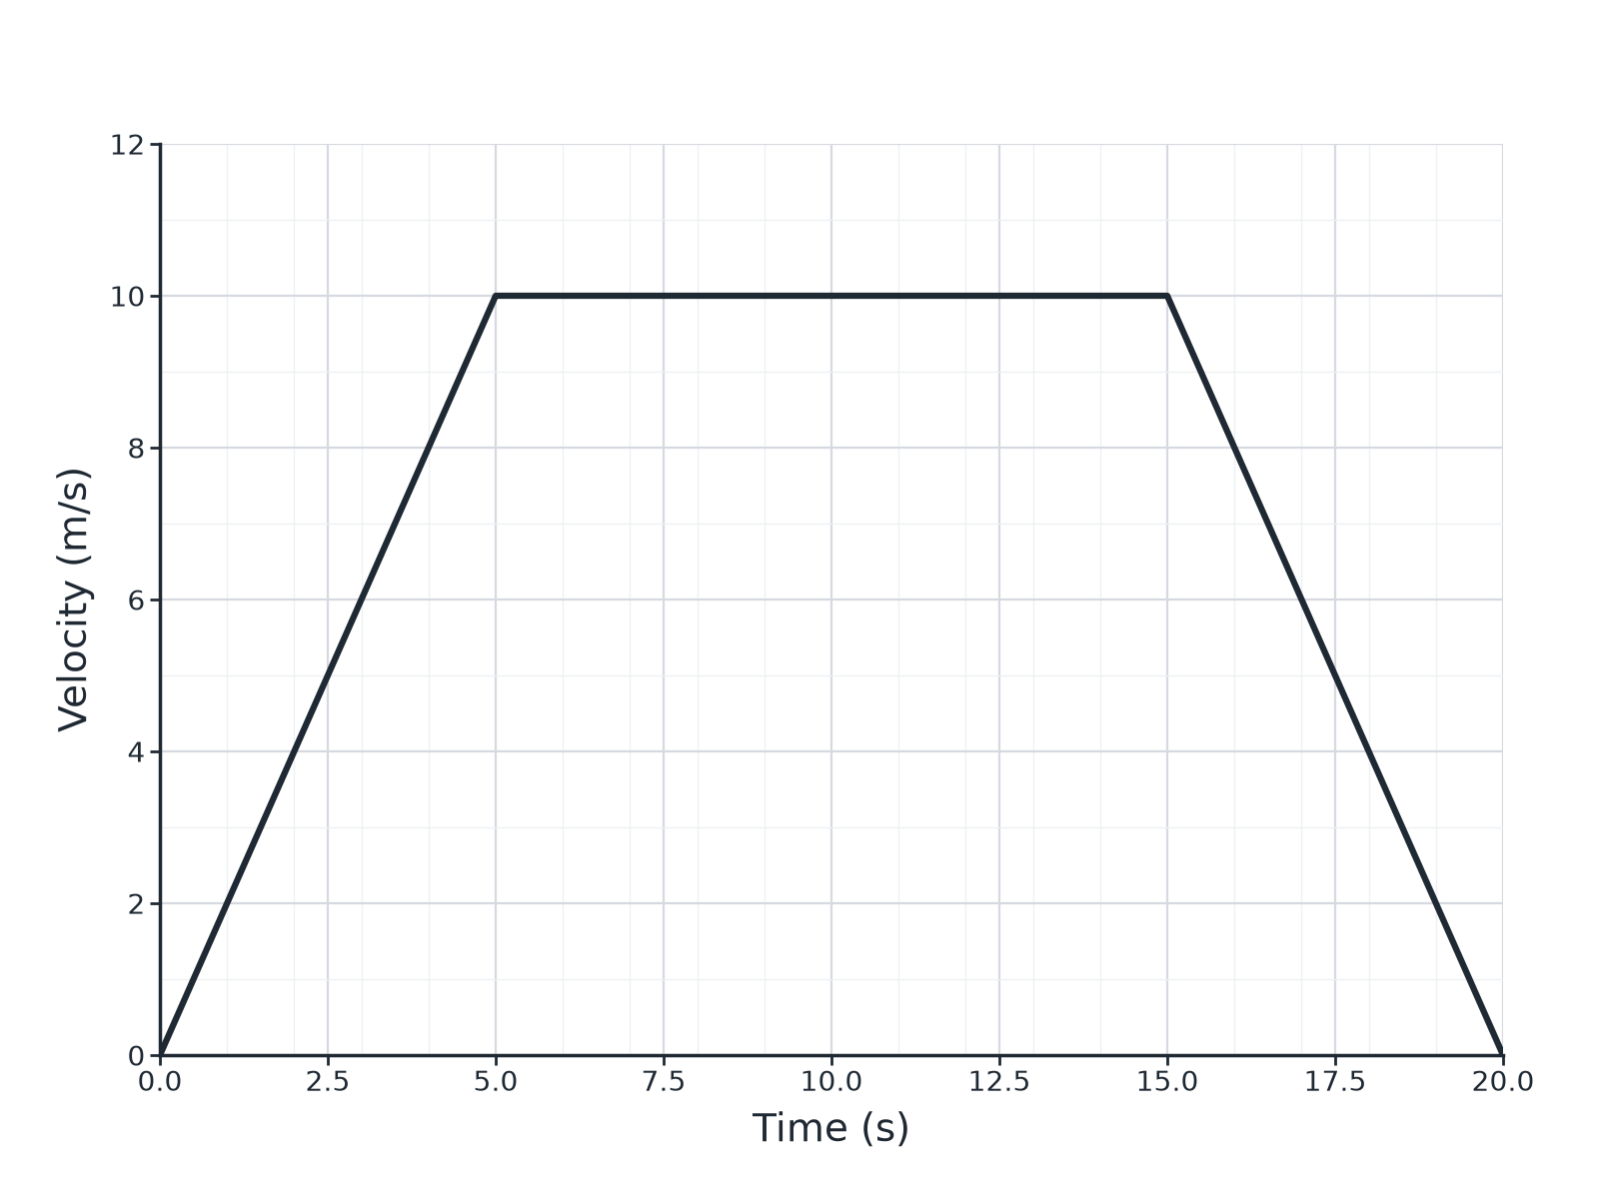

Question 2 · mark scheme
4 marks available. Award a mark for each point made.
▸ Change in velocity 10 m/s. 1 mark
▸ 2.0 m/s². 1 mark
▸ Constant velocity. 1 mark
▸ 10 m/s. 1 mark
▸ Model answer. (a) 10 ÷ 5 = 2.0 m/s². (b) Constant velocity of 10 m/s (zero acceleration).
Question 3 · 3 marks · Calculate
“A car starts at 10 m/s and accelerates uniformly at 2.0 m/s² over a distance of 100 m. Calculate its final velocity. Use the equation: (final velocity)² − (initial velocity)² = 2 × acceleration × distance”
HOW TO ANSWER IT Command word: Calculate. Worth 3 marks, so plan before writing.
Question 3 · mark scheme
3 marks available. Award a mark for each point made.
▸ Correct substitution. 1 mark
▸ v² = 500. 1 mark
▸ 22 m/s. 1 mark
▸ Model answer. v² = 10² + 2 × 2.0 × 100 = 500; v = 22 m/s (22.4)
Question 4 · 3 marks · Calculate
“Use the velocity–time graph in question 2 to calculate the total distance travelled by the cyclist.”
HOW TO ANSWER IT Command word: Calculate. Worth 3 marks, so plan before writing.
Question 4 · mark scheme
3 marks available. Award a mark for each point made.
▸ Areas of the three sections. 1 mark
▸ 25 + 100 + 25. 1 mark
▸ 150 m. 1 mark
▸ Model answer. Area = ½ × 5 × 10 + 10 × 10 + ½ × 5 × 10 = 25 + 100 + 25 = 150 m.
Question 5 · 3 marks · Calculate
“A ball is dropped from rest from a height of 20 m. Assume no air resistance. The acceleration of free fall is 9.8 m/s². Calculate the speed of the ball when it lands.”
HOW TO ANSWER IT Command word: Calculate. Worth 3 marks, so plan before writing.
Question 5 · mark scheme
3 marks available. Award a mark for each point made.
▸ Uses v² = 2as. 1 mark
▸ 392. 1 mark
▸ 19.8 m/s. 1 mark
▸ Model answer. v² = 2 × 9.8 × 20 = 392; v = 19.8 m/s

