AQA GCSE PHYSICS · PAPER 2 · FOUNDATION & HIGHER
Newton's Second Law
Forces · Lesson 15 of 20
Teacher copy - includes the notes for whoever is teaching from it.
Warm-up
Answer each one, then check.
1. What is a resultant force?
The single force with the same effect as all the forces
2. What is acceleration?
Rate of change of velocity
3. What is the unit of force?
Newton
4. What is proportional?
Doubling one doubles the other
5. What does inversely proportional mean?
Doubling one halves the other
Learning Objectives
1. State Newton's Second Law.
2. Recall and apply F = ma.
3. Describe how to investigate the effect of force and mass on acceleration (Required Practical 7).
4. Explain inertial mass (Higher tier).
Newton's Second Law
resultant force = mass × acceleration F = ma
The acceleration of an object is proportional to the resultant force and inversely proportional to its mass: a ∝ F and a ∝ 1/m.
Required Practical 7: Force, Mass and Acceleration
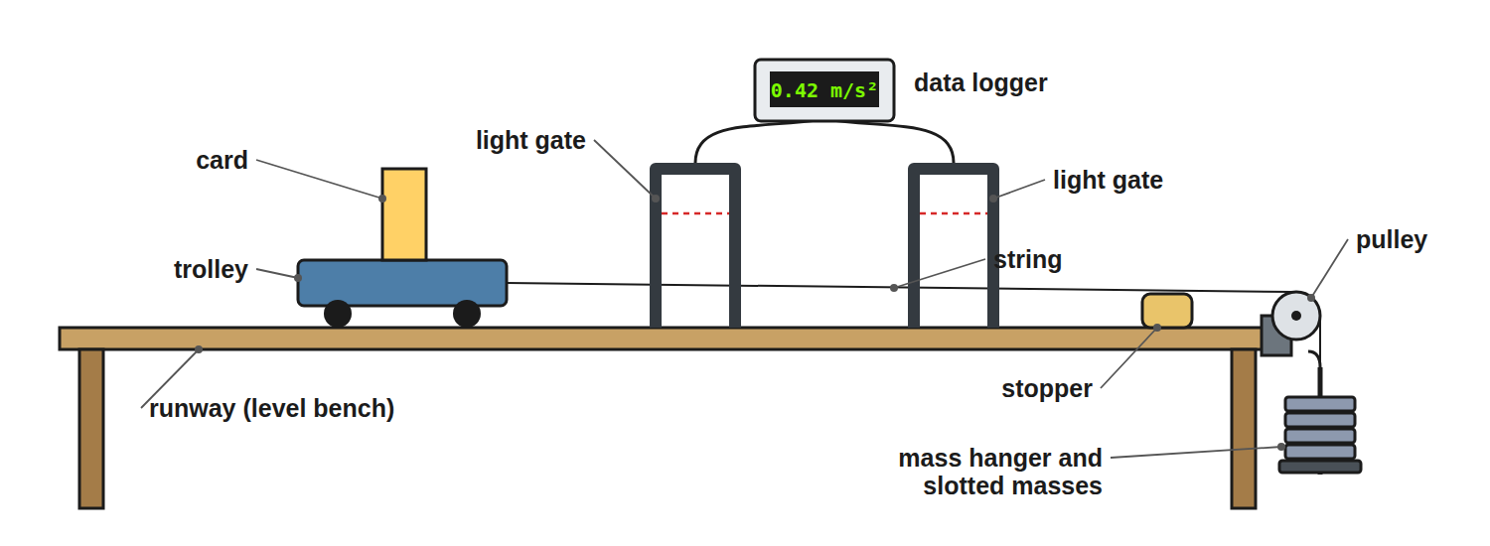
The weight of the hanging masses provides the force.
A trolley pulled along a runway by a falling mass, with light gates measuring its speed to find acceleration.
Required Practical 7: Method
Two investigations.
1  Force varied  Keep the total mass constant by moving masses from the trolley to the hanger; the force is the weight of the hanging masses. | 2  Measure acceleration  From the light gates: a = (v − u) ÷ t. | 3  Plot  Acceleration against force: a straight line through the origin. | 4  Mass varied  Keep the force constant and add masses to the trolley. | 5  Plot  Acceleration against mass (a curve) or against 1/mass (a straight line). | 6  Repeat  Take repeat readings and compensate for friction by slightly tilting the runway.
Finding Acceleration
A car of mass 1200 kg has a resultant force of 3000 N. Calculate its acceleration.

1. Rearrange
a = F ÷ m
2. Substitute
a = 3000 ÷ 1200
3. Answer
a = 2.5 m/s²
Answer: 2.5 m/s²
Finding the Force
A 0.50 kg trolley accelerates at 4.0 m/s². Calculate the resultant force.

1. Write the equation
F = ma
2. Substitute
F = 0.50 × 4.0
3. Answer
F = 2.0 N
Answer: 2.0 N
Using a Graph
A graph of acceleration against force for a trolley is a straight line through (2.0 N, 1.0 m/s²). Find the mass.

1. Gradient
a ÷ F = 1.0 ÷ 2.0 = 0.50 kg⁻¹
2. Since a = F ÷ m
Gradient = 1 ÷ m
3. Mass
m = 1 ÷ 0.50 = 2.0 kg
Answer: 2.0 kg
Inertial Mass (Higher)
Explain what is meant by inertial mass.

1. Definition
The ratio of force to acceleration
2. Meaning
A measure of how difficult it is to change the velocity of an object
Answer: Inertial mass = force ÷ acceleration: how hard it is to change an object's velocity.
Estimating
Use sensible values.
▸ Everyday values. A car accelerating from 0 to 27 m/s (60 mph) in 10 s has a ≈ 2.7 m/s².
▸ Force. For a 1000 kg car: F = 1000 × 2.7 ≈ 2700 N.
▸ Symbol ~. Means approximately.
▸ Units. Mass in kg, a in m/s², F in N.
Required Practical 7: Variables
Know which is which for each investigation.
Investigation | Independent | Dependent | Control
Effect of force | Force (weight on the hanger) | Acceleration | Total mass of trolley and hanger
Effect of mass | Mass of the trolley | Acceleration | The accelerating force
Errors and Improvements
Where the practical goes wrong and how to fix it.
▸ Friction. Friction reduces the resultant force. Tilting the runway slightly until the trolley rolls at a steady speed compensates for it.
▸ Timing. Stopwatches add human reaction time. Light gates and a data logger measure times far more precisely.
▸ Keeping mass constant. When varying force, take masses off the trolley and put them on the hanger, so the total mass being accelerated stays the same.
Inertia and Inertial Mass HIGHER
Mass resists changes in motion.
▸ Inertia. The tendency of any object to stay at rest or keep moving at a constant velocity.
▸ Inertial mass. Defined as force ÷ acceleration: the bigger it is, the harder it is to change the object's velocity.
▸ Example. A loaded lorry needs a much larger force than a car to reach the same acceleration, because its inertial mass is larger.
Key Terms
Resultant force  The net force acting on an object. | Acceleration  Rate of change of velocity.
Inertial mass  Force divided by acceleration. | Proportional  Increasing by the same factor.
Inversely proportional  One quantity halves as the other doubles. | Light gate  A sensor that times how long a card takes to pass.
Independent variable  The variable you change in an experiment. | Dependent variable  The variable you measure in an experiment.
Your Task: Predict the Acceleration
10 minutes
A trolley has a mass of 1.0 kg and accelerates at 2.0 m/s² under a resultant force. What acceleration would the same force give a 2.0 kg trolley? What force is needed for 2.0 kg to accelerate at 2.0 m/s²?
1. Use F = ma.
2. Compare the masses.
A good answer shows: Half the acceleration: 1.0 m/s². Force = 2.0 × 2.0 = 4.0 N.
Note: Ask learners to link this to a ∝ 1/m.
Can I...?
☐ State Newton's second law.
☐ Recall F = ma.
☐ Rearrange for a or m.
☐ Describe Required Practical 7.
☐ Interpret a force–acceleration graph.
☐ Explain inertial mass.
☐ Estimate forces on a car.
☐ Use units.
Summary
✓ F = ma.
✓ Acceleration ∝ force; ∝ 1/mass.
✓ Inertial mass = force ÷ acceleration.
✓ Use light gates to measure acceleration.
✓ Compensate for friction by tilting the runway.

EXAM FOCUS
A 1200 kg car has a resultant force of 3000 N. Calculate its acceleration. (2 marks)
Rearrange F = ma to a = F ÷ m, substitute 3000 ÷ 1200 and give 2.5 m/s². Use the resultant force, not just the driving force.
Exam Practice: Newton's Second Law
Answer all questions. Use the mark allocation as a guide to how much to write. · 17 minutes
▸ Question 1 · 2 marks · Calculate. A car has a mass of 1200 kg. The resultant force on the car is 3000 N. Calculate the acceleration of the car. Use the equation: resultant…
▸ Question 2 · 2 marks · Calculate. A trolley of mass 0.50 kg accelerates at 4.0 m/s². Calculate the resultant force on the trolley.
▸ Question 3 · 4 marks · Use the graph. A student investigates how the acceleration of a trolley depends on the resultant force. The graph shows the results. (a) Describe the…
▸ Question 4 · 6 marks · Describe. Describe an investigation to show how the acceleration of a trolley depends on the resultant force acting on it. Your answer should include…
▸ Question 5 · 2 marks · Explain. Explain what is meant by the inertial mass of an object.
Question 1 · 2 marks · Calculate
“A car has a mass of 1200 kg. The resultant force on the car is 3000 N. Calculate the acceleration of the car. Use the equation: resultant force = mass × acceleration”
HOW TO ANSWER IT Command word: Calculate. Worth 2 marks, so plan before writing.
Question 1 · mark scheme
2 marks available. Award a mark for each point made.
▸ Rearranges to a = F ÷ m. 1 mark
▸ 2.5 m/s². 1 mark
▸ Model answer. a = 3000 ÷ 1200 = 2.5 m/s²
Question 2 · 2 marks · Calculate
“A trolley of mass 0.50 kg accelerates at 4.0 m/s². Calculate the resultant force on the trolley.”
HOW TO ANSWER IT Command word: Calculate. Worth 2 marks, so plan before writing.
Question 2 · mark scheme
2 marks available. Award a mark for each point made.
▸ Correct substitution. 1 mark
▸ 2.0 N. 1 mark
▸ Model answer. F = 0.50 × 4.0 = 2.0 N
Question 3 · 4 marks · Use the graph
A student investigates how the acceleration of a trolley depends on the resultant force. The graph shows the results. (a) Describe the relationship. (b) Use the graph to calculate the mass of the trolley. (4 marks) | 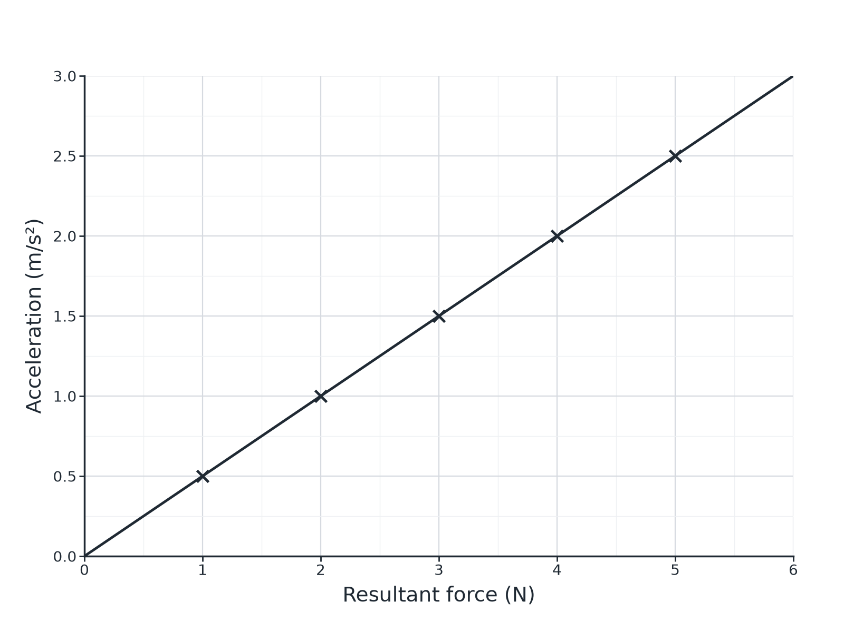

Question 3 · mark scheme
4 marks available. Award a mark for each point made.
▸ Straight line through the origin / directly proportional. 1 mark
▸ Uses the gradient. 1 mark
▸ Gradient = 1/m. 1 mark
▸ 2.0 kg. 1 mark
▸ Model answer. (a) Acceleration is directly proportional to the resultant force (a straight line through the origin). (b) Gradient = 2.5 ÷ 5.0 = 0.50; m = 1 ÷ 0.50 = 2.0 kg
Question 4 · 6 marks · Describe
“Describe an investigation to show how the acceleration of a trolley depends on the resultant force acting on it. Your answer should include the apparatus, the measurements and how you would use the results.”
HOW TO ANSWER IT Command word: Describe. Worth 6 marks, so plan before writing.
Question 4 · mark scheme
6 marks available. Award a mark for each point made.
▸ Level 3 (5 to 6 marks): a complete method (trolley, runway, pulley, hanging masses, light gates or ticker timer), keeping total mass constant, measuring acceleration for several forces, plotting acceleration against force and describing the expected straight line, with a precaution or repeat. 5 to 6 marks
▸ Level 2 (3 to 4 marks): a method with most apparatus and measurements but with gaps. 3 to 4 marks
▸ Level 1 (1 to 2 marks): simple statements about pulling a trolley. 1 to 2 marks
▸ Model answer. See levels-of-response scheme.
Question 5 · 2 marks · Explain
“Explain what is meant by the inertial mass of an object.”
HOW TO ANSWER IT Command word: Explain. Worth 2 marks, so plan before writing.
Question 5 · mark scheme
2 marks available. Award a mark for each point made.
▸ How difficult it is to change velocity. 1 mark
▸ Force divided by acceleration. 1 mark
▸ Model answer. Inertial mass is a measure of how difficult it is to change the velocity of an object; it is the ratio of force to acceleration.

