AQA GCSE PHYSICS · PAPER 2 · FOUNDATION & HIGHER
Reflection of waves
Waves · Lesson 3 of 12
Teacher copy - includes the notes for whoever is teaching from it.
Warm-up
Answer each one, then check.
1. What is a ray?
A straight line showing the path of light
2. What is a mirror?
A smooth shiny surface that reflects light
3. What is a normal?
A line at right angles to a surface
4. What is an angle?
A measure of turn, in degrees
5. Name a material that light passes through.
Glass or water
Learning Objectives
1. Describe reflection, absorption and transmission of waves at a boundary.
2. State and apply the law of reflection.
3. Construct ray diagrams showing reflection at a surface.
4. Describe how to investigate the reflection of light by different surfaces.
Reflection
Waves can be reflected, absorbed or transmitted at the boundary between two materials. The angle of incidence equals the angle of reflection.
Angles are measured between the ray and the normal, a line at right angles to the surface at the point where the ray strikes it.
The Law of Reflection
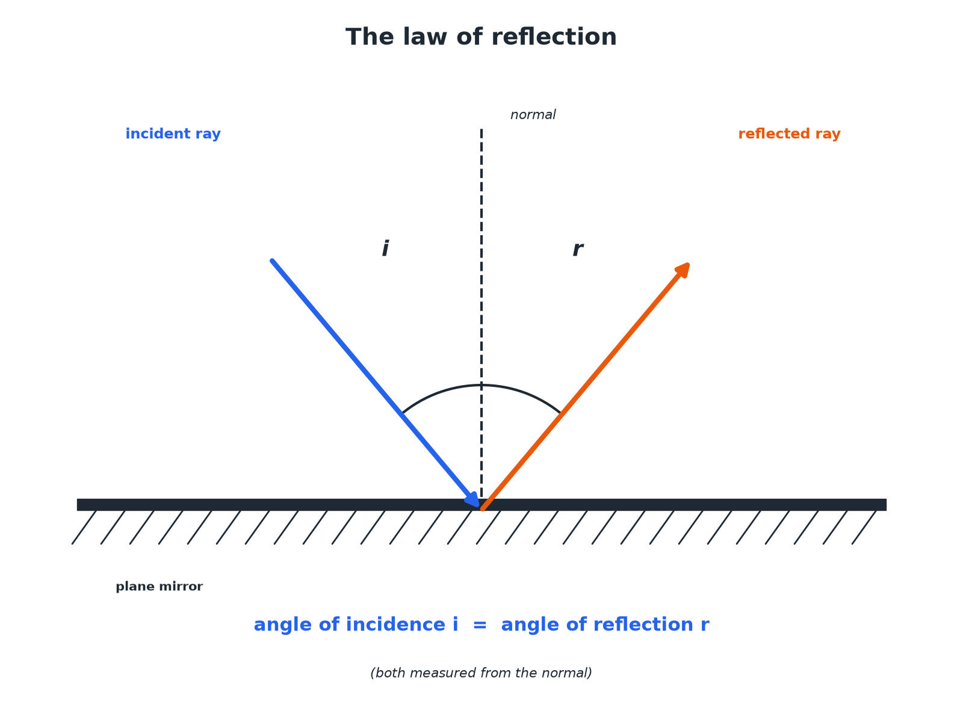
Measure both angles from the normal.
A ray reflecting from a plane mirror with equal angles of incidence and reflection measured from the normal.
Required Practical 9: Reflection with a Ray Box
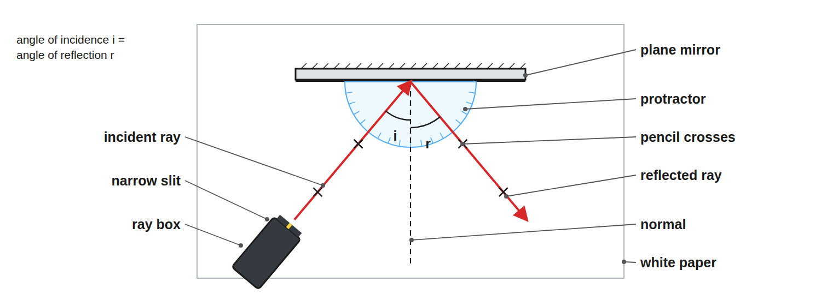
Draw the normal, then measure both angles from it.
A ray box shining a narrow beam onto a plane mirror on white paper, with a protractor for measuring angles.
How to Draw a Reflection Ray Diagram
Follow the steps.
1  Draw the mirror  A straight line. | 2  Draw the normal  A dashed line at 90° to the mirror at the point of incidence. | 3  Draw the incident ray  Toward the point, with an arrow. | 4  Measure the angle of incidence  Between the ray and the normal. | 5  Draw the reflected ray  At the same angle on the other side of the normal, with an arrow.
What Happens at a Boundary
Waves can do three things.
Effect | What it means | Example
Reflection | The wave bounces off the surface | Light from a mirror; an echo
Absorption | The wave's energy is transferred to the material | Black paper absorbs light and warms up
Transmission | The wave passes through the material | Light passing through glass
Finding Angles
A ray strikes a plane mirror so that the angle between the ray and the mirror surface is 50°. Find the angle of reflection.

1. Angle to the normal
90°− 50°= 40°
2. Law of reflection
Angle of reflection = angle of incidence
Answer: 40°, measured from the normal.
Practical Tips
Get accurate results.
▸ Narrow beam. Use a single slit so the ray is thin.
▸ Mark the ray. Put a cross on the ray at two points and draw a line through them.
▸ Repeat. Measure for several angles of incidence.
▸ Conclusion. The angle of incidence equals the angle of reflection.
Reflection, Absorption or Transmission?
Which one happens depends on the wavelength and the material.
▸ Glass and light. Glass transmits most visible light, reflects a little (you see a faint reflection in a window) and absorbs very little.
▸ Wavelength matters. The same material can behave differently for different waves. Glass transmits visible light but absorbs much of the ultraviolet.
▸ Sound. Hard, smooth walls reflect sound and cause echoes; soft materials like curtains and foam absorb it, which is why concert halls use them.
Images in a Plane Mirror
PROPERTIES OF THE IMAGE | WHERE IT APPEARS
▸ Virtual: it cannot be put on a screen.  ▸ Upright, the same way up as the object.  ▸ The same size as the object.  ▸ Laterally inverted: left and right are swapped. | ▸ The same distance behind the mirror as the object is in front.  ▸ On a line through the object at right angles to the mirror.  ▸ Found by extending reflected rays backwards as dashed lines.
Case Study
CASE STUDY
Periscopes
A periscope uses two plane mirrors, each at 45°. Light from an object hits the top mirror at 45° to the normal and reflects straight down the tube. The bottom mirror reflects it at 45° again, out to the viewer's eye. It lets someone see over a wall or out of a submarine.

45°  Angle of each mirror to the tube | 2  Reflections, so the image is the right way up
Key Terms
Reflection  When a wave bounces off a surface. | Absorption  When a wave's energy is taken in by a material.
Transmission  When a wave passes through a material. | Normal  A line at right angles to a surface.
Angle of incidence  The angle between the incident ray and the normal. | Angle of reflection  The angle between the reflected ray and the normal.
Plane mirror  A flat mirror. | Incident ray  The ray travelling towards a surface.
Ray box
A lamp with a slit that produces a narrow beam of light.
Your Task: Reflect It
10 minutes
A ray hits a mirror at an angle of incidence of 35°. Draw a ray diagram. State the angle between the reflected ray and the mirror surface.
1. Draw the normal first.
2. Mirror the angle.
A good answer shows: The angle of reflection is 35°. The angle to the mirror is 90° − 35° = 55°.
Note: Ask what would happen at 0°.
Can I...?
☐ Define reflection.
☐ Define absorption and transmission.
☐ State the law of reflection.
☐ Draw a normal.
☐ Measure angles from the normal.
☐ Draw a reflected ray.
☐ Describe the practical.
☐ Find an angle to the mirror.
Summary
✓ Angle of incidence = angle of reflection.
✓ Angles measured from the normal.
✓ Reflection, absorption, transmission.
✓ Use a ray box, mirror and protractor.
✓ A plane mirror image is virtual, upright and the same size.

EXAM FOCUS
State the law of reflection. (1 mark)
Write the full rule: angle of incidence = angle of reflection. Then remember both angles are measured to the normal, not to the mirror surface.
Exam Practice: Reflection of waves
Answer all questions. Use the mark allocation as a guide to how much to write. · 15 minutes
▸ Question 1 · 2 marks · State. State what happens to a wave when it is reflected, absorbed and transmitted at the boundary between two materials.
▸ Question 2 · 3 marks · Complete the diagram. The diagram shows a ray of light striking a plane mirror. Complete the diagram to show the reflected ray. Label the angle of incidence and…
▸ Question 3 · 2 marks · Calculate. A ray of light hits a plane mirror. The angle between the ray and the surface of the mirror is 50°. Calculate the angle of reflection.
▸ Question 4 · 5 marks · Describe. Describe how you would investigate the law of reflection using a ray box and a plane mirror. Your answer should include the measurements…
▸ Question 5 · 2 marks · Explain. Explain why a black surface gets hot in sunlight.
Question 1 · 2 marks · State
“State what happens to a wave when it is reflected, absorbed and transmitted at the boundary between two materials.”
HOW TO ANSWER IT Command word: State. Worth 2 marks, so plan before writing.
Question 1 · mark scheme
2 marks available. Award a mark for each point made.
▸ Reflected. 1 mark
▸ Absorbed or transmitted explained. 1 mark
▸ Model answer. Reflected: the wave bounces off. Absorbed: the energy is taken in by the material. Transmitted: the wave passes through.
Question 2 · 3 marks · Complete the diagram
The diagram shows a ray of light striking a plane mirror. Complete the diagram to show the reflected ray. Label the angle of incidence and the angle of reflection. (3 marks) | 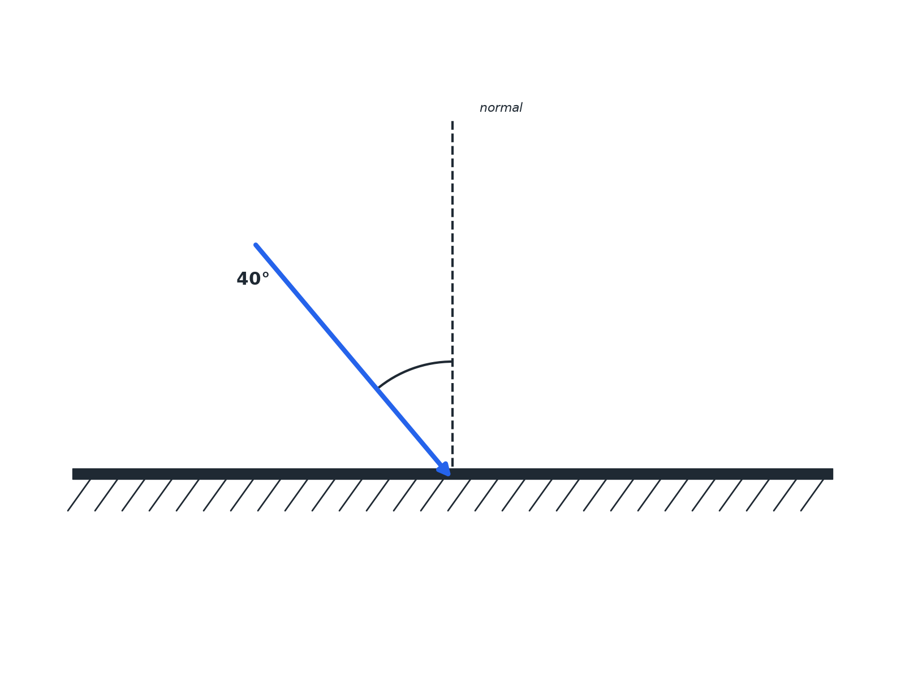

Question 2 · mark scheme
3 marks available. Award a mark for each point made.
▸ Normal drawn or used. 1 mark
▸ Reflected ray at 40° on the far side of the normal. 1 mark
▸ Angles labelled. 1 mark
▸ Model answer. A reflected ray drawn from the point of incidence at 40° to the normal on the other side, with an arrow; both angles labelled i and r.
Question 3 · 2 marks · Calculate
“A ray of light hits a plane mirror. The angle between the ray and the surface of the mirror is 50°. Calculate the angle of reflection.”
HOW TO ANSWER IT Command word: Calculate. Worth 2 marks, so plan before writing.
Question 3 · mark scheme
2 marks available. Award a mark for each point made.
▸ 90 − 50 = 40. 1 mark
▸ 40° (angle of reflection = angle of incidence). 1 mark
▸ Model answer. Angle of incidence = 90° − 50° = 40°, so the angle of reflection is 40°.
Question 4 · 5 marks · Describe
“Describe how you would investigate the law of reflection using a ray box and a plane mirror. Your answer should include the measurements you would take and the result you would expect.”
HOW TO ANSWER IT Command word: Describe. Worth 5 marks, so plan before writing.
Question 4 · mark scheme
5 marks available. Award a mark for each point made.
▸ Ray box with a narrow beam at a mirror on paper. 1 mark
▸ Normal drawn. 1 mark
▸ Rays marked and angles measured from the normal. 1 mark
▸ Repeat for different angles. 1 mark
▸ Angle of incidence equals angle of reflection. 1 mark
▸ Model answer. Shine a narrow ray onto a plane mirror placed on paper. Draw round the mirror and draw the normal. Mark the incident and reflected rays with crosses and draw the lines. Measure the angle of incidence and the angle of reflection from the normal with a protractor. Repeat for several angles. The angles should be equal.
Question 5 · 2 marks · Explain
“Explain why a black surface gets hot in sunlight.”
HOW TO ANSWER IT Command word: Explain. Worth 2 marks, so plan before writing.
Question 5 · mark scheme
2 marks available. Award a mark for each point made.
▸ Absorbs the radiation. 1 mark
▸ Energy transferred to thermal store. 1 mark
▸ Model answer. It absorbs most of the light, so the energy of the wave is transferred to the thermal energy store of the surface.

