EDEXCEL GCSE HISTORY · PAPER 1 · CRIME & PUNISHMENT
Crime and Punishment in Anglo-Saxon England
c1000-1066 · Chapter 1: Crime and punishment in medieval England, c1000-1066 · Lesson 1 of 4
Teacher copy - includes the notes for whoever is teaching from it.
What Do You Already Think?
Answer before the lesson, then check your ideas at the end.
1. Who would catch a thief in a village with no police?
The villagers themselves, through the hue and cry and the tithing.
2. How could a court decide guilt with no evidence?
Oaths from respected neighbours, or trial by ordeal - letting God decide.
3. Were there prisons?
Hardly any. Gaols held people awaiting trial; prison was not a punishment.
4. Who made the laws?
The king, through written law codes, with local custom alongside.
Learning Objectives
1. Identify crimes against the person, property and authority in Anglo-Saxon England.
2. Explain how tithings, the hue and cry and the local courts kept order without a police force.
3. Describe how guilt was decided, including oaths and trial by ordeal.
4. Explain the aims of Anglo-Saxon punishments, including wergild.
Setting the Scene
Around 1000, England was a Christian kingdom of small villages where almost everyone knew everyone. The king kept the King's Peace by issuing law codes, but he had no police force and few officials. Law and order depended on the community: villagers were expected to catch, accuse and bring wrongdoers to court themselves.
c1000 - England is divided into shires, and each shire into hundreds, each with its own court. | c1008 - King Aethelred's law codes set out the duties of free men and the penalties for crime. | c1020 - King Cnut's law codes restate the tithing, the hue and cry and wergild. | 1066 - The Norman conquest - the end of the Anglo-Saxon system as a system of its own.
Types of Crime
Historians sort medieval crime into three kinds - the exam expects you to use them.
Crimes against the person  Murder, assault, rape. Treated as harm done to a family, who expected compensation. | Crimes against property  Theft, robbery, arson, poaching. Theft was by far the most common crime.
Crimes against authority  Treason - betraying the king or your lord - and rebellion. The most serious crime of all. | Moral crimes  Adultery, drunkenness, failing to attend church. Dealt with by the Church.
Why theft dominated  Most people were poor farmers; a stolen animal or tools could ruin a family. | The King's Peace  A crime was increasingly seen as a breach of the king's peace, not only harm to a victim.
Keeping Order Without a Police Force
Every free man was part of a system that made his neighbours responsible for him.
▸ Tithings. Groups of ten men over the age of twelve who were responsible for each other's behaviour. If one broke the law, the others had to bring him to court or pay a fine.
▸ Hue and cry. A victim or witness raised the alarm and every man in the village had to stop work and chase the suspect. A village that failed to join in could be fined.
▸ The reeve. The king's local official. The shire-reeve - later the sheriff - brought suspects to court and collected fines.
▸ Collective responsibility. Because the whole community paid if it failed, everyone had a reason to keep watch on everyone else.
From Crime to Court
Every stage depended on ordinary people, not officials.
1  Hue and cry  The alarm is raised and the village chases the suspect. | 2  Tithing answers  If he escapes, his tithing must produce him at court or pay. | 3  Court meets  The hundred court (monthly) or shire court (twice a year) hears the accusation in the open. | 4  Oath-helpers  Respected men swear to the accused's good character - enough oaths could clear him. | 5  Ordeal  If oaths could not settle it, the case went to God through trial by ordeal.
Trial by Ordeal
When a court could not decide, it asked God. Ordeals took place in or near a church, after the accused had fasted and heard Mass, and a priest blessed the water or the iron.  The four ordeals  ▸ Hot iron. Carry a red-hot iron bar three paces. If the bandaged burn healed cleanly after three days, innocent.  ▸ Hot water. Pick a stone out of boiling water. Judged by the healing of the hand, as with hot iron.  ▸ Cold water. Lowered into blessed water: sinking meant innocent, floating meant the water had rejected you.  ▸ Consecrated bread. For priests. Choke on the blessed bread and you were guilty. | 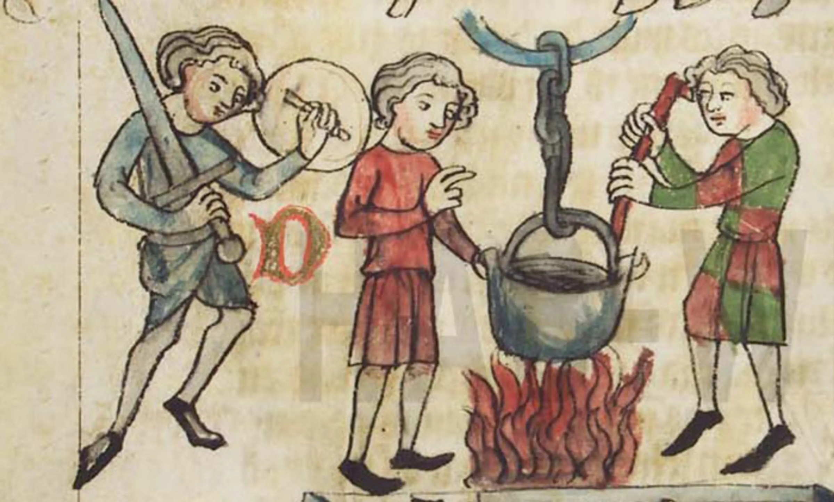  Guilt was left for God to reveal.
Medieval manuscript illustration; look for a public domain copy on Wikimedia Commons.
How Offenders Were Punished
Punishment aimed at compensation and deterrence, not reform.
Punishment | Used for | Why
Wergild | Murder and injury | Compensation to the family, set by the victim's rank, to stop blood feuds
Fines | Most minor crimes | Paid to the victim, and increasingly to the king
Stocks and pillory | Petty crimes | Public humiliation as a warning to others
Mutilation | Repeat offenders | Cutting off a hand, ear or nose - a lasting mark and deterrent
Execution | Treason, repeat theft | Hanging, for crimes that threatened the king or the community
The Law in the King's Own Words
“And if anyone flees from the hue and cry, let him pay the wergild of the man he has slain, and let his tithing answer for him.”
— Adapted from the law code of King Cnut, c1020
WHAT IT SHOWS Even the king's written law works through the tithing and the hue and cry - Anglo-Saxon justice depended on the community rather than on royal officials.
Key Terms
Tithing  A group of ten men over twelve who were responsible for each other's behaviour. | Hue and cry  The duty of every villager to chase a suspect once the alarm was raised.
Wergild  "Man price": compensation paid to a victim's family, set by the victim's rank. | Trial by ordeal  A religious test asking God to show whether the accused was guilty.
Oath-helpers  Men who swore to the good character of the accused. | King's Peace  The idea that the king was responsible for keeping order across his kingdom.
Reeve
A local royal official; the shire-reeve became the sheriff.
Summary
✓ Theft was the most common crime; treason the most serious.
✓ Order depended on the community: tithings, the hue and cry and local courts.
✓ Where oaths could not decide guilt, trial by ordeal left it to God.
✓ Punishments aimed at compensation (wergild) and deterrence, not prison.

EXAM FOCUS
Explain why the community played such an important role in law enforcement in Anglo-Saxon England. (12 marks)
Give at least three reasons, each explained with specific detail - and include one that goes beyond the stimulus points.
Exam Practice - Anglo-Saxon England
Answer all questions. Use specific names, dates and examples in every answer. · 35 minutes
▸ Question 1 · 4 marks · Explain one way. Explain one way in which the role of the community in law enforcement in Anglo-Saxon England was different from the role of the community…
▸ Question 2 · 12 marks · Explain why. Explain why the community played such an important role in law enforcement in Anglo-Saxon England. You may use the following in your…
▸ Question 3 · 16 marks · How far do you agree?. "The main aim of punishment in Anglo-Saxon England was to deter people from committing crime." How far do you agree? Explain your answer…
Question 1 · 4 marks · Explain one way
“Explain one way in which the role of the community in law enforcement in Anglo-Saxon England was different from the role of the community in law enforcement in the period c1200-c1500.”
HOW TO ANSWER IT Command word: Explain one way. Worth 4 marks, so plan before writing.
Question 1 · mark scheme
4 marks available. Award a mark for each point made.
▸ A valid difference identified. 1-2 marks
▸ Supported with specific knowledge of both periods. 3-4 marks
▸ Model answer. In Anglo-Saxon England the community did almost all of the work of law enforcement itself: through tithings and the hue and cry, villagers caught suspects and were fined if they failed. After 1200 the community was still involved, but the king's officials took on more of the work - for example, coroners from 1194 investigated suspicious deaths, and Keepers of the Peace (later Justices of the Peace) were appointed to keep order in each area. So the difference is that responsibility shifted from the community towards royal officials.
Question 2 · 12 marks · Explain why
“Explain why the community played such an important role in law enforcement in Anglo-Saxon England. You may use the following in your answer: tithings; the hue and cry. You must also use information of your own.”
HOW TO ANSWER IT Command word: Explain why. Worth 12 marks, so plan before writing.
Question 2 · mark scheme
12 marks available. Award a mark for each point made.
▸ Level 1 (1-3). A simple or general answer
▸ Level 2 (4-6). Some explanation of one or more reasons, with some knowledge
▸ Level 3 (7-9). A developed explanation linked to the question, with accurate knowledge
▸ Level 4 (10-12). An analytical explanation of several reasons, with knowledge that goes beyond the stimulus points
▸ Model answer. One reason was that there was no police force, and the king had very few officials. The reeve could not patrol every village, so the only people who could watch for crime were the villagers themselves. Tithings made this work: every man over twelve belonged to a group of ten who were responsible for each other, and if one broke the law the others had to bring him to court or pay a fine. That gave everyone a financial reason to keep watch. A second reason was that communities were small and close-knit. In a village where everyone knew everyone, a stranger or a thief was quickly noticed, which is why the hue and cry worked: once the alarm was raised, every man had to stop work and chase the suspect, and the whole village could be fined if it failed to join in. A third reason, beyond the stimulus, was the way trials worked. Courts met in the open in the hundred and the shire, and guilt was often decided by oath-helpers - neighbours who swore to the accused's good character. Justice therefore relied on local knowledge of who was trustworthy. Together these show that the community was not just helping the king's justice - it was the system.
Question 3 · 16 marks · How far do you agree?
“"The main aim of punishment in Anglo-Saxon England was to deter people from committing crime." How far do you agree? Explain your answer. You may use the following in your answer: the stocks and pillory; wergild. You must also use information of your own. (16 marks, plus 4 for spelling…”
HOW TO ANSWER IT Command word: How far do you agree?. Worth 16 marks, so plan before writing.
Question 3 · mark scheme
16 marks available. Award a mark for each point made.
▸ Level 1 (1-4). A simple or generalised answer
▸ Level 2 (5-8). Some analysis, with a judgement that is asserted
▸ Level 3 (9-12). Analysis of both sides with accurate knowledge and a supported judgement
▸ Level 4 (13-16). Sustained analysis, knowledge beyond the stimulus, and a clear, justified judgement
▸ SPaG (4). Accurate spelling, punctuation and grammar, with specialist terms such as wergild and tithing
▸ Model answer. On the one hand, many punishments were designed to deter. The stocks and pillory were used in public so that the whole community saw what happened to wrongdoers. Mutilation - cutting off a hand, nose or ear - left a permanent mark that warned others, and hanging for treason and repeat theft showed the price of the most serious crimes. On the other hand, other aims mattered as much or more. Wergild was compensation paid to the victim's family, set by the victim's rank; its main purpose was to prevent blood feuds by giving the family something other than revenge. Fines were also about paying back the victim and, increasingly, the king. Retribution mattered too: mutilation and execution were seen as a fitting punishment for the crime. Overall, deterrence was an important aim, especially for public punishments, but for the most serious everyday crime - violence between families - the main aim was compensation to keep the peace. The best answer recognises that the aim depended on the type of crime.

