EDEXCEL GCSE HISTORY · PAPER 1 · CRIME & PUNISHMENT
Crime and Punishment in Norman England
1066-c1200 · Chapter 1: Crime and punishment in medieval England, 1066-c1200 · Lesson 2 of 4
Teacher copy - includes the notes for whoever is teaching from it.
Starter: Anglo-Saxon Recap
Pair each term with its meaning.
Term | Meaning
Tithing
Ten men responsible for each other
Hue and cry
The village chases the suspect
Wergild
Compensation paid to the victim's family
Oath-helpers
Neighbours who swore to your character
Ordeal
Letting God decide guilt
Learning Objectives
1. Explain why William I needed to control a hostile Anglo-Saxon population.
2. Describe the new crimes and punishments the Normans introduced, including the Forest Laws and the murdrum fine.
3. Explain the continuity in Norman law enforcement, and assess how much changed after 1066.
Setting the Scene
In 1066 William of Normandy won the Battle of Hastings, but around 10,000 Normans now had to rule about two million English people who resented them. Rebellions followed, and William crushed them brutally in the Harrying of the North (1069-70). His laws were designed to protect his power and his followers.
1066 - Battle of Hastings: William becomes king. | 1069-70 - Harrying of the North: rebellion crushed by laying waste to the land. | 1079 - The New Forest is created as a royal hunting forest. | 1086 - The Domesday Book records who holds the land - and owes the king service. | 1166 - Henry II's Assize of Clarendon strengthens royal justice.
The Feudal System
Crime against your lord was now a crime against the whole structure of power.
The king | Owned all the land; granted it in return for loyalty
Barons and bishops | Held land from the king; supplied knights
Knights | Held land from barons; fought when called
Peasants | Worked the land; owed labour and obedience to their lord
What Changed and What Stayed the Same
CONTINUITY FROM THE ANGLO-SAXONS | NORMAN CHANGES
▸ Tithings and the hue and cry still made communities police themselves.  ▸ Hundred and shire courts still heard most cases.  ▸ Trial by ordeal continued, run by the Church.  ▸ Stocks, pillory, fines and execution were all still used. | ▸ The Forest Laws created new crimes on royal land.  ▸ The murdrum fine punished a hundred for a Norman's murder.  ▸ Trial by combat was introduced.  ▸ Wergild ended: fines went to the king, not the victim's family.
The Forest Laws
William declared large areas of England, including the New Forest, to be royal forest. People who had lived there for generations were suddenly criminals for doing what they had always done.  What became a crime  ▸ Hunting. Killing deer or boar on royal land - poaching.  ▸ Everyday life. Cutting wood, grazing animals or carrying a bow in the forest.  ▸ Harsh penalties. Poaching a deer could be punished by blinding or mutilation.  ▸ A social crime. Most people did not see poaching as really wrong, so many helped poachers. | 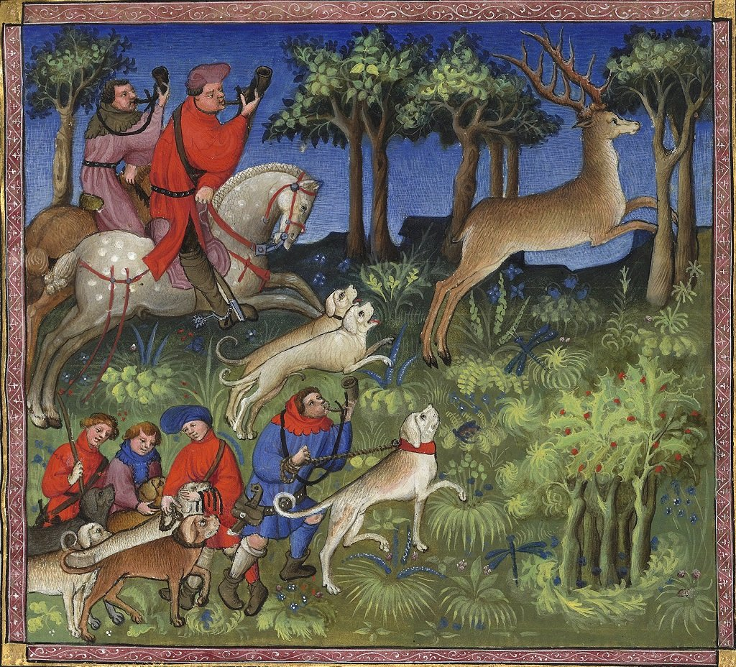  Royal forests covered a large part of England by 1200.
Medieval manuscript illustration; public domain copies on Wikimedia Commons.
Case Study
CASE STUDY
The Murdrum Fine
Normans were being killed by resentful English people, and the killers were hard to find because locals protected each other. William's answer was the murdrum fine: if a Norman was found murdered and the killer was not handed over, the whole hundred where the body lay had to pay a very large fine. It used the Anglo-Saxon idea of collective responsibility, but turned it into a way of protecting the conquerors.

Hundred  The area that paid if the killer was not produced | 1066-1340  The murdrum fine stayed in use for nearly 300 years
Punishment Under the Normans
The Normans made punishment serve the king.
▸ Wergild ends. Fines were now paid to the king rather than to the victim's family, so crime became an offence against royal authority.
▸ More capital crimes. Execution was used more, especially for crimes against the king such as rebellion.
▸ Mutilation. William preferred mutilation to execution for many crimes: blinding and castration were used, partly to show that offenders still had time to repent.
▸ Trial by combat. The accuser and accused fought, often to the death, until one gave in. The loser was hanged if he survived.
Law Enforcement and Courts
The machinery barely changed, but the authority behind it did.
▸ Sheriffs. The sheriff became more powerful, collecting fines and taxes and bringing criminals to court for the king.
▸ Church courts. William created separate Church courts, which dealt with clergy and moral crimes.
▸ Henry II. The Assize of Clarendon (1166) sent royal judges round the country and used juries of local men to report suspects, and ordered new gaols to be built.
▸ Castles. Around 500 castles built by 1100 were a constant reminder of Norman power.
How Much Did 1066 Change?
Place each development on the line.
CONTINUITY ——▸ CHANGE
1. Tithings and hue and cry. Unchanged: communities still policed themselves
2. Trial by ordeal. Unchanged, though now alongside combat
3. Courts and sheriffs. Same system, more royal control
4. Punishments. Wergild gone; fines to the king
5. Forest Laws and murdrum. Brand new crimes to protect Norman power
The Big Idea
The Normans changed who justice served more than how it worked.
The tithing, the hue and cry and the ordeal all survived - but now they protected the king and the conquerors.
Key Terms
Forest Laws  Laws making hunting and gathering wood on royal land a crime. | Poaching  Illegally hunting animals on land that belonged to someone else.
Social crime  A crime most people do not think is really wrong, such as poaching. | Murdrum fine  A fine on a whole hundred if a Norman was murdered and the killer not found.
Trial by combat  The accuser and accused fought to decide guilt. | Feudal system  Land held from the king in return for loyalty and service.
Assize of Clarendon
Henry II's law of 1166 that strengthened royal justice.
Summary
✓ William needed to control a hostile population, so his laws protected Norman power.
✓ New crimes: the Forest Laws and the murdrum fine.
✓ Tithings, the hue and cry and trial by ordeal continued.
✓ Wergild ended - fines now went to the king.

EXAM FOCUS
"The Norman Conquest brought major changes to crime and punishment in England." How far do you agree? (16 marks)
Argue both sides with specific examples, then judge: continuity in methods, change in whose authority they served.
Exam Practice - Norman England
Answer all questions. Use specific names, dates and examples in every answer. · 35 minutes
▸ Question 1 · 4 marks · Explain one way. Explain one way in which punishments in Anglo-Saxon England were similar to punishments in Norman England.
▸ Question 2 · 12 marks · Explain why. Explain why the Normans introduced new laws after 1066. You may use the following in your answer: the Forest Laws; the murdrum fine. You…
▸ Question 3 · 16 marks · How far do you agree?. "The Norman Conquest brought major changes to crime and punishment in England." How far do you agree? Explain your answer. You may use the…
Question 1 · 4 marks · Explain one way
“Explain one way in which punishments in Anglo-Saxon England were similar to punishments in Norman England.”
HOW TO ANSWER IT Command word: Explain one way. Worth 4 marks, so plan before writing.
Question 1 · mark scheme
4 marks available. Award a mark for each point made.
▸ A valid similarity identified. 1-2 marks
▸ Supported with specific knowledge of both periods. 3-4 marks
▸ Model answer. In both periods physical punishments were used to deter people from crime. The Anglo-Saxons used mutilation, such as cutting off a hand, for repeat offenders, and the Normans continued to use mutilation - William I preferred blinding and castration to execution for many crimes. In both periods execution by hanging was used for the most serious crimes, such as treason.
Question 2 · 12 marks · Explain why
“Explain why the Normans introduced new laws after 1066. You may use the following in your answer: the Forest Laws; the murdrum fine. You must also use information of your own.”
HOW TO ANSWER IT Command word: Explain why. Worth 12 marks, so plan before writing.
Question 2 · mark scheme
12 marks available. Award a mark for each point made.
▸ Level 1 (1-3). A simple or general answer
▸ Level 2 (4-6). Some explanation of one or more reasons, with some knowledge
▸ Level 3 (7-9). A developed explanation linked to the question, with accurate knowledge
▸ Level 4 (10-12). An analytical explanation of several reasons, with knowledge that goes beyond the stimulus points
▸ Model answer. One reason was that William needed to control a hostile population. Around 10,000 Normans ruled around two million English people, and rebellions such as those that led to the Harrying of the North showed the danger. The murdrum fine was a response: if a Norman was murdered and the killer was not handed over, the whole hundred had to pay a heavy fine, which forced the English to police each other on the Normans' behalf. A second reason was to show and protect royal power and privilege. The Forest Laws turned large areas such as the New Forest into royal land where hunting, cutting wood or grazing animals became crimes. They protected the king's hunting and showed that the land belonged to him, with harsh punishments such as blinding for poaching deer. A third reason, beyond the stimulus, was the feudal system. William owned all the land and granted it in return for loyalty, so crime was increasingly seen as a threat to the king's authority. That is why wergild was replaced by fines paid to the king, and why more crimes against the king were punished by death. The new laws all served the same purpose: making the conquest secure.
Question 3 · 16 marks · How far do you agree?
“"The Norman Conquest brought major changes to crime and punishment in England." How far do you agree? Explain your answer. You may use the following in your answer: trial by ordeal; the Forest Laws. You must also use information of your own. (16 marks, plus 4 for spelling, punctuation, grammar and…”
HOW TO ANSWER IT Command word: How far do you agree?. Worth 16 marks, so plan before writing.
Question 3 · mark scheme
16 marks available. Award a mark for each point made.
▸ Level 1 (1-4). A simple or generalised answer
▸ Level 2 (5-8). Some analysis, with a judgement that is asserted
▸ Level 3 (9-12). Analysis of both sides with accurate knowledge and a supported judgement
▸ Level 4 (13-16). Sustained analysis, knowledge beyond the stimulus, and a clear, justified judgement
▸ SPaG (4). Accurate spelling, punctuation and grammar, with specialist terms such as murdrum and feudal
▸ Model answer. On the one hand, the Normans introduced important changes. The Forest Laws created new crimes out of everyday activities such as hunting and gathering wood, with harsh punishments like blinding. The murdrum fine made a whole hundred pay for the murder of a Norman. Trial by combat was introduced, and wergild was abolished, so fines went to the king - crime became an offence against royal authority rather than a matter between families. On the other hand, much stayed the same. Trial by ordeal continued, still run by the Church. Tithings and the hue and cry still made communities responsible for catching criminals, and the hundred and shire courts still heard cases. Even the murdrum fine relied on the Anglo-Saxon idea of collective responsibility. Overall, the methods of law enforcement and trial changed very little, but the purpose of the law changed significantly - it now protected the king and the Norman elite. So the conquest brought major change in who the law served, but not a major change in how it worked.

