EDEXCEL GCSE HISTORY · PAPER 1 · CRIME & PUNISHMENT
The Role of the Church in Crime and Punishment
c1000-c1500 · Chapter 1: Crime and punishment in medieval England, c1000-c1500 · Lesson 3 of 4
Learning Objectives
1. Describe the work of Church courts and the punishments they gave.
2. Explain how sanctuary and benefit of clergy worked, and why they caused conflict.
3. Explain why trial by ordeal ended in 1215, and assess the significance of the Church's influence.
Setting the Scene
In medieval England the Church was as powerful as the king. Almost everyone believed in Heaven and Hell, and the Church owned land, collected taxes and ran its own courts. The Church saw crime as sin, and it believed sinners should have the chance to repent - which meant its justice was often gentler than the king's.
1070s - William I sets up separate Church courts. | 1164 - Henry II's Constitutions of Clarendon try to limit Church courts. | 1170 - Archbishop Thomas Becket is murdered in Canterbury Cathedral. | 1215 - The Pope bans priests from taking part in trials by ordeal.
Church Courts
The Church dealt with its own - and with sins as well as crimes.
▸ Who they tried. Members of the clergy - priests, monks and nuns - for any crime, and anyone for moral crimes such as adultery, drunkenness or failing to go to church.
▸ Punishments. Church courts never sentenced anyone to death. They used penance, fines, public shaming and, at worst, excommunication.
▸ Why gentler. The Church believed punishment should give sinners the chance to repent and save their souls.
▸ Criticism. Many people thought Church courts let criminal clergy off too lightly.
Sanctuary and Benefit of Clergy
Two ways the Church protected people from the king's courts.
Sanctuary  A person accused of a crime could claim protection in a church. After 40 days they had to face trial or leave England. | Abjuring the realm  Leaving England: the fugitive walked to a named port, barefoot and carrying a cross, and took the first ship.
Benefit of clergy  Clergy accused of a crime could be tried in a Church court, where there was no death penalty. | The neck verse  To prove they were clergy, the accused read a passage from the Bible - later Psalm 51. People learned it by heart to escape hanging.
Church Against Crown: Thomas Becket
Henry II wanted clergy who committed serious crimes to be punished in the king's courts. His Archbishop of Canterbury, Thomas Becket, refused. In 1170 four of Henry's knights murdered Becket in his own cathedral.  Why it mattered  ▸ Martyr. Becket was made a saint and Canterbury became a place of pilgrimage.  ▸ Henry backs down. Henry did public penance, and benefit of clergy survived for the rest of the Middle Ages.  ▸ Church and crown. The case shows the Church's power over justice - even against a strong king. | 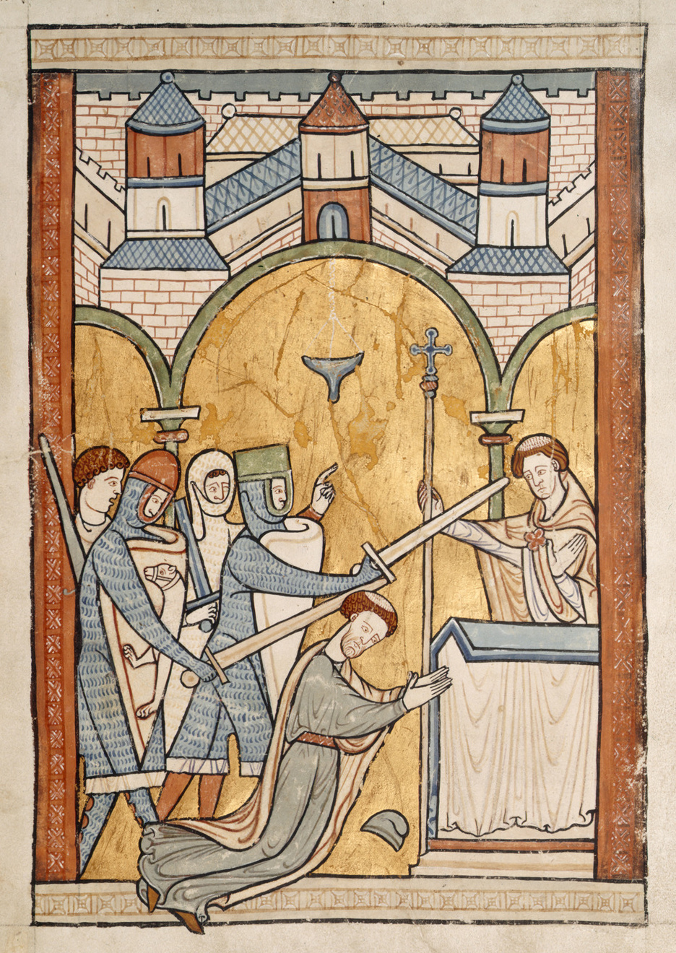  The murder of Thomas Becket, 1170.
Medieval manuscript illustration; public domain copies on Wikimedia Commons.
The End of Trial by Ordeal
The Church had run the ordeals - and in 1215 it stopped.
▸ The decision. In 1215 Pope Innocent III's Fourth Lateran Council banned priests from taking part in trials by ordeal.
▸ Why. Many churchmen doubted that God should be asked to perform a miracle to decide a court case, and ordeals were open to trickery.
▸ The effect. Without priests, ordeals could not work. By the 1220s trial by jury replaced them in the king's courts.
▸ Significance. A decision made by the Church changed how guilt was decided in England.
Did the Church Help or Hinder Justice?
IT HELPED | IT HINDERED
▸ Gave accused people protection from hasty punishment through sanctuary.  ▸ Offered a chance to repent instead of death.  ▸ Its decision in 1215 led to trial by jury - a fairer system. | ▸ Benefit of clergy let criminal clergy escape hanging.  ▸ Sanctuary could let the guilty escape justice.  ▸ It clashed with the king over who had authority.
Key Terms
Church courts  Courts run by the Church for clergy and moral crimes; never gave the death penalty. | Sanctuary  Protection given to an accused person who took refuge in a church.
Abjuring the realm  Leaving England for ever instead of facing trial. | Benefit of clergy  The right of clergy to be tried in Church courts.
Neck verse  Psalm 51, read to prove you were clergy and escape hanging. | Excommunication  Being cut off from the Church - believed to mean going to Hell.
Fourth Lateran Council
The Church meeting of 1215 that ended priests' part in trial by ordeal.
Summary
✓ Church courts tried clergy and moral crimes, and never used the death penalty.
✓ Sanctuary gave fugitives 40 days' protection before trial or leaving England.
✓ Benefit of clergy let the clergy - and later anyone who could read - escape hanging.
✓ In 1215 the Church ended trial by ordeal, leading to trial by jury.

EXAM FOCUS
Explain why the Church had an important influence on crime and punishment in the early thirteenth century. (12 marks)
Explain each factor - sanctuary, benefit of clergy, the end of the ordeal - and say why it mattered, not just what it was.

