EDEXCEL GCSE HISTORY · PAPER 1 · CRIME & PUNISHMENT
The Role of the Church in Crime and Punishment
c1000-c1500 · Chapter 1: Crime and punishment in medieval England, c1000-c1500 · Lesson 3 of 4
Teacher copy - includes the notes for whoever is teaching from it.
Learning Objectives
1. Describe the work of Church courts and the punishments they gave.
2. Explain how sanctuary and benefit of clergy worked, and why they caused conflict.
3. Explain why trial by ordeal ended in 1215, and assess the significance of the Church's influence.
Setting the Scene
In medieval England the Church was as powerful as the king. Almost everyone believed in Heaven and Hell, and the Church owned land, collected taxes and ran its own courts. The Church saw crime as sin, and it believed sinners should have the chance to repent - which meant its justice was often gentler than the king's.
1070s - William I sets up separate Church courts. | 1164 - Henry II's Constitutions of Clarendon try to limit Church courts. | 1170 - Archbishop Thomas Becket is murdered in Canterbury Cathedral. | 1215 - The Pope bans priests from taking part in trials by ordeal.
Church Courts
The Church dealt with its own - and with sins as well as crimes.
▸ Who they tried. Members of the clergy - priests, monks and nuns - for any crime, and anyone for moral crimes such as adultery, drunkenness or failing to go to church.
▸ Punishments. Church courts never sentenced anyone to death. They used penance, fines, public shaming and, at worst, excommunication.
▸ Why gentler. The Church believed punishment should give sinners the chance to repent and save their souls.
▸ Criticism. Many people thought Church courts let criminal clergy off too lightly.
Sanctuary and Benefit of Clergy
Two ways the Church protected people from the king's courts.
Sanctuary  A person accused of a crime could claim protection in a church. After 40 days they had to face trial or leave England. | Abjuring the realm  Leaving England: the fugitive walked to a named port, barefoot and carrying a cross, and took the first ship.
Benefit of clergy  Clergy accused of a crime could be tried in a Church court, where there was no death penalty. | The neck verse  To prove they were clergy, the accused read a passage from the Bible - later Psalm 51. People learned it by heart to escape hanging.
Church Against Crown: Thomas Becket
Henry II wanted clergy who committed serious crimes to be punished in the king's courts. His Archbishop of Canterbury, Thomas Becket, refused. In 1170 four of Henry's knights murdered Becket in his own cathedral.  Why it mattered  ▸ Martyr. Becket was made a saint and Canterbury became a place of pilgrimage.  ▸ Henry backs down. Henry did public penance, and benefit of clergy survived for the rest of the Middle Ages.  ▸ Church and crown. The case shows the Church's power over justice - even against a strong king. | 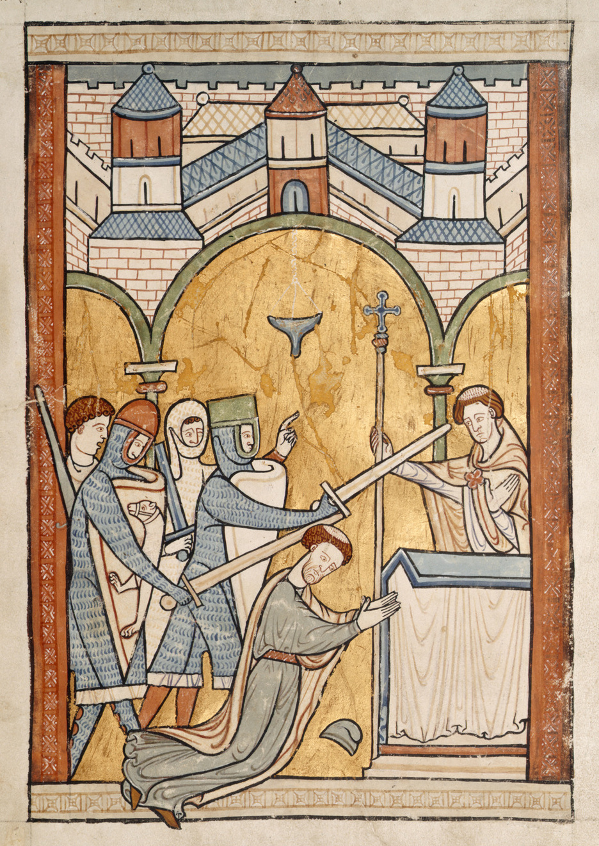  The murder of Thomas Becket, 1170.
Medieval manuscript illustration; public domain copies on Wikimedia Commons.
The End of Trial by Ordeal
The Church had run the ordeals - and in 1215 it stopped.
▸ The decision. In 1215 Pope Innocent III's Fourth Lateran Council banned priests from taking part in trials by ordeal.
▸ Why. Many churchmen doubted that God should be asked to perform a miracle to decide a court case, and ordeals were open to trickery.
▸ The effect. Without priests, ordeals could not work. By the 1220s trial by jury replaced them in the king's courts.
▸ Significance. A decision made by the Church changed how guilt was decided in England.
Did the Church Help or Hinder Justice?
IT HELPED | IT HINDERED
▸ Gave accused people protection from hasty punishment through sanctuary.  ▸ Offered a chance to repent instead of death.  ▸ Its decision in 1215 led to trial by jury - a fairer system. | ▸ Benefit of clergy let criminal clergy escape hanging.  ▸ Sanctuary could let the guilty escape justice.  ▸ It clashed with the king over who had authority.
Key Terms
Church courts  Courts run by the Church for clergy and moral crimes; never gave the death penalty. | Sanctuary  Protection given to an accused person who took refuge in a church.
Abjuring the realm  Leaving England for ever instead of facing trial. | Benefit of clergy  The right of clergy to be tried in Church courts.
Neck verse  Psalm 51, read to prove you were clergy and escape hanging. | Excommunication  Being cut off from the Church - believed to mean going to Hell.
Fourth Lateran Council
The Church meeting of 1215 that ended priests' part in trial by ordeal.
Summary
✓ Church courts tried clergy and moral crimes, and never used the death penalty.
✓ Sanctuary gave fugitives 40 days' protection before trial or leaving England.
✓ Benefit of clergy let the clergy - and later anyone who could read - escape hanging.
✓ In 1215 the Church ended trial by ordeal, leading to trial by jury.

EXAM FOCUS
Explain why the Church had an important influence on crime and punishment in the early thirteenth century. (12 marks)
Explain each factor - sanctuary, benefit of clergy, the end of the ordeal - and say why it mattered, not just what it was.
Exam Practice - The Role of the Church
Answer all questions. Use specific names, dates and examples in every answer. · 35 minutes
▸ Question 1 · 4 marks · Explain one way. Explain one way in which the way guilt was decided in the period c1000-c1200 was different from the way guilt was decided in the period…
▸ Question 2 · 12 marks · Explain why. Explain why the Church had an important influence on crime and punishment in the early thirteenth century. You may use the following in…
▸ Question 3 · 16 marks · How far do you agree?. "The Church was the most important influence on crime and punishment in the period c1000-c1500." How far do you agree? Explain your answer…
Question 1 · 4 marks · Explain one way
“Explain one way in which the way guilt was decided in the period c1000-c1200 was different from the way guilt was decided in the period c1200-c1500.”
HOW TO ANSWER IT Command word: Explain one way. Worth 4 marks, so plan before writing.
Question 1 · mark scheme
4 marks available. Award a mark for each point made.
▸ A valid difference identified. 1-2 marks
▸ Supported with specific knowledge of both periods. 3-4 marks
▸ Model answer. Before 1200, if oath-helpers could not settle a case, guilt was decided by trial by ordeal, where people believed God would reveal the truth - for example through trial by hot iron or cold water. After the Church banned priests from taking part in ordeals in 1215, guilt was decided by trial by jury, where local men judged the evidence. So guilt moved from being decided by God to being decided by people.
Question 2 · 12 marks · Explain why
“Explain why the Church had an important influence on crime and punishment in the early thirteenth century. You may use the following in your answer: sanctuary; trial by ordeal. You must also use information of your own.”
HOW TO ANSWER IT Command word: Explain why. Worth 12 marks, so plan before writing.
Question 2 · mark scheme
12 marks available. Award a mark for each point made.
▸ Level 1 (1-3). A simple or general answer
▸ Level 2 (4-6). Some explanation of one or more reasons, with some knowledge
▸ Level 3 (7-9). A developed explanation linked to the question, with accurate knowledge
▸ Level 4 (10-12). An analytical explanation of several reasons, with knowledge that goes beyond the stimulus points
▸ Model answer. One reason was that the Church could protect accused people from the king's justice through sanctuary. A person who reached a church could claim protection for 40 days, after which they either faced trial or abjured the realm, walking to a port and leaving England. This meant the Church, not the king, decided what happened to some fugitives. A second reason was the Church's decision in 1215 to end trial by ordeal. The ordeals relied on priests to bless the water or iron, so when Pope Innocent III's Fourth Lateran Council banned priests from taking part, they could no longer be held. This forced the king's courts to find a new way of deciding guilt, and by the 1220s trial by jury had replaced the ordeal - a lasting change caused directly by the Church. A third reason, beyond the stimulus, was benefit of clergy. Clergy accused of crimes could be tried in Church courts, which never used the death penalty, and Henry II's failure to change this after the murder of Thomas Becket in 1170 showed how strong the Church's position was. The Church therefore shaped who was tried, how they were tried, and how they were punished.
Question 3 · 16 marks · How far do you agree?
“"The Church was the most important influence on crime and punishment in the period c1000-c1500." How far do you agree? Explain your answer. You may use the following in your answer: benefit of clergy; the Statute of Labourers (1351). You must also use information of your own. (16 marks, plus 4 for…”
HOW TO ANSWER IT Command word: How far do you agree?. Worth 16 marks, so plan before writing.
Question 3 · mark scheme
16 marks available. Award a mark for each point made.
▸ Level 1 (1-4). A simple or generalised answer
▸ Level 2 (5-8). Some analysis, with a judgement that is asserted
▸ Level 3 (9-12). Analysis of both sides with accurate knowledge and a supported judgement
▸ Level 4 (13-16). Sustained analysis, knowledge beyond the stimulus, and a clear, justified judgement
▸ SPaG (4). Accurate spelling, punctuation and grammar, with specialist terms such as sanctuary and benefit of clergy
▸ Model answer. On the one hand, the Church had a major influence throughout the period. It ran trial by ordeal until 1215, and its decision to end it led to trial by jury. Church courts tried clergy and moral crimes and never gave the death penalty, and benefit of clergy let criminal clergy - and later anyone who could read the neck verse - escape hanging. Sanctuary gave fugitives protection. When Henry II tried to limit this, the murder of Becket in 1170 forced him to back down. On the other hand, kings and governments were arguably more important. The Normans' Forest Laws and murdrum fine were created by the king to protect royal power. Royal justice grew steadily - Henry II's Assize of Clarendon (1166), travelling judges, coroners and Justices of the Peace. New crimes were created by the government in response to events, such as the Statute of Labourers of 1351 after the Black Death, and the Treason Act of 1351. Even heresy laws in 1401 were enforced by the state burning heretics. Overall, the Church's influence was very significant in how guilt was decided and in protecting some people from punishment, but the king and government were the main influence on what counted as a crime and how most people were punished. Over the period royal power grew while the Church's role became more limited.

