EDEXCEL GCSE HISTORY · PAPER 1 · CRIME & PUNISHMENT
Crime and Punishment in the Later Middle Ages
c1200-c1500 · Chapter 1: Crime and punishment in medieval England, c1200-c1500 · Lesson 4 of 4
Learning Objectives
1. Describe the new royal officials who enforced the law after 1200.
2. Explain why new crimes were created, including the Statute of Labourers and the heresy laws.
3. Assess how far crime and punishment changed across the whole period c1000-c1500.
Setting the Scene
After 1200 English kings built up a much larger system of royal justice. Towns were growing, and the country was shaken by the Black Death (1348-49), which killed around a third of the population. New problems led to new laws - and the king's officials, not just the village, now did much of the work of enforcing them.
1194 - Coroners are appointed to investigate suspicious deaths. | 1195 - Richard I appoints Keepers of the Peace. | 1285 - Statute of Winchester: watchmen in towns and the hue and cry reinforced. | 1348 - The Black Death reaches England. | 1351 - Statute of Labourers and the Treason Act. | 1361 - Justices of the Peace are established in every county. | 1401 - De Heretico Comburendo: heretics can be burned.
New Royal Officials
Law enforcement was still local, but the king's officials took on more of it.
▸ Coroners. From 1194, coroners investigated any unexpected or suspicious death, holding an inquest with a jury.
▸ Keepers of the Peace. Appointed from 1195 to keep order in troublesome areas; in 1361 they became Justices of the Peace (JPs).
▸ Justices of the Peace. Local landowners who heard minor cases and kept order in each county - still the backbone of local justice in 1500.
▸ Royal judges. Judges travelled on circuits to hear serious cases at the assizes, and the King's Bench court sat in Westminster.
Law Enforcement in Towns and Villages
The community was still expected to play its part.
▸ Statute of Winchester. In 1285 Edward I ordered towns to have watchmen at their gates at night and made every man keep weapons to join the hue and cry.
▸ Tithings and hue and cry. Still used, especially in the countryside - a clear sign of continuity from Anglo-Saxon times.
▸ Parish constables. Local men chosen for a year to keep order and bring suspects to the JPs.
▸ Trial by jury. Juries of local men now decided guilt instead of the ordeal.
New Crimes, c1200-c1500
Each new law was a response to a problem the authorities feared.
Law | Date | What it did | Why
Statute of Labourers | 1351 | Capped wages at pre-plague levels; peasants could not leave their lord | The Black Death caused a labour shortage and peasants demanded more pay
Treason Act | 1351 | Defined high treason, punished by hanging, drawing and quartering | Kings wanted to protect their authority
De Heretico Comburendo | 1401 | Heretics who refused to recant could be burned | The Lollards challenged the Church
Poaching laws | Throughout | Hunting on private or royal land punished | Landowners protected their game
Punishment in Public
Punishments in the later Middle Ages were still public and aimed at deterrence and retribution. Prison was still mainly for holding people before trial or for debtors.  Punishments, c1200-c1500  ▸ Fines. The most common punishment for minor crimes.  ▸ Stocks and pillory. Public humiliation for crimes such as cheating customers.  ▸ Hanging. For serious crimes, including theft of goods worth more than 12 pence.  ▸ Hanging, drawing and quartering. For treason - the harshest punishment of all. | 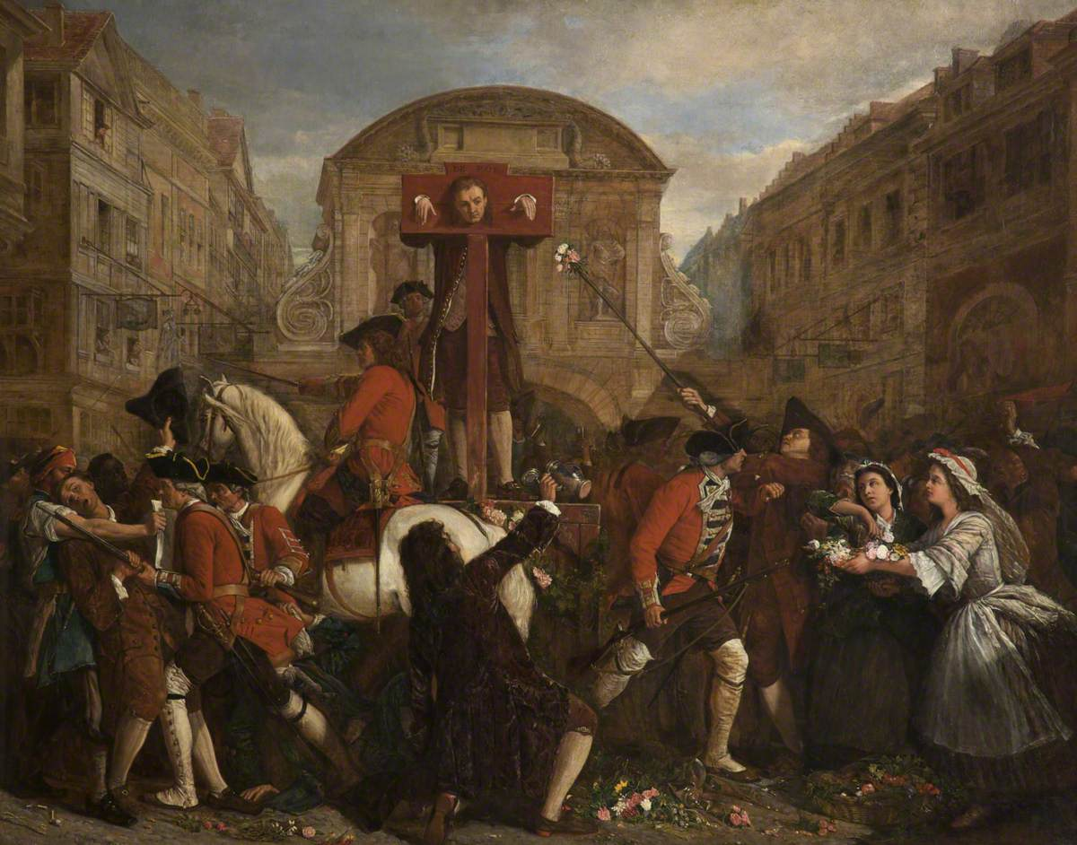  Public punishment was meant to shame and deter.
Medieval manuscript illustration; public domain copies on Wikimedia Commons.
Crime and Punishment c1000-c1500
Medieval justice

Crimes  ▸ Theft most common  ▸ treason most serious  ▸ poaching  ▸ moral crimes  ▸ heresy | Enforcement  ▸ Tithings  ▸ hue and cry  ▸ sheriffs  ▸ coroners  ▸ JPs  ▸ watchmen
Trials  ▸ Oath-helpers  ▸ ordeal until 1215  ▸ combat  ▸ juries | Punishments  ▸ Wergild  ▸ fines  ▸ stocks and pillory  ▸ mutilation  ▸ hanging  ▸ burning heretics
The Church  ▸ Church courts  ▸ sanctuary  ▸ benefit of clergy  ▸ end of ordeal | The king  ▸ King's Peace  ▸ Forest Laws  ▸ murdrum  ▸ royal judges  ▸ new statutes
Can I...?
Tick off what you can already do for the exam.
☐ Explain the difference between crimes against the person, property and authority
☐ Explain how tithings and the hue and cry worked
☐ Describe the Forest Laws and the murdrum fine
☐ Explain sanctuary and benefit of clergy
☐ Explain why trial by ordeal ended in 1215
☐ Describe the roles of coroners and JPs
☐ Explain why the Statute of Labourers was introduced
☐ Judge how far crime and punishment changed c1000-c1500
Key Terms
Coroner  An official who investigated suspicious deaths, from 1194. | Justice of the Peace (JP)  A local landowner appointed to keep order and try minor cases, from 1361.
Statute of Labourers  A 1351 law capping wages after the Black Death. | Treason Act  A 1351 law defining high treason.
Heresy  Holding religious beliefs that go against the Church's teaching. | Lollards  Followers of John Wycliffe who challenged the Church.
Assizes
Courts where travelling royal judges heard serious cases.
Summary
✓ Royal officials - coroners, Keepers of the Peace and JPs - took on more of law enforcement.
✓ The community still mattered: the hue and cry, watchmen and juries.
✓ New crimes followed new fears: the Black Death, treason and heresy.
✓ Punishment stayed public, harsh and aimed at deterrence.

EXAM FOCUS
Explain why there were changes in the definition of crime in the period c1200-c1500. (12 marks)
Link each new law to the problem that caused it - the Black Death, the Lollards, the protection of royal authority.

