EDEXCEL GCSE HISTORY · PAPER 1 · CRIME & PUNISHMENT
Crime and Punishment in the Later Middle Ages
c1200-c1500 · Chapter 1: Crime and punishment in medieval England, c1200-c1500 · Lesson 4 of 4
Teacher copy - includes the notes for whoever is teaching from it.
Learning Objectives
1. Describe the new royal officials who enforced the law after 1200.
2. Explain why new crimes were created, including the Statute of Labourers and the heresy laws.
3. Assess how far crime and punishment changed across the whole period c1000-c1500.
Setting the Scene
After 1200 English kings built up a much larger system of royal justice. Towns were growing, and the country was shaken by the Black Death (1348-49), which killed around a third of the population. New problems led to new laws - and the king's officials, not just the village, now did much of the work of enforcing them.
1194 - Coroners are appointed to investigate suspicious deaths. | 1195 - Richard I appoints Keepers of the Peace. | 1285 - Statute of Winchester: watchmen in towns and the hue and cry reinforced. | 1348 - The Black Death reaches England. | 1351 - Statute of Labourers and the Treason Act. | 1361 - Justices of the Peace are established in every county. | 1401 - De Heretico Comburendo: heretics can be burned.
New Royal Officials
Law enforcement was still local, but the king's officials took on more of it.
▸ Coroners. From 1194, coroners investigated any unexpected or suspicious death, holding an inquest with a jury.
▸ Keepers of the Peace. Appointed from 1195 to keep order in troublesome areas; in 1361 they became Justices of the Peace (JPs).
▸ Justices of the Peace. Local landowners who heard minor cases and kept order in each county - still the backbone of local justice in 1500.
▸ Royal judges. Judges travelled on circuits to hear serious cases at the assizes, and the King's Bench court sat in Westminster.
Law Enforcement in Towns and Villages
The community was still expected to play its part.
▸ Statute of Winchester. In 1285 Edward I ordered towns to have watchmen at their gates at night and made every man keep weapons to join the hue and cry.
▸ Tithings and hue and cry. Still used, especially in the countryside - a clear sign of continuity from Anglo-Saxon times.
▸ Parish constables. Local men chosen for a year to keep order and bring suspects to the JPs.
▸ Trial by jury. Juries of local men now decided guilt instead of the ordeal.
New Crimes, c1200-c1500
Each new law was a response to a problem the authorities feared.
Law | Date | What it did | Why
Statute of Labourers | 1351 | Capped wages at pre-plague levels; peasants could not leave their lord | The Black Death caused a labour shortage and peasants demanded more pay
Treason Act | 1351 | Defined high treason, punished by hanging, drawing and quartering | Kings wanted to protect their authority
De Heretico Comburendo | 1401 | Heretics who refused to recant could be burned | The Lollards challenged the Church
Poaching laws | Throughout | Hunting on private or royal land punished | Landowners protected their game
Punishment in Public
Punishments in the later Middle Ages were still public and aimed at deterrence and retribution. Prison was still mainly for holding people before trial or for debtors.  Punishments, c1200-c1500  ▸ Fines. The most common punishment for minor crimes.  ▸ Stocks and pillory. Public humiliation for crimes such as cheating customers.  ▸ Hanging. For serious crimes, including theft of goods worth more than 12 pence.  ▸ Hanging, drawing and quartering. For treason - the harshest punishment of all. | 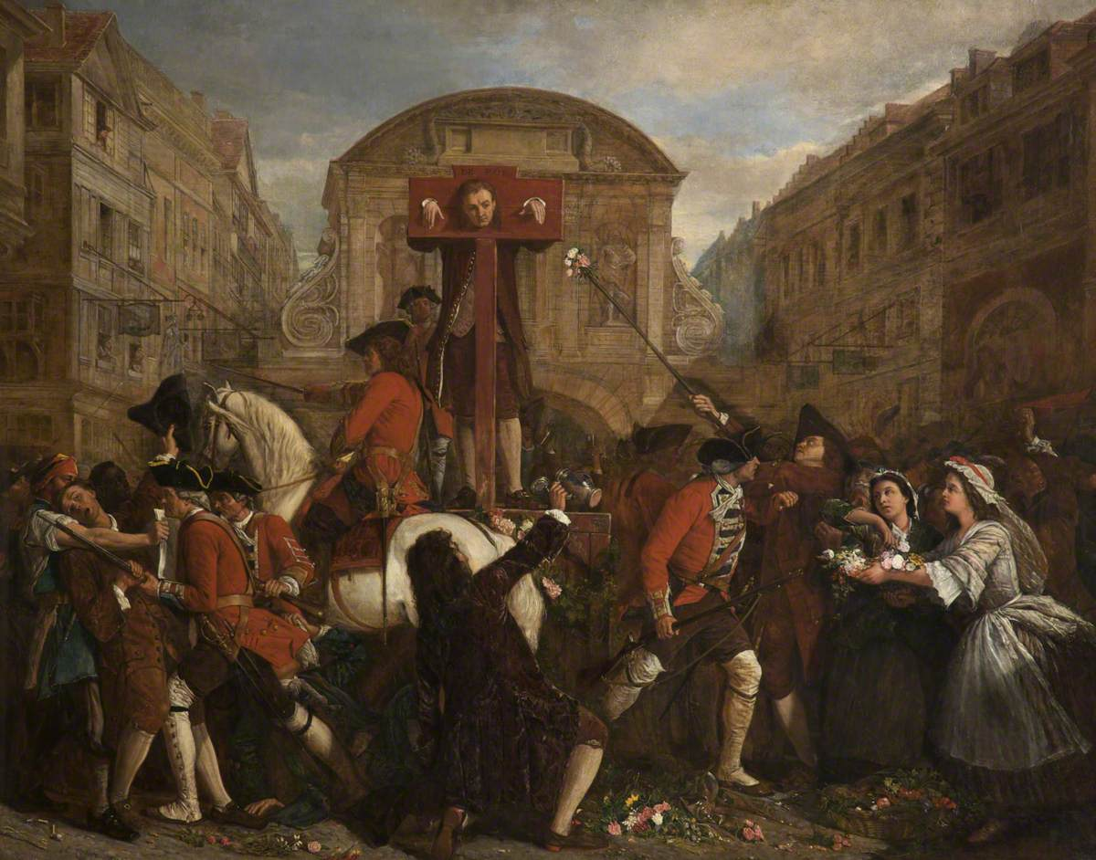  Public punishment was meant to shame and deter.
Medieval manuscript illustration; public domain copies on Wikimedia Commons.
Crime and Punishment c1000-c1500
Medieval justice

Crimes  ▸ Theft most common  ▸ treason most serious  ▸ poaching  ▸ moral crimes  ▸ heresy | Enforcement  ▸ Tithings  ▸ hue and cry  ▸ sheriffs  ▸ coroners  ▸ JPs  ▸ watchmen
Trials  ▸ Oath-helpers  ▸ ordeal until 1215  ▸ combat  ▸ juries | Punishments  ▸ Wergild  ▸ fines  ▸ stocks and pillory  ▸ mutilation  ▸ hanging  ▸ burning heretics
The Church  ▸ Church courts  ▸ sanctuary  ▸ benefit of clergy  ▸ end of ordeal | The king  ▸ King's Peace  ▸ Forest Laws  ▸ murdrum  ▸ royal judges  ▸ new statutes
Can I...?
Tick off what you can already do for the exam.
☐ Explain the difference between crimes against the person, property and authority
☐ Explain how tithings and the hue and cry worked
☐ Describe the Forest Laws and the murdrum fine
☐ Explain sanctuary and benefit of clergy
☐ Explain why trial by ordeal ended in 1215
☐ Describe the roles of coroners and JPs
☐ Explain why the Statute of Labourers was introduced
☐ Judge how far crime and punishment changed c1000-c1500
Key Terms
Coroner  An official who investigated suspicious deaths, from 1194. | Justice of the Peace (JP)  A local landowner appointed to keep order and try minor cases, from 1361.
Statute of Labourers  A 1351 law capping wages after the Black Death. | Treason Act  A 1351 law defining high treason.
Heresy  Holding religious beliefs that go against the Church's teaching. | Lollards  Followers of John Wycliffe who challenged the Church.
Assizes
Courts where travelling royal judges heard serious cases.
Summary
✓ Royal officials - coroners, Keepers of the Peace and JPs - took on more of law enforcement.
✓ The community still mattered: the hue and cry, watchmen and juries.
✓ New crimes followed new fears: the Black Death, treason and heresy.
✓ Punishment stayed public, harsh and aimed at deterrence.

EXAM FOCUS
Explain why there were changes in the definition of crime in the period c1200-c1500. (12 marks)
Link each new law to the problem that caused it - the Black Death, the Lollards, the protection of royal authority.
Exam Practice - The Later Middle Ages
Answer all questions. Use specific names, dates and examples in every answer. · 40 minutes
▸ Question 1 · 4 marks · Explain one way. Explain one way in which law enforcement in the period c1200-c1500 was similar to law enforcement in Anglo-Saxon England.
▸ Question 2 · 12 marks · Explain why. Explain why there were changes in the definition of crime in the period c1200-c1500. You may use the following in your answer: the Black…
▸ Question 3 · 16 marks · How far do you agree?. "The role of the authorities in law enforcement changed very little in the period c1000-c1500." How far do you agree? Explain your answer…
Question 1 · 4 marks · Explain one way
“Explain one way in which law enforcement in the period c1200-c1500 was similar to law enforcement in Anglo-Saxon England.”
HOW TO ANSWER IT Command word: Explain one way. Worth 4 marks, so plan before writing.
Question 1 · mark scheme
4 marks available. Award a mark for each point made.
▸ A valid similarity identified. 1-2 marks
▸ Supported with specific knowledge of both periods. 3-4 marks
▸ Model answer. In both periods the local community was still expected to help catch criminals. In Anglo-Saxon England every man had to join the hue and cry when a crime was reported. In the later Middle Ages the hue and cry was still used and was reinforced by the Statute of Winchester in 1285, which ordered every man to keep weapons so that he could join the chase.
Question 2 · 12 marks · Explain why
“Explain why there were changes in the definition of crime in the period c1200-c1500. You may use the following in your answer: the Black Death; the Lollards. You must also use information of your own.”
HOW TO ANSWER IT Command word: Explain why. Worth 12 marks, so plan before writing.
Question 2 · mark scheme
12 marks available. Award a mark for each point made.
▸ Level 1 (1-3). A simple or general answer
▸ Level 2 (4-6). Some explanation of one or more reasons, with some knowledge
▸ Level 3 (7-9). A developed explanation linked to the question, with accurate knowledge
▸ Level 4 (10-12). An analytical explanation of several reasons, with knowledge that goes beyond the stimulus points
▸ Model answer. One reason was the Black Death of 1348-49, which killed around a third of the population. The labour shortage meant peasants could demand higher wages or move to work for a different lord. Landowners feared losing control, so the Statute of Labourers of 1351 made it a crime to ask for or pay more than the wages of 1346, or to leave your lord. A new crime was created to protect the landowners' position. A second reason was the threat of heresy. The Lollards, followers of John Wycliffe, criticised the Church and wanted the Bible in English. Because the Church and the king worked closely together, challenging the Church was seen as a threat to order, and in 1401 De Heretico Comburendo made heresy a crime punishable by burning at the stake. A third reason, beyond the stimulus, was the desire of kings to protect their own authority. The Treason Act of 1351 set out exactly what counted as high treason, such as plotting the king's death, and made it punishable by hanging, drawing and quartering. In each case the definition of crime changed because those in power faced a new threat.
Question 3 · 16 marks · How far do you agree?
“"The role of the authorities in law enforcement changed very little in the period c1000-c1500." How far do you agree? Explain your answer. You may use the following in your answer: the hue and cry; Justices of the Peace. You must also use information of your own. (16 marks, plus 4 for spelling…”
HOW TO ANSWER IT Command word: How far do you agree?. Worth 16 marks, so plan before writing.
Question 3 · mark scheme
16 marks available. Award a mark for each point made.
▸ Level 1 (1-4). A simple or generalised answer
▸ Level 2 (5-8). Some analysis, with a judgement that is asserted
▸ Level 3 (9-12). Analysis of both sides with accurate knowledge and a supported judgement
▸ Level 4 (13-16). Sustained analysis, knowledge beyond the stimulus, and a clear, justified judgement
▸ SPaG (4). Accurate spelling, punctuation and grammar, with specialist terms such as coroner and Justice of the Peace
▸ Model answer. On the one hand, the community remained central throughout. The hue and cry was used from Anglo-Saxon times and was still being reinforced in 1285 by the Statute of Winchester. Tithings continued after 1066, local courts continued to hear most cases, and there was still no police force by 1500. Local people still did much of the work of catching criminals. On the other hand, the authorities took on a much bigger role. The Normans made crime an offence against the king - fines went to the king rather than the victim - and strengthened the sheriff. Henry II's Assize of Clarendon (1166) sent royal judges around the country. Coroners were appointed from 1194, Keepers of the Peace from 1195, and Justices of the Peace from 1361. After 1215 trial by jury in the king's courts replaced the ordeal. Overall, the methods of catching criminals changed little, because the community still did most of it, but the authorities' role in organising and running justice grew a great deal. By 1500 royal officials, not the village, controlled trials and punishment. So the statement is only partly true.

