EDEXCEL GCSE HISTORY · PAPER 1 · CRIME & PUNISHMENT
Heresy and its Punishment
c1500-c1700 · Chapter 2: Crime and punishment in early modern England, c1500-c1700 · Lesson 2 of 5
Learning Objectives
1. Define heresy and explain why it was seen as such a serious crime.
2. Describe how heretics were tried and punished, including burning at the stake.
3. Explain how and why the treatment of heresy changed between 1500 and 1700.
Setting the Scene
Heresy meant holding religious beliefs that went against the official teaching of the Church. People believed a heretic's soul was damned - and that a heretic could lead others to damnation too. Because the official religion kept changing, the same belief could be heresy under one monarch and the law under the next.
1530s - Henry VIII burns Protestants who deny Catholic beliefs about the Mass. | 1547 - Edward VI repeals the old heresy laws. | 1555 - Mary I begins burning Protestants; Bishops Latimer and Ridley burned at Oxford. | 1556 - Archbishop Thomas Cranmer is burned. | 1563 - John Foxe publishes his Book of Martyrs. | 1612 - The last burnings for heresy in England.
Why Heresy Was So Serious
To people at the time, heresy was worse than murder: it killed the soul, not just the body.
▸ Damnation. People believed heretics would go to Hell, and that heresy could spread and damn whole communities.
▸ Order. The Church taught obedience; rejecting its teaching seemed to threaten order and the authority of the monarch.
▸ Example. Punishment was public so that others would be frightened away from the heretic's ideas.
▸ Chance to recant. Accused heretics were urged to recant - take back their beliefs - and many who did were spared.
How a Heretic Was Dealt With
Church and state worked together.
1  Accused  A suspect was reported to the Church authorities. | 2  Questioned  Church officials examined their beliefs, often over weeks or months. | 3  Urged to recant  They were given the chance to take back their beliefs publicly. | 4  Condemned  If they refused, the Church handed them to the state. | 5  Burned  The state carried out the sentence: burning at the stake in public.
Foxe's Book of Martyrs
John Foxe's Book of Martyrs described the Protestants burned under Mary I in vivid detail. It was placed in many churches and shaped how English Protestants remembered her reign.  Why it matters as a source  ▸ Detailed. Names, places and dates for hundreds of executions.  ▸ Biased. Written by a Protestant to show Catholics as cruel.  ▸ Influential. Helped create the name "Bloody Mary". | 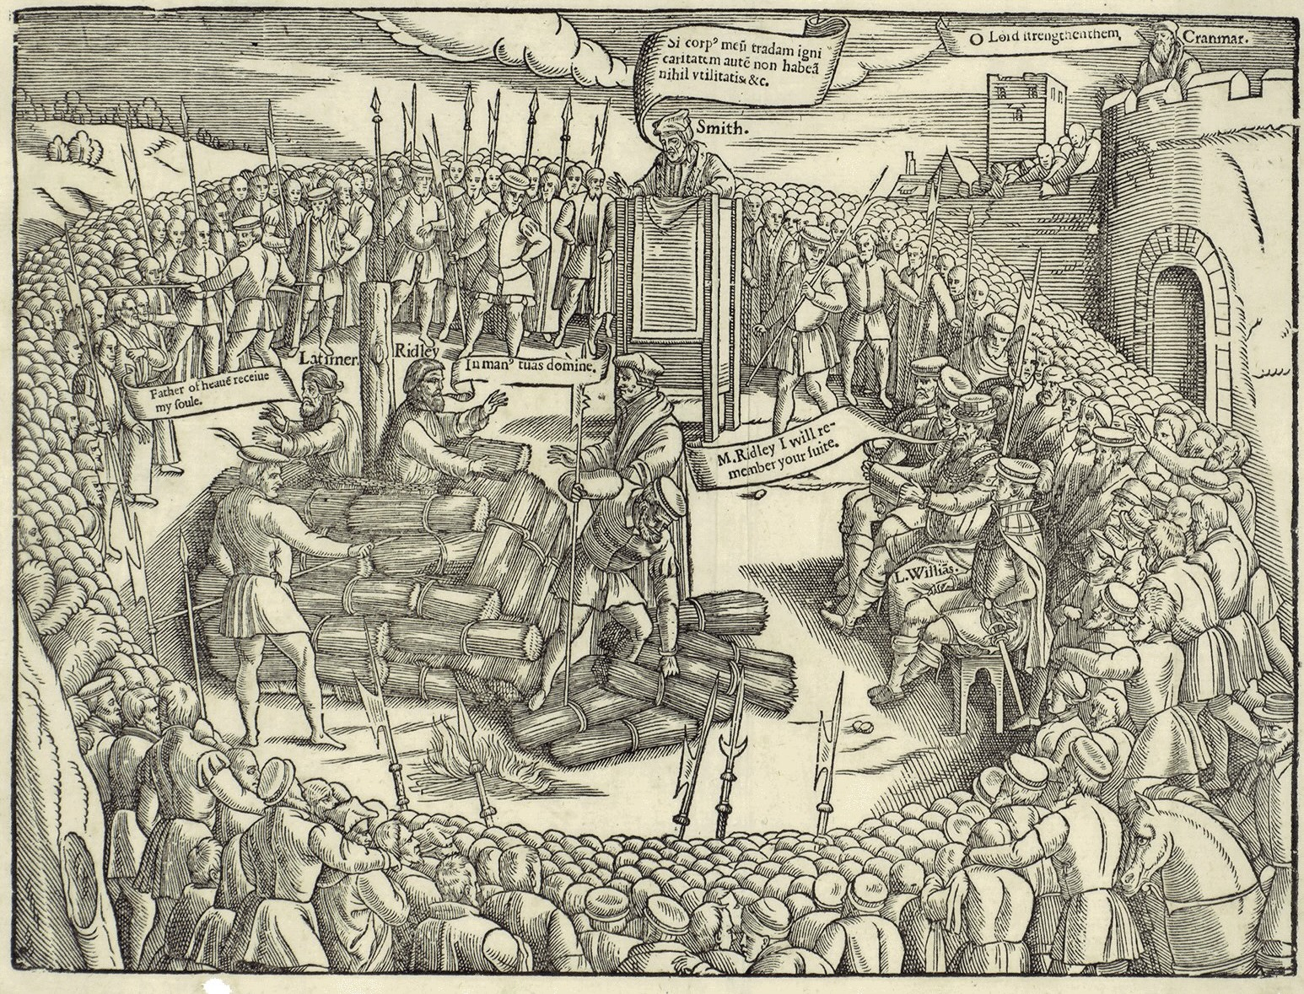  Protestant martyrs, as shown by John Foxe.
John Foxe, Actes and Monuments (1563); public domain copies on Wikimedia Commons.
How Heresy Changed, 1500-1700
Heresy did not disappear - but it was increasingly replaced by treason as the way to punish religious opponents.
▸ Henry VIII. Burned both Protestants who denied Catholic teaching and Catholics who denied his supremacy - the second as traitors.
▸ Mary I. Revived the heresy laws in 1554 and burned around 280 Protestants in under four years.
▸ Elizabeth I. Burned only a handful of heretics; she mainly punished Catholics for treason instead.
▸ James I. The last burnings for heresy in England took place in 1612.
Latimer at the Stake
“Be of good comfort, Master Ridley, and play the man. We shall this day light such a candle, by God's grace, in England, as I trust shall never be put out.”
— Hugh Latimer to Nicholas Ridley as they were burned at Oxford, 1555, as reported by John Foxe
WHAT IT SHOWS Burning heretics was meant to stamp out their ideas - but the martyrs' courage, retold by Foxe, helped spread Protestantism instead.
Key Terms
Heresy  Holding religious beliefs that go against the official teaching of the Church. | Heretic  A person found guilty of heresy.
Recant  To take back your beliefs publicly. | Martyr  Someone who dies for their beliefs.
Burning at the stake  The punishment for heresy: death by fire in public. | Book of Martyrs  John Foxe's 1563 account of Protestants burned under Mary I.
Summary
✓ Heresy was seen as a threat to people's souls and to order.
✓ Heretics were questioned by the Church and burned by the state.
✓ Mary I burned around 280 Protestants; Elizabeth mostly used treason instead.
✓ The last heresy burnings in England were in 1612.

EXAM FOCUS
Explain why heresy was punished so severely in the period c1500-c1700. (12 marks)
Explain the religious reasons (souls, damnation) and the political reasons (the monarch's authority), then support each with a specific example.

