EDEXCEL GCSE HISTORY · PAPER 1 · CRIME & PUNISHMENT
Heresy and its Punishment
c1500-c1700 · Chapter 2: Crime and punishment in early modern England, c1500-c1700 · Lesson 2 of 5
Teacher copy - includes the notes for whoever is teaching from it.
Learning Objectives
1. Define heresy and explain why it was seen as such a serious crime.
2. Describe how heretics were tried and punished, including burning at the stake.
3. Explain how and why the treatment of heresy changed between 1500 and 1700.
Setting the Scene
Heresy meant holding religious beliefs that went against the official teaching of the Church. People believed a heretic's soul was damned - and that a heretic could lead others to damnation too. Because the official religion kept changing, the same belief could be heresy under one monarch and the law under the next.
1530s - Henry VIII burns Protestants who deny Catholic beliefs about the Mass. | 1547 - Edward VI repeals the old heresy laws. | 1555 - Mary I begins burning Protestants; Bishops Latimer and Ridley burned at Oxford. | 1556 - Archbishop Thomas Cranmer is burned. | 1563 - John Foxe publishes his Book of Martyrs. | 1612 - The last burnings for heresy in England.
Why Heresy Was So Serious
To people at the time, heresy was worse than murder: it killed the soul, not just the body.
▸ Damnation. People believed heretics would go to Hell, and that heresy could spread and damn whole communities.
▸ Order. The Church taught obedience; rejecting its teaching seemed to threaten order and the authority of the monarch.
▸ Example. Punishment was public so that others would be frightened away from the heretic's ideas.
▸ Chance to recant. Accused heretics were urged to recant - take back their beliefs - and many who did were spared.
How a Heretic Was Dealt With
Church and state worked together.
1  Accused  A suspect was reported to the Church authorities. | 2  Questioned  Church officials examined their beliefs, often over weeks or months. | 3  Urged to recant  They were given the chance to take back their beliefs publicly. | 4  Condemned  If they refused, the Church handed them to the state. | 5  Burned  The state carried out the sentence: burning at the stake in public.
Foxe's Book of Martyrs
John Foxe's Book of Martyrs described the Protestants burned under Mary I in vivid detail. It was placed in many churches and shaped how English Protestants remembered her reign.  Why it matters as a source  ▸ Detailed. Names, places and dates for hundreds of executions.  ▸ Biased. Written by a Protestant to show Catholics as cruel.  ▸ Influential. Helped create the name "Bloody Mary". | 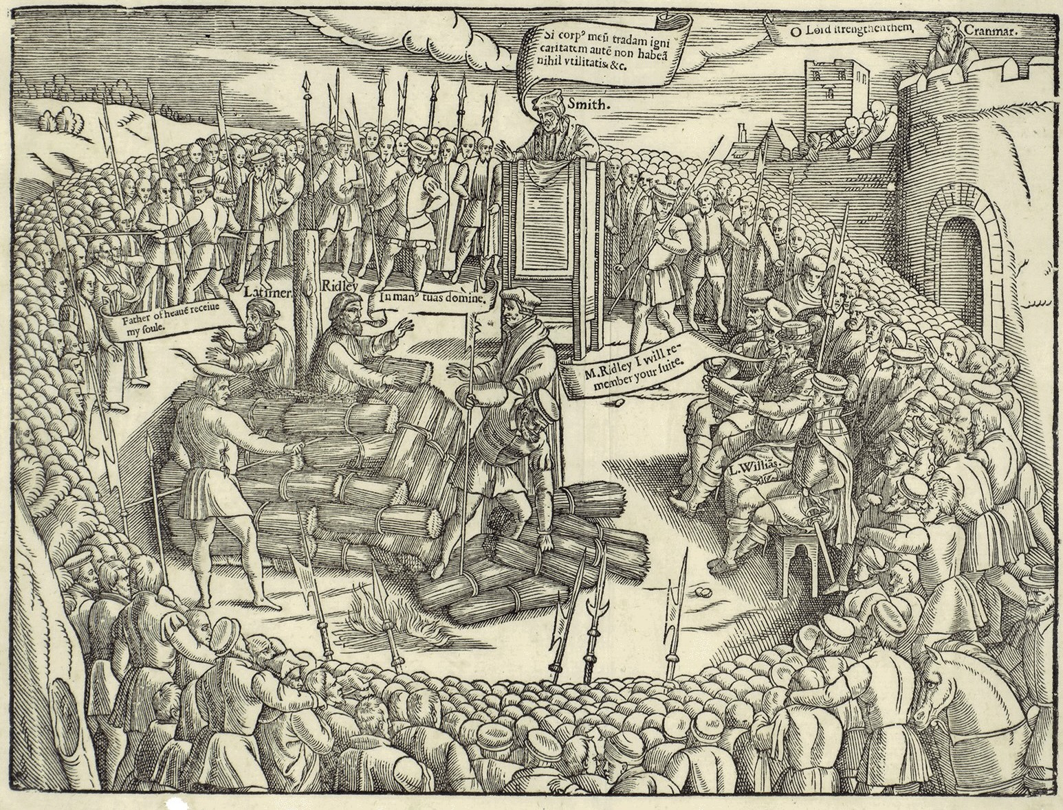  Protestant martyrs, as shown by John Foxe.
John Foxe, Actes and Monuments (1563); public domain copies on Wikimedia Commons.
How Heresy Changed, 1500-1700
Heresy did not disappear - but it was increasingly replaced by treason as the way to punish religious opponents.
▸ Henry VIII. Burned both Protestants who denied Catholic teaching and Catholics who denied his supremacy - the second as traitors.
▸ Mary I. Revived the heresy laws in 1554 and burned around 280 Protestants in under four years.
▸ Elizabeth I. Burned only a handful of heretics; she mainly punished Catholics for treason instead.
▸ James I. The last burnings for heresy in England took place in 1612.
Latimer at the Stake
“Be of good comfort, Master Ridley, and play the man. We shall this day light such a candle, by God's grace, in England, as I trust shall never be put out.”
— Hugh Latimer to Nicholas Ridley as they were burned at Oxford, 1555, as reported by John Foxe
WHAT IT SHOWS Burning heretics was meant to stamp out their ideas - but the martyrs' courage, retold by Foxe, helped spread Protestantism instead.
Key Terms
Heresy  Holding religious beliefs that go against the official teaching of the Church. | Heretic  A person found guilty of heresy.
Recant  To take back your beliefs publicly. | Martyr  Someone who dies for their beliefs.
Burning at the stake  The punishment for heresy: death by fire in public. | Book of Martyrs  John Foxe's 1563 account of Protestants burned under Mary I.
Summary
✓ Heresy was seen as a threat to people's souls and to order.
✓ Heretics were questioned by the Church and burned by the state.
✓ Mary I burned around 280 Protestants; Elizabeth mostly used treason instead.
✓ The last heresy burnings in England were in 1612.

EXAM FOCUS
Explain why heresy was punished so severely in the period c1500-c1700. (12 marks)
Explain the religious reasons (souls, damnation) and the political reasons (the monarch's authority), then support each with a specific example.
Exam Practice - Heresy
Answer all questions. Use specific names, dates and examples in every answer. · 35 minutes
▸ Question 1 · 4 marks · Explain one way. Explain one way in which the punishment of heresy under Henry VIII was similar to the punishment of heresy under Mary I.
▸ Question 2 · 12 marks · Explain why. Explain why heresy was punished so severely in the period c1500-c1700. You may use the following in your answer: the burnings under Mary I…
▸ Question 3 · 16 marks · How far do you agree?. "The main reason religious opponents were punished in the period c1500-c1700 was to protect the authority of the monarch." How far do you…
Question 1 · 4 marks · Explain one way
“Explain one way in which the punishment of heresy under Henry VIII was similar to the punishment of heresy under Mary I.”
HOW TO ANSWER IT Command word: Explain one way. Worth 4 marks, so plan before writing.
Question 1 · mark scheme
4 marks available. Award a mark for each point made.
▸ A valid similarity identified. 1-2 marks
▸ Supported with specific knowledge of both reigns. 3-4 marks
▸ Model answer. In both reigns heretics were punished by burning at the stake in public. Under Henry VIII, Protestants who denied Catholic teaching about the Mass were burned, and under Mary I around 280 Protestants were burned between 1555 and 1558, including Latimer and Ridley at Oxford in 1555. In both reigns the burnings were public so that they would frighten others away from heresy.
Question 2 · 12 marks · Explain why
“Explain why heresy was punished so severely in the period c1500-c1700. You may use the following in your answer: the burnings under Mary I; the authority of the monarch. You must also use information of your own.”
HOW TO ANSWER IT Command word: Explain why. Worth 12 marks, so plan before writing.
Question 2 · mark scheme
12 marks available. Award a mark for each point made.
▸ Level 1 (1-3). A simple or general answer
▸ Level 2 (4-6). Some explanation of one or more reasons, with some knowledge
▸ Level 3 (7-9). A developed explanation linked to the question, with accurate knowledge
▸ Level 4 (10-12). An analytical explanation of several reasons, with knowledge that goes beyond the stimulus points
▸ Model answer. One reason was religious belief. People believed heretics would go to Hell and could lead others there too, so heresy was seen as more dangerous than murder. Mary I burned around 280 Protestants between 1555 and 1558 because she believed she was saving England's souls by restoring the Catholic faith and stopping the spread of Protestant ideas. A second reason was the authority of the monarch. After the Act of Supremacy of 1534, the monarch was Head of the Church of England, so rejecting the official religion also meant rejecting the monarch. Heresy was therefore a threat to order as well as to souls, and punishing it severely showed the monarch's power. A third reason, beyond the stimulus, was deterrence. Burnings were carried out in public, such as those of Latimer and Ridley at Oxford in 1555, so that crowds would see the terrible price of heresy and be frightened away from it. Accused heretics were given the chance to recant, which shows that the aim was to stop the belief spreading rather than simply to kill.
Question 3 · 16 marks · How far do you agree?
“"The main reason religious opponents were punished in the period c1500-c1700 was to protect the authority of the monarch." How far do you agree? Explain your answer. You may use the following in your answer: Mary I; recusancy. You must also use information of your own. (16 marks, plus 4 for…”
HOW TO ANSWER IT Command word: How far do you agree?. Worth 16 marks, so plan before writing.
Question 3 · mark scheme
16 marks available. Award a mark for each point made.
▸ Level 1 (1-4). A simple or generalised answer
▸ Level 2 (5-8). Some analysis, with a judgement that is asserted
▸ Level 3 (9-12). Analysis of both sides with accurate knowledge and a supported judgement
▸ Level 4 (13-16). Sustained analysis, knowledge beyond the stimulus, and a clear, justified judgement
▸ SPaG (4). Accurate spelling, punctuation and grammar, with specialist terms such as heresy and recusancy
▸ Model answer. On the one hand, protecting the monarch's authority was very important. After the Act of Supremacy in 1534, denying the king's headship of the Church was treason, and Thomas More was executed in 1535. Elizabeth I fined recusants and executed around 200 Catholics, mostly priests, for treason, because after 1570 the Pope had told Catholics they need not obey her. These punishments were clearly about loyalty to the monarch. On the other hand, religious belief itself was also a major reason. Mary I burned around 280 Protestants as heretics because she believed they endangered souls and the true Catholic faith, not simply because they threatened her power. The public burnings, like those of Latimer and Ridley in 1555, were meant to stop dangerous ideas spreading, and heretics were given the chance to recant to save their souls. Overall, both reasons mattered, but they were so closely linked that they are hard to separate: because the monarch led the Church, a religious opponent was also a political one. The balance shifted over time - Mary's punishments were mainly religious, while Elizabeth's were mainly about protecting her authority.

