EDEXCEL GCSE HISTORY · PAPER 1 · CRIME & PUNISHMENT
The Gunpowder Plot, 1605
1605-1606 · Chapter 2: Crime and punishment in early modern England, 1605-1606 · Lesson 5 of 5
Teacher copy - includes the notes for whoever is teaching from it.
Learning Objectives
1. Explain why a group of Catholics plotted to kill James I in 1605.
2. Describe how the plot was discovered and how the plotters were punished.
3. Explain why the punishment was so severe, and what the consequences were for Catholics.
Setting the Scene
When James I became king in 1603, English Catholics hoped he would treat them better than Elizabeth had. He did not, and recusancy fines continued. A small group of Catholics led by Robert Catesby decided to kill the king, his government and Parliament in one explosion, and put a Catholic monarch on the throne.
1603 - James I becomes king of England. | 1604 - The plotters rent a cellar beneath the House of Lords. | 26 Oct 1605 - Lord Monteagle receives an anonymous warning letter. | 4-5 Nov 1605 - Guy Fawkes is caught guarding 36 barrels of gunpowder. | 8 Nov 1605 - Catesby and Thomas Percy are killed at Holbeach House. | Jan 1606 - The surviving plotters are tried and executed.
How the Plot Unravelled
The plot failed before it could be carried out.
1  The plan  Blow up the House of Lords at the State Opening of Parliament on 5 November 1605, killing the king. | 2  The warning  Lord Monteagle, a Catholic, received an anonymous letter telling him to stay away from Parliament. | 3  The search  The cellars were searched late on 4 November, and Guy Fawkes was found with 36 barrels of gunpowder. | 4  Interrogation  James I allowed Fawkes to be tortured in the Tower of London; he gave up the names of the other plotters. | 5  Capture  The plotters fled to the Midlands; Catesby and Percy were killed at Holbeach House on 8 November.
The Monteagle Letter
“I would advise you, as you tender your life, to devise some excuse to shift your attendance at this parliament... they shall receive a terrible blow this parliament and yet they shall not see who hurts them.”
— The anonymous letter sent to Lord Monteagle, 26 October 1605
WHAT IT SHOWS The letter warned a Catholic lord to stay away - and when it was shown to the government, it led directly to the search that caught Guy Fawkes.
The Conspirators
The plot involved thirteen conspirators. Robert Catesby was the leader; Guy Fawkes, an experienced soldier, was chosen to guard and light the gunpowder.  Key plotters  ▸ Robert Catesby. Leader of the plot; killed at Holbeach House.  ▸ Guy Fawkes. Caught with the gunpowder; tortured and executed.  ▸ Thomas Percy. Rented the cellar; killed at Holbeach House. | 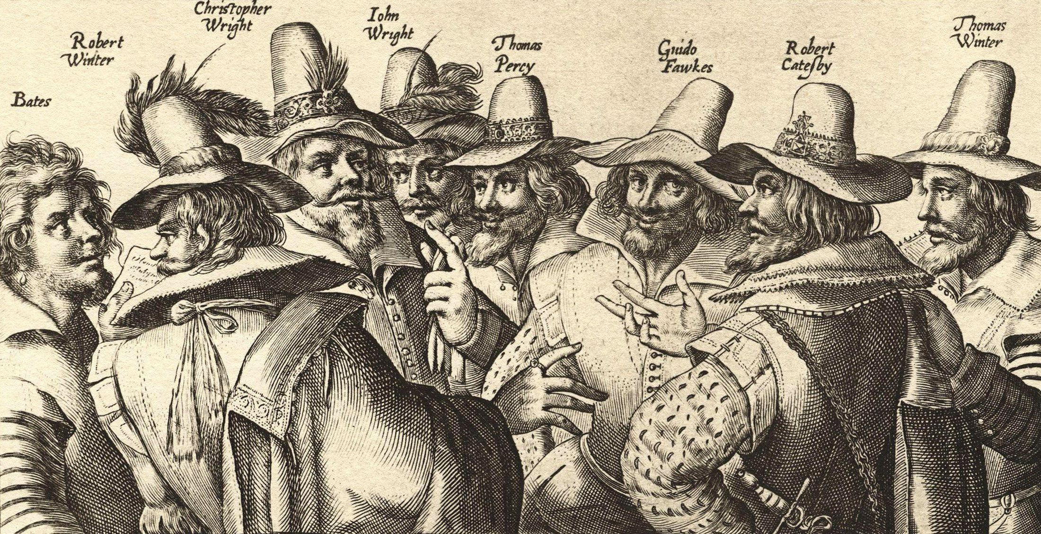  Eight of the thirteen conspirators, engraved in 1605.
Crispijn van de Passe the Elder, 1605; public domain copies on Wikimedia Commons.
Trial and Punishment
The punishment was designed to be seen.
▸ The trial. The surviving plotters were tried in Westminster Hall on 27 January 1606 and all were found guilty of high treason.
▸ The sentence. They were sentenced to be hanged, drawn and quartered - the traditional punishment for treason.
▸ The executions. Four were executed in St Paul's Churchyard on 30 January and four, including Fawkes, at Westminster on 31 January 1606.
▸ Display. Their heads were put on display in London as a warning to others.
Why Was the Punishment So Severe?
Several reasons combined.
Treason  Plotting to kill the monarch was the most serious crime of all, and hanging, drawing and quartering was its set punishment. | The scale  The plot aimed to kill the king, his family, the government and Parliament in one blow.
Deterrence  A public, brutal execution warned other Catholics not to try anything similar. | Royal authority  James wanted to show his power as a new king from Scotland.
Consequences for Catholics
The actions of a few were used to justify harsher treatment of all Catholics.
▸ Popish Recusants Act. The Popish Recusants Act of 1606 made Catholics swear an oath of allegiance to the king and increased pressure on recusants.
▸ Restrictions. Catholics were barred from professions such as the law, and from holding office.
▸ Suspicion. Catholics were seen as potential traitors for the rest of the century.
▸ Celebration. The Observance of 5th November Act (1606) ordered an annual day of thanksgiving for the king's survival.
Key Terms
Gunpowder Plot  The 1605 Catholic plan to blow up James I and Parliament. | High treason  Plotting to harm or overthrow the monarch.
Hanged, drawn and quartered  The punishment for treason: hanged, cut open and cut into four. | Monteagle letter  The anonymous warning that led to the plot's discovery.
Popish Recusants Act  The 1606 law that increased restrictions on Catholics. | Oath of allegiance  A promise of loyalty to the king that Catholics had to swear.
Summary
✓ Catholic plotters led by Catesby tried to blow up James I on 5 November 1605.
✓ The Monteagle letter led to the discovery of Guy Fawkes and the gunpowder.
✓ The plotters were hanged, drawn and quartered for high treason in January 1606.
✓ The plot led to harsher laws against Catholics, including the Popish Recusants Act.

EXAM FOCUS
Explain why the Gunpowder plotters were punished so severely. (12 marks)
Go beyond "it was treason" - explain why this treason was seen as so dangerous and what the government wanted the punishment to achieve.
Exam Practice - The Gunpowder Plot
Answer all questions. Use specific names, dates and examples in every answer. · 35 minutes
▸ Question 1 · 4 marks · Explain one way. Explain one way in which the punishment of the Gunpowder plotters in 1606 was similar to the punishment of Catholic priests under Elizabeth…
▸ Question 2 · 12 marks · Explain why. Explain why the Gunpowder plotters were punished so severely. You may use the following in your answer: the crime of treason; the Monteagle…
▸ Question 3 · 16 marks · How far do you agree?. "The main consequence of the Gunpowder Plot was harsher treatment of Catholics." How far do you agree? Explain your answer. You may use the…
Question 1 · 4 marks · Explain one way
“Explain one way in which the punishment of the Gunpowder plotters in 1606 was similar to the punishment of Catholic priests under Elizabeth I.”
HOW TO ANSWER IT Command word: Explain one way. Worth 4 marks, so plan before writing.
Question 1 · mark scheme
4 marks available. Award a mark for each point made.
▸ A valid similarity identified. 1-2 marks
▸ Supported with specific knowledge of both. 3-4 marks
▸ Model answer. In both cases Catholics were punished for high treason rather than for heresy, with the traditional punishment for treason: hanging, drawing and quartering. Around 200 Catholics, mostly priests, were executed for treason under Elizabeth I, and the surviving Gunpowder plotters were executed in the same way in January 1606. In both cases the executions were public, so that they would warn other Catholics against threatening the monarch.
Question 2 · 12 marks · Explain why
“Explain why the Gunpowder plotters were punished so severely. You may use the following in your answer: the crime of treason; the Monteagle letter. You must also use information of your own.”
HOW TO ANSWER IT Command word: Explain why. Worth 12 marks, so plan before writing.
Question 2 · mark scheme
12 marks available. Award a mark for each point made.
▸ Level 1 (1-3). A simple or general answer
▸ Level 2 (4-6). Some explanation of one or more reasons, with some knowledge
▸ Level 3 (7-9). A developed explanation linked to the question, with accurate knowledge
▸ Level 4 (10-12). An analytical explanation of several reasons, with knowledge that goes beyond the stimulus points
▸ Model answer. One reason was that the plotters were guilty of high treason, the most serious crime of all. They planned to kill James I at the State Opening of Parliament on 5 November 1605, and the set punishment for treason was hanging, drawing and quartering. The trial in Westminster Hall in January 1606 found them all guilty, and they were executed on 30 and 31 January. A second reason was the enormous scale of what they had planned. The Monteagle letter warned that Parliament would "receive a terrible blow", and the search found Guy Fawkes with 36 barrels of gunpowder beneath the House of Lords - enough to kill the king, his family, his government and Parliament at once. A plot that could have destroyed the whole government demanded the harshest possible response. A third reason, beyond the stimulus, was the need to deter others and show royal authority. James I was a new king from Scotland and Catholics were already seen as a threat after the plots against Elizabeth. By executing the plotters in public and displaying their heads, the government sent a clear warning to any other Catholics, and James showed that he was in control.
Question 3 · 16 marks · How far do you agree?
“"The main consequence of the Gunpowder Plot was harsher treatment of Catholics." How far do you agree? Explain your answer. You may use the following in your answer: the Popish Recusants Act (1606); the Observance of 5th November Act (1606). You must also use information of your own. (16 marks…”
HOW TO ANSWER IT Command word: How far do you agree?. Worth 16 marks, so plan before writing.
Question 3 · mark scheme
16 marks available. Award a mark for each point made.
▸ Level 1 (1-4). A simple or generalised answer
▸ Level 2 (5-8). Some analysis, with a judgement that is asserted
▸ Level 3 (9-12). Analysis of both sides with accurate knowledge and a supported judgement
▸ Level 4 (13-16). Sustained analysis, knowledge beyond the stimulus, and a clear, justified judgement
▸ SPaG (4). Accurate spelling, punctuation and grammar, with specialist terms such as treason and recusant
▸ Model answer. On the one hand, harsher treatment of Catholics was a major consequence. The Popish Recusants Act of 1606 made Catholics swear an oath of allegiance to the king and increased the pressure on recusants. Catholics were barred from professions such as the law and from holding office, and they were treated as potential traitors. The actions of thirteen men were used to justify restrictions on all Catholics. On the other hand, there were other important consequences. The plot strengthened James I's position: his survival was presented as a sign of God's protection, and the Observance of 5th November Act of 1606 ordered an annual day of thanksgiving, celebrating the king's escape every year afterwards. The executions themselves showed the power of the Crown, and the plot reinforced the idea that treason would be punished in the most severe and public way. Overall, harsher treatment of Catholics was the most direct consequence because it affected the whole Catholic population through new laws. But the strengthening of royal authority was also significant, and the two were linked: presenting Catholics as a threat helped James present himself as the protector of Protestant England.

