EDEXCEL GCSE BUSINESS · PAPER 1
The dynamic nature of business
Enterprise and entrepreneurship · Lesson 1 of 3
Teacher copy - includes the notes for whoever is teaching from it.
What Do You Already Know?
Jot your answers down before we look at them.
1. Name a business you use that did not exist fifteen years ago.
Examples: Deliveroo, TikTok Shop, Uber, Spotify, Monzo - all made possible by smartphones and apps.
2. Name a product your parents used that hardly anyone buys now.
Examples: DVDs, CDs, film cameras, satellite navigation boxes, landline phones.
3. What does "dynamic" mean?
Constantly changing and developing.
4. Why might a business that sells exactly the same thing for twenty years get into trouble?
Customers' wants, technology and competitors all change around it.
Note: Ninety seconds. This is about getting them thinking about businesses they already use, not about right answers.
Learning Objectives
1. Explain what is meant by the dynamic nature of business.
2. Explain why new business ideas come about: changes in technology, changes in what consumers want, and products and services becoming obsolete.
3. Explain how new business ideas come about: original ideas, and adapting existing products, services and ideas.
4. Apply these reasons to real businesses in an exam answer.
The Big Idea
Markets never stand still, so neither can the businesses in them.
Every change in technology or in what people want is a threat to one business and an opportunity for another.
What Does "Dynamic" Mean?
A dynamic market is one that is constantly changing.
▸ Constant change. The business world changes all the time: new technology is invented, customers' tastes shift, and new competitors arrive.
▸ Threats. A business that does not keep up can lose its customers to rivals who do, and eventually close.
▸ Opportunities. Every change creates a gap that an entrepreneur can fill with a new product or service.
▸ Why it matters. Businesses must keep watching their market and be ready to adapt what they sell and how they sell it.
Where Do New Ideas Come From?
New business ideas do not appear out of nowhere. Something in the world changes, somebody notices a gap it has left, and they come up with a product or service to fill it - either something completely new or a better version of something that already exists. |   Most new businesses begin as one idea talked through around a table.

PART ONE
Why New Business Ideas Come About
Three kinds of change create the gaps that new businesses fill.
Why new business ideas come about
Why new business ideas come about

Changes in technology  ▸ new products (smartphones, electric cars)  ▸ new ways to sell (online, apps)  ▸ new services (streaming, ride-hailing) | Changes in consumer wants  ▸ healthier eating  ▸ ethical and sustainable products  ▸ convenience  ▸ new fashions and trends | Products becoming obsolete  ▸ DVDs replaced by streaming  ▸ film cameras by phone cameras  ▸ paper maps by sat-nav and apps
Changes in Technology
New technology makes new products, and new ways of selling, possible.
▸ New products. Technology allows products that could not exist before, such as smartphones, smart watches, electric cars and video doorbells.
▸ New services. The smartphone made app-based services possible: food delivery (Deliveroo, Just Eat), ride-hailing (Uber) and music streaming (Spotify).
▸ New ways of selling. The internet lets even a tiny business sell to customers across the country through its own website, Etsy, eBay or social media.
▸ Lower costs. Technology can make production cheaper, so a small business can compete - for example 3D printing, or online tools for design and accounts.
Technology Creates New Businesses
Before smartphones, ordering a takeaway meant phoning the restaurant, and most restaurants did not deliver at all. Delivery apps link customers, restaurants and riders in one place - a whole new business that technology created.  The same change created other businesses too  ▸ Dark kitchens. Kitchens with no dining room that cook only for delivery.  ▸ Riders. Self-employed riders working for several apps.  ▸ Restaurants. Able to reach customers without paying for more tables. |   App-based delivery only became possible once most people carried a smartphone.

Changes in Consumer Wants
What customers want changes over time, and new businesses spring up to supply it.
▸ Healthier lifestyles. Growing interest in health has created demand for gyms, protein snacks, low-sugar drinks and fitness apps.
▸ Ethical and green choices. Customers increasingly want products that are sustainable, recyclable, plant-based or fairly traded - opening markets for refill shops and vegan food brands.
▸ Convenience. Busy lives mean customers will pay for things that save time: meal kits, next-day delivery, click-and-collect.
▸ Fashions and trends. Tastes change quickly, often driven by social media, so a product that is popular this year may not be next year.
Products and Services Becoming Obsolete
Obsolete means out of date - no longer wanted because something better has replaced it.
▸ What happens. When a product becomes obsolete, demand for it falls, often very quickly, and businesses that rely on it may fail.
▸ Why it happens. Usually because new technology produces a better product, or because consumer wants have changed.
▸ The opportunity. Every obsolete product leaves customers who still have the need, so an entrepreneur can supply the replacement.
▸ Examples. DVDs and CDs replaced by streaming, film cameras by phone cameras, paper road maps by sat-nav and map apps.
Case in Point: Watching Films at Home
The way people watch films at home has been replaced three times in forty years. Each change made one business model obsolete and created a new one.
1980s - Video shops rent out VHS tapes and become a feature of every high street. | 1997 - DVDs go on sale, and Netflix is founded in the USA to post DVDs to customers. | 2007 - Netflix launches streaming, using faster broadband to play films online. | 2012 - Netflix launches in the UK. | 2013 - Blockbuster's UK stores close: renting a disc from a shop is now obsolete.
From Obsolete to New
The same need - watching a film at home - met in two very different ways.
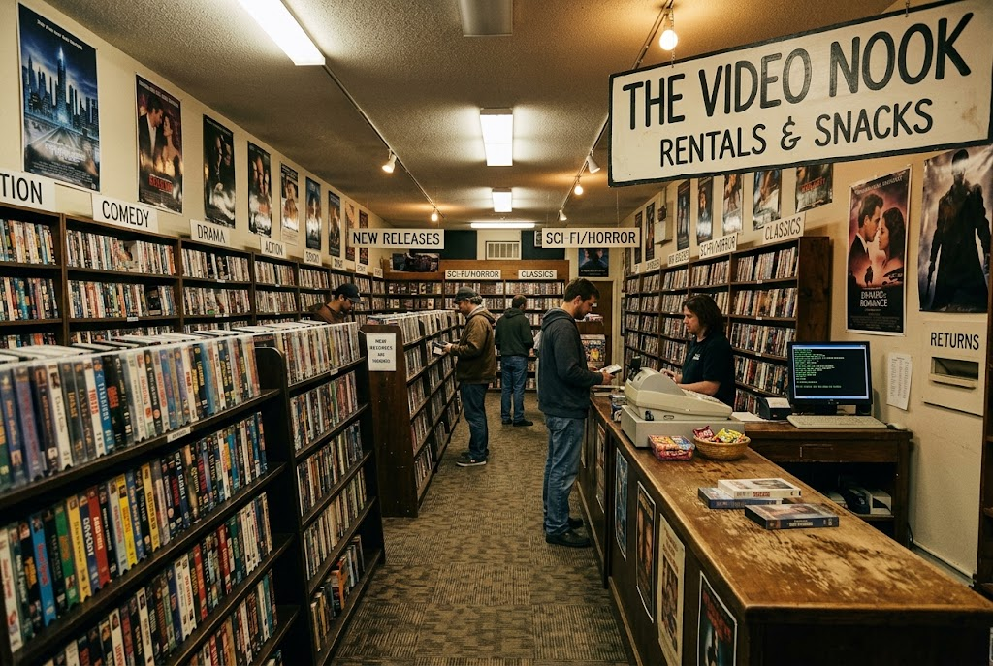  Renting a disc from a shop: now obsolete. | 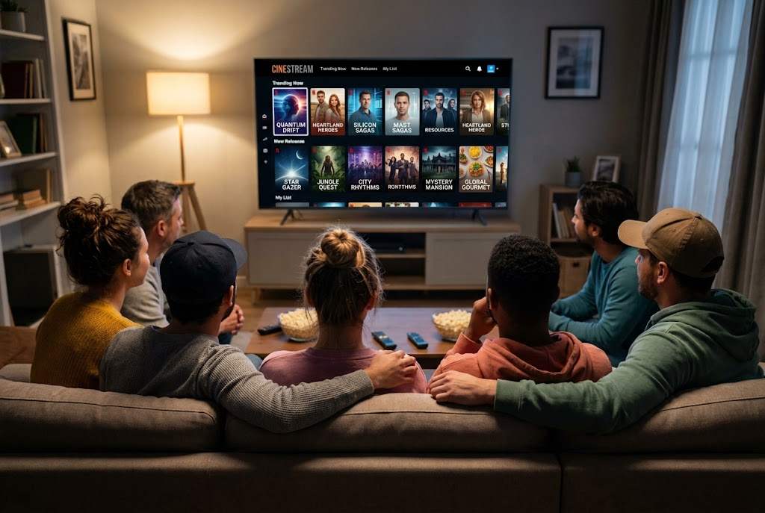  Streaming: the service that replaced it.

PART TWO
How New Business Ideas Come About
Once a gap appears, an entrepreneur can fill it in one of two ways.
Original Ideas or Adapting Existing Ones?
ORIGINAL IDEAS | ADAPTING EXISTING IDEAS
▸ Something genuinely new that has not been done before.  ▸ Often comes from new technology or an invention.  ▸ Can give the business the whole market to itself at first.  ▸ Riskier: nobody knows yet whether customers will want it.  ▸ Example: Dyson's bagless vacuum cleaner. | ▸ Taking a product, service or idea that already exists and changing it.  ▸ Often comes from spotting a weakness in what is already on offer.  ▸ Customers already understand the product, so it is easier to sell.  ▸ Less risky, but there will already be competitors.  ▸ Example: a café adding vegan options, or a gym opening 24 hours a day.
Original Ideas
An original idea is a completely new product or service.
▸ What it is. An idea that has not been done before, often the result of an invention or a new use of technology.
▸ Advantage. The business may be first into the market with no direct competitors, and can often charge a higher price.
▸ Disadvantage. It is risky: there is no proof that customers want it, and developing something new can be expensive and slow.
▸ Example. James Dyson invented a vacuum cleaner that did not need a bag, which no other manufacturer offered at the time.
Adapting Existing Products, Services and Ideas
Most new businesses do not invent something new - they improve something that already exists.
▸ Improving a product. Making it better, cheaper, faster, healthier or more convenient than what is already sold.
▸ A new market. Taking an idea that works in one place or for one group of customers and offering it somewhere else or to someone else.
▸ Combining ideas. Putting two existing ideas together, for example a bookshop with a café in it.
▸ Why it works. Customers already understand the product, so there is less risk - but the business must find a way to stand out from existing competitors.
Case Study
CASE STUDY
Netflix: Adapting to Survive
Netflix began in 1997 by adapting an existing idea: instead of customers going to a shop to rent a DVD, it posted the DVDs to them. When faster broadband arrived, Netflix adapted again and moved to streaming in 2007, making its own DVD-by-post business out of date before a competitor could. Blockbuster, which did not adapt quickly enough, closed its UK shops in 2013. Netflix shows all three reasons for new ideas at once: new technology (broadband), changing consumer wants (instant, on-demand viewing) and an obsolete product (the rented disc).

1997  Founded as a DVD-by-post service | 2007  Moved into streaming
Key Terms
Dynamic  Constantly changing. Business markets are dynamic because technology, customer wants and competition keep changing. | Obsolete  Out of date and no longer wanted, usually because a better product has replaced it.
Consumer wants  The goods and services that customers would like to buy. | Original idea  A completely new product or service that has not been offered before.
Adapting  Changing an existing product, service or idea to improve it or to suit different customers. | Innovation  Turning a new idea into a product or service that is actually sold.
Match the Change to the Business
Which reason explains each new business?
New business | Why it came about
A refill shop selling loose pasta and washing-up liquid
Changing consumer wants: less plastic packaging
A phone repair stall in a shopping centre
Changing technology: almost everyone owns a smartphone
A music streaming app
A product becoming obsolete: CDs replaced by streaming
A vegan burger range
Changing consumer wants: more people eating less meat
An electric car charging company
Changing technology: the switch to electric cars
Your Task: Spot the Gap
10 minutes
Choose three products or services you or your family have stopped using in the last five years. For each one, say what replaced it, which reason for new business ideas explains the change, and whether the new business was an original idea or an adaptation.
1. Name the old product and what replaced it.
2. Name the reason for the change.
3. Decide: original idea or adaptation? Explain why.
A good answer shows: Three examples, each linked to a named reason (technology, consumer wants or obsolescence) and a judgement of original or adapted, with a reason.
Note: Push them to explain WHY the change happened, not just name it - that is the analysis marks in the exam.
Can I...?
☐ Explain what is meant by the dynamic nature of business.
☐ Explain how changes in technology lead to new business ideas.
☐ Explain how changes in consumer wants lead to new business ideas.
☐ Explain what obsolete means and how it creates new business ideas.
☐ Explain the difference between an original idea and an adapted idea.
☐ Use a real example for each.
Summary
✓ Business is dynamic: technology, customer wants and competition change all the time.
✓ New ideas come about because of changes in technology, changes in consumer wants and products becoming obsolete.
✓ New ideas are either original or adaptations of existing products, services and ideas.
✓ Adapting is less risky than an original idea, but there is more competition.

EXAM FOCUS
Outline one reason why new business ideas come about. (2 marks)
Outline questions are worth 2 marks: 1 for the reason and 1 for developing it. Name the reason, then add a linked point that shows why it leads to a new business idea - an example helps.
Exam Practice: The Dynamic Nature of Business
Answer all questions. Use the context of the business in the question where one is given. · 20 minutes
▸ Question 1 · 1 mark · Define. Define the term 'obsolete'.
▸ Question 2 · 1 mark · State. State one reason why new business ideas come about.
▸ Question 3 · 2 marks · Outline. Outline one reason why new business ideas come about.
▸ Question 4 · 2 marks · Outline. Outline one way an entrepreneur can come up with a new business idea.
▸ Question 5 · 3 marks · Explain. Explain one risk to a business of its product becoming obsolete.
Question 1 · 1 mark · Define
“Define the term 'obsolete'.”
HOW TO ANSWER IT Command word: Define. Worth 1 mark, so plan before writing.
Question 1 · mark scheme
1 mark available. Award a mark for each point made.
▸ Out of date / no longer wanted or used. 1 mark
▸ Model answer. A product or service that is out of date and no longer wanted by customers, usually because something better has replaced it.
Question 2 · 1 mark · State
“State one reason why new business ideas come about.”
HOW TO ANSWER IT Command word: State. Worth 1 mark, so plan before writing.
Question 2 · mark scheme
1 mark available. Award a mark for each point made.
▸ Any one of: changes in technology; changes in consumer wants; products or services becoming obsolete. 1 mark
▸ Model answer. Changes in technology.
Question 3 · 2 marks · Outline
“Outline one reason why new business ideas come about.”
HOW TO ANSWER IT Command word: Outline. Worth 2 marks, so plan before writing.
Question 3 · mark scheme
2 marks available. Award a mark for each point made.
▸ A reason identified, e.g. changes in technology / consumer wants / products becoming obsolete. 1 mark
▸ Developed: why this leads to a new business idea. 1 mark
▸ Model answer. Changes in technology create new business ideas (1) because they make new products and services possible, for example smartphones made app-based food delivery services such as Deliveroo possible (1).
Question 4 · 2 marks · Outline
“Outline one way an entrepreneur can come up with a new business idea.”
HOW TO ANSWER IT Command word: Outline. Worth 2 marks, so plan before writing.
Question 4 · mark scheme
2 marks available. Award a mark for each point made.
▸ A way identified: an original idea / adapting an existing product, service or idea. 1 mark
▸ Developed: how this produces a business idea. 1 mark
▸ Model answer. An entrepreneur can adapt an existing product (1). Observing existing products can lead to ideas about how they might be improved, so the entrepreneur can innovate an existing product rather than start from nothing (1).
Question 5 · 3 marks · Explain
“Explain one risk to a business of its product becoming obsolete.”
HOW TO ANSWER IT Command word: Explain. Worth 3 marks, so plan before writing.
Question 5 · mark scheme
3 marks available. Award a mark for each point made.
▸ A risk identified, e.g. falling sales / revenue / business failure. 1 mark
▸ First linked point of explanation. 1 mark
▸ Second linked point of explanation. 1 mark
▸ Model answer. Its sales could fall sharply (1) because customers will switch to the newer product that has replaced it (1). As a result the business's revenue falls, and if it cannot adapt quickly enough it may be forced to close, as Blockbuster's UK stores did when streaming replaced DVD rental (1).

