EDEXCEL GCSE BUSINESS · PAPER 1
Risk and reward
Enterprise and entrepreneurship · Lesson 2 of 3
Teacher copy - includes the notes for whoever is teaching from it.
Last Lesson
Answer from memory before the answers appear.
1. Give the three reasons why new business ideas come about.
Changes in technology, changes in consumer wants, and products or services becoming obsolete.
2. What does obsolete mean?
Out of date and no longer wanted, because something better has replaced it.
3. Give the two ways new business ideas come about.
Original ideas, and adapting existing products, services or ideas.
4. Why is adapting an idea less risky than an original idea?
Customers already understand and want the product.
Learning Objectives
1. Explain the risks of starting a business: business failure, financial loss and lack of security.
2. Explain the rewards of starting a business: business success, profit and independence.
3. Explain how risk and reward affect the decisions entrepreneurs make.
4. Weigh up risk against reward in the context of a business.
What Is an Entrepreneur?
An entrepreneur is someone who sets up a business, taking a risk in the hope of a reward.
▸ Spots an opportunity. Sees a gap in the market or a way to do something better.
▸ Organises resources. Brings together the money, people, equipment and premises the business needs.
▸ Makes decisions. Decides what to sell, at what price and to whom.
▸ Takes risks. Puts their own time and money into an idea that might not work.
Day One
Every entrepreneur on their first day has taken a risk. They may have spent their savings, taken out a loan and given up a job with a regular wage. Whether that risk pays off - in success, profit and the freedom of being their own boss - is what the rest of this lesson is about. |   Opening day: the savings are spent, and the risks and the rewards both begin.

PART ONE
The Risks
What an entrepreneur could lose by starting a business.
Business Failure
The business may not survive.
▸ What it is. The business closes because it cannot make enough money to cover its costs.
▸ How common. Many new businesses close within their first few years; official UK figures show fewer than half are still trading after five years.
▸ Why it happens. Not enough customers, strong competitors, costs higher than expected, poor planning, or running out of cash.
▸ The impact. The entrepreneur loses the business they have built and the time and money they put into it.
Financial Loss
The entrepreneur could lose money - sometimes more than they put in.
▸ Their own money. Most entrepreneurs use their savings to start the business. If it fails, those savings may be lost.
▸ Borrowed money. Loans still have to be repaid, with interest, even if the business fails.
▸ Personal belongings. For some types of business, such as a sole trader, the owner can be made to pay the business's debts from personal belongings, even their home.
▸ Impact on decisions. The fear of losing money may stop people starting a business at all, or make them borrow less and start smaller.
Lack of Security
Working for yourself means giving up the security of employment.
▸ No regular income. An employee is paid the same wage every month. An entrepreneur's income depends on how well the business does, and in the early months it may be nothing at all.
▸ No paid holiday or sick pay. If an entrepreneur is ill or takes time off, the business may earn nothing.
▸ Uncertainty. It is hard to plan ahead - for example to get a mortgage - without a predictable income.
▸ Long hours. Many entrepreneurs work far longer hours than they did as employees, especially at the start.
The Risk Is Real
What keeps new owners awake  ▸ Paying the bills. Rent, stock and wages are due whether customers come or not.  ▸ Repaying loans. The bank must be paid back even if the business fails.  ▸ No safety net. No regular wage, no sick pay, no paid holiday. | 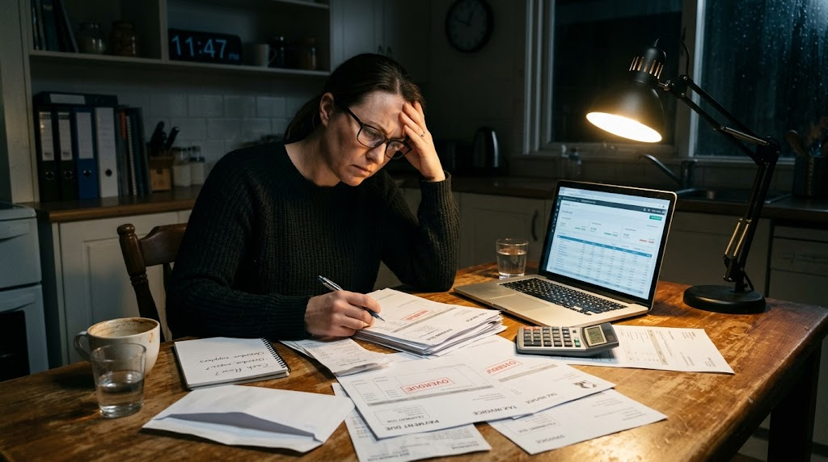  Financial loss and lack of security: the side of enterprise that rarely makes the news.

PART TWO
The Rewards
Why people take those risks.
The Three Rewards
Business success  Achieving what they set out to do: a business that survives, grows and is respected. Many entrepreneurs value the satisfaction and recognition as much as the money. | Profit  The money left when all the costs have been taken away from revenue. The owner can keep it, or reinvest it to grow the business. It is the reward for taking the risk.
Independence
Being your own boss: choosing what to do, when to work and how the business is run, and doing something you enjoy.
Business Success
Success means different things to different entrepreneurs.
▸ Survival. For a new business, simply lasting the first year or two is a success.
▸ Growth. Opening more branches, taking on staff or selling to more customers.
▸ Satisfaction. Pride in having built something from nothing, and in doing something the entrepreneur cares about.
▸ Recognition. A good reputation, loyal customers and respect in the local community.
Profit
Profit = total revenue - total costs.
▸ What it is. The money the business makes after all its costs have been paid.
▸ Reward for risk. Profit is what an entrepreneur receives in return for risking their own money.
▸ Choices. The owner can keep the profit as income, or reinvest it in the business to help it grow.
▸ Potentially unlimited. An employee's pay is fixed; an entrepreneur whose business does well can earn far more.
Independence
Being your own boss.
▸ Control. The entrepreneur makes the decisions and does not have to follow someone else's orders.
▸ Flexibility. They can choose their own working hours and where they work.
▸ Doing what they enjoy. Many people start a business to turn a hobby or passion into a job.
▸ The trade-off. Independence also means responsibility: when things go wrong there is nobody else to blame.
Weighing Risk Against Reward
RISKS | REWARDS
▸ Business failure: the business may close.  ▸ Financial loss: savings and borrowed money may be lost.  ▸ Lack of security: no regular income, sick pay or holiday pay.  ▸ Can put people off starting a business at all. | ▸ Business success: the business survives and grows.  ▸ Profit: money earned as a reward for taking the risk.  ▸ Independence: being your own boss.  ▸ Encourage people to start and grow businesses.
How Risky Is It?
Generally, the higher the risk, the higher the possible reward. Place each business idea on the line.
LOWER RISK ——▸ HIGHER RISK
1. Dog walking from home. Almost no start-up costs; if it fails, little is lost
2. Selling on Etsy. Small stock costs, no premises
3. Opening a café. Rent, equipment and staff before a single sale
4. Inventing a new product. Years of costly development before any income
How Entrepreneurs Reduce Risk
Entrepreneurs cannot remove risk, but they can reduce it.
▸ Market research. Checking that customers actually want the product before spending money on it.
▸ A business plan. Thinking through costs, revenue and cash before starting.
▸ Starting small. Beginning part-time, from home or online, while keeping a job.
▸ Limiting borrowing. Using savings the owner can afford to lose rather than large loans.
Case Study
CASE STUDY
James Dyson: Risk Before Reward
In the late 1970s James Dyson set out to build a vacuum cleaner that did not lose suction as its bag filled up. Over about five years he built 5,127 prototypes before he had a design that worked, and he fell deeply into debt doing it. Existing manufacturers were not interested in his idea, so in 1993 he launched the DC01 under his own name. The risk paid off: the business succeeded, made him one of the richest people in Britain, and let him run the company his own way.

5,127  Prototypes built before the design worked | 1993  The first Dyson vacuum cleaner, the DC01, goes on sale
Key Terms
Entrepreneur  Someone who sets up a business, organising resources and taking risks in the hope of a reward. | Risk  The chance that something will go wrong, such as the business failing or the owner losing money.
Reward  What an entrepreneur gains from running a business: success, profit and independence. | Business failure  When a business closes because it cannot cover its costs.
Financial loss  Losing money, for example savings invested in a business that fails. | Lack of security  Having no guaranteed income, sick pay or holiday pay, as an employee would.
Profit  Total revenue minus total costs. | Independence  Being your own boss and making your own decisions.
Your Task: Would You Take the Risk?
12 minutes
Amira earns £28,000 a year as a hairdresser in a salon. She is thinking of leaving to open her own salon, using £15,000 of savings and a £10,000 bank loan. Write a paragraph advising her whether to go ahead.
1. Identify two risks Amira faces, using the figures.
2. Identify two rewards she could gain.
3. Decide: should she go ahead? Give your main reason.
A good answer shows: At least one risk and one reward, each explained using Amira's situation (her savings, loan and wage), and a clear decision with a reason.
Note: The strongest answers use the numbers: her £28,000 wage is the security she gives up; the £25,000 is the financial loss if it fails.
Can I...?
☐ Explain the three risks: business failure, financial loss and lack of security.
☐ Explain the three rewards: business success, profit and independence.
☐ Explain why higher risk often brings the chance of higher reward.
☐ Suggest ways an entrepreneur can reduce risk.
☐ Apply risk and reward to a named business or person.
Summary
✓ The risks of starting a business are business failure, financial loss and lack of security.
✓ The rewards are business success, profit and independence.
✓ Entrepreneurs weigh up risk against reward before starting a business.
✓ The higher the risk, the higher the possible reward - and the bigger the possible loss.

EXAM FOCUS
Explain one risk an entrepreneur might face when starting a business. (3 marks)
Explain questions are worth 3 marks: 1 for identifying the risk, then 2 for a chain of reasoning - use "because" and "this means that" to link each step.
Exam Practice: Risk and Reward
Answer all questions. Use the context of the business in the question where one is given. · 25 minutes
▸ Question 1 · 1 mark · Multiple choice. Which one of the following is an example of a reward from business activity? Select one answer. A: Lack of security. B: Profit. C: Business…
▸ Question 2 · 1 mark · Define. Define the term 'entrepreneur'.
▸ Question 3 · 2 marks · Outline. Outline one reward an entrepreneur might gain from starting a business.
▸ Question 4 · 3 marks · Explain. Explain one risk an entrepreneur might face when starting a business.
▸ Question 5 · 6 marks · Analyse. Analyse the impact on Kofi of the risks involved in starting his street-food business.
Question 1 · 1 mark · Multiple choice
“Which one of the following is an example of a reward from business activity? Select one answer. A: Lack of security. B: Profit. C: Business failure. D: Financial loss.”
HOW TO ANSWER IT Command word: Multiple choice. Worth 1 mark, so plan before writing.
Question 1 · mark scheme
1 mark available. Award a mark for each point made.
▸ B: Profit. 1 mark. A, C and D are all risks.
▸ Model answer. B - Profit.
Question 2 · 1 mark · Define
“Define the term 'entrepreneur'.”
HOW TO ANSWER IT Command word: Define. Worth 1 mark, so plan before writing.
Question 2 · mark scheme
1 mark available. Award a mark for each point made.
▸ A person who takes the risk of starting / running a business. 1 mark
▸ Model answer. Someone who sets up a business, organising resources and taking risks in the hope of making a reward such as profit.
Question 3 · 2 marks · Outline
“Outline one reward an entrepreneur might gain from starting a business.”
HOW TO ANSWER IT Command word: Outline. Worth 2 marks, so plan before writing.
Question 3 · mark scheme
2 marks available. Award a mark for each point made.
▸ A reward identified: business success / profit / independence. 1 mark
▸ Developed: what the reward means for the entrepreneur. 1 mark
▸ Model answer. Independence (1). The entrepreneur can make their own decisions and choose their own working hours, rather than taking orders from an employer (1).
Question 4 · 3 marks · Explain
“Explain one risk an entrepreneur might face when starting a business.”
HOW TO ANSWER IT Command word: Explain. Worth 3 marks, so plan before writing.
Question 4 · mark scheme
3 marks available. Award a mark for each point made.
▸ A risk identified: business failure / financial loss / lack of security. 1 mark
▸ First linked point of explanation. 1 mark
▸ Second linked point of explanation. 1 mark
▸ Model answer. Financial loss (1). Many entrepreneurs invest their own savings or borrow money to start the business (1). If the business does not attract enough customers and fails, the savings are lost and any loan must still be repaid (1).
Question 5 · 6 marks · Analyse
“Analyse the impact on Kofi of the risks involved in starting his street-food business.”
— Kofi has worked as a chef in a hotel kitchen for eight years, earning £30,000 a year. He plans to leave his job and open a Caribbean street-food van, using £12,000 of his savings…
HOW TO ANSWER IT Command word: Analyse. Worth 6 marks, so plan before writing.
Question 5 · mark scheme
6 marks available. Award a mark for each point made.
▸ AO2 (Application, 3 marks): uses the context - Kofi's £12,000 savings, £30,000 salary, markets and festivals. Level 1-3
▸ AO3a (Analysis, 3 marks): chains of reasoning showing the impact of each risk on Kofi. Level 1-3
▸ Indicative content: financial loss of savings; loss of a secure £30,000 salary; seasonal income; possible business failure. Credit any relevant risk
▸ Model answer. The first risk is financial loss. Kofi is using £12,000 of his own savings to buy the van, so if customers do not buy enough food to cover his costs, he could lose much of this money. This means he may be left with little to fall back on if the business fails. A second risk is lack of security. Kofi is giving up a regular salary of £30,000, and his income will now depend on how many customers he has at markets and festivals. Because festivals are seasonal, his income may be very low in winter, making it hard for him to pay his own bills. This means the business must make a profit quickly for Kofi to replace his lost wage.

