EDEXCEL GCSE BUSINESS · PAPER 1
The role of business enterprise
Enterprise and entrepreneurship · Lesson 3 of 3
Teacher copy - includes the notes for whoever is teaching from it.
Last Lesson
Answer from memory before the answers appear.
1. Name the three risks of starting a business.
Business failure, financial loss and lack of security.
2. Name the three rewards.
Business success, profit and independence.
3. What is profit?
Total revenue minus total costs.
4. Give one way an entrepreneur can reduce risk.
Market research, a business plan, starting small, or limiting borrowing.
Learning Objectives
1. Explain the purpose of business activity: producing goods or services, meeting customer needs and adding value.
2. Explain the role of the entrepreneur: organising resources, making decisions and taking risks.
3. Define added value and calculate it.
4. Explain how entrepreneurs add value through convenience, branding, quality, design and a unique selling point.
The Purpose of Business Activity
Why do businesses exist at all?
▸ To produce goods or services. Goods are physical products you can touch, such as trainers or a phone. Services are things done for you, such as a haircut or a bus journey.
▸ To meet customer needs. A business will only survive if it sells something customers want at a price they are willing to pay.
▸ To add value. A business turns inputs into something worth more to the customer than the inputs cost - which is how it makes a profit.
▸ To make a profit. For most businesses, adding value and meeting needs is how they make the profit that rewards the owner.
How a Business Turns Inputs into Outputs
Every business, from a café to a car factory, does the same thing.
1  Inputs  Resources: raw materials, staff, equipment, premises and money. | 2  The business process  The entrepreneur organises the inputs to make a product or provide a service. | 3  Outputs  Goods or services sold to customers. | 4  Added value  The outputs are worth more than the inputs cost - the difference is the value added.
The Role of the Entrepreneur
Organises resources  Brings together the inputs a business needs: materials, staff, equipment, premises and money. | Makes business decisions  Decides what to sell, how to make it, what price to charge and who to sell it to.
Takes risks
Puts their own time and money into the business, knowing it could fail.
PART TWO
Adding Value
The difference between what a business pays for its inputs and what a customer pays for the product.
What Is Added Value?
Added value = selling price - cost of bought-in materials and components.
▸ What it means. The extra amount a customer is willing to pay for a product over and above what its materials cost.
▸ Why it matters. Added value is used to pay the business's other costs, such as wages and rent. What is left is profit.
▸ More value, more choice. A business that adds more value can charge a higher price, or attract more customers at the same price.
▸ Not the same as profit. Added value is before the business's other costs are paid; profit is what is left after all costs.
Added Value, Drawn Out
The coffee beans, milk and cup in a takeaway coffee cost the café about 80p. The customer pays £3.20. The £2.40 difference is the value the café has added - through the barista's skill, the convenience of the location, the brand and the quality of the coffee. | 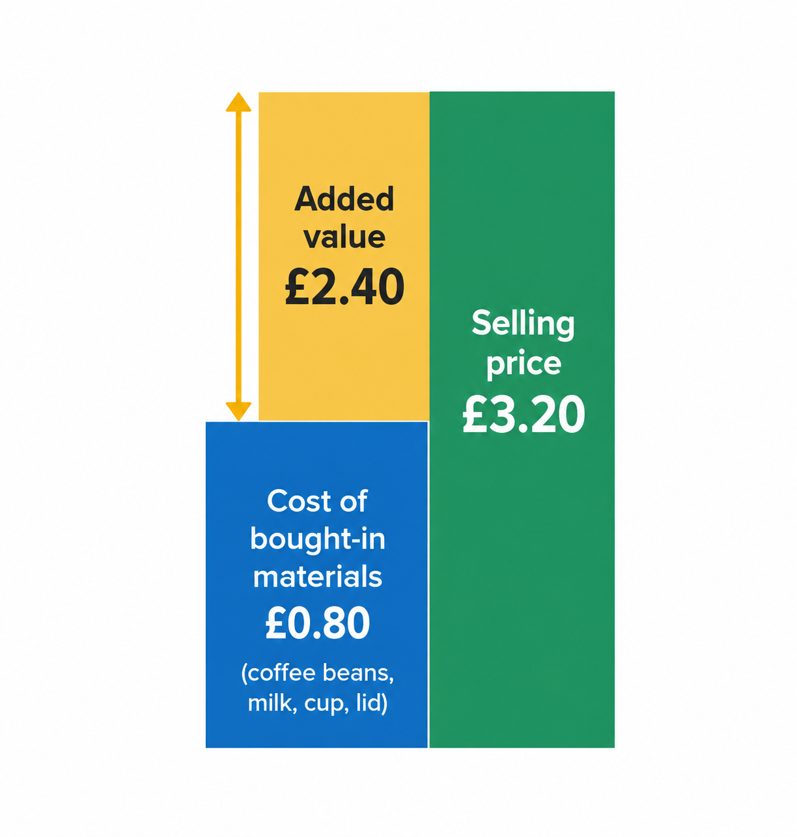  Added value = selling price (£3.20) - cost of bought-in materials (£0.80) = £2.40.

Calculating Added Value
Edexcel "Calculate" questions: show your working for the method mark.
A bakery sells a birthday cake for £24. The flour, eggs, butter, sugar, decorations and box cost £7.50. Calculate the added value.

1. Write the formula
Added value = selling price - cost of bought-in materials
2. Put in the numbers
Added value = £24.00 - £7.50
3. Work it out
= £16.50
Answer: Added value = £16.50
PART THREE
How Entrepreneurs Add Value
Five ways to make customers willing to pay more.
Ways to add value
Ways to add value

Convenience  ▸ open late  ▸ close by  ▸ home delivery  ▸ easy online ordering | Branding  ▸ a recognisable name and logo  ▸ a strong image  ▸ customer loyalty | Quality  ▸ better materials  ▸ reliability  ▸ excellent service
Design  ▸ looks good  ▸ easy to use  ▸ stands out on the shelf | Unique selling point  ▸ something no competitor offers  ▸ makes the product stand out
Convenience
Making the product easier or quicker to buy or use.
▸ What it is. Saving the customer time or effort: a good location, long opening hours, home delivery, or ordering on an app.
▸ Why it adds value. Customers will pay more to save time, which is why a sandwich costs more at a station than in a supermarket.
▸ Example. Ready-to-eat meals and meal kits cost more than the ingredients because the customer does not have to prepare them.
Branding
Giving the product a name, logo and image customers recognise and trust.
▸ What it is. A brand is a name, symbol or design that makes a product recognisable and different from its rivals.
▸ Why it adds value. A strong brand builds trust and loyalty, so customers will pay more for the branded product than for an unbranded one that is almost the same.
▸ Example. Branded trainers and branded cola sell for far more than supermarket own-label versions.
Same Shoe, Different Value
What is a brand worth?
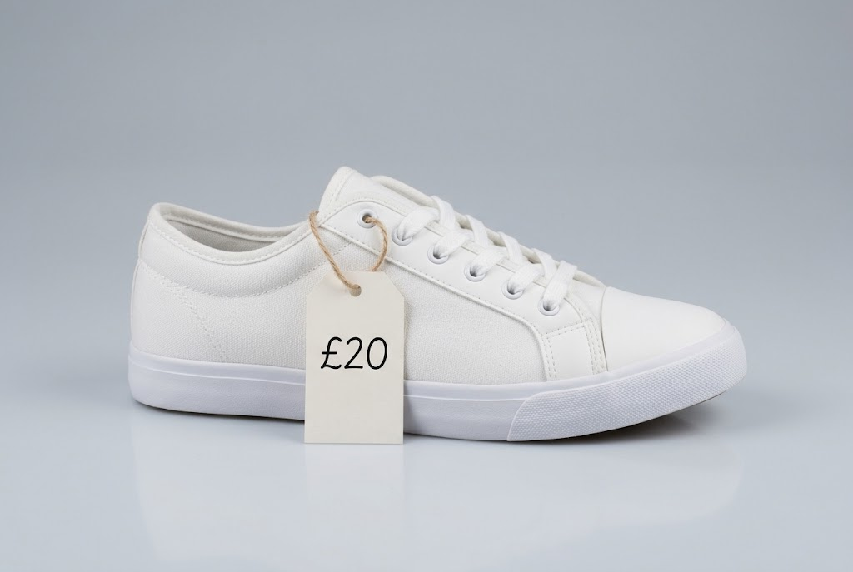  Unbranded: £20 | 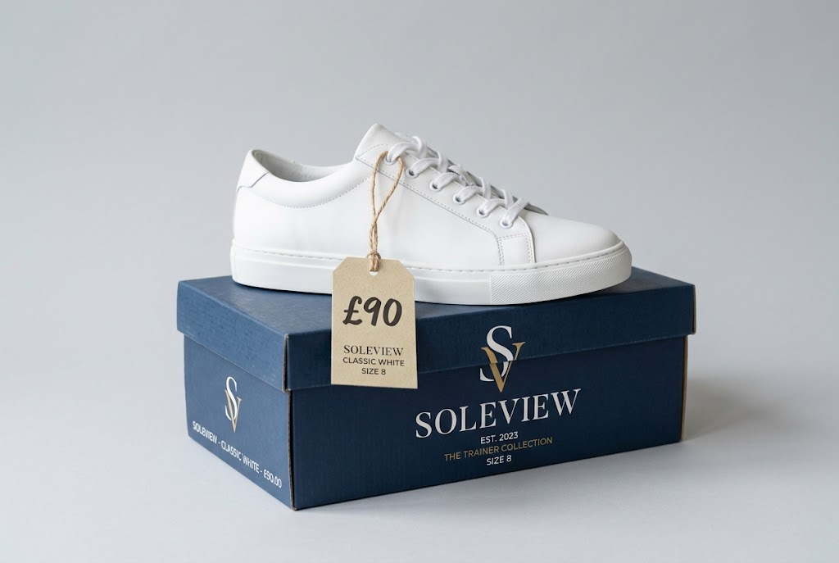  Branded: £90

Quality
Making a product that is better made, lasts longer or comes with better service.
▸ What it is. Using better materials, making the product more reliable, or giving excellent customer service.
▸ Why it adds value. Customers will pay more for something they believe will last longer or work better.
▸ Example. Hand-made furniture, or a restaurant with fresh local ingredients, charges more than mass-produced alternatives.
Design
Making a product that looks good and is easy to use.
▸ What it is. How a product looks, how it works and how easy it is to use.
▸ Why it adds value. An attractive, well-designed product stands out from its rivals and customers will pay more for it.
▸ Example. Dyson products are designed to look different from other vacuum cleaners, and sell at a premium price.
Unique Selling Point (USP)
The feature that makes a product different from every competitor's.
▸ What it is. Something about a product or service that no competitor offers, which makes it stand out.
▸ Why it adds value. If customers cannot buy it anywhere else, the business can charge a higher price and win customers from rivals.
▸ Examples. Dyson's bagless vacuum when it was launched; a café that is the only one in town open 24 hours.
▸ Protecting it. A USP is valuable only as long as it lasts: competitors will copy a successful one, so businesses must keep adding value.
Adding Value in Practice
One coffee, three ways of adding value  ▸ Convenience. A shop on the way to work, ready in two minutes.  ▸ Quality. Skilled baristas and better beans.  ▸ Branding. A name and cup customers recognise and trust. |   A coffee shop adds value through convenience, quality and branding at once.

Case Study
CASE STUDY
Innocent Drinks: Adding Value to Fruit
Innocent was started in 1999 by three friends who tested their smoothies at a London music festival, asking customers to throw their empty bottles into a bin marked YES or NO to say whether they should give up their jobs. The YES bin won. Innocent adds value to fruit through branding (a friendly, jokey brand with chatty labels), quality (no added sugar or concentrates in its smoothies), design (simple, recognisable bottles) and convenience (a healthy drink ready to grab from a shop fridge). Coca-Cola began buying the business in 2009 and later took full control.

1999  Innocent founded after testing smoothies at a festival | 2009  Coca-Cola begins buying the business
Ways of Adding Value at a Glance
Way | What it means | Example
Convenience | Saving the customer time or effort | Food delivery apps
Branding | A recognised name, logo and image | Branded trainers
Quality | Better materials, reliability or service | Hand-made furniture
Design | Looks good and easy to use | Dyson vacuum cleaners
USP | Something no competitor offers | A 24-hour café in a small town
Key Terms
Goods  Physical products that can be touched, such as a phone or a pair of trainers. | Services  Things done for a customer, such as a haircut or a taxi journey.
Added value  The difference between the selling price of a product and the cost of the bought-in materials used to make it. | Convenience  Making a product quicker or easier for customers to buy or use.
Brand  A name, symbol or design that makes a product recognisable and different from its competitors. | Quality  How well a product meets customers' needs: how well made and reliable it is.
Design  How a product looks, works and is used. | Unique selling point (USP)  A feature of a product or service that makes it different from all its competitors.
Your Task: Add Value to a Plain Bottle of Water
10 minutes
A plain 500ml bottle of water costs a business 10p to produce and sells for 50p. Using at least three of the five ways of adding value, explain how a new business could sell its bottled water for £1.50.
1. Name the way of adding value.
2. Say exactly what the business would change.
3. Explain why customers would pay more.
A good answer shows: Three ways named, each with a specific change to the product and an explanation of why customers would pay more for it.
Note: Good answers are specific - a refillable metal bottle (design), a sports brand (branding), vending machines in gyms (convenience).
Can I...?
☐ Explain the purpose of business activity.
☐ Describe the role of the entrepreneur.
☐ Define added value.
☐ Calculate added value.
☐ Explain how convenience adds value.
☐ Explain how branding adds value.
☐ Explain how quality adds value.
☐ Explain how design adds value.
☐ Explain what a USP is and why it adds value.
Summary
✓ Businesses exist to produce goods or services, meet customer needs and add value.
✓ Entrepreneurs organise resources, make business decisions and take risks.
✓ Added value = selling price - cost of bought-in materials.
✓ Value is added through convenience, branding, quality, design and a USP.

EXAM FOCUS
Explain one way an entrepreneur could add value to a product. (3 marks)
Name one way only - an answer that lists several with no explanation earns 1 mark. Then explain how it makes customers willing to pay more, and link that to higher revenue or profit for the business.
Exam Practice: The Role of Business Enterprise
Answer all questions. Show your working in calculations. · 30 minutes
▸ Question 1 · 1 mark · Define. Define the term 'unique selling point'.
▸ Question 2 · 1 mark · Define. Define the term 'added value'.
▸ Question 3 · 2 marks · Calculate. A café sells a sandwich for £4.50. The bread, filling and packaging cost £1.20. Calculate the added value of the sandwich. You are advised…
▸ Question 4 · 3 marks · Explain. Explain one way an entrepreneur could add value to a product.
▸ Question 5 · 3 marks · Explain. Explain one benefit to a business of having a strong brand.
▸ Question 6 · 9 marks · Justify. Justify which one of these two options Priya should choose to add value to her products.
Question 1 · 1 mark · Define
“Define the term 'unique selling point'.”
HOW TO ANSWER IT Command word: Define. Worth 1 mark, so plan before writing.
Question 1 · mark scheme
1 mark available. Award a mark for each point made.
▸ A feature that differentiates a product / makes it stand out from competitors. 1 mark
▸ Model answer. A feature of a product or service that makes it different from those of its competitors.
Question 2 · 1 mark · Define
“Define the term 'added value'.”
HOW TO ANSWER IT Command word: Define. Worth 1 mark, so plan before writing.
Question 2 · mark scheme
1 mark available. Award a mark for each point made.
▸ Selling price minus cost of bought-in materials / inputs. 1 mark
▸ Model answer. The difference between the selling price of a product and the cost of the bought-in materials and components used to make it.
Question 3 · 2 marks · Calculate
“A café sells a sandwich for £4.50. The bread, filling and packaging cost £1.20. Calculate the added value of the sandwich. You are advised to show your working.”
HOW TO ANSWER IT Command word: Calculate. Worth 2 marks, so plan before writing.
Question 3 · mark scheme
2 marks available. Award a mark for each point made.
▸ Correct method: selling price - cost of bought-in materials. 1 mark
▸ Correct answer: £3.30. 1 mark (award 2 marks for the correct answer with no working)
▸ Model answer. Added value = £4.50 - £1.20 = £3.30
Question 4 · 3 marks · Explain
“Explain one way an entrepreneur could add value to a product.”
HOW TO ANSWER IT Command word: Explain. Worth 3 marks, so plan before writing.
Question 4 · mark scheme
3 marks available. Award a mark for each point made.
▸ A way identified: convenience / branding / quality / design / USP. 1 mark
▸ First linked point: how it makes the product more attractive to customers. 1 mark
▸ Second linked point: customers pay more, so value added / profit increases. 1 mark
▸ Answers listing several ways with no explanation. maximum 1 mark
▸ Model answer. By giving the product a unique selling point (1). This will differentiate it from competitors' products, so customers cannot buy the same thing elsewhere (1). As a result customers may be willing to pay a higher price, which increases the value added and the business's profit (1).
Question 5 · 3 marks · Explain
“Explain one benefit to a business of having a strong brand.”
HOW TO ANSWER IT Command word: Explain. Worth 3 marks, so plan before writing.
Question 5 · mark scheme
3 marks available. Award a mark for each point made.
▸ A benefit identified, e.g. loyalty / can charge higher prices / stands out from competitors. 1 mark
▸ First linked point of explanation. 1 mark
▸ Second linked point of explanation. 1 mark
▸ Model answer. Customer loyalty (1). Customers who recognise and trust the brand are more likely to buy from the business again rather than from a competitor (1). This means the business can charge a higher price than an unbranded rival, increasing its added value (1).
Question 6 · 9 marks · Justify
“Justify which one of these two options Priya should choose to add value to her products.”
— Priya runs a small bakery in a market town. She sells bread and cakes at similar prices to the supermarket nearby, and her sales have fallen for two years. She has enough money…
HOW TO ANSWER IT Command word: Justify. Worth 9 marks, so plan before writing.
Question 6 · mark scheme
9 marks available. Award a mark for each point made.
▸ AO2 (Application, 3 marks): uses Priya's context - small bakery, falling sales, supermarket competitor. Level 1-3
▸ AO3a (Analysis, 3 marks): chains of reasoning about how each option adds value. Level 1-3
▸ AO3b (Evaluation, 3 marks): a justified choice with a supported judgement, e.g. "it depends on". Level 1-3
▸ Model answer. Option 1, convenience, would let customers order from home, so Priya could reach busy customers who do not visit the town centre. This could increase sales without her needing to cut prices. However, delivery adds costs such as a driver and fuel, which would reduce her added value per order. Option 2, quality, would give Priya a clear difference from the supermarket, which cannot match fresh local organic baking. This gives her a unique selling point, so customers may be willing to pay a higher price, directly increasing added value. On balance Priya should choose Option 2, because her problem is that she sells at supermarket prices with nothing to make her stand out; the supermarket already offers convenience, but it cannot offer locally baked organic quality. This depends, though, on whether her customers can afford to pay more.

