EDEXCEL GCSE BUSINESS · PAPER 1
Customer needs
Spotting a business opportunity · Lesson 1 of 5
Last Chapter
Answer from memory before the answers appear.
1. Give the three reasons why new business ideas come about.
Changes in technology, changes in consumer wants, and products or services becoming obsolete.
2. Name the three rewards of starting a business.
Business success, profit and independence.
3. What is added value?
Selling price minus the cost of bought-in materials.
4. Name two ways a business can add value.
Any two of: convenience, branding, quality, design, a unique selling point.
Learning Objectives
1. Explain what is meant by customer needs.
2. Explain the four main customer needs: price, quality, choice and convenience.
3. Explain why identifying and understanding customer needs generates sales.
4. Explain why meeting customer needs is vital for a business's survival.
The Big Idea
No customers, no business.
Every successful business starts by working out what its customers need - and then giving it to them better than anyone else.
What Are Customer Needs?
A customer need is what a customer requires from a product or service.
▸ Customers. The people or businesses that buy a product. They are not always the same as consumers, who use it - a parent buying a child's toy is the customer; the child is the consumer.
▸ Needs. What customers require before they will buy: a price they can pay, a quality they expect, a choice they like and a way of buying that suits them.
▸ Different customers, different needs. A student, a family and a retired couple buying the same product may want very different things from it.
▸ The business's job. Find out what customers need, then provide a product that meets those needs better than competitors do.
Every Shopper Wants Something Different
Walk down any high street and every shopper is looking for something slightly different. Some want the cheapest option, some want the best quality, some want lots to choose from and some just want whatever is quickest. A business has to know which of these customers it is serving - and what they need. |   Every one of these shoppers has different needs.

PART ONE
The Four Customer Needs
What customers look for before they buy.
What Customers Need
Price  The amount customers are willing and able to pay. It must feel like good value for money. | Quality  How well the product is made and how well it works - it must meet or beat what the customer expects.
Choice  A range of products, sizes, colours or options, so customers can find exactly what suits them. | Convenience  How easy it is to buy and use the product: location, opening hours, delivery and ordering online.
Price
Customers want a price that they think is fair for what they get.
▸ Value for money. Customers compare the price with the benefits they get. A higher price is acceptable if the quality or convenience is higher too.
▸ What they can afford. Customers on low incomes may choose the cheapest option; others will pay more for quality or a brand.
▸ Competition. Customers can easily compare prices, especially online, so a business charging more than rivals must give a reason to pay it.
▸ Example. Discount supermarkets such as Aldi and Lidl have grown quickly by meeting customers' need for low prices.
Quality
Customers want a product that does what it should and lasts.
▸ What it means. A product is good quality if it meets customers' expectations - not necessarily the most luxurious version.
▸ Reliability. Customers want products that work and do not break, and services that are delivered properly every time.
▸ Reputation. A reputation for quality brings customers back and encourages them to recommend the business.
▸ Example. Customers expect a £5 umbrella to keep them dry; they expect a £50 umbrella to last for years.
Choice
Customers like to be able to choose.
▸ Range. Different sizes, flavours, colours or versions of the product.
▸ Personal taste. Choice lets each customer find something that suits them exactly.
▸ Too much choice. Too many options can confuse customers and increase a business's costs of holding stock.
▸ Example. A coffee shop offers different sizes, milks, syrups and decaffeinated options to suit every customer.
Convenience
Customers want buying and using a product to be quick and easy.
▸ Location. Shops close to home, work or school, or on the way to them.
▸ Opening hours. Being open when customers want to shop - early, late or at weekends.
▸ Online and delivery. Ordering on a website or app, next-day delivery and click-and-collect.
▸ Example. Convenience stores charge higher prices than large supermarkets, but customers pay because the shop is nearby and open late.
Weighing Up the Choice
What the shopper is thinking  ▸ Price. Which one is better value?  ▸ Quality. Which one will taste or work better?  ▸ Choice. Is there something else on the shelf that suits me more? | 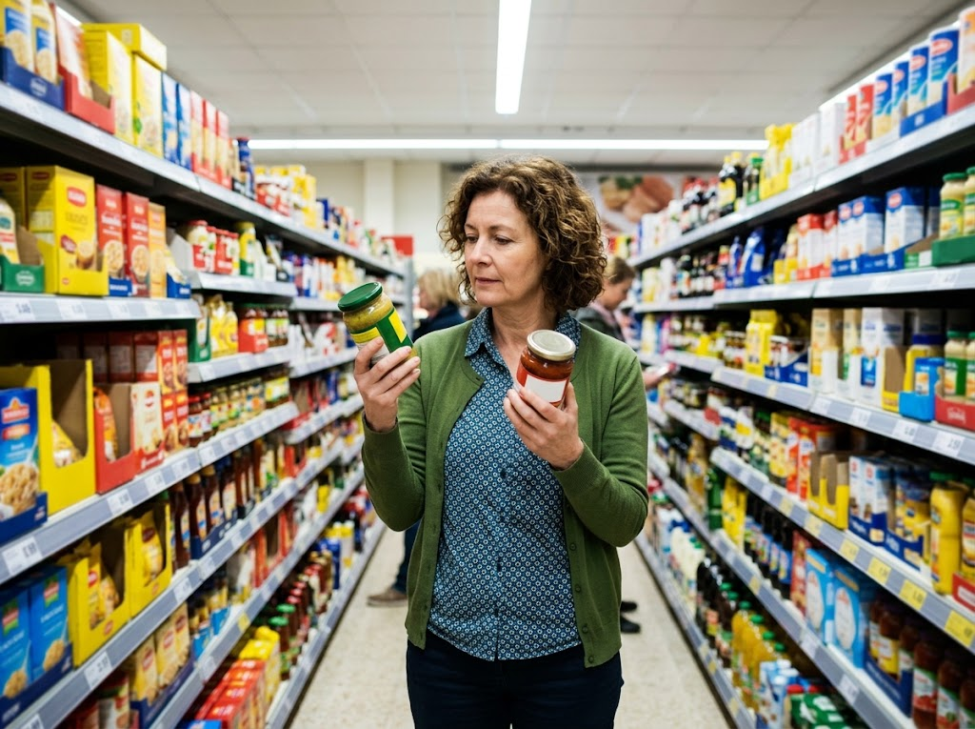  Price, quality and choice, weighed up in a few seconds.

PART TWO
Why Customer Needs Matter
Understanding customers is not optional - it decides whether a business sells anything at all.
From Understanding to Survival
Each step depends on the one before it.
1  Identify customer needs  Find out what customers want, usually through market research. | 2  Provide a product that meets them  Get the price, quality, choice and convenience right. | 3  Generate sales  Customers buy the product, and come back to buy again. | 4  Business survival  Enough sales mean enough revenue to cover costs and make a profit, so the business survives.
Meeting Needs, or Missing Them
A BUSINESS THAT MEETS CUSTOMER NEEDS | A BUSINESS THAT MISSES THEM
▸ Customers buy the product, so sales rise.  ▸ Customers come back and become loyal.  ▸ Happy customers recommend it to others.  ▸ It can often charge a higher price.  ▸ It is more likely to survive and grow. | ▸ Customers buy from competitors instead.  ▸ Sales fall and stock is left unsold.  ▸ Unhappy customers post bad reviews.  ▸ It may have to cut prices to sell anything.  ▸ It is more likely to fail.
Case Study
CASE STUDY
Greggs: Meeting Customer Needs
Greggs, the bakery chain, meets several customer needs at once. Its prices are low compared with coffee shops and sandwich chains, its shops are on high streets, at stations and in retail parks for convenience, and it offers choice from breakfast rolls to sausage rolls to salads. In January 2019 it responded to a change in what its customers wanted by launching a vegan sausage roll, which became one of its best-selling products. By listening to its customers, Greggs has grown to more than 2,000 shops across the UK.

2019  The vegan sausage roll launched | 2,000+  Greggs shops across the UK
Key Terms
Customer  A person or business that buys a product. | Consumer  The person who uses a product. They may not be the customer who bought it.
Customer needs  What customers require from a product: the right price, quality, choice and convenience. | Value for money  When customers feel the benefits of a product are worth the price they pay.
Convenience  How quick and easy it is for customers to buy and use a product. | Customer loyalty  When customers keep buying from the same business rather than switching to competitors.
Your Task: Needs Detective
10 minutes
Pick three businesses you have bought from this month - for example a supermarket, a takeaway and an online shop. For each one, decide which customer need it meets best (price, quality, choice or convenience) and explain how.
1. Name the business.
2. Name the customer need it meets best.
3. Give one piece of evidence to back it up.
A good answer shows: Three businesses, each linked to one customer need with a specific piece of evidence, such as opening hours, a price or the size of the range.
Can I...?
☐ Explain what customer needs are.
☐ Explain how price, quality, choice and convenience are customer needs.
☐ Explain why meeting customer needs generates sales.
☐ Explain why meeting customer needs helps a business survive.
☐ Use a real business as an example.
Summary
✓ Customers need the right price, quality, choice and convenience.
✓ Different customers have different needs.
✓ Meeting customer needs generates sales and customer loyalty.
✓ A business that does not meet customer needs is unlikely to survive.

EXAM FOCUS
Explain one reason why it is important for a business to identify customer needs. (3 marks)
Explain questions are worth 3 marks: 1 for the reason, then 2 for linked steps of explanation. Take the chain all the way to sales, revenue or survival.

