EDEXCEL GCSE BUSINESS · PAPER 1
Market research
Spotting a business opportunity · Lesson 2 of 5
Teacher copy - includes the notes for whoever is teaching from it.
Last Lesson
Answer from memory before the answers appear.
1. Name the four customer needs.
Price, quality, choice and convenience.
2. What is the difference between a customer and a consumer?
The customer buys the product; the consumer uses it.
3. Why does meeting customer needs help a business survive?
It generates sales and revenue to cover costs.
4. How might a business find out what customers need?
By asking them - market research.
Learning Objectives
1. Explain the purpose of market research.
2. Compare primary and secondary market research and their methods.
3. Explain the difference between qualitative and quantitative data.
4. Explain the role of social media in collecting market research.
5. Explain how sample size and bias affect the reliability of market research.
What Is Market Research?
Market research is the process of collecting information about customers, competitors and the market.
▸ To identify and understand customer needs. Find out what customers want, how much they will pay and where they want to buy.
▸ To identify gaps in the market. Spot needs that no business is currently meeting.
▸ To reduce risk. Check that there is demand before spending money on a new product, so the business is less likely to fail.
▸ To inform decisions. Help the business decide on price, product, location and promotion using evidence instead of guesswork.
PART ONE
Primary and Secondary Research
Collecting new information, or using information that already exists.
Primary or Secondary?
PRIMARY RESEARCH | SECONDARY RESEARCH
▸ New information collected first-hand by the business itself.  ▸ Also called field research.  ▸ Specific to the business's own questions.  ▸ Up to date, and competitors do not have it.  ▸ Expensive and time-consuming to collect. | ▸ Information that already exists, collected by someone else.  ▸ Also called desk research.  ▸ Quick and cheap, often free.  ▸ May be out of date or not quite what the business needs.  ▸ Competitors can see it too.
Methods of Primary Research
Survey and questionnaire  A set of questions answered by customers, in person, by phone, by post or online. Can reach lots of people cheaply. | Focus group  A small group of customers discuss a product in depth, led by a researcher. Gives detailed opinions, but only from a few people.
Observation  Watching how customers behave - for example counting how many people walk past a shop at lunchtime. | Interviews and product testing  Asking customers one to one, or letting them try a product and give feedback.
Asking the Customers
A street survey is one of the simplest kinds of primary research. The business writes its own questions, so every answer is about exactly what it needs to know - but it takes time to collect enough answers to rely on. | 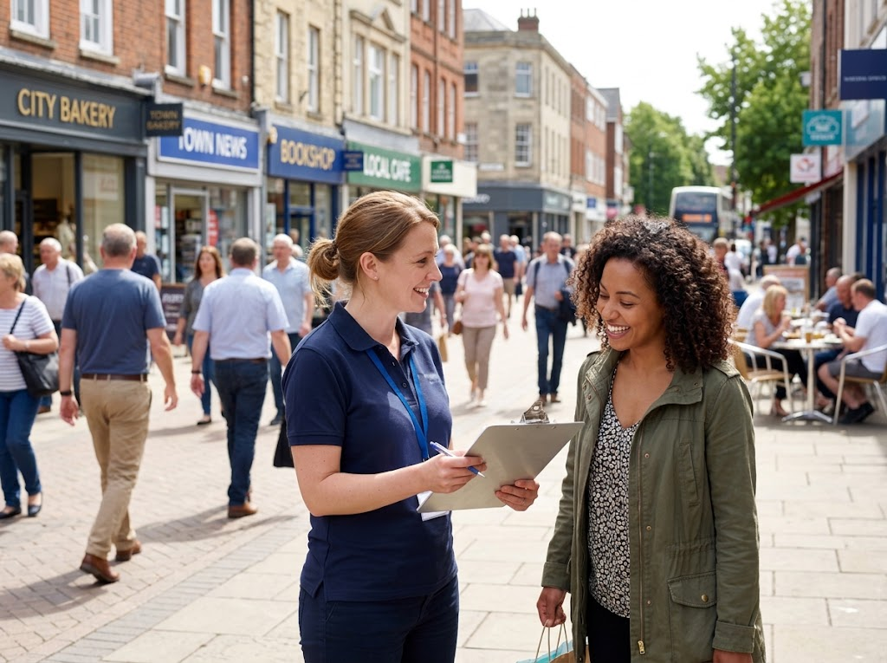  A street survey: primary research, collected first-hand.

Methods of Secondary Research
The internet  Competitors' websites, prices and customer reviews, and news articles about the market. | Market reports  Detailed reports on a market written by specialist research companies. Useful, but often expensive to buy.
Government publications  Free statistics, for example from the Office for National Statistics and the census, about population, incomes and spending. | Newspapers and trade magazines  Articles about trends, new products and changes in an industry.
Digging Deeper
Focus groups  ▸ Strength. Detailed opinions and reasons, not just ticks in boxes.  ▸ Weakness. A small group may not represent all customers.  ▸ Weakness. One loud person can sway the rest of the group. |   A focus group gives detailed opinions - but only from a handful of people.

PART TWO
Qualitative and Quantitative Data
Numbers, or opinions?
Quantitative or Qualitative?
QUANTITATIVE DATA | QUALITATIVE DATA
▸ Numerical data that can be counted and measured.  ▸ Comes from closed questions, e.g. "How many times a week do you buy coffee?"  ▸ Easy to put into graphs, charts and percentages.  ▸ Easy to compare and analyse.  ▸ Does not explain why customers think or behave as they do. | ▸ Opinions, feelings and reasons, in words.  ▸ Comes from open questions and focus groups, e.g. "What do you like about our coffee?"  ▸ Explains why customers behave as they do.  ▸ Gives detail and new ideas.  ▸ Hard to analyse and compare, and can be interpreted differently.
The Role of Social Media
Social media gives even the smallest business a cheap way to research its market.
▸ Quick polls. Businesses can run polls and questions on Instagram, TikTok or Facebook and get answers within hours.
▸ Comments and reviews. Customers say what they think in comments, messages and reviews, which the business can read for free.
▸ Following trends. Businesses can see what customers are talking about and what competitors are doing.
▸ Limitation. Only followers reply, so the answers may not represent all customers, and some comments are not honest.
PART THREE
Can You Trust the Results?
Research is only useful if it is reliable.
Reliability, Sample Size and Bias
Reliable research gives results the business can trust to make decisions.
▸ Sample. The group of people who take part in the research, chosen to represent the whole market.
▸ Sample size. The bigger the sample, the more reliable the results usually are - asking 10 people tells you far less than asking 500. But larger samples cost more time and money.
▸ Bias. Research is biased when the results are pushed in one direction - for example asking only friends and family, or asking a leading question such as "Don't you agree our cakes are delicious?"
▸ Representative. The sample should reflect the business's real customers in age, gender, location and income. An online survey only reaches people who choose to answer.
▸ Out of date. Secondary data may no longer be true, especially in a fast-changing market.
Working Out a Percentage from a Survey
Edexcel "Calculate" questions often use survey results. Show your working.
A café asked 250 customers whether they would buy a new vegan breakfast. 90 said yes. What percentage of customers said yes?

1. Write the formula
Percentage = (number who said yes ÷ total asked) × 100
2. Put in the numbers
= (90 ÷ 250) × 100
3. Work it out
= 0.36 × 100 = 36%
Answer: 36% of customers said yes.
Case Study
CASE STUDY
Tesco Clubcard: Research Every Time You Shop
Tesco launched its Clubcard loyalty scheme in 1995. Every time a customer scans the card, Tesco records what they buy, when and where. This gives Tesco a huge amount of quantitative data about its customers' needs, which it uses to decide what to stock in each store, which offers to send each customer and which new products to develop. Customers get points and lower Clubcard prices in return - and Tesco gets market research on millions of shoppers without having to ask a single question.

1995  Clubcard launched | Millions  Of shoppers' purchases recorded
Key Terms
Market research  Collecting information about customers, competitors and the market to help make business decisions. | Primary research  New information collected first-hand by the business. Also called field research.
Secondary research  Information that already exists, collected by someone else. Also called desk research. | Quantitative data  Numerical data that can be counted and measured.
Qualitative data  Data about opinions, feelings and reasons. | Focus group  A small group of customers who discuss a product in depth.
Sample  The group of people chosen to take part in market research. | Bias  When research results are distorted, so they do not give a true picture of the market.
Reliability
How far the results of market research can be trusted.
Your Task: Design a Survey
15 minutes
A new juice bar wants to open near your school. Write five questions for a survey of students. Include at least three closed questions (for quantitative data) and one open question (for qualitative data). Then explain how you would choose your sample to avoid bias.
1. Write three closed questions.
2. Write at least one open question.
3. Check none of them is a leading question.
4. Explain who you would ask, and how many.
A good answer shows: Five clear, non-leading questions labelled closed or open, and a sampling plan that explains its size and why it represents the juice bar's customers.
Note: Watch for leading questions - "Wouldn't you love a juice bar?" - and samples of only their friends. Both are bias.
Can I...?
☐ Explain the purpose of market research.
☐ Give methods of primary research.
☐ Give methods of secondary research.
☐ Compare primary and secondary research.
☐ Explain qualitative and quantitative data.
☐ Explain the role of social media.
☐ Explain how sample size affects reliability.
☐ Explain what bias is and how to avoid it.
☐ Calculate a percentage from survey results.
Summary
✓ Market research finds out about customers, competitors and the market, to reduce risk.
✓ Primary research is new and specific but costly; secondary research is cheap but may be out of date.
✓ Quantitative data is numerical; qualitative data is opinions and reasons.
✓ Social media is a cheap way to research, but may not be representative.
✓ A large, unbiased sample makes research more reliable.

EXAM FOCUS
Explain one disadvantage to a business of using primary market research. (3 marks)
Name one disadvantage, then link two steps of explanation. Always finish by saying what it means for the business - its costs, its decisions or its risk.
Exam Practice: Market Research
Answer all questions. Show your working in calculations. · 25 minutes
▸ Question 1 · 1 mark · Define. Define the term 'secondary market research'.
▸ Question 2 · 1 mark · State. State one method of primary market research.
▸ Question 3 · 2 marks · Calculate. A gym surveyed 400 people. 120 said they would join if the gym opened 24 hours a day. Calculate the percentage of people who said they…
▸ Question 4 · 2 marks · Outline. Outline one benefit to a business of using social media for market research.
▸ Question 5 · 3 marks · Explain. Explain one disadvantage to a business of using primary market research.
▸ Question 6 · 3 marks · Explain. Explain one reason why the size of a sample affects the reliability of market research.
Question 1 · 1 mark · Define
“Define the term 'secondary market research'.”
HOW TO ANSWER IT Command word: Define. Worth 1 mark, so plan before writing.
Question 1 · mark scheme
1 mark available. Award a mark for each point made.
▸ Using existing data / data collected by others. 1 mark
▸ Model answer. Research using information that already exists, which has been collected by someone else.
Question 2 · 1 mark · State
“State one method of primary market research.”
HOW TO ANSWER IT Command word: State. Worth 1 mark, so plan before writing.
Question 2 · mark scheme
1 mark available. Award a mark for each point made.
▸ Any one of: survey / questionnaire; focus group; observation; interview; product testing. 1 mark
▸ Model answer. A focus group.
Question 3 · 2 marks · Calculate
“A gym surveyed 400 people. 120 said they would join if the gym opened 24 hours a day. Calculate the percentage of people who said they would join. You are advised to show your working.”
HOW TO ANSWER IT Command word: Calculate. Worth 2 marks, so plan before writing.
Question 3 · mark scheme
2 marks available. Award a mark for each point made.
▸ Correct method: (120 ÷ 400) × 100. 1 mark
▸ Correct answer: 30%. 1 mark (award 2 marks for the correct answer with no working)
▸ Model answer. (120 ÷ 400) × 100 = 30%
Question 4 · 2 marks · Outline
“Outline one benefit to a business of using social media for market research.”
HOW TO ANSWER IT Command word: Outline. Worth 2 marks, so plan before writing.
Question 4 · mark scheme
2 marks available. Award a mark for each point made.
▸ A benefit identified, e.g. cheap / quick / reaches many customers / real-time feedback. 1 mark
▸ Developed: why this helps the business. 1 mark
▸ Model answer. It is cheap (1), because the business can run polls and read customers' comments for free instead of paying a research company (1).
Question 5 · 3 marks · Explain
“Explain one disadvantage to a business of using primary market research.”
HOW TO ANSWER IT Command word: Explain. Worth 3 marks, so plan before writing.
Question 5 · mark scheme
3 marks available. Award a mark for each point made.
▸ A disadvantage identified, e.g. expensive / time-consuming / risk of bias with a small sample. 1 mark
▸ First linked point of explanation. 1 mark
▸ Second linked point of explanation. 1 mark
▸ Model answer. It is expensive (1). The business must pay for staff time or a research company to design, carry out and analyse surveys or focus groups (1). This increases the business's costs, which a small business with limited finance may not be able to afford (1).
Question 6 · 3 marks · Explain
“Explain one reason why the size of a sample affects the reliability of market research.”
HOW TO ANSWER IT Command word: Explain. Worth 3 marks, so plan before writing.
Question 6 · mark scheme
3 marks available. Award a mark for each point made.
▸ A reason identified, e.g. small samples are less representative. 1 mark
▸ First linked point of explanation. 1 mark
▸ Second linked point of explanation. 1 mark
▸ Model answer. A small sample may not represent the whole market (1). The views of a few people could be very different from those of most customers (1). This means the business could make the wrong decision, such as launching a product that few customers actually want (1).

