EDEXCEL GCSE BUSINESS · PAPER 1
Business aims and objectives
Putting a business idea into practice · Lesson 1 of 5
Last Chapter
Answer from memory before the answers appear.
1. Name the four customer needs.
Price, quality, choice and convenience.
2. What is the difference between primary and secondary research?
Primary is new, first-hand information; secondary already exists.
3. Name the five ways to segment a market.
Location, demographics, lifestyle, income and age.
4. Give one limitation of a market map.
A gap may have no demand, only two features are shown, or positions are based on opinion.
Learning Objectives
1. Explain the difference between business aims and objectives.
2. Explain the financial aims and objectives of a business: survival, profit, sales, market share and financial security.
3. Explain the non-financial aims and objectives: social objectives, personal satisfaction, challenge, independence and control.
4. Explain why aims and objectives differ between businesses.
Aims and Objectives
An aim says where a business wants to go; its objectives are the steps that get it there.
▸ Aim. A general, long-term goal the business wants to achieve, for example "to become the most popular café in town".
▸ Objective. A specific, measurable target that helps achieve the aim, for example "to increase sales by 10% within 12 months".
▸ SMART objectives. Good objectives are Specific, Measurable, Achievable, Realistic and Time-bound, so the owner can tell whether they have been met.
▸ Why set them. Aims and objectives give the business a direction, motivate staff, help with decisions and let the owner measure success.
Setting the Direction
Before a business opens its doors, its owner has to decide what it is for. Is the first goal simply to survive the first year? To make as much profit as possible? To help the local community? The answer shapes every decision that follows. |   Aims and objectives turn a business idea into a plan.

PART ONE
Financial Aims and Objectives
Goals that are measured in money.
Financial Aims and Objectives
Survival  Staying in business, especially in the first year or two when many new businesses fail. | Profit  Making revenue greater than costs - the reward for the owner's risk.
Sales  Increasing the number of products sold, or the value of sales (revenue). | Market share  Increasing the business's percentage of the total sales in its market.
Financial security
Having enough money to cover costs and unexpected problems, so the owner is not worried about paying bills.
Understanding the Financial Aims
Which financial aim matters most depends on the business's situation.
▸ Survival first. A brand-new business, or one facing a new competitor or a recession, may simply aim to survive.
▸ Profit. Once it is established, most owners want profit - to reward themselves and to reinvest.
▸ Sales and market share. A business may aim to grow sales even at the expense of short-term profit, to beat competitors and become well known.
▸ Market share formula. Market share (%) = (the business's sales ÷ total market sales) × 100.
▸ Financial security. Building up savings and cash so the business, and the owner's income, are safe from surprises.
PART TWO
Non-financial Aims and Objectives
Goals that are not measured in money.
Non-financial Aims and Objectives
Social objectives  Doing good for society or the environment, such as helping the local community or reducing waste. | Personal satisfaction  The pride and enjoyment of doing something worthwhile and doing it well.
Challenge  Testing yourself by building something new and overcoming problems. | Independence and control  Being your own boss and making your own decisions.
Business With a Purpose
Some businesses are set up mainly for social objectives. A social enterprise sells products like any other business, but uses its profits to help people or the environment - for example by training young people who struggle to find work. | 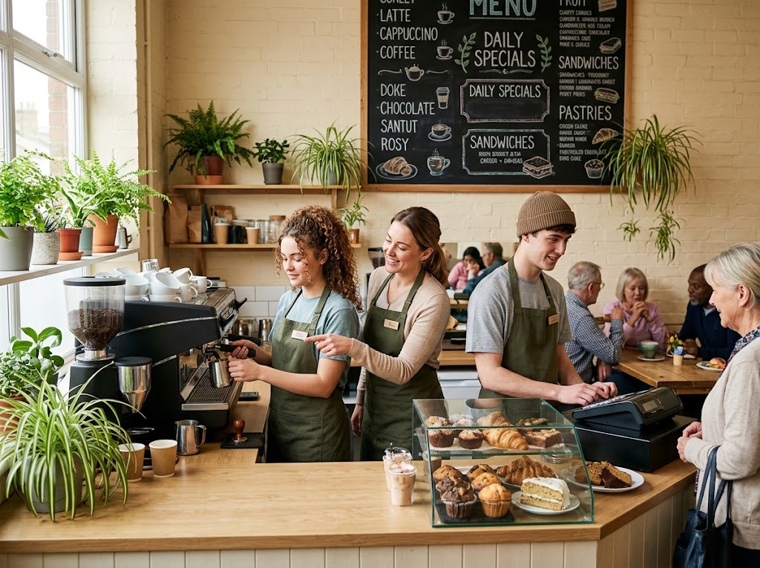  A social enterprise: a business run to help people, not only to make money.

Case Study
CASE STUDY
The Big Issue: A Social Objective
The Big Issue was launched in 1991 by John Bird and Gordon Roddick to help people who were homeless earn a legitimate income. Vendors buy copies of the magazine and sell them on the street at the cover price, keeping the difference. The business still needs to cover its costs, but its main aim is social: giving people a way to work their way out of poverty.

1991  The Big Issue launched | Social  Its main aim: helping vendors earn an income
Why Aims and Objectives Differ
No two businesses have exactly the same aims.
▸ Size. A small business may aim to survive or give its owner independence; a large one may aim for market share.
▸ Age. A new business usually aims to survive; an established one aims for growth and profit.
▸ The owner's priorities. Some owners want to make as much money as possible; others want a good work-life balance or to help their community.
▸ Type of business. A social enterprise puts social objectives first; a company owned by shareholders puts profit first.
▸ Competition. A business in a fiercely competitive market may have to focus on survival or keeping its market share.
Financial or Non-financial?
FINANCIAL AIMS | NON-FINANCIAL AIMS
▸ Survival.  ▸ Profit.  ▸ Sales.  ▸ Market share.  ▸ Financial security. | ▸ Social objectives.  ▸ Personal satisfaction.  ▸ Challenge.  ▸ Independence and control.
Key Terms
Aim  A general, long-term goal a business wants to achieve. | Objective  A specific, measurable target that helps a business achieve its aim.
Survival  Continuing to trade rather than closing down. | Market share  The percentage of total sales in a market made by one business.
Financial security  Having enough money to cover costs and deal with unexpected problems. | Social objective  An aim to help society or the environment.
Social enterprise
A business whose main aim is social, using its profits to do good.
Your Task: Whose Aims Are These?
10 minutes
For each business, decide on its most likely main aim and explain why - a market stall that opened last month; a café run by a charity that trains young people; a gym chain with 200 branches; a freelance web designer who left a stressful office job.
1. Name the most likely main aim.
2. Say whether it is financial or non-financial.
3. Explain why it suits that business.
A good answer shows: A named aim for each business, with a reason linked to its size, age, type or owner.
Can I...?
☐ Explain the difference between an aim and an objective.
☐ Explain the five financial aims.
☐ Explain the four non-financial aims.
☐ Calculate market share.
☐ Explain why aims differ between businesses.
Summary
✓ Aims are long-term goals; objectives are specific, measurable targets.
✓ Financial aims: survival, profit, sales, market share and financial security.
✓ Non-financial aims: social objectives, personal satisfaction, challenge, independence and control.
✓ Aims differ with the size, age and type of business and the owner's priorities.

EXAM FOCUS
Explain one reason why the aims of a new business might be different from the aims of an established business. (3 marks)
Name the difference, then explain why the business's situation causes it - a new business has few customers and little cash, so survival comes first.

