EDEXCEL GCSE BUSINESS · PAPER 1
Revenue, costs and profit
Putting a business idea into practice · Lesson 2 of 5
Last Lesson
Answer from memory before the answers appear.
1. What is the difference between an aim and an objective?
An aim is a general long-term goal; an objective is a specific, measurable target.
2. Name three financial aims.
Any three of: survival, profit, sales, market share, financial security.
3. Name two non-financial aims.
Any two of: social objectives, personal satisfaction, challenge, independence and control.
4. How do you calculate market share?
(Business's sales ÷ total market sales) × 100.
Learning Objectives
1. Calculate revenue.
2. Explain and calculate fixed costs, variable costs and total costs.
3. Calculate profit and loss.
4. Calculate interest on a loan as a percentage.
The Big Idea
Profit = revenue - costs. Everything else in this lesson is about getting those two numbers right.
Revenue
Revenue is the money a business receives from selling its products.
▸ Formula. Revenue = sales price × quantity sold.
▸ Also called. Sales revenue, turnover or income.
▸ Not the same as profit. Revenue is all the money coming in, before any costs are paid.
▸ Example. A café sells 3,000 coffees at £4 each: revenue = £4 × 3,000 = £12,000.
Every Sale Is Revenue
Every time a customer pays, the business's revenue goes up. But revenue alone says nothing about whether the business is doing well - that depends on how much it cost to make and sell the product. |   Price × quantity: every sale adds to revenue.

PART ONE
Costs
Some costs stay the same however much is sold. Others rise with every sale.
Fixed or Variable Costs?
FIXED COSTS | VARIABLE COSTS
▸ Do not change with the number of products made or sold.  ▸ Must be paid even if nothing is sold.  ▸ Examples: rent, salaries, insurance, loan repayments, advertising.  ▸ Can change over time, e.g. when the rent goes up. | ▸ Change directly with the number of products made or sold.  ▸ Are zero if nothing is made.  ▸ Examples: raw materials, ingredients, packaging, stock.  ▸ Total variable costs = variable cost per unit × quantity.
Fixed and Variable Costs
Rent must be paid whatever happens. Ingredients are only needed for every cup sold.
  Rent: a fixed cost. | 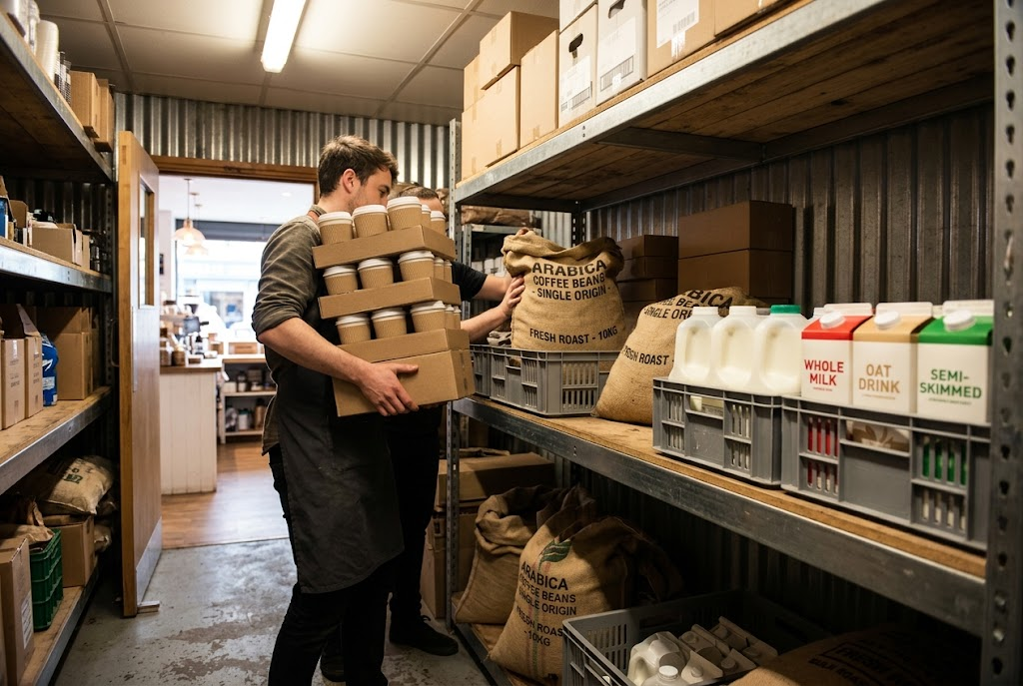  Ingredients: a variable cost.

Total Costs
Total costs are everything a business spends to make and sell its products.
▸ Formula. Total costs = fixed costs + total variable costs.
▸ Total variable costs. Variable cost per unit × quantity sold.
▸ Example. The café's fixed costs are £6,000 a month and each coffee costs £1.50 to make. Selling 3,000 coffees: total variable costs = £1.50 × 3,000 = £4,500. Total costs = £6,000 + £4,500 = £10,500.
PART TWO
Profit and Loss
What is left - or missing - once costs are paid.
Profit and Loss
Profit = total revenue - total costs.
▸ Profit. When revenue is greater than total costs, the business makes a profit.
▸ Loss. When total costs are greater than revenue, the business makes a loss. A loss is shown as a negative number or in brackets, e.g. -£500 or (£500).
▸ Why it matters. Profit rewards the owner and can be reinvested; losses cannot go on for ever, or the business will fail.
▸ Example. The café's revenue is £12,000 and its total costs are £10,500, so its profit = £12,000 - £10,500 = £1,500.
The Café's Month in Numbers
Work through it in order, and show every step.
A café sells 3,000 coffees at £4 each. Its fixed costs are £6,000 a month and each coffee costs £1.50 to make. Calculate its profit.

1. Revenue
£4 × 3,000 = £12,000
2. Total variable costs
£1.50 × 3,000 = £4,500
3. Total costs
£6,000 + £4,500 = £10,500
4. Profit
£12,000 - £10,500 = £1,500
Answer: Profit = £1,500
The Café's Month at a Glance
£12,000  Revenue | £6,000  Fixed costs | £4,500  Total variable costs | £1,500  Profit
PART THREE
Interest
The cost of borrowing money.
Interest on Loans
Interest is the extra money a business pays back on top of what it borrowed.
▸ What it is. The cost of borrowing - the reward the lender gets for lending the money.
▸ Formula. Interest (%) = (total repayment - borrowed amount) ÷ borrowed amount × 100.
▸ A fixed cost. Interest must be paid whatever the business sells, so it adds to fixed costs and reduces profit.
▸ Why it matters. A high interest rate makes borrowing expensive, so a business may borrow less or look for cheaper finance.
Calculating Interest as a Percentage
Edexcel asks for interest as a percentage of the amount borrowed.
A business borrows £5,000 and repays £5,600 in total. Calculate the rate of interest.

1. Find the interest paid
£5,600 - £5,000 = £600
2. Divide by the amount borrowed
£600 ÷ £5,000 = 0.12
3. Multiply by 100
0.12 × 100 = 12%
Answer: Interest = 12%
Case Study
CASE STUDY
When Fixed Costs Rise
In 2022 wholesale energy prices rose sharply across the UK. Many small bakeries, which run ovens for hours every day, saw their energy bills rise several times over. Energy is largely a fixed cost for a bakery - the ovens must be heated whether it sells 100 loaves or 1,000 - so higher bills cut straight into profit. Some bakeries raised their prices to protect their profit, some cut their opening hours, and some were forced to close.

2022  Energy prices rise sharply | Profit  Falls when fixed costs rise and prices do not
Key Terms
Revenue  The money a business receives from sales. Price × quantity sold. | Fixed costs  Costs that do not change with the number of products made or sold, such as rent.
Variable costs  Costs that change directly with the number of products made or sold, such as raw materials. | Total costs  Fixed costs + total variable costs.
Profit  Total revenue minus total costs, when revenue is greater. | Loss  When total costs are greater than total revenue.
Interest
The cost of borrowing money, paid on top of the amount borrowed.
Fixed or Variable?
Match each cost to its type.
Cost | Type
Rent for the shop
Fixed
Flour for each loaf
Variable
The manager's salary
Fixed
Packaging for each order
Variable
Insurance
Fixed
Stock bought to sell
Variable
Your Task: Run the Numbers
12 minutes
A phone case business sells 500 cases a month at £12 each. Its fixed costs are £2,000 a month and each case costs £5 to make. Calculate its revenue, total costs and profit. Then work out what happens to its profit if it sells only 250 cases.
1. Calculate revenue.
2. Calculate total variable costs, then total costs.
3. Calculate profit.
4. Repeat for 250 cases.
A good answer shows: Revenue £6,000, total costs £4,500 and profit £1,500 at 500 cases; revenue £3,000, total costs £3,250 and a loss of £250 at 250 cases.
Can I...?
☐ Calculate revenue.
☐ Explain fixed costs, with examples.
☐ Explain variable costs, with examples.
☐ Calculate total variable costs.
☐ Calculate total costs.
☐ Calculate profit or loss.
☐ Calculate interest as a percentage.
Summary
✓ Revenue = price × quantity.
✓ Total costs = fixed costs + total variable costs.
✓ Profit = total revenue - total costs.
✓ Interest (%) = (total repayment - borrowed amount) ÷ borrowed amount × 100.

EXAM FOCUS
Calculate the profit a business makes if it sells 800 units at £8 each, with fixed costs of £2,000 and variable costs of £3 per unit. (2 marks)
Write the formula first, then the numbers, then the answer with its unit (£ or %). A correct method can earn a mark even if the final answer is wrong.

