EDEXCEL GCSE BUSINESS · PAPER 1
Business location
Making the business effective · Lesson 2 of 4
Last Lesson
Answer from memory before the answers appear.
1. What is unlimited liability?
The owner is personally responsible for all the business's debts.
2. Which types of business have unlimited liability?
Sole traders and ordinary partnerships.
3. What is a franchisee?
The business that buys the right to trade under a franchisor's brand.
4. Give one disadvantage of franchising for the franchisee.
Fees, royalties, lack of independence, or damage from other franchisees.
Learning Objectives
1. Explain the factors that influence where a business locates: proximity to the market, labour, materials and competitors.
2. Explain how the importance of each factor depends on the type of business.
3. Explain the impact of the internet and e-commerce on location decisions.
4. Weigh up fixed premises against selling online.
Why Location Matters
The right location brings in customers and keeps costs down; the wrong one can sink a business.
▸ Customers. A shop or café that customers cannot easily reach will struggle to make sales.
▸ Costs. Rent, wages and delivery costs all depend on where the business is.
▸ Hard to change. Moving is expensive and disruptive, so a new business needs to choose well the first time.
▸ Different needs. A café, a factory and an online shop all need very different locations.
PART ONE
Factors That Influence Location
Four things an owner weighs up.
The Four Location Factors
Proximity to the market  Being close to customers. Vital for shops, cafés and services that customers visit. | Proximity to labour  Being close to enough workers with the right skills, at a wage the business can afford.
Proximity to materials  Being close to suppliers of raw materials, especially if they are heavy, bulky or perishable. | Proximity to competitors  Staying away from rivals to avoid competition - or locating near them where customers already go.
Proximity to the Market
How close the business is to its customers.
▸ Footfall. The number of people walking past. High footfall on a busy high street brings in passing customers.
▸ Services and shops. A hairdresser, café or corner shop must be where its customers live, work or travel.
▸ The trade-off. Busy locations have the highest rents, so the extra sales must be worth the extra cost.
▸ Delivery. Businesses that deliver to customers want to be close enough to keep delivery quick and cheap.
Where the Customers Are
For a café or a small shop, being where customers already walk past can matter more than anything else. But landlords know it too, so the busiest streets charge the highest rents. | 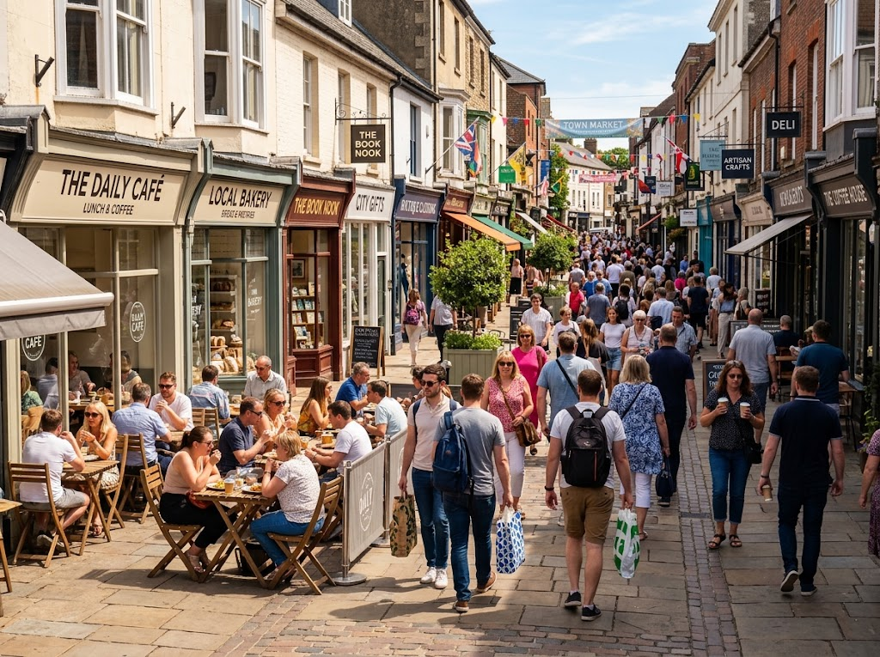  High footfall brings passing customers - and high rents.

Proximity to Labour
How close the business is to the workers it needs.
▸ Skilled workers. A business needing specialist skills - software developers, chefs, engineers - must be where those people live.
▸ Wage costs. Wages are usually higher in big cities, especially London, and lower in other areas.
▸ Enough workers. A business that needs many staff must be somewhere with enough people looking for work.
▸ Less important for some. A sole trader working alone barely needs to think about it.
Proximity to Materials
How close the business is to its suppliers.
▸ Heavy or bulky materials. Transporting them is expensive, so it makes sense to be near the supplier.
▸ Perishable materials. Fresh food must be used quickly, so food producers may locate near farms or markets.
▸ Reliable supply. Being close to suppliers means deliveries arrive quickly and reliably.
▸ Example. A sawmill locates near forests; a farm shop is on the farm.
Proximity to Competitors
Near rivals, or far away from them?
▸ Away from competitors. A business may choose an area with no rivals, so it gets all the local customers.
▸ Near competitors. Some businesses gain from being close together, because customers come to that area to compare and choose - restaurants on a food street, or shops in a shopping centre.
▸ Research first. A market map and a look at the local area show where competitors already are.
▸ Example. A second fish and chip shop on the same small street would struggle; a new restaurant on a busy restaurant street might thrive.
PART TWO
The Impact of the Internet
E-commerce has changed where - and whether - a business needs premises.
E-commerce and Location
E-commerce means buying and selling goods and services online.
▸ No shop needed. A business selling online can run from home, a small unit or a cheap warehouse instead of an expensive high-street shop.
▸ Lower costs. Without a shop, rent and staff costs are much lower, so prices can be lower too.
▸ A bigger market. An online business can sell to customers anywhere in the country, or the world, not just those nearby.
▸ Location still matters. An online business still needs to be near good roads and delivery services, and near the workers who pack and send the orders.
Fixed Premises or Online?
Two ways to reach customers: a shop they walk into, or a website that sends the goods to them.
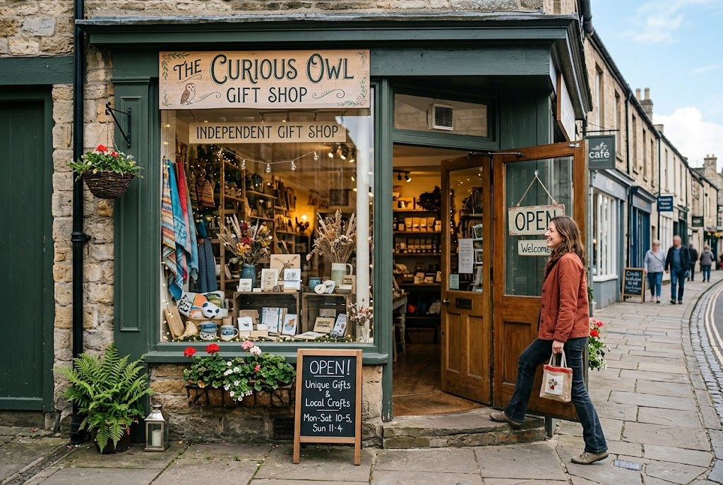  Fixed premises: customers come to the business. |   E-commerce: the business goes to the customers.

Fixed Premises or E-commerce?
FIXED PREMISES | E-COMMERCE
▸ Customers can see, touch and try products before buying.  ▸ Face-to-face service builds loyalty.  ▸ Essential for services customers must visit, such as hairdressers and cafés.  ▸ But: high rent and staff costs, and only reaches local customers.  ▸ Limited opening hours. | ▸ Much lower costs - no expensive shop.  ▸ Can reach customers anywhere in the country or the world.  ▸ Open 24 hours a day.  ▸ But: customers cannot try products, and delivery costs and returns must be managed.  ▸ Strong online competition and the need to be found on search engines and social media.
Case Study
CASE STUDY
Gymshark: From a Garage to the World
Gymshark was started in 2012 by Ben Francis, then a 19-year-old student, and his friend Lewis Morgan. They made and sold gym clothing online from Ben's parents' garage near Birmingham. Because the business sold only through its website, it did not need a shop on a high street: location mattered far less than it would have for a traditional clothing shop, and customers anywhere could buy from it. By selling online, a business run from a garage could reach customers all over the world.

2012  Gymshark started in a garage | Online  Where it sold, with no high-street shop
Key Terms
Location  Where a business is based. | Proximity  How close something is.
Footfall  The number of people who walk past or into a business. | Labour  The workers a business employs.
E-commerce  Buying and selling goods and services online. | Fixed premises  A physical building a business operates from, such as a shop, office or factory.
Your Task: Choose the Location
12 minutes
For each business, rank the four location factors from most to least important and explain your top choice: a sandwich shop; a bakery making bread for local cafés; a small software company; an online shop selling handmade jewellery.
1. Rank the four factors for each business.
2. Explain why the top factor matters most.
3. Say whether it needs fixed premises at all.
A good answer shows: A ranking for each business, with the most important factor explained using the type of business - customers for the sandwich shop, labour for the software company, delivery links for the online shop.
Can I...?
☐ Explain proximity to the market.
☐ Explain proximity to labour.
☐ Explain proximity to materials.
☐ Explain proximity to competitors.
☐ Explain how e-commerce affects location decisions.
☐ Compare fixed premises with selling online.
Summary
✓ Location factors: proximity to the market, labour, materials and competitors.
✓ Which factor matters most depends on the type of business.
✓ E-commerce lets businesses sell without expensive premises and reach customers anywhere.
✓ Services that customers must visit still need fixed premises in the right place.

EXAM FOCUS
Explain one reason why the internet has reduced the importance of location for some businesses. (3 marks)
Name the business type in your answer - e-commerce changes location for a shop selling goods, not for a hairdresser whose customers must visit.

