EDEXCEL GCSE BUSINESS · PAPER 1
The marketing mix
Making the business effective · Lesson 3 of 4
Teacher copy - includes the notes for whoever is teaching from it.
Last Lesson
Answer from memory before the answers appear.
1. Name the four location factors.
Proximity to the market, labour, materials and competitors.
2. What is e-commerce?
Buying and selling goods and services online.
3. Give one advantage of selling online instead of from a shop.
Lower costs, reaching more customers, or being open 24 hours.
4. Why does a hairdresser still need fixed premises?
Customers must visit in person.
Learning Objectives
1. Explain what the marketing mix is.
2. Explain the importance of each of the four Ps: product, price, promotion and place.
3. Explain how the elements of the marketing mix work together.
4. Explain how changing customer needs, technology and competition affect the marketing mix.
The Big Idea
The right product, at the right price, promoted in the right way, in the right place.
That is the whole of the marketing mix - and all four have to be right at once.
The marketing mix
The marketing mix

Product  ▸ what the business sells  ▸ its features, quality and appearance  ▸ how it meets customer needs | Price  ▸ how much customers pay  ▸ must suit the target market  ▸ must cover costs
Promotion  ▸ how customers find out about it  ▸ social media, leaflets, adverts, special offers | Place  ▸ where and how customers buy it  ▸ shop, market stall, website, app
PART ONE
The Four Ps
Why each element matters.
Product
The good or service the business sells.
▸ What it includes. What the product does, its quality, how it looks, its size and its packaging.
▸ Why it matters. If the product does not meet customer needs, no amount of promotion will make customers keep buying it.
▸ Standing out. A small business often needs something that makes its product different from competitors' - a unique selling point.
▸ Example. A bakery's product is not just bread: it is fresh, baked on site each morning, with local ingredients.
Price
The amount customers pay for the product.
▸ Cover costs. The price must be high enough to cover costs and make a profit.
▸ Suit the target market. It must be a price the target customers are willing and able to pay.
▸ Match the product. Customers expect a high-quality product to cost more; a very low price can make them doubt the quality.
▸ Look at competitors. Customers compare prices, so a business charging more than rivals must give them a reason to pay it.
Product and Price on Show
A customer looking at this table judges the product and the price together. Handmade, attractively displayed products suggest quality, so customers expect - and accept - a higher price than for mass-produced versions in a supermarket. | 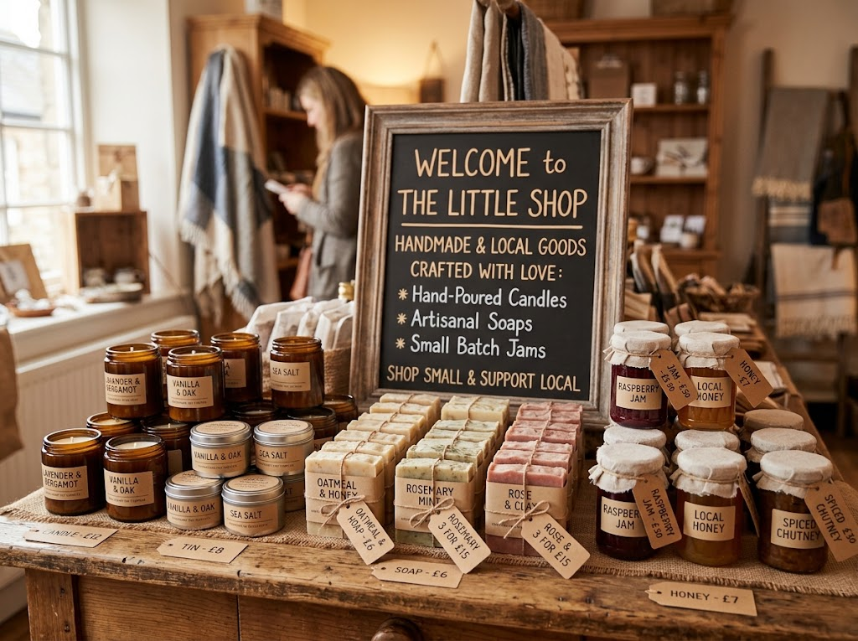  Product and price: the first two Ps, side by side on the shelf.

Promotion
How the business tells customers about its product and persuades them to buy.
▸ Why it matters. Customers cannot buy a product they have never heard of.
▸ Reaching the target market. Promotion must appear where the target customers will see it.
▸ Small-business options. Social media posts, a website, leaflets, local newspapers, word of mouth and special offers.
▸ Cost. Small businesses have small budgets, so they choose cheap methods that reach the right people.
Place
Where and how customers can buy the product.
▸ Why it matters. Customers need to be able to buy the product easily, when and where they want.
▸ Options for a small business. Its own shop, a market stall, other shops that stock its products, its own website or an online marketplace.
▸ Match the customer. Place must suit how the target market likes to shop - older customers may prefer a shop; younger customers may prefer an app.
▸ Convenience. The easier it is to buy, the more customers will buy.
PART TWO
Making the Mix Work Together
Four Ps that fit together - an integrated marketing mix.
An Integrated Marketing Mix
The four Ps must support each other and suit the same target market.
▸ Consistency. Each P sends the same message. A luxury product needs a high price, stylish promotion and an upmarket place to sell.
▸ Mismatches confuse customers. A premium chocolate brand sold cheaply in a discount shop, with cheap-looking adverts, would not be believed.
▸ Changing one P affects the others. Improving the product's quality may mean raising the price and promoting the new quality.
▸ Balancing the mix. A small business may not be able to afford everything, so it balances the four - for example a good product sold at a fair price, with cheap social media promotion.
One Café, Two Target Markets
The P | Budget student café | Upmarket brunch café
Product | Simple coffee, toasties, big portions | Speciality coffee, fresh brunch dishes
Price | Low - £2 coffee, meal deals | High - £4 coffee, £14 brunch
Promotion | Student discount, Instagram, flyers on campus | Food bloggers, a stylish website, local magazines
Place | Near the university, fast takeaway counter | Quiet, stylish street with table service
PART THREE
A Mix That Changes
The marketing mix never stays fixed.
Changing Customer Needs
When customers want something different, the mix has to change.
▸ Product. Businesses add new products as tastes change - vegan options, low-sugar drinks, eco-friendly packaging.
▸ Price. If customers have less money to spend, a business may offer smaller, cheaper versions or value deals.
▸ Promotion. The message changes to show the business meets the new need, such as "plastic-free" or "locally sourced".
▸ Place. As more customers shop online, small businesses add websites, delivery and click-and-collect.
The Impact of Technology
E-commerce and digital communication have changed every P for small businesses.
▸ Place: e-commerce. A small business can sell online to customers anywhere, through its own website or an online marketplace.
▸ Promotion: digital communication. Social media, email and websites let a small business promote itself cheaply and target exactly the right customers.
▸ Price. Customers can compare prices online in seconds, so businesses must keep their prices competitive.
▸ Product. Customers leave online reviews, so product quality matters even more - one bad review can put off many buyers.
Promotion on a Small Budget
Why social media suits small businesses  ▸ Cheap. Posting is free; paid adverts can start from a few pounds.  ▸ Targeted. Adverts can be shown only to the right age, location and interests.  ▸ Two-way. Customers comment and share, spreading word of mouth. | 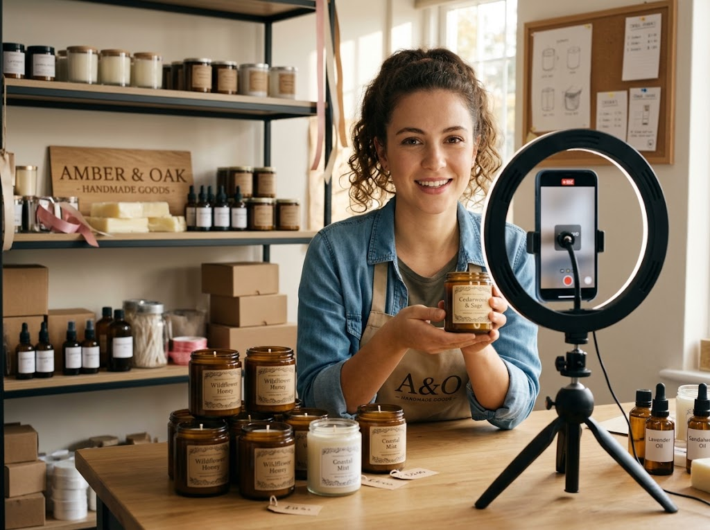  Digital communication: promotion that costs almost nothing.

The Mix in a Competitive Market
When there are many competitors, the mix must give customers a reason to choose this business.
▸ Product. Make it different - better quality, a unique feature or better service.
▸ Price. Keep it close to competitors, unless the product is clearly better.
▸ Promotion. Tell customers what makes the business different, not just that it exists.
▸ Place. Be easier to buy from than rivals - open longer, deliver faster or sell online.
Key Terms
Marketing mix  The four elements a business uses to market its product: product, price, promotion and place. | Product  The good or service a business sells.
Price  The amount customers pay for a product. | Promotion  How a business tells customers about its product and persuades them to buy.
Place  Where and how customers can buy a product. | Integrated marketing mix  A marketing mix in which the four Ps fit together and suit the same target market.
Digital communication
Promoting a business and talking to customers online, e.g. through social media, email and websites.
Your Task: Build a Mix
15 minutes
You are launching a small business selling healthy smoothies to secondary school students. Plan all four Ps, making sure they fit together for your target market. Then explain one change you would make if a rival smoothie bar opened next door.
1. Describe your product.
2. Set a price and explain it.
3. Choose how to promote it.
4. Choose where to sell it.
5. Plan your response to the new competitor.
A good answer shows: A product, price, promotion and place that all suit teenage students and support each other, plus a response to competition linked to one of the Ps.
Note: Check for integration - a £6 smoothie promoted in a local newspaper does not fit a teenage target market.
Can I...?
☐ Name the four Ps.
☐ Explain why product matters.
☐ Explain why price matters.
☐ Explain why promotion matters.
☐ Explain why place matters.
☐ Explain what an integrated marketing mix is.
☐ Explain how changing customer needs affect the mix.
☐ Explain how technology affects the mix.
☐ Explain how competition affects the mix.
Summary
✓ The marketing mix is product, price, promotion and place.
✓ Each element matters, and all four must fit together for the target market.
✓ The mix changes as customer needs change.
✓ E-commerce and digital communication have changed every P, especially for small businesses.

EXAM FOCUS
Explain one way that digital communication can help a small business promote its products. (3 marks)
Name the method (social media, email, a website), then explain the benefit for a small business specifically - low cost, targeting the right customers, reaching more people.
Exam Practice: The Marketing Mix
Answer all questions. Use the context of the business in the question where one is given. · 25 minutes
▸ Question 1 · 1 mark · Define. Define the term 'marketing mix'.
▸ Question 2 · 1 mark · State. State one element of the marketing mix.
▸ Question 3 · 2 marks · Outline. Outline one way e-commerce has affected the place element of the marketing mix.
▸ Question 4 · 3 marks · Explain. Explain one way that digital communication can help a small business promote its products.
▸ Question 5 · 6 marks · Analyse. Analyse the importance to Kai of having an integrated marketing mix.
Question 1 · 1 mark · Define
“Define the term 'marketing mix'.”
HOW TO ANSWER IT Command word: Define. Worth 1 mark, so plan before writing.
Question 1 · mark scheme
1 mark available. Award a mark for each point made.
▸ The four Ps / product, price, promotion and place. 1 mark
▸ Model answer. The combination of product, price, promotion and place that a business uses to sell its product.
Question 2 · 1 mark · State
“State one element of the marketing mix.”
HOW TO ANSWER IT Command word: State. Worth 1 mark, so plan before writing.
Question 2 · mark scheme
1 mark available. Award a mark for each point made.
▸ Any one of: product; price; promotion; place. 1 mark
▸ Model answer. Promotion.
Question 3 · 2 marks · Outline
“Outline one way e-commerce has affected the place element of the marketing mix.”
HOW TO ANSWER IT Command word: Outline. Worth 2 marks, so plan before writing.
Question 3 · mark scheme
2 marks available. Award a mark for each point made.
▸ A way identified, e.g. selling online / reaching customers anywhere / no need for a shop. 1 mark
▸ Developed: the effect on the business or its customers. 1 mark
▸ Model answer. Businesses can sell their products online (1), so customers can buy from anywhere at any time without visiting a shop (1).
Question 4 · 3 marks · Explain
“Explain one way that digital communication can help a small business promote its products.”
HOW TO ANSWER IT Command word: Explain. Worth 3 marks, so plan before writing.
Question 4 · mark scheme
3 marks available. Award a mark for each point made.
▸ A way identified, e.g. social media / email / website. 1 mark
▸ First linked point of explanation. 1 mark
▸ Second linked point of explanation. 1 mark
▸ Model answer. A small business can use social media to promote its products (1). Posting is free and paid adverts can be shown only to people of the right age, location and interests (1). This means the business reaches its target market for much less money than traditional advertising, which suits its small budget (1).
Question 5 · 6 marks · Analyse
“Analyse the importance to Kai of having an integrated marketing mix.”
— Kai runs a small shop selling handmade leather wallets and bags. His products are high quality and take many hours to make, but he prices them only slightly above mass-produced…
HOW TO ANSWER IT Command word: Analyse. Worth 6 marks, so plan before writing.
Question 5 · mark scheme
6 marks available. Award a mark for each point made.
▸ AO2 (Application, 3 marks): uses the context - handmade leather, low price, leaflets, young professionals. Level 1-3
▸ AO3a (Analysis, 3 marks): chains of reasoning showing why the four Ps must fit together. Level 1-3
▸ Model answer. Kai's product is high quality and handmade, but his price is only slightly above mass-produced wallets. This sends a mixed message: customers may doubt that the product is really special if it is priced like a cheaper one, and Kai earns too little on each item to cover the many hours it takes to make. If he raised his price to match the quality, his price and product would support each other and his profit per item would rise. His promotion also does not fit his target market. Young professionals aged 25 to 40 are more likely to see social media than leaflets through the door, so his leaflets may be reaching the wrong people. If Kai promoted his handmade quality online, where his target customers are, all four Ps would work together, which should increase his sales.

