EDEXCEL GCSE BUSINESS · PAPER 1
Business stakeholders
Understanding external influences on business · Lesson 1 of 5
Teacher copy - includes the notes for whoever is teaching from it.
Last Chapter
Answer from memory before the answers appear.
1. What is limited liability?
The owners can only lose the money they invested in the business.
2. Name the four location factors.
Proximity to the market, labour, materials and competitors.
3. Name the four Ps.
Product, price, promotion and place.
4. Give two reasons for writing a business plan.
To minimise risk and to obtain finance.
Learning Objectives
1. Explain who a business's stakeholders are.
2. Explain the different objectives of each stakeholder group.
3. Explain how stakeholders are affected by, and can affect, business activity.
4. Explain why stakeholders' objectives can conflict.
What Is a Stakeholder?
A stakeholder is any person or group with an interest in a business, because they affect it or are affected by it.
▸ Not just the owners. Customers, staff, suppliers, neighbours and the government all have a "stake" in what the business does.
▸ Internal stakeholders. People inside the business: the owners, managers and employees.
▸ External stakeholders. People outside the business: customers, suppliers, the local community, pressure groups and the government.
▸ Why they matter. A small business needs the support of its stakeholders - without customers, staff and suppliers it cannot operate at all.
A small business's stakeholders
A small business's stakeholders

Owners (shareholders)  ▸ profit  ▸ the business surviving and growing  ▸ the value of their investment | Employees  ▸ fair pay  ▸ job security  ▸ good working conditions
Managers  ▸ a good salary  ▸ responsibility  ▸ the business succeeding | Customers  ▸ good quality  ▸ low prices  ▸ good service and choice
Suppliers  ▸ regular orders  ▸ being paid on time  ▸ a long relationship | Local community  ▸ jobs  ▸ little noise, litter or traffic  ▸ support for local causes
Pressure groups  ▸ the business changing how it behaves on the issue they campaign about | The government  ▸ taxes paid  ▸ laws followed  ▸ jobs created
The People Inside the Business
In a small business the owner and employees work side by side every day. They both want the business to succeed - but the owner wants profit, and the employees want good pay, and every pound spent on one is a pound less for the other. |   Owners and employees: internal stakeholders who want different things from the same business.

PART ONE
Each Stakeholder's Objectives
What each group wants from the business.
Stakeholders and Their Objectives
Stakeholder | Who they are | What they want
Owners (shareholders) | The people who own the business | Profit, survival and growth
Employees | People who work for the business | Good pay, job security, safe conditions
Managers | Employees who run parts of the business | Good salary, responsibility, success
Customers | People who buy the products | Quality, low prices, good service
Suppliers | Businesses that sell materials or stock to it | Regular orders and prompt payment
Local community | People living near the business | Jobs, little disruption, local support
Pressure groups | Groups campaigning on an issue | The business changing its behaviour
The government | National and local government | Taxes, jobs, following the law
PART TWO
Stakeholders and the Business
The influence runs both ways.
A Two-Way Relationship
HOW BUSINESS ACTIVITY AFFECTS STAKEHOLDERS | HOW STAKEHOLDERS AFFECT THE BUSINESS
▸ A new café creates jobs for local people.  ▸ Raising prices costs customers more.  ▸ Paying suppliers late causes them cash-flow problems.  ▸ Late-night opening may disturb neighbours.  ▸ Profits pay the owner and taxes pay for public services. | ▸ Customers decide whether to buy - they decide sales.  ▸ Employees' skill and effort decide the quality of service.  ▸ Suppliers can refuse trade credit or raise prices.  ▸ The local council can refuse planning permission.  ▸ Pressure groups can organise protests and bad publicity.
When the Community Pushes Back
Even a small business can find itself in conflict with its neighbours. Residents worried about noise, litter or traffic can object to planning applications, complain to the council or campaign on social media - and a business that ignores them risks losing both its permission and its reputation. | 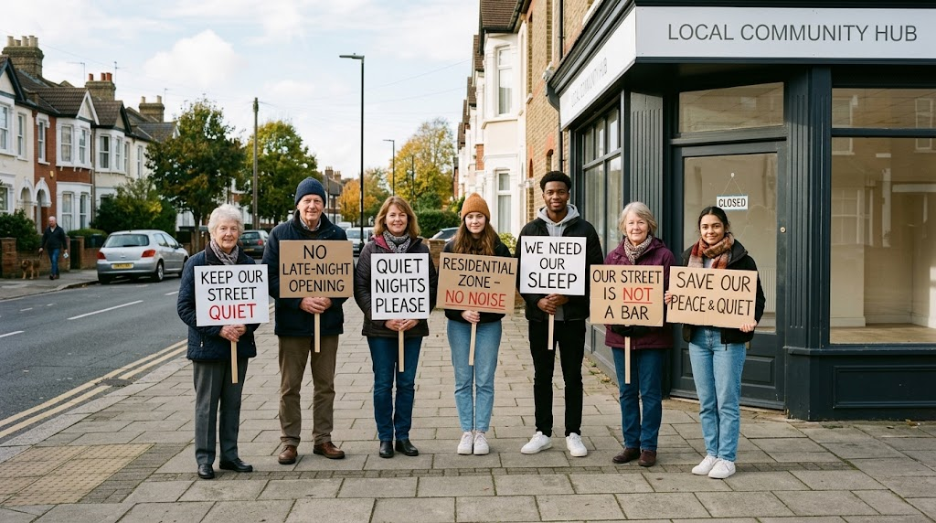  The local community and pressure groups can change a business's plans.

Pressure Groups
A pressure group is an organised group that tries to change what businesses or the government do.
▸ What they want. Change on one issue, such as animal welfare, pollution, plastic waste or protecting a local area.
▸ How they act. Campaigns on social media, protests, petitions, boycotts and contacting the local council or newspapers.
▸ Impact on a small business. Bad publicity can put customers off, so the business may change its plans.
▸ Local groups. Many pressure groups are small and local, formed to fight one decision - such as a new takeaway on a quiet street.
PART THREE
When Stakeholders Disagree
What is good for one group can be bad for another.
Conflicts Between Stakeholders
Stakeholders | One wants... | The other wants...
Owners and employees | Lower wage costs to raise profit | Higher pay
Owners and customers | Higher prices to raise profit | Lower prices
Customers and local community | Late opening for convenience | Quiet evenings and no litter
Owners and suppliers | Lower prices and longer to pay | Higher prices and prompt payment
Owners and pressure groups | The cheapest packaging | Plastic-free packaging, which costs more
Dealing With Conflict
A business cannot please everyone, so it has to make choices.
▸ Prioritise. Most small businesses put customers and owners first, because without sales and profit the business cannot survive.
▸ Compromise. A café might open late on weekends only, to keep customers happy without annoying neighbours every night.
▸ Communicate. Explaining decisions to staff, customers and neighbours can reduce complaints.
▸ Long term. Treating employees, suppliers and the community well often pays off in loyalty and reputation.
Key Terms
Stakeholder  Any person or group with an interest in a business, who affects it or is affected by it. | Internal stakeholder  A stakeholder inside the business: owners, managers and employees.
External stakeholder  A stakeholder outside the business, such as customers, suppliers and the community. | Shareholder  An owner of part of a company.
Pressure group  An organised group that tries to change the behaviour of businesses or the government. | Local community  The people who live and work near a business.
Your Task: The New Takeaway
12 minutes
A new pizza takeaway plans to open until 2am on a street of houses near a town centre. Choose four stakeholders. For each one, say whether they will support or oppose the plan and why. Then identify the biggest conflict and suggest a compromise.
1. Choose four stakeholders.
2. Support or oppose? Explain why.
3. Name the biggest conflict.
4. Suggest a compromise.
A good answer shows: Four stakeholders with clear objectives linked to the plan, one conflict explained, and a realistic compromise such as earlier closing on weeknights.
Note: Push them beyond "customers like it": students out late may love it, but families next door with young children will not - both are stakeholders.
Can I...?
☐ Explain what a stakeholder is.
☐ Name the eight stakeholder groups.
☐ Explain the objectives of each group.
☐ Explain how a business affects its stakeholders.
☐ Explain how stakeholders affect a business.
☐ Explain what a pressure group does.
☐ Explain a conflict between two stakeholders.
☐ Suggest how a business could deal with a conflict.
Summary
✓ Stakeholders are anyone affected by, or who affects, a business.
✓ Owners, employees, managers, customers, suppliers, the local community, pressure groups and the government all have different objectives.
✓ Business activity affects stakeholders, and stakeholders affect the business.
✓ Stakeholders' objectives often conflict, so a business has to prioritise or compromise.

EXAM FOCUS
Explain one possible conflict between the owners and the employees of a small business. (3 marks)
Name both stakeholders and what each one wants, then explain why the business cannot fully give both what they want at the same time.
Exam Practice: Business Stakeholders
Answer all questions. Use the context of the business in the question where one is given. · 20 minutes
▸ Question 1 · 1 mark · Define. Define the term 'stakeholder'.
▸ Question 2 · 1 mark · State. State one objective that customers might have.
▸ Question 3 · 2 marks · Outline. Outline one way the local community could be affected by a new business opening.
▸ Question 4 · 3 marks · Explain. Explain one possible conflict between the owners and the employees of a small business.
▸ Question 5 · 6 marks · Analyse. Analyse the impact of Nadia's plan on two of her stakeholders.
Question 1 · 1 mark · Define
“Define the term 'stakeholder'.”
HOW TO ANSWER IT Command word: Define. Worth 1 mark, so plan before writing.
Question 1 · mark scheme
1 mark available. Award a mark for each point made.
▸ A person / group with an interest in / affected by a business. 1 mark
▸ Model answer. Any person or group who has an interest in a business, because they affect it or are affected by it.
Question 2 · 1 mark · State
“State one objective that customers might have.”
HOW TO ANSWER IT Command word: State. Worth 1 mark, so plan before writing.
Question 2 · mark scheme
1 mark available. Award a mark for each point made.
▸ Any valid objective, e.g. low prices; good quality; good customer service; choice. 1 mark
▸ Model answer. Low prices.
Question 3 · 2 marks · Outline
“Outline one way the local community could be affected by a new business opening.”
HOW TO ANSWER IT Command word: Outline. Worth 2 marks, so plan before writing.
Question 3 · mark scheme
2 marks available. Award a mark for each point made.
▸ An effect identified, e.g. jobs / noise / litter / traffic / more choice of shops. 1 mark
▸ Developed: the impact on the community. 1 mark
▸ Model answer. It could create jobs for local people (1), giving them an income close to home and money to spend in other local businesses (1).
Question 4 · 3 marks · Explain
“Explain one possible conflict between the owners and the employees of a small business.”
HOW TO ANSWER IT Command word: Explain. Worth 3 marks, so plan before writing.
Question 4 · mark scheme
3 marks available. Award a mark for each point made.
▸ A conflict identified, e.g. pay vs profit / hours / job security. 1 mark
▸ First linked point of explanation. 1 mark
▸ Second linked point of explanation. 1 mark
▸ Model answer. The employees may want higher pay, while the owners want to keep costs low (1). Paying higher wages increases the business's costs (1). This means the owners' profit falls, so the owners may refuse the pay rise, leaving employees unhappy (1).
Question 5 · 6 marks · Analyse
“Analyse the impact of Nadia's plan on two of her stakeholders.”
— Nadia owns a small café on a quiet residential street. To increase sales, she plans to stay open until 11pm and sell alcohol in the evenings. She would need to hire two extra…
HOW TO ANSWER IT Command word: Analyse. Worth 6 marks, so plan before writing.
Question 5 · mark scheme
6 marks available. Award a mark for each point made.
▸ AO2 (Application, 3 marks): uses the context - the quiet residential street, 11pm opening, alcohol, two extra staff. Level 1-3
▸ AO3a (Analysis, 3 marks): chains of reasoning showing the impact on each of two stakeholders. Level 1-3
▸ Model answer. Nadia's plan would benefit her employees and people looking for work. She needs two extra staff for evening shifts, which creates jobs, and her existing staff may get extra hours and so earn more money. This could make them more loyal to the café. However, the plan could have a negative impact on the local community. Because the café is on a quiet residential street, customers drinking until 11pm could cause noise when neighbours are trying to sleep. This means residents may complain to the council when Nadia applies for her alcohol licence, which could stop the plan going ahead or damage the café's reputation with local customers.

