EDEXCEL GCSE BUSINESS · PAPER 1
Technology and business
Understanding external influences on business · Lesson 2 of 5
Teacher copy - includes the notes for whoever is teaching from it.
Last Lesson
Answer from memory before the answers appear.
1. What is a stakeholder?
Anyone who affects, or is affected by, a business.
2. Name two external stakeholders.
Any two of: customers, suppliers, the local community, pressure groups, the government.
3. What do employees usually want?
Fair pay, job security and good working conditions.
4. Give one example of a stakeholder conflict.
Owners want profit; employees want higher pay - or owners want higher prices; customers want lower prices.
Learning Objectives
1. Explain the types of technology used by small businesses: e-commerce, social media, digital communication and payment systems.
2. Explain how technology affects a business's sales.
3. Explain how technology affects a business's costs.
4. Explain how technology affects the marketing mix.
PART ONE
Types of Technology
Four kinds of technology every small business now meets.
Technology Used by Businesses
E-commerce  Buying and selling online, through a business's own website, an app or an online marketplace. | Social media  Platforms such as Instagram, TikTok and Facebook, used to promote products and talk to customers.
Digital communication  Email, messaging apps, video calls and websites, used to keep in touch with customers, staff and suppliers. | Payment systems  Ways customers pay: contactless cards, mobile phone payments, card readers and online payment services.
E-commerce
Selling online, twenty-four hours a day.
▸ Reach. A small business can sell to customers anywhere in the country, not just those who walk past.
▸ Always open. Customers can order at any time, even while the owner sleeps.
▸ Online marketplaces. Sites such as Etsy, eBay and Amazon let a tiny business sell without building its own website - in return for a fee on each sale.
▸ Challenges. Delivery, returns and strong online competition, with customers comparing prices in seconds.
Social Media and Digital Communication
Cheap, fast ways to reach customers and keep in touch.
▸ Promotion. Posts, videos and adverts reach large numbers of people for little or no cost.
▸ Targeting. Paid adverts can be shown only to people of the right age, location and interests.
▸ Two-way contact. Customers message, comment and review - giving feedback, but also airing complaints in public.
▸ Working with others. Email, messaging and video calls make it quick to order from suppliers and organise staff.
Payment Systems
How customers pay has changed completely in a few years.
▸ Contactless. Customers tap a card or phone to pay in seconds, which speeds up queues.
▸ Mobile card readers. Small, cheap card readers that connect to a phone let market stalls, food vans and tradespeople take card payments anywhere.
▸ Online payments. Secure online payment services let customers pay on a website without the business handling card details itself.
▸ Fewer lost sales. Customers who carry no cash can still buy - a stall that only takes cash turns them away.
Tap to Pay
A few years ago, taking card payments meant renting an expensive machine from a bank. Now a small card reader that links to a phone costs little to buy, so even a market stall or a food van can accept cards and phone payments - and stop losing customers who carry no cash. | 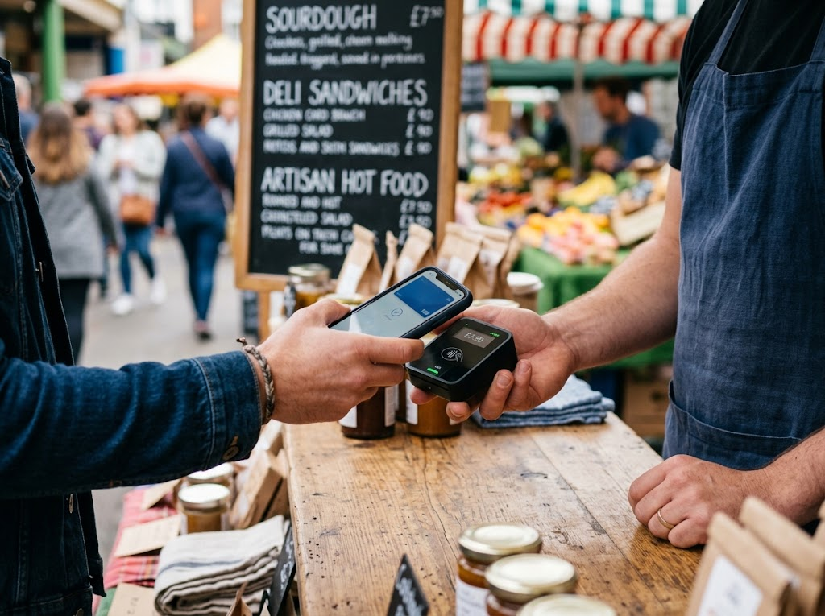  A cheap card reader lets even a market stall take card payments.

Then and Now
The same small shop counter, ten years apart.
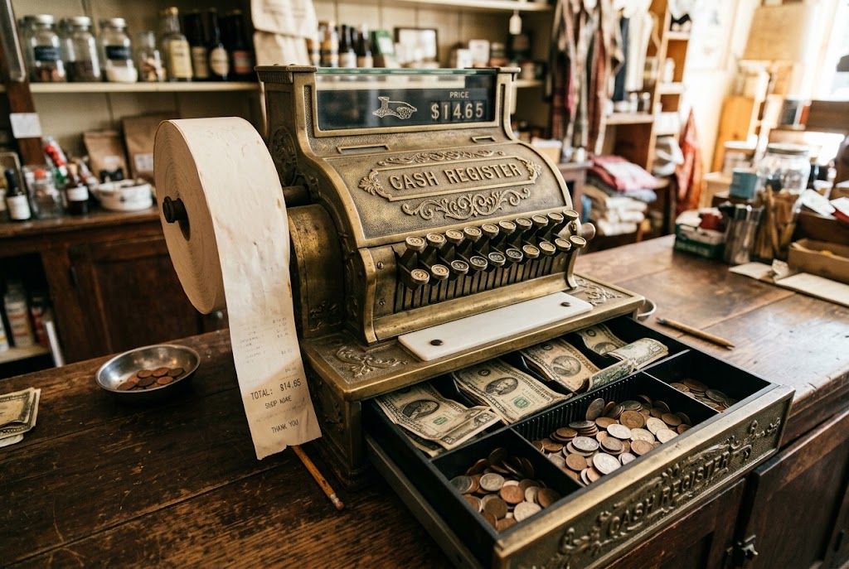  Then: cash only, sales counted by hand. | 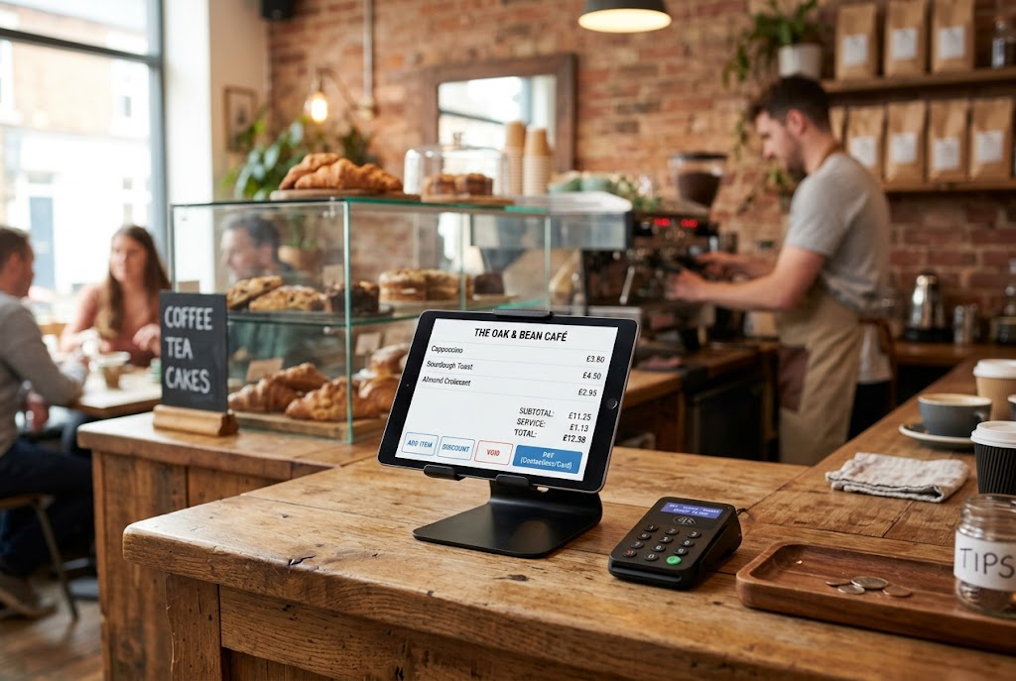  Now: card payments, with every sale recorded automatically.

PART TWO
How Technology Influences Business
Sales, costs and the marketing mix.
The Impact on Sales
Technology can increase sales - but it also increases competition.
▸ More customers. E-commerce reaches customers far beyond the local area.
▸ More sales per customer. Easy payment and one-click ordering make buying quicker, so customers buy more.
▸ Reviews. Good online reviews attract new customers; bad ones drive them away.
▸ More competition. Customers can find and compare rivals online in seconds, so sales can be lost as easily as won.
The Impact on Costs
Technology can cut some costs while adding others.
▸ Lower costs. Selling online avoids high-street rent; social media promotion is cheap; digital records save staff time.
▸ New costs. Buying equipment and software, building a website, fees on card payments and online marketplaces.
▸ Training. Staff may need training to use new systems.
▸ Keeping up. Technology changes quickly, so equipment and websites need updating.
Technology and the Marketing Mix
The P | How technology changes it
Product | New products become possible, and online reviews make quality more visible
Price | Customers compare prices online, so prices must be competitive
Promotion | Social media and digital communication make promotion cheap and targeted
Place | E-commerce lets customers buy online, anywhere, at any time
Case Study
CASE STUDY
Contactless: A Payment Revolution
Contactless card payments began in the UK in 2007, with a limit of £10 per payment. As customers came to trust it, the limit rose - to £20, then £30, then £45 in 2020 - and in October 2021 it reached £100. For small businesses, cheap mobile card readers mean that a market stall, a food van or a window cleaner can now take contactless payments as easily as a supermarket. A business that still takes only cash risks losing the growing number of customers who rarely carry any.

2007  Contactless payments launched in the UK at £10 | £100  The contactless limit since October 2021
Key Terms
E-commerce  Buying and selling goods and services online. | Social media  Websites and apps that let users share content and talk to each other.
Digital communication  Communicating electronically, e.g. by email, messaging, video calls and websites. | Payment system  A way for customers to pay, such as contactless cards, mobile phones or online payment services.
Online marketplace
A website where many businesses sell their products, usually paying a fee on each sale.
Your Task: Bring the Business Up to Date
12 minutes
A family-run fish and chip shop takes orders only over the counter, accepts only cash, and promotes itself with a sign in the window. Recommend three technologies it should use. For each, explain the likely effect on its sales and on its costs.
1. Choose three technologies.
2. Explain the effect on sales.
3. Explain the effect on costs.
A good answer shows: Three technologies from the four types, each with a specific effect on sales and a specific cost, such as card fees or delivery-app commission.
Note: Strong answers recognise the trade-off - a delivery app brings sales but takes a big share of each order.
Can I...?
☐ Explain e-commerce.
☐ Explain how small businesses use social media.
☐ Explain digital communication.
☐ Explain modern payment systems.
☐ Explain how technology affects sales.
☐ Explain how technology affects costs.
☐ Explain how technology affects the marketing mix.
Summary
✓ Four types of technology: e-commerce, social media, digital communication and payment systems.
✓ Technology can increase sales, but makes competition fiercer.
✓ It cuts some costs and adds others.
✓ It has changed every element of the marketing mix.

EXAM FOCUS
Explain one way that new payment systems could increase the sales of a small business. (3 marks)
Name the technology, then take the chain all the way to sales, costs or profit. "Customers can pay by card" is only the first step.
Exam Practice: Technology and Business
Answer all questions. Use the context of the business in the question where one is given. · 20 minutes
▸ Question 1 · 1 mark · State. State one type of technology used by businesses.
▸ Question 2 · 1 mark · Define. Define the term 'digital communication'.
▸ Question 3 · 2 marks · Outline. Outline one way technology could reduce the costs of a small business.
▸ Question 4 · 3 marks · Explain. Explain one way that new payment systems could increase the sales of a small business.
▸ Question 5 · 6 marks · Analyse. Analyse the impact of technology on Owen's business.
Question 1 · 1 mark · State
“State one type of technology used by businesses.”
HOW TO ANSWER IT Command word: State. Worth 1 mark, so plan before writing.
Question 1 · mark scheme
1 mark available. Award a mark for each point made.
▸ Any one of: e-commerce; social media; digital communication; payment systems. 1 mark
▸ Model answer. Social media.
Question 2 · 1 mark · Define
“Define the term 'digital communication'.”
HOW TO ANSWER IT Command word: Define. Worth 1 mark, so plan before writing.
Question 2 · mark scheme
1 mark available. Award a mark for each point made.
▸ Electronic communication / examples such as email, social media. 1 mark
▸ Model answer. Communicating electronically, for example by email, messaging apps, video calls, websites and social media.
Question 3 · 2 marks · Outline
“Outline one way technology could reduce the costs of a small business.”
HOW TO ANSWER IT Command word: Outline. Worth 2 marks, so plan before writing.
Question 3 · mark scheme
2 marks available. Award a mark for each point made.
▸ A way identified, e.g. e-commerce / cheap social media promotion / digital records. 1 mark
▸ Developed: the effect on costs. 1 mark
▸ Model answer. Selling online through e-commerce (1) means the business does not need to rent an expensive high-street shop, so its fixed costs are lower (1).
Question 4 · 3 marks · Explain
“Explain one way that new payment systems could increase the sales of a small business.”
HOW TO ANSWER IT Command word: Explain. Worth 3 marks, so plan before writing.
Question 4 · mark scheme
3 marks available. Award a mark for each point made.
▸ A way identified, e.g. contactless / mobile card readers / online payment. 1 mark
▸ First linked point of explanation. 1 mark
▸ Second linked point of explanation. 1 mark
▸ Model answer. The business could accept contactless card and phone payments (1). Customers who carry no cash can still buy, and paying takes only seconds, so queues move faster (1). This means fewer customers walk away without buying, increasing the business's sales and revenue (1).
Question 5 · 6 marks · Analyse
“Analyse the impact of technology on Owen's business.”
— Owen runs a small shop selling second-hand vinyl records. He sells only in his shop and takes only cash. He is thinking of setting up a website to sell records online and buying a…
HOW TO ANSWER IT Command word: Analyse. Worth 6 marks, so plan before writing.
Question 5 · mark scheme
6 marks available. Award a mark for each point made.
▸ AO2 (Application, 3 marks): uses the context - second-hand records, the shop, cash only, the website and card reader. Level 1-3
▸ AO3a (Analysis, 3 marks): chains of reasoning about the impact on sales and costs. Level 1-3
▸ Model answer. Setting up a website would let Owen sell records to collectors anywhere in the country, not just those who visit his shop. Second-hand records are specialist products that collectors search for online, so e-commerce could increase his sales significantly. However, it would add costs - building the website, packaging and postage - and he would face strong competition from other online sellers, so he would need to price competitively. Buying a card reader would also affect his sales. Because he takes only cash, customers who carry no cash cannot buy, and he may be losing sales every day. A card reader is cheap, so taking card payments should increase sales for very little cost, although he will pay a small fee on each card payment, slightly reducing his profit per sale.

