EDEXCEL GCSE BUSINESS · PAPER 1
The economy and business
Understanding external influences on business · Lesson 4 of 5
Teacher copy - includes the notes for whoever is teaching from it.
Last Lesson
Answer from memory before the answers appear.
1. Under consumer law, what three things must goods be?
Of satisfactory quality, fit for purpose and as described.
2. What can a customer get within 30 days for faulty goods?
A full refund.
3. Name the four areas of employment law.
Recruitment, pay, discrimination and health and safety.
4. Give one consequence of breaking the law.
Fines, compensation, bad publicity or closure.
Learning Objectives
1. Explain how unemployment and changing consumer incomes affect businesses.
2. Explain how inflation affects businesses.
3. Explain how changes in interest rates affect businesses.
4. Explain how government taxation affects businesses.
5. Explain how changes in exchange rates affect businesses that import or export.
The Economic Climate
The economic climate is the state of the economy as a whole - whether people have jobs, money to spend and confidence.
▸ Outside the business's control. A small business cannot change the economy; it can only respond to it.
▸ Good times. Most people have jobs and rising incomes, so they spend more and businesses sell more.
▸ Hard times. Jobs are lost and incomes fall, so customers cut back and many businesses struggle.
▸ Some businesses gain. In hard times, discount shops and repair services may do better as customers look for cheaper options.
PART ONE
Jobs and Incomes
How much customers have to spend.
Unemployment
Unemployment is when people who want to work cannot find a job.
▸ Less spending. Unemployed people have less income, so they spend less - especially on luxuries such as meals out and holidays.
▸ Lower sales. Businesses selling non-essentials see sales fall.
▸ Easier to recruit. More people are looking for work, so a small business can find staff more easily and may not need to raise pay.
▸ Cheaper goods do better. Businesses selling cheaper alternatives may gain customers.
Changing Levels of Consumer Income
Consumer income is the money people have to spend after tax.
▸ Rising income. Customers spend more, and buy more luxuries and higher-quality products. Sales rise.
▸ Falling income. Customers cut back, look for cheaper options and delay big purchases. Sales of luxuries fall.
▸ Different businesses, different effects. A budget supermarket may gain customers when incomes fall; an upmarket restaurant may lose them.
▸ The business's response. Adjust the marketing mix - value deals when incomes fall, premium products when they rise.
PART TWO
Prices and Borrowing
Inflation and interest rates.
Inflation
Inflation is the rise in the general level of prices over time, usually measured as a percentage each year.
▸ Higher costs. A business pays more for materials, energy and stock, and staff ask for higher wages to keep up.
▸ Pressure on prices. To protect its profit, the business raises its own prices - but customers may buy less.
▸ Customers cut back. If wages rise more slowly than prices, customers' real incomes fall and they spend less.
▸ Planning is harder. Rising costs make it harder to forecast costs, prices and profit.
Calculating a Percentage Price Rise
Edexcel often asks for percentage changes. Show your working.
A café's coffee beans cost £12.00 a bag last year. This year they cost £13.20. Calculate the percentage increase.

1. Find the change
£13.20 - £12.00 = £1.20
2. Divide by the original
£1.20 ÷ £12.00 = 0.1
3. Multiply by 100
0.1 × 100 = 10%
Answer: The price rose by 10%.
Changes in Interest Rates
The interest rate is the cost of borrowing money, and the reward for saving it. The Bank of England sets the Bank Rate, which banks follow.
▸ Borrowing costs more. When interest rates rise, loan and overdraft repayments go up, increasing a business's costs and reducing profit.
▸ Customers spend less. Customers with mortgages and loans pay more interest, so they have less to spend.
▸ Saving is more attractive. Higher rates encourage people to save rather than spend.
▸ The reverse. When interest rates fall, borrowing is cheaper, customers have more to spend, and businesses are more willing to borrow to grow.
When Interest Rates Rise
One change, felt all the way down the chain.
1  Interest rates rise  The Bank of England raises the Bank Rate. | 2  Borrowing costs more  Customers' mortgage and loan repayments rise, and so do the business's. | 3  Customers spend less  They have less money left over for non-essentials. | 4  Sales fall and costs rise  The business sells less and pays more interest. | 5  Profit falls  The business may delay plans, cut costs or look for new customers.
UK Inflation and Interest Rates, 2020-2024
In 2022 prices in the UK rose faster than at any time in forty years. To slow inflation, the Bank of England raised interest rates quickly - making borrowing more expensive for businesses and customers alike. Small businesses were hit twice: by rising costs, and by customers with less money to spend. | 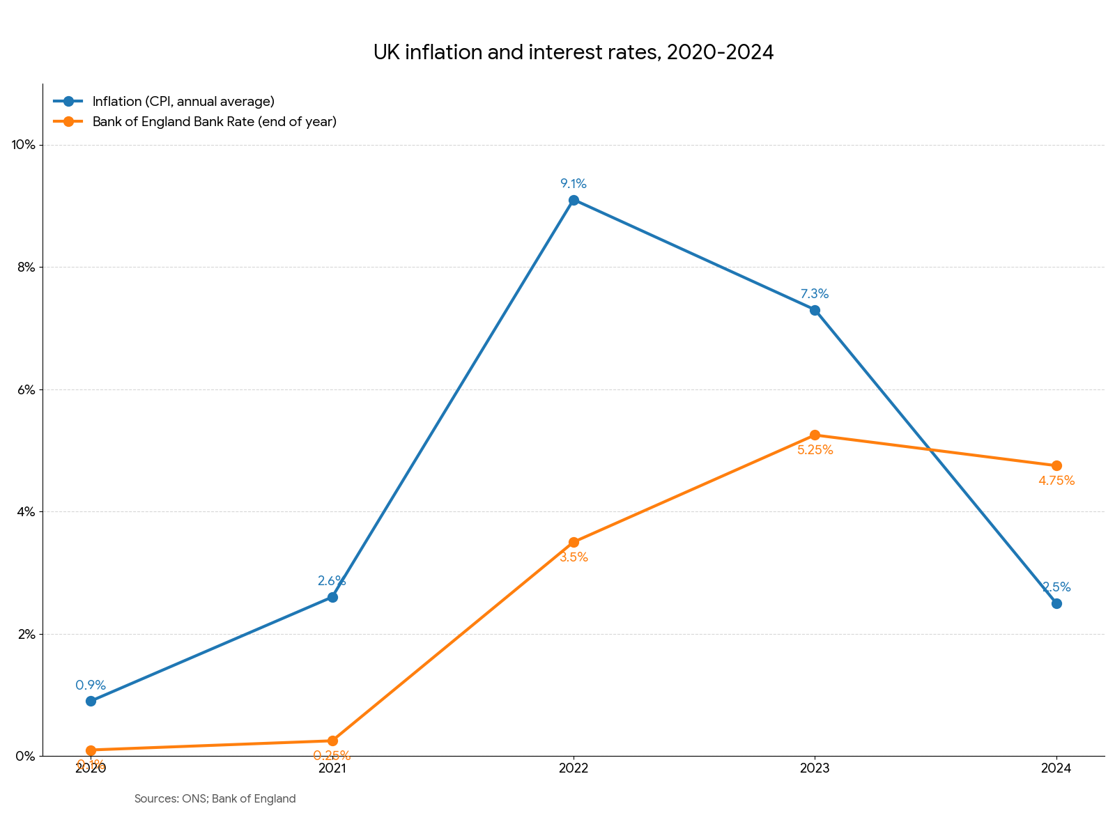  Inflation shot up in 2022, and the Bank of England raised interest rates to bring it back down.

The Figures Behind the Chart
Year | Inflation (CPI, annual average) | Bank Rate (end of year)
2020 | 0.9% | 0.1%
2021 | 2.6% | 0.25%
2022 | 9.1% | 3.5%
2023 | 7.3% | 5.25%
2024 | 2.5% | 4.75%
PART THREE
Taxes and Exchange Rates
What the government takes, and what the pound is worth.
Government Taxation
Taxes are payments to the government that businesses and customers must make.
▸ VAT. A tax added to the price of most goods and services - 20% at the standard rate. A rise makes products more expensive, so customers may buy less.
▸ Income tax. A tax on people's wages. Higher income tax leaves customers with less to spend.
▸ Taxes on business profits. Sole traders pay income tax on their profits; companies pay corporation tax. Higher taxes leave the owners with less profit.
▸ Employer costs. Businesses also pay National Insurance on their employees' wages, so a rise increases the cost of employing staff.
Feeling the Squeeze
When inflation is high, interest rates rise or taxes go up, customers look more carefully at every price. They buy fewer items, switch to cheaper brands and cut back on treats - and small businesses see it straight away in their sales. | 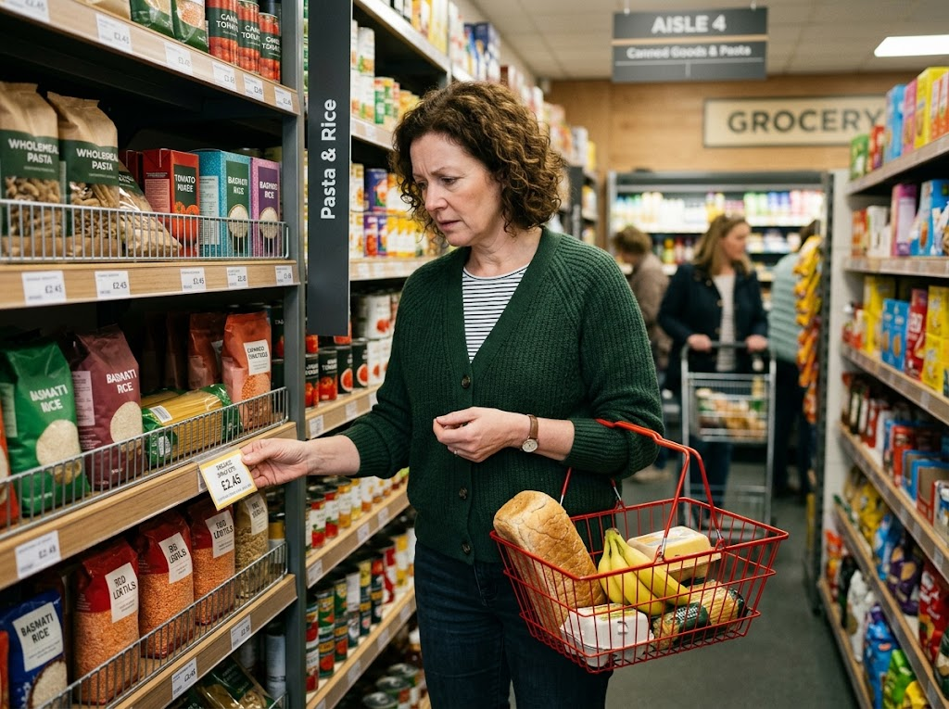  When prices rise faster than wages, customers buy less.

Changes in Exchange Rates
The exchange rate is the value of one currency in terms of another, for example £1 = €1.15.
▸ Importing. A small business that buys supplies from abroad - a café importing Italian coffee, a shop buying stock from China - pays in foreign currency.
▸ Exporting. A small business that sells abroad - such as an online shop with customers in Europe - is paid in foreign currency or sets prices in it.
▸ A stronger pound. Buys more foreign currency, so imports become cheaper, but UK exports become more expensive for foreign customers.
▸ A weaker pound. Buys less foreign currency, so imports become more expensive, but UK exports become cheaper for foreign customers.
SPICED: Strong Pound, Imports Cheap, Exports Dear
WHEN THE POUND IS STRONG | WHEN THE POUND IS WEAK
▸ £1 buys more foreign currency.  ▸ Imports are cheaper: good for a business buying supplies from abroad.  ▸ Exports are dearer (more expensive) for foreign customers.  ▸ A business selling abroad may lose sales. | ▸ £1 buys less foreign currency.  ▸ Imports are dearer: bad for a business buying supplies from abroad.  ▸ Exports are cheaper for foreign customers.  ▸ A business selling abroad may gain sales.
Exchange Rates in Action
To convert pounds to euros, multiply by the exchange rate.
A UK online shop sells a handmade bag for £40 to customers in France. The exchange rate changes from £1 = €1.10 to £1 = €1.20. Calculate the price in euros before and after, and explain the effect.

1. Price before
£40 × 1.10 = €44
2. Price after
£40 × 1.20 = €48
3. The effect
The pound has strengthened, so the same bag now costs French customers €4 more
Answer: €44 before, €48 after - the stronger pound makes the export dearer, so sales may fall.
Key Terms
Economic climate  The state of the economy, including jobs, incomes and prices. | Unemployment  When people who want to work cannot find a job.
Consumer income  The money people have to spend. | Inflation  A rise in the general level of prices over time.
Interest rate  The cost of borrowing money, and the reward for saving it. | Taxation  Payments to the government, such as VAT and income tax.
Exchange rate  The value of one currency in terms of another. | Import  A good or service bought from another country.
Export
A good or service sold to another country.
Your Task: Winners and Losers
15 minutes
For each change, name one small business that would suffer and one that might benefit, and explain why: unemployment rises; interest rates rise; inflation reaches 10%; the pound gets weaker against the euro.
1. Name a business that suffers, and explain why.
2. Name a business that benefits, and explain why.
A good answer shows: A loser and a winner for each change, with a chain of reasoning - e.g. a weak pound hurts a café importing Italian coffee but helps a UK gift shop selling online to European customers.
Note: The winners are the hard part and the best evidence of understanding - repair shops and discount stores in a downturn, exporters with a weak pound.
Can I...?
☐ Explain the impact of unemployment.
☐ Explain the impact of changing consumer incomes.
☐ Explain the impact of inflation.
☐ Calculate a percentage change.
☐ Explain the impact of interest rate changes.
☐ Explain the impact of taxation.
☐ Explain the impact of exchange rate changes.
☐ Convert a price using an exchange rate.
Summary
✓ Rising unemployment and falling incomes cut customer spending.
✓ Inflation raises costs and makes customers cut back.
✓ Higher interest rates raise borrowing costs and reduce customer spending.
✓ Higher taxes leave customers and owners with less money.
✓ A strong pound makes imports cheap and exports dear (SPICED).

EXAM FOCUS
Explain one impact on a small business of a rise in interest rates. (3 marks)
Economic questions have two sides - the business's own costs and its customers' spending. The strongest answers pick one side and take it all the way to sales or profit.
Exam Practice: The Economy and Business
Answer all questions. Show your working in calculations. · 25 minutes
▸ Question 1 · 1 mark · Define. Define the term 'inflation'.
▸ Question 2 · 2 marks · Calculate. The price of a bag of flour a bakery buys has risen from £2.50 to £2.75. Calculate the percentage increase in price. You are advised to…
▸ Question 3 · 2 marks · Calculate. A UK business sells a jacket for £60 to customers in Germany. The exchange rate is £1 = €1.15. Calculate the price of the jacket in euros…
▸ Question 4 · 2 marks · Outline. Outline one way rising unemployment could affect a small restaurant.
▸ Question 5 · 3 marks · Explain. Explain one impact on a small business of a rise in interest rates.
Question 1 · 1 mark · Define
“Define the term 'inflation'.”
HOW TO ANSWER IT Command word: Define. Worth 1 mark, so plan before writing.
Question 1 · mark scheme
1 mark available. Award a mark for each point made.
▸ Rising prices / increase in the general price level. 1 mark
▸ Model answer. A rise in the general level of prices over time.
Question 2 · 2 marks · Calculate
“The price of a bag of flour a bakery buys has risen from £2.50 to £2.75. Calculate the percentage increase in price. You are advised to show your working.”
HOW TO ANSWER IT Command word: Calculate. Worth 2 marks, so plan before writing.
Question 2 · mark scheme
2 marks available. Award a mark for each point made.
▸ Correct method: (new - old) ÷ old × 100. 1 mark
▸ Correct answer: 10%. 1 mark (award 2 marks for the correct answer with no working)
▸ Model answer. (£2.75 - £2.50) ÷ £2.50 × 100 = £0.25 ÷ £2.50 × 100 = 10%
Question 3 · 2 marks · Calculate
“A UK business sells a jacket for £60 to customers in Germany. The exchange rate is £1 = €1.15. Calculate the price of the jacket in euros. You are advised to show your working.”
HOW TO ANSWER IT Command word: Calculate. Worth 2 marks, so plan before writing.
Question 3 · mark scheme
2 marks available. Award a mark for each point made.
▸ Correct method: £60 × 1.15. 1 mark
▸ Correct answer: €69. 1 mark (award 2 marks for the correct answer with no working)
▸ Model answer. £60 × 1.15 = €69
Question 4 · 2 marks · Outline
“Outline one way rising unemployment could affect a small restaurant.”
HOW TO ANSWER IT Command word: Outline. Worth 2 marks, so plan before writing.
Question 4 · mark scheme
2 marks available. Award a mark for each point made.
▸ An effect identified, e.g. lower sales / easier to recruit staff. 1 mark
▸ Developed in the context of a restaurant. 1 mark
▸ Model answer. Its sales could fall (1), because people who have lost their jobs have less income and cut back on non-essentials such as eating out (1).
Question 5 · 3 marks · Explain
“Explain one impact on a small business of a rise in interest rates.”
HOW TO ANSWER IT Command word: Explain. Worth 3 marks, so plan before writing.
Question 5 · mark scheme
3 marks available. Award a mark for each point made.
▸ An impact identified, e.g. higher borrowing costs / customers spend less / delay expansion. 1 mark
▸ First linked point of explanation. 1 mark
▸ Second linked point of explanation. 1 mark
▸ Model answer. The cost of its loan repayments would increase (1). If the business has borrowed money, it must pay more interest each month, raising its costs (1). This reduces its profit and could cause cash-flow problems if the business cannot increase its revenue (1).

