EDEXCEL GCSE BUSINESS · PAPER 1
External influences
Understanding external influences on business · Lesson 5 of 5
Teacher copy - includes the notes for whoever is teaching from it.
Last Lesson
Answer from memory before the answers appear.
1. How does rising unemployment affect a business selling luxuries?
Customers have less income, so sales fall.
2. What does SPICED stand for?
Strong Pound, Imports Cheap, Exports Dear.
3. How do higher interest rates affect a business with a loan?
Repayments rise, increasing costs and reducing profit.
4. What is VAT?
A tax added to the price of most goods and services.
Learning Objectives
1. Explain why external influences are important to a business.
2. Explain possible responses to changes in technology.
3. Explain possible responses to changes in legislation.
4. Explain possible responses to changes in the economic climate.
Why External Influences Matter
External influences are factors outside a business that it cannot control but that affect how it operates.
▸ Outside its control. A small business cannot stop a new law, a rise in interest rates or a new technology.
▸ Opportunities. Some changes help - a new technology may cut costs, or a weaker pound may boost exports.
▸ Threats. Others hurt - rising costs, new rules or customers with less to spend.
▸ The key skill. Spotting changes early and responding well, so the business survives and even benefits.
The Three External Influences
Technology  New ways to sell, promote, communicate and take payment - e-commerce, social media, digital communication and payment systems. | Legislation  New or changed laws on consumer rights, pay, discrimination, and health and safety.
The economic climate
Changes in unemployment, incomes, inflation, interest rates, taxes and exchange rates.
PART ONE
Responding to Change
How a small business can react to each influence.
Responding to Changes in Technology
Adapt, or be left behind by competitors who do.
▸ Adopt it. Start selling online, take contactless payments or promote on social media.
▸ Train staff. Make sure staff can use new systems to serve customers well.
▸ Change the marketing mix. Sell through new channels, compete on price online, promote digitally.
▸ Weigh the cost. New technology costs money, so a small business must judge whether the extra sales or savings are worth it.
Responding to Changes in Legislation
Obeying the law is not optional, but how a business adapts is a choice.
▸ Update practices. Change pay rates, refund policies, recruitment adverts or safety procedures.
▸ Absorb or pass on costs. Accept lower profit, or raise prices to cover the extra cost - for example after a minimum wage rise.
▸ Cut other costs. Find savings elsewhere, such as reducing waste or energy use.
▸ Use it positively. Promote high standards, such as a five-star hygiene rating, to win customers.
Responding to Changes in the Economic Climate
When the economy changes, the marketing mix and costs usually change with it.
▸ Falling incomes or rising unemployment. Offer cheaper products, value deals or smaller portions, and target new customers.
▸ Inflation. Raise prices carefully, find cheaper suppliers, cut waste and reduce costs.
▸ Higher interest rates. Pay off loans, avoid new borrowing, and delay expensive plans.
▸ Exchange rates. An importer might find a UK supplier when the pound is weak; an exporter might sell more abroad.
Change and Response
External change | Threat or opportunity? | Possible response
A rival starts selling online | Threat | Build a website or use an online marketplace
The minimum wage rises | Threat | Raise prices slightly or cut costs elsewhere
Inflation raises ingredient costs | Threat | Find cheaper suppliers or reduce portion sizes
Interest rates fall | Opportunity | Borrow to invest in new equipment
The pound weakens | Opportunity for an exporter | Promote more to overseas customers online
Unemployment rises | Threat for luxuries | Offer value deals and cheaper options
Adapting to Survive
This café is responding to several external influences at once. A value lunch deal answers customers who have less to spend; online ordering and contactless payments answer changing technology. None of the changes were the owner's choice - but the response was. | 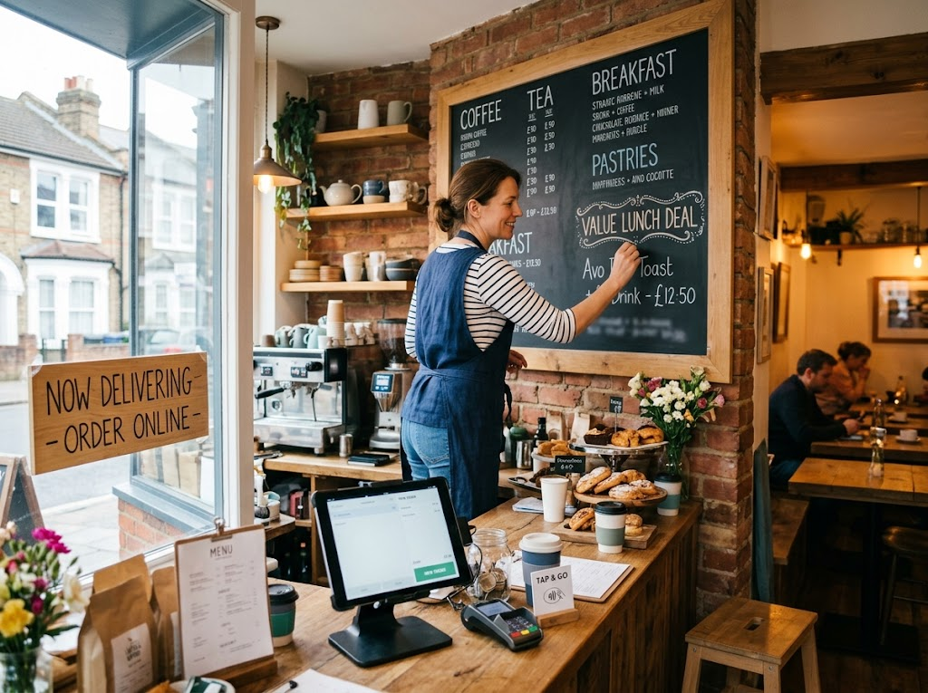  Value deals for the economy, online ordering for technology: responding to change.

Case Study
CASE STUDY
2020: Every Influence at Once
In March 2020 the COVID-19 pandemic brought sudden changes from every direction. New laws forced cafés, restaurants and pubs to close their doors to customers. Many small food businesses responded with technology, switching to takeaway, delivery apps and online ordering almost overnight. The government responded to the economic damage with support such as the furlough scheme, which paid most of the wages of staff who could not work, and in August 2020 "Eat Out to Help Out", which paid half the cost of meals out from Monday to Wednesday, up to £10 per person. The businesses that survived were those that adapted fastest.

March 2020  Lockdown laws close cafés and restaurants | August 2020  Eat Out to Help Out: 50% off meals, up to £10 a head
Key Terms
External influence  A factor outside a business that it cannot control but that affects it. | Economic climate  The state of the economy, including jobs, incomes and prices.
Opportunity  An external change that could help a business. | Threat  An external change that could harm a business.
Adapt
To change the way the business works in response to an external change.
Your Task: The Business Response Plan
15 minutes
You run a small independent bike shop that imports most of its bikes from Europe. In the same year, the pound weakens, the National Minimum Wage rises, and a large online retailer starts selling bikes more cheaply. For each change, say whether it is a threat or an opportunity, and plan one response.
1. Weak pound: threat or opportunity? Response?
2. Minimum wage rise: threat or opportunity? Response?
3. Online competitor: threat or opportunity? Response?
A good answer shows: All three changes identified as threats, each with a realistic response - e.g. find UK suppliers, raise prices carefully or cut costs, and compete on repairs, expert advice and servicing that an online retailer cannot offer.
Note: The best answers use what a small shop can do that the online giant cannot - expert advice, servicing and repairs.
Can I...?
☐ Explain what an external influence is.
☐ Explain why external influences matter to a business.
☐ Explain responses to changes in technology.
☐ Explain responses to changes in legislation.
☐ Explain responses to changes in the economic climate.
☐ Judge whether a change is a threat or an opportunity.
Summary
✓ External influences are outside a business's control but affect everything it does.
✓ The three influences are technology, legislation and the economic climate.
✓ Changes can be threats or opportunities.
✓ The business can choose how it responds - adapting quickly helps it survive.

EXAM FOCUS
Justify how a small business should respond to a rise in the cost of its raw materials. (9 marks)
For response questions, weigh up two options, explain the effect of each on sales, costs and profit, and make a clear, justified choice - "it depends on" how customers react.
Exam Practice: External Influences
Answer all questions. Use the context of the business in the question where one is given. · 25 minutes
▸ Question 1 · 1 mark · Define. Define the term 'external influence'.
▸ Question 2 · 1 mark · State. State one external influence on a business.
▸ Question 3 · 2 marks · Outline. Outline one way a small business could respond to a rise in inflation.
▸ Question 4 · 3 marks · Explain. Explain one way a small shop could respond to a competitor that starts selling online.
▸ Question 5 · 9 marks · Justify. Justify which one of these two options Rosa should choose.
Question 1 · 1 mark · Define
“Define the term 'external influence'.”
HOW TO ANSWER IT Command word: Define. Worth 1 mark, so plan before writing.
Question 1 · mark scheme
1 mark available. Award a mark for each point made.
▸ A factor outside the business / beyond its control that affects it. 1 mark
▸ Model answer. A factor outside a business that it cannot control but that affects how it operates.
Question 2 · 1 mark · State
“State one external influence on a business.”
HOW TO ANSWER IT Command word: State. Worth 1 mark, so plan before writing.
Question 2 · mark scheme
1 mark available. Award a mark for each point made.
▸ Any one of: technology; legislation; the economic climate (or a named part of it, e.g. interest rates). 1 mark
▸ Model answer. The economic climate.
Question 3 · 2 marks · Outline
“Outline one way a small business could respond to a rise in inflation.”
HOW TO ANSWER IT Command word: Outline. Worth 2 marks, so plan before writing.
Question 3 · mark scheme
2 marks available. Award a mark for each point made.
▸ A response identified, e.g. cheaper suppliers / raise prices / cut waste. 1 mark
▸ Developed: how it helps the business. 1 mark
▸ Model answer. It could look for cheaper suppliers (1), so that its costs rise less and it does not have to raise its own prices as much (1).
Question 4 · 3 marks · Explain
“Explain one way a small shop could respond to a competitor that starts selling online.”
HOW TO ANSWER IT Command word: Explain. Worth 3 marks, so plan before writing.
Question 4 · mark scheme
3 marks available. Award a mark for each point made.
▸ A response identified, e.g. sell online / improve service / compete on expertise. 1 mark
▸ First linked point of explanation. 1 mark
▸ Second linked point of explanation. 1 mark
▸ Model answer. The shop could start selling online itself (1). This would let it reach customers who prefer to shop online and are not near the shop (1). As a result it could protect its sales rather than losing those customers to the competitor (1).
Question 5 · 9 marks · Justify
“Justify which one of these two options Rosa should choose.”
— Rosa runs a small bakery. Inflation has increased the cost of her flour, butter and energy by 15% in a year, and her profit has fallen. Many of her customers are families on tight…
HOW TO ANSWER IT Command word: Justify. Worth 9 marks, so plan before writing.
Question 5 · mark scheme
9 marks available. Award a mark for each point made.
▸ AO2 (Application, 3 marks): uses Rosa's context - 15% cost rise, falling profit, families on tight budgets, the two options. Level 1-3
▸ AO3a (Analysis, 3 marks): chains of reasoning about each option. Level 1-3
▸ AO3b (Evaluation, 3 marks): a justified choice with a supported judgement, e.g. "it depends on". Level 1-3
▸ Model answer. Option 1 would raise her revenue per item, helping to cover the 15% increase in her costs and restore some of her profit. However, many of her customers are families on tight budgets, who are also affected by inflation. A 10% price rise may push them to buy less or switch to a supermarket, so her sales could fall and her total revenue might not rise at all. Option 2 keeps her prices the same, so her price-sensitive customers are less likely to leave. Switching to a cheaper flour supplier and baking fewer types of cake would cut her costs and reduce waste. But cheaper flour could lower quality, and fewer types of cake means less choice, so some customers might be disappointed. On balance Rosa should choose Option 2, because her customers are on tight budgets and a price rise risks losing them to cheaper rivals, while cutting costs protects profit without driving them away. However, this depends on the cheaper flour being good enough that customers do not notice a fall in quality.

