EDEXCEL GCSE BUSINESS · PAPER 2
Business operations
Making operational decisions · Lesson 1 of 4
From Making Marketing Decisions
Answer from memory before the answers appear.
1. Name the three parts of the design mix.
Function, aesthetics and cost.
2. What is an extension strategy?
An action taken to extend a product's life.
3. What is cost-plus pricing?
Adding a percentage mark-up to the cost of a product.
4. What is competitive advantage?
Anything that makes a business more attractive to customers than its rivals.
Learning Objectives
1. Explain the purpose of business operations.
2. Explain job, batch and flow production, with their advantages and disadvantages.
3. Explain what productivity is.
4. Explain the impact of technology on production: costs, productivity, quality and flexibility.
What Are Business Operations?
Operations are the activities that turn inputs into the goods and services a business sells.
▸ Inputs. Raw materials, components, labour, machinery and energy.
▸ The process. Making, assembling, preparing or delivering the product or service.
▸ Outputs. Finished goods or services, sold to customers.
▸ The aim. To produce products of the right quality, at the right cost, in the right quantity, at the right time.
PART ONE
Production Processes
Job, batch and flow.
Three Production Processes
Job production  One product made at a time, usually to a customer's individual order. Every product is unique - a wedding dress, a bespoke kitchen, a building. | Batch production  A group of identical products made together, then the process switches to a different batch - loaves of bread, then rolls; a batch of red paint, then blue.
Flow production
Identical products made continuously on a production line, often by machines - cars, cans of drink, chocolate bars.
One at a Time, or Thousands a Day?
The two extremes of production.
  Job production: every suit is unique. | 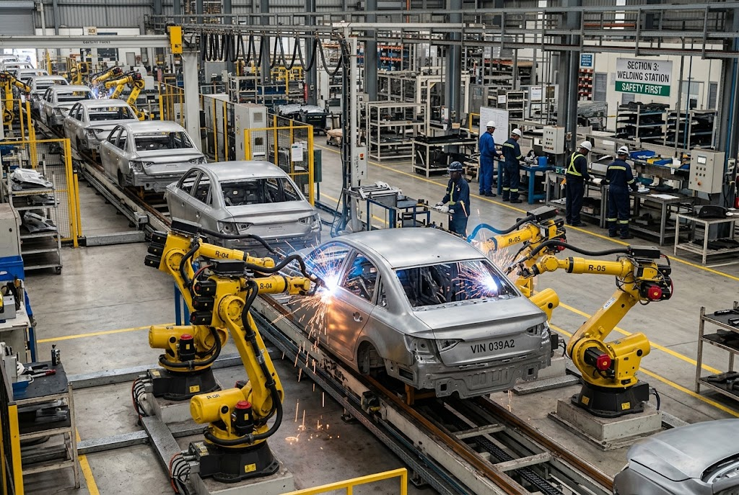  Flow production: identical cars, non-stop.

Comparing Production Processes
Feature | Job | Batch | Flow
Number made | One at a time | Groups of identical items | Huge numbers, continuously
Product | Unique, made to order | Same within a batch | Identical
Cost per unit | High | Medium | Low
Workers | Highly skilled | Semi-skilled | Mostly machines, less skilled
Flexibility | Very high | Some | Very low
Example | Wedding dress | Bread | Cars
Batch by Batch
A bakery is the classic example of batch production. It makes a batch of rolls, then switches to croissants, then to loaves. Each batch is identical, but the business can still offer variety - at the cost of time lost changing over between batches. | 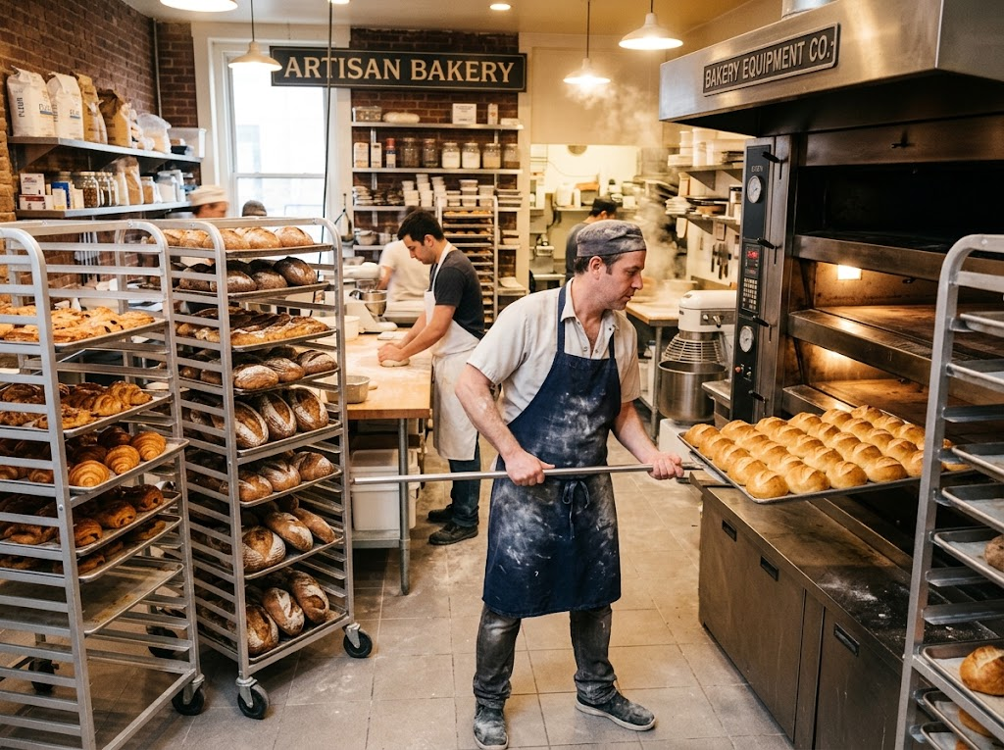  Batch production: one batch of rolls, then a batch of croissants.

Flexibility or Low Cost?
JOB AND BATCH PRODUCTION | FLOW PRODUCTION
▸ Flexible: products can be changed or customised.  ▸ Suits small orders and variety.  ▸ Customers get what they want.  ▸ But: higher cost per unit.  ▸ Skilled staff are expensive. | ▸ Very low cost per unit through economies of scale.  ▸ Consistent quality from machines.  ▸ Huge output.  ▸ But: expensive to set up.  ▸ Inflexible: hard to change the product, and boring, repetitive work.
PART TWO
Technology and Production
How machines and computers change operations.
Productivity
Productivity is the output produced per worker, or per machine, in a period of time.
▸ Example. A bakery worker who makes 400 loaves a day is more productive than one who makes 300.
▸ Why it matters. Higher productivity means more output for the same cost, so the cost of each unit falls.
▸ How to raise it. Better technology, training, and motivated staff.
The Impact of Technology on Production
Costs  Machines are expensive to buy, but reduce labour costs and waste, so cost per unit falls over time. | Productivity  Robots and automated machines work faster and non-stop, producing far more output.
Quality  Computer-controlled machines make every product to exactly the same standard, with fewer mistakes. | Flexibility  Modern computer-aided machines can be reprogrammed quickly, so even flow production can offer some variety.
Case Study
CASE STUDY
Morgan: Still Built by Hand
The Morgan Motor Company has made cars in Malvern, Worcestershire, since 1910. While most car makers use flow production with thousands of robots, Morgan still builds its cars largely by hand, using skilled craftspeople and, on many models, a frame made partly of ash wood. Customers can choose colours, leather and details for their own car. Output is tiny compared with a mass-market factory and each car costs far more - but customers pay for a hand-built, personalised car that flow production could never offer.

1910  Morgan founded in Malvern | By hand  How most of each car is built
Key Terms
Operations  The activities that turn inputs into goods and services. | Job production  Making one unique product at a time, usually to order.
Batch production  Making a group of identical products together before switching to another batch. | Flow production  Making identical products continuously on a production line.
Productivity  Output per worker or per machine in a period of time. | Automation  Using machines and computers to carry out tasks with little human input.
Your Task: Which Process?
10 minutes
Choose the best production process for each and explain why: a custom-built garden shed; 50,000 identical cans of cola a day; 200 birthday cards in each of 20 designs; a portrait painting; frozen pizzas in six flavours.
1. Choose job, batch or flow.
2. Explain your choice.
A good answer shows: Job for the shed and the portrait, flow for the cola, batch for the cards and the pizzas, each with a reason about quantity, variety and cost.
Can I...?
☐ Explain what operations are.
☐ Explain job production.
☐ Explain batch production.
☐ Explain flow production.
☐ Compare the three processes.
☐ Explain productivity.
☐ Explain how technology affects costs and productivity.
☐ Explain how technology affects quality and flexibility.
Summary
✓ Job production: unique products, high cost, very flexible.
✓ Batch production: groups of identical products, some flexibility.
✓ Flow production: identical products continuously, low unit cost, inflexible.
✓ Technology affects costs, productivity, quality and flexibility.

EXAM FOCUS
Explain one impact on a business of introducing automated machinery into its production. (3 marks)
Technology questions have two sides: high set-up costs now, lower unit costs and better quality later. Use the business's context to decide which matters more.

